Gender Inequalities in Academic Work: Mid-career women and the prestige economy
Kelly Coate
King’s Learning Institute, King’s College London Kelly.coate@kcl.ac.uk
Camille Kandiko Howson and Tania de St Croix
King’s College London, Camille.kandiko_howson@kcl.ac.uk; tania.de_st_croix@kcl.ac.uk
Abstract
The under-representation of academic women in senior positions in higher education (HE) is a continuing problem (David 2014). This paper will report on findings from a project funded by the Leadership Foundation which examined the career strategies of academic women in the middle stages of their careers. Research has tended to focus on academic women who are early-career researchers or those who are in senior and leadership positions (e.g. Hoskins 2012; Fitzgerald 2014; Dean et al 2009). Valuable as this research is, it is also important to explore the experiences and perspectives of women who see themselves as being mid-career, particularly as this stage probably encompasses the longest period of most women’s working lives.

The research aims to share the strategies that women have found useful in developing their careers, while also arguing for institutional change. We interviewed thirty women from nine different London universities who were from a variety of disciplines, with a majority from the natural sciences. Participants were allowed to self-select as being mid-career, and the sample ended up including a variety of job titles, reflecting disciplinary norms, women’s non-standard career pathways and institutional differences. The interviews started with a concept-mapping exercise whereby the interviewees produced visual representations of their 5-10 year career plans. We then discussed these maps with them, asking questions about obstacles and opportunities they perceived in terms of their career development, about the role of prestige in promotion and progression, and about other forms of recognition and reward.

One of the areas of focus in the interviews was the role of prestige in academic careers. We use the term ‘prestige economy’ to describe the collection of beliefs, values and behaviours that characterise and express what a group of people prizes highly (English 2005). High-status publications and substantial grant income are obvious indicators of esteem in the university. Other indicators include being invited to give keynote speeches at international conferences, editing journals and supervising PhD students. Previous research on motivation in academic work has highlighted the role of prestige in career advancement (Coate and Kandiko Howson 2014). However, prestige is a gendered concept, and this research contributes to evidence that women find it harder to access the types of currency that advance their reputations (Morley 2014).

This research raised many of the challenges that women face in advancing their academic careers, particularly negotiating disciplinary prestige, institutional structures and unbalanced workload allocations and managing caring responsibilities. At a time when more women are entering academia and finding mid-career success—but failing to advance to senior positions—we believe this project makes a very useful contribution to understanding what leaders and managers need to be thinking about to manage challenges, remove barriers and support the success of women in higher education. Enabling women to flourish at the most senior levels of universities will inevitably bring many benefits to society.

Keywords
Gender, Academic work, Prestige

Introduction
The under-representation of academic women in senior positions in higher education (HE) is a continuing problem (David 2014) that is not typically perceived to be an issue of social justice (to relate to the theme of this conference). After all, women in academic careers are in relatively privileged positions in society. However, I will argue that discrimination on the basis of gender is a social justice issue, wherever it occurs. Over the course of several decades of research into why women’s academic careers lag behind their male counterparts, it is difficult to conclude that gender discrimination within higher education institutions is not a contributing factor. As institutions committed to improving lives, it is striking that universities can be so complacent about the low levels of women in senior positions. If academic women are unable to reach their full potential due to gender discrimination, should we not treat this as a social justice issue?

This paper will report on findings from a project funded by the Leadership Foundation which examined the career strategies of academic women in the middle stages of their careers. Research has tended to focus on academic women who are early-career researchers or, more commonly, those who are in senior and leadership positions (e.g. Hoskins 2012; Fitzgerald 2014; Dean et al 2009). Valuable as this research is, it is also important to explore the experiences and perspectives of women who see themselves as being mid-career, particularly as this stage probably encompasses the longest period of most women’s working lives. In a similar vein to Pyke (2013), who also looked at women just below the professoriate, we wanted to challenge the view that under-representation of women might be because they ‘opt out’ of taking deliberate steps to progress their careers.

We therefore wanted to explore how mid-career academic women were thinking about their careers, while also arguing for institutional change. While focusing primarily on gender, we drew on feminist theories of intersectionality to consider multiple forms of identity (Crenshaw 1991; Berger and Guidroz 2009). This conceptualisation reflects a perspective of universities as highly complex sites where multiple and intersecting spheres of ‘difference’, including culture, ethnicity, gender, disability, socio-economic status and language interact.

A central focus in the interviews was the role of prestige in academic careers. We use the term ‘prestige economy’ to describe the collection of beliefs, values and behaviours that characterise and express what a group of people prizes highly (English 2005). High-status publications and substantial grant income are obvious indicators of esteem in the university. Other indicators include being invited to give keynote speeches at international conferences, editing journals and supervising PhD students. Previous research on motivation in academic work has highlighted the role of prestige in career advancement (Coate and Kandiko Howson 2014). However, prestige is a gendered concept, and this research contributes to evidence that women find it harder to access the types of currency that advance their reputations (Morley 2014).

Methodology

We interviewed thirty women from nine different London universities who were from a variety of disciplines, with a majority from the natural sciences. Participants were allowed to self-identify as being mid-career, and we received many queries from interested participants as to whether they qualified as being ‘mid-career’ (which we deliberately avoided defining in order to gauge women’s perceptions of what mid-career means to them). That a handful of professors and PhD students volunteered to take part (along with everything in between) demonstrates the breadth of the term ‘mid-career’. In the end, the sample included a variety of job titles, reflecting disciplinary norms, women’s non-standard career pathways and institutional differences. It was clear that the mid-career stage felt quite protracted for many women, with a number of them stating that they do not know if they will ever consider themselves to be ‘senior’.

The interviews started with a concept-mapping exercise whereby the interviewees produced visual representations of their 5-10 year career plans. We then discussed these maps with them, asking questions about the obstacles and opportunities they perceived in terms of their career development, about the role of prestige in promotion and progression, and about other forms of recognition and reward. The concept of prestige in academic work resonated with our respondents and almost all were able to point to ways in which they perceived their gender had impacted on their or their colleagues’ access to prestige.

We undertook a thematic analysis of the interview data, and developed four main areas of concern. These were: the neglected but lengthy mid-career stage; work-life balance; career strategies; and the role of prestige. In this paper we will focus on how academic women viewed the prestige economy in relation to their careers.

Academic Women and the Prestige Game

Many of the women we interviewed were highly and passionately motivated by traditional academic values such as the love of science, learning and the pursuit of knowledge. These positive elements of academic work sat alongside other aspects such as good working environments, flexibility, autonomy and making a wider contribution to society. However, this love of academic work was often tempered by the necessity to participate in ‘gameplaying’ to meet key performance indicators set by the institution, which often did not map onto outcomes related to disciplinary success or fulfilment of job duties (particularly teaching, managing labs and research teams and building collective success). Many interviewees told us that their institutions valued monetary income above all else.

For some, this meant a lack of confidence in their likelihood of future success as academics. High profile publications were considered both prestigious and necessary for a successful academic career, as well as being understood as a route to funding. However, not all income-related activity was considered prestigious. Research-related income was clearly more prestigious than income from students, and working with undergraduates – who may be seen as the most lucrative group – was widely considered the least prestigious form of teaching. So-called ‘serious academics’ were perceived to focus on income generation through research and other work that would be recognised as prestigious. As Diane said:

Education is women’s work at [institution]. That’s not what serious academics do around here. Serious academics do other things. They don’t really do teaching . . . (Diane)

These gendered divisions of labour seemed to mirror the gendered division of labour in the home, where necessary but under-rewarded labour (childcare and housework in the home, teaching and repetitive lab work or data entry in the university) is done more often by women, ‘freeing up’ others (mostly men) for ‘successful’ and prestigious forms of work. In this way, the prestige economy operates to reward certain forms of labour while ignoring or undervaluing others. In addition, the currency carried by different indicators of esteem was not always equal when possessed by men and women.

When women attempted to play the prestige game, they did not always feel they were as readily recognised as men. As Eve said:

Men and women who do the same things, the men accrue prestige and the women don’t. So writing books, sitting on advisory committees . . . to give plenary talks at conferences, and also getting money. So getting large grants. The men who get those things get more prestige than the women who have done exactly the same. And, you know, although it’s secret, I am sure they get paid more. (Eve)

The prestige economy was widely viewed to operate differently for men than women. The perception is that men more easily acquire the indicators of esteem that enable them to enter the prestige economy, and to continue to ‘trade up’ as their prestige accrues. For academic women, who often are taking care of the ‘domestic work’ in the academy, access to the prestige economy becomes more difficult and of lower value. However, Eve’s criticism of the prestige economy was somewhat ambivalent (as was the case with many other respondents). As she said, accruing prestige is pleasurable:

I actually think I seek that kind of thing to some extent . . . I like it when I’m invited to sit on an advisory committee. So I went to give an opening talk at a conference. I do feel validated by that. I’m increasingly invited to sit and do quite high-pro le things. I don’t think anyone in my department’s noticed. (Eve)

The difficulty with getting ‘noticed’ was often perceived to be related to self-promotion. As one of our respondents pointed out, the willingness to self-promote and ‘play the game’ is gendered and yet this should not suggest that ‘all women’ are modest while ‘all men’ sell themselves. The reality is more complicated, with many women engaging in self-promotion and doing well in the prestige economy. As Bernadette said:

I play the REF game, I play the publication game, I play the getting grants game, definitely, but I think that it’s really important to be collegial and I don’t always see that, and that really annoys me. And I’m not sure to what extent collegiality is really fostered or valued, especially if it comes to things like stepping in for teaching, you know, things that aren’t research, that are meant to count. My first single thought was whatever men do, white men, is prestigious . . . and some men might also struggle with that who don’t play that game, and some women might do incredibly well who play that game. (Bernadette)

A central theme emerging about the prestige economy was ambivalence: all of our interviews were cognisant of its importance in shaping academic careers, and some acknowledged a willingness to participate fully in it, even if they were uneasy about the implications of engaging in self-promoting activities. As Bernadette’s concept map illustrates, she has a good understanding of what she needs to progress to a Readership in 5 years’ time, but she is worried about how these plans do not take due consideration of her students.

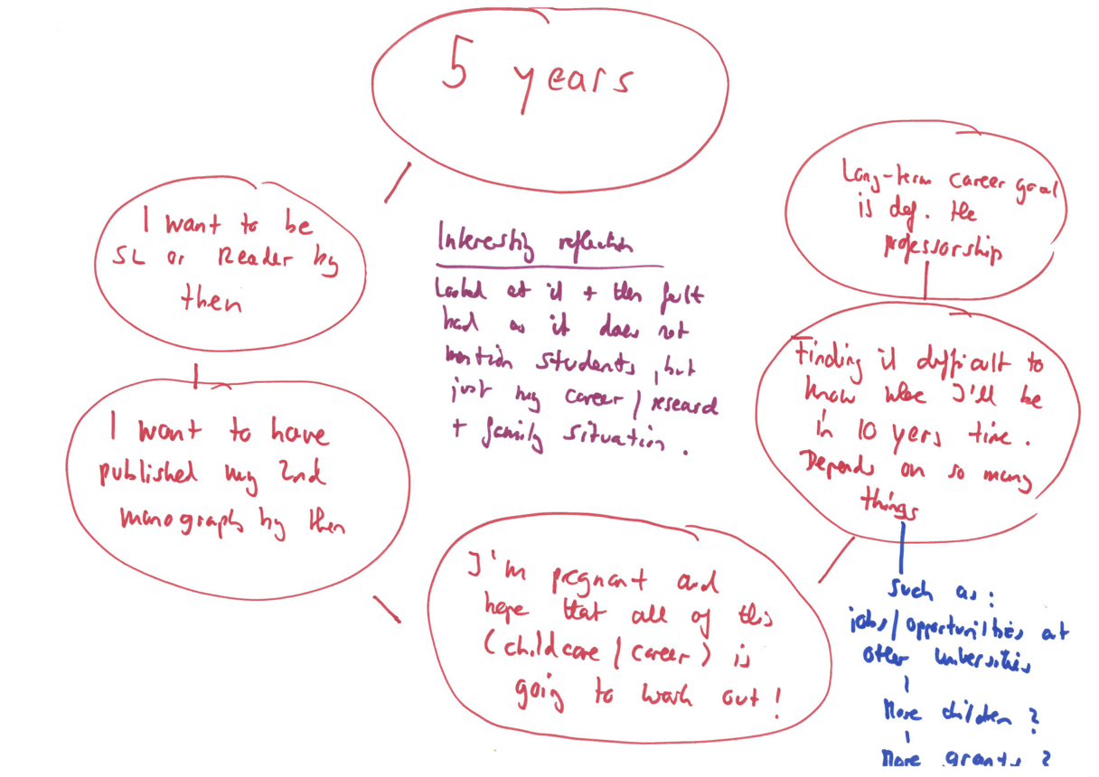

Figure 1: Bernadette’s Concept Map

Our research confirmed other research which suggests there can be a cultural and gendered reluctance to engage in self-promotional activities (e.g Doherty & Manfredi 2006). As a Japanese participant in our research stated:

Japanese women are brought up to be modest, but in the academic world you have to be, you know, present [that] you’re very good, which I’m not really good at doing so far. So to say I’m reasonably good, I have to achieve much more. (Janeru)

The key issue in relation to whether a reluctance to engage in self-promotion is gendered and culturally nuanced is that the academic career structure is highly individualistic and competitive. A number of the women we interviewed discussed their belated realisation that self-promotion would progress their careers more quickly, and again, they sometimes felt very ambivalent about this realisation. As Yvonne explained:

I didn’t bother applying for academic promotion for a very long time. And it never occurred to me that it was important. I always used to think, well listen, it doesn’t really matter whether I’m a senior lecturer, a reader or a professor. It’s the quality of my work that matters and I don’t really care... And then only latterly it occurred to me... that I should have been promoted a long time ago and it would be a good idea. Because I was going to meetings where I would be the only person on the panel who’s not a professor... And when I did the promotion to reader, I realised that I probably met the criteria quite a bit previously. (Yvonne)

A notable aspect of the issue of women’s seeming reluctance to engage in the types of activities that would enable them to progress is that they often seemed to discuss this in terms of personal realisation rather than institutional support. It was very clear that some women had supportive networks, role models and/or effective mentors, whereas others clearly did not have access to these same forms of support and advice. The difference that good advice and support can make to a career is undoubtedly substantial.

A common institutional response to women’s lack of progression is to ‘help’ them learn how to be more assertive. Yet we would argue that a more helpful response would be to reorient reward structures in academia. Clearly, women found it frustrating that the types of things that motivated them in their work were the least likely to be the things that receive recognition and reward. A fairer system would place much higher regard on collective endeavours, particularly given that achievements in teaching and research in academia are always the result of the collective rather than the individual.

Conclusion

This research raised many of the challenges that women face in advancing their academic careers, particularly negotiating disciplinary prestige, institutional structures and unbalanced workload allocations and managing caring responsibilities. At a time when more women are entering academia and finding mid-career success - but failing to advance to senior positions – this research contributes to an understanding of what leaders and managers need to be thinking about to manage challenges, remove barriers and support the success of women in higher education. At the very least, managers need to have gender in mind when engaged in decision-making activities.

We therefore made a number of recommendations (Coate et al 2015) that we believe are important in identifying actions that could support the progression of academic women. One set of recommendations is around recognising the ‘mid-career’ stage of academic careers. For many women, this is a protracted stage of their career, in which they are trying to juggle many demands as they develop their research and teaching profiles. It often coincides with caring responsibilities in their personal lives, either of elderly parents or children. Women therefore asked for more support during this difficult stage, such as targeted funding or mentoring, particularly in relation to ‘promotion-readiness’. We found that academic women can feel reluctant to apply for promotion, signalling as it does to their colleagues that they feel ready to progress, which in turn leads to anxieties about being seen to fail.

However, as stated above, the over-riding emphasis in our recommendations is to consider how to change the recognition and reward structures of academic careers. The highly individualistic and competitive nature of promotions does not do justice to the collective efforts of all the types of teams that help higher education institutions achieve success. The competitive nature of the promotions process can result in women feeling a personal sense of failure, when in reality their efforts and those of their colleagues are highly dependent on each other. Furthermore, the higher levels of prestige that accrue through research income and outputs as compared with teaching needs addressing, not just as an issue of gender inequality, but as a means of properly recognising one of the core functions of universities. There is an urgent need for more women to rise the academic career ladder to the highest levels, in order to show the next generation of female students what is possible to achieve.

References

Berger, M. T., and Guidroz, K. (eds.) (2009). The intersectional approach: Transforming the academic through race, class, and gender. Chapel Hill, N.C.: University of North Carolina Press.

Coate, K. & Kandiko Howson, C. (2014) Indicators of esteem: Gender and prestige in academic work, British Journal or Sociology of Education, 37(4): 567-585.

Coate, K., Kandiko Howson, C., & de St. Croix, T. (2015) Mid-career academic women: Strategies, Choices and Motivation. London: Leadership Foundation for Higher Education.

Crenshaw, K. W. (1991) Mapping the margins: intersectionality, identity politics, and violence against women of color. Stanford Law Review, 1241 -1299.

David, M.E. (2014) Feminism, Gender & Universities: Politics, Passion & Pedagogies. London: Ashgate.

Dean, D.R., Bracken, S.J. and Allen, J.K. (Eds) (2009) Women in academic leadership: Professional strategies, personal choices. Sterling, VA: Stylus Publishing.

Doherty, L. and Manfredi. S. (2006) Women’s progression to senior positions in English universities, Employee Relations 28(6): 553-572.

English, J.F. (2005) The economy of prestige. Cambridge, MA: Harvard University Press.

Fitzgerald, T. (2014) Women leaders in higher education: Shattering the myths. Abingdon: Routledge.

Hoskins, K. (2012) Women and success: professors in the UK academy. Staffordshire. Trentham Books.

Morley, L. (2014) Lost leaders: Women in the global academy. Higher Education Research and Development, 33(1): 114-128.

Pyke, J. (2013) Women, choice and promotion or why women are still a minority in the professoriate. Journal of Higher Education Policy and Management. 35(4): 444-454.

