Front cover page single image of people enjoying the river e.g.
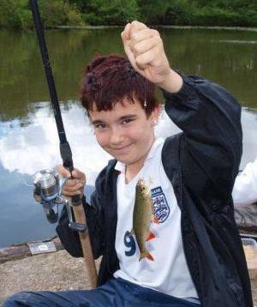

  Suggest this is the only logo in the plan | my river my plan  our joint ambition for the care of the  River Don catchment  March 2012

The purpose of this document is to assist discussion by members of the Don Network about what a joint catchment plan might be like and what it might include.

It is not intended to represent anything like a finished document and everything is up for change.

However it includes the outputs of the Don Network workshops held to date so it should be familiar in places to members of the Network.

The draft Sheffield Waterways Strategy has identified some very useful issues to consider and these are included to prompt discussion.

For the Environment Agency this plan would one way of progressing WFD outcomes but it is emphasised that this document would be a joint plan and incorporate the aspirations of a broad range of organisations with an interest in the Don.

My explanatory notes are highlighted in yellow italics.

This draft would be 18 pages long.

The structure proposed is:

- Welcome page
- Vision
- Introduction to the Don catchment
- Success stories - two pages.
- Ten themes – one page each theme each with its own colour
- List of supporting documents

It is suggested that the plan would include many photos and the text would be laid out in an attractive, open and easy to read way.

The proposed audience is people working for organisations with an interest in the River Don and members of the public with an understanding of environmental issues. Jargon, abbreviations and technical terms would be avoided.

The document would not be very long and would be designed to be a precursor to action.

Technical information about the catchment including WFD data would be found in a separate document.

It is proposed that a more accessible summary leaflet would also be produced for distribution to members of the general public.

Stuart Jenkinson
Don Pilot coordinator
Environment Agency
5 January 2012

Welcome page

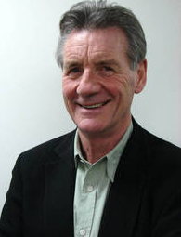

Positive aspirational introduction by local celebrity relevant to South Yorkshire with photo - not a politician, chief executive, senior manager etc

Yes - I think we could get Michael Palin - he is from Sheffield!

Note about the plan, what its purpose is, which organisations had a role in preparing it, intention to revise it periodically, how people can get hold of more copies and in other formats, link to website, contact details for comment/feedback
By this stage we need to have all the local authorities on board

Date note we will need to produce a draft for people to comment on (March 2012) AND a final version for Dec 2012.
In what format should these be available down load pdf? Printed hard copy?

Our Vision

Include our Vision here – shouldn’t be more than one page

Text to follow

Notes from Don Network meetings

“A healthy living Don”
Watercourses both look attractive and are ecologically sound

Introduction to the River Don catchment – better title needed

Two pages
History- see Sheffield Waterways Strategy for example content
Show area covered by the plan, just what is the Don catchment?
Facts and figures about the catchment

Simplified map of the Don catchment something like this showing main towns, rivers Don, Rother, Dearne, Ea beck and Went, motorways and a couple of ‘landmark’ sites. Not a reproduction of an OS map or anything technical

Text box on WFD – what is trying to achieve, by when, pie-chart of current classification – about third of a page only.
There won’t be a full section dedicated on WFD but will aim to have WFD related objectives in each relevant sections

There are already some great places on the River Don,
but let’s make it even better

Two pages (photo led) of some positive inspirational case studies, providing multiple benefits

Possible examples
RSPB Old Moor, Centenary Riverside, RSC, improvements at Blackburn Meadows WWTW, clean up of the river over last 20 years/return of fish + otters, flood risk management schemes, Five Weirs Walk, Upper Don Walk, Shire Brook Valley, Charlton Brook WHERE? Tongue Gutter WHERE? Blackburn Meadows nature reserve, Salmon Pastures, Crabtree Ponds

Flooding

This is an important section that will be ‘hook’ for many stakeholders to get involved. The 2007 floods – a wake up call for many about rivers

<Text to follow – where we are now, what the problems are, what the Don Network would like to see happen>

Notes from Don Network meetings
Reservoirs managed to reduce flood risk

Sheffield Waterways Strategy
Blue spaces to make space for water

“I’m really worried now about living next to the river. In 2007 we lost everything when the river burst its banks and it took years to get our house right again. I’m on edge every time it rains”.  These quotes are all made up! I’d suggest we obtain real ones if this feature is liked. I’m keen that PEOPLE feature prominently in the document.  Harry Watson, Doncaster | 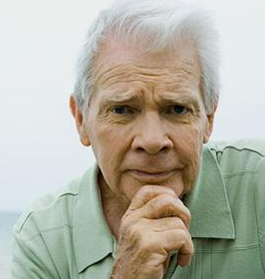

We believe that example statements only
Flooding from all sources can be a serous threat to communities and businesses
Extreme weather events are becoming more likely DNW1
A multi-agency approach is needed to reduce flood risk
Flood defences are well maintained – DNW1
Adequate resources – DNW1

What we want to see happen – include just a few headline actions
Risk of flooding is reduced – DNW1
Work to improve the flood resilience of at risk communities – DNW1
More natural approach to managing flood risk – DNW1
See also the Don Network action plan this would be separate document

The natural world

<Text to follow – where we are now, what the problems are, what the Don Network would like to see happen>

Notes from Don Network meetings
Return of iconic species such as salmon
Bio/geo-diversity understood and valued by the community
Create a joined up ecological network
Action on invasive species
Local people understand and value wildlife
Fish/angling as a recreational/economic resource

“I’ve been working on the River Don for over 15 years and sometimes I can’t believe how much it has improved. Long stretches of the Don were once virtually dead but now are now producing some prize specimens of fish – which means conditions are better for wildlife too”  Neil Trudgill, Environment Agency Fisheries officer | 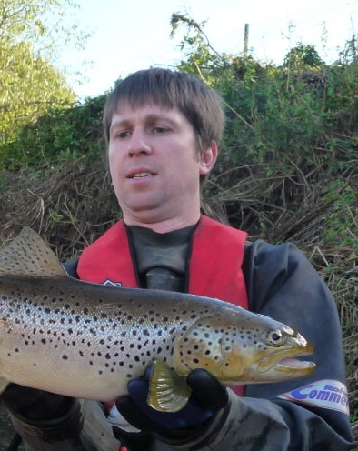

Sheffield Waterways Strategy
Green/blue corridors - SWS
SWS – Sheffield Waterways Strategy
Day- lighting or removal of culverts - SWS
Create nature reserves in urban areas for more contact with people – SWS

Bring about biodiversity improvements including those required by WFD – SJ

Remember geo-diversity too!

We believe that

What we want to see happen

Amenity and recreation

<Text to follow – where we are now, what the problems are, what the Don Network would like to see happen>

Notes from Don Network meetings
People use the water environment
Better access to river and river banks
Create a network of routes
Cleaned up waters are used for recreation
Economic value of tourism – DNW1

Sheffield Waterways Strategy
Riverside gardens, allotments, orchards and woodlands
City wide network of riverside paths

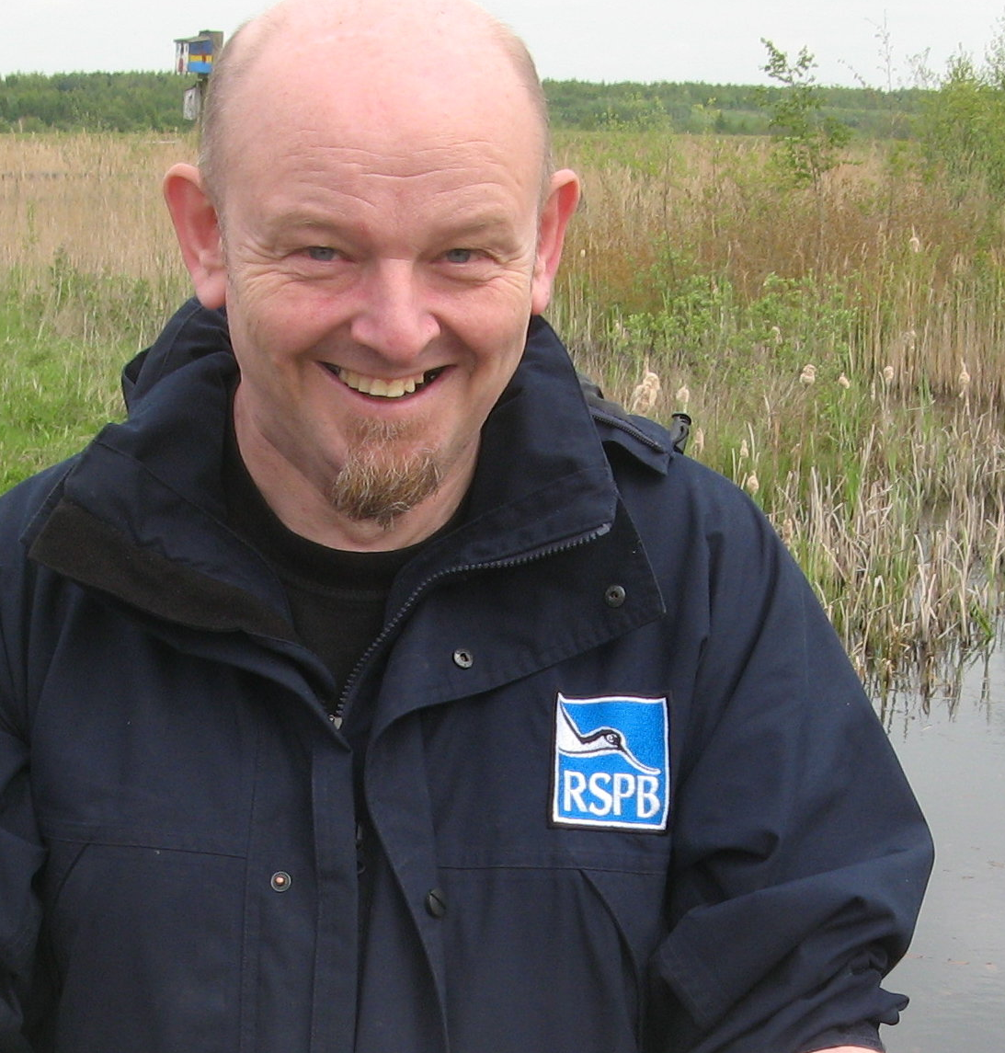 | “The Dearne Valley is very important place for birds, the RSPB and the thousands of visitors we get at our Old Moor visitor centre each. I’m really proud how we have played a part in change one of the most polluted places in Europe in to the green heart of South Yorkshire”  Pete Wall RSPB Old Moor, Barnsley

We believe that

What we want to see happen

Regeneration and economy

<Text to follow – where we are now, what the problems are, what the Don Network would like to see happen>

Notes from Don Network meetings
Less red tape!
Rivers not a constraint on development
Business more aware of how to avoid pollution
Investment in infrastructure
Waterways for transport

Sheffield Waterways Strategy
‘Lost’ riverside communities – no river frontage
Making businesses and landowners aware of their obligations
Waterside and Dearne Valley Eco-vision
Improving the rivers can change perceptions of South Yorks as a location for investment. Sheffield aspires to be a European-class city.

We need to make connections with local enterprise partnership. It would be good to have their support for this document. The LEP has endorsed the Chesterfield

Address relevant WFD reasons for failure

Use redevelopment opportunities to make watercourses as natural as possible, remove barriers to fish migration

 | “There is still too much derelict and underused land in South Yorkshire especially along the river corridor. There’s a great opportunity to use these sites for new businesses and bring much needed jobs to the area”  Alistair Rodger, South Yorkshire Local Enterprise Partnership

We believe that

What we want to see happen

‘Land management’ need a better title

<Text to follow – where we are now, what the problems are, what the Don Network would like to see happen>

Notes from Don Network meeting
Sector more aware of how to avoid pollution – better control
Less red tape!

Address relevant WFD reasons for failure - SJ

“The farming community has cared for the land for centuries. Looking after becks and streams is a big part of these. Good clean water is essential to all farmers everywhere”  James Wagoner, Penistone | 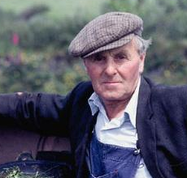

We believe that

What we want to see happen

People and communities

<Text to follow – where we are now, what the problems are, what the Don Network would like to see happen>

Notes from Don Network meeting
Counter negative perceptions of river / alienation
People are aware of and take pride in their surroundings
Waterways become centre of the community
Help local communities bring about improvements themselves, build their capacity
‘Friends of groups’ formed
Reach a variety of audiences including farmers, business
No more fly-tipping in rivers
Importance of enthusiastic individuals in local improvements

Sheffield Waterways Strategy
Rivers are good places for people to encounter wildlife
Work with communities to create – ‘river rescue plans’
Gap analysis of riverside paths
Increase footfall along existing paths
Annual community clean ups of rivers

How can local people contribute to WFD outcomes?

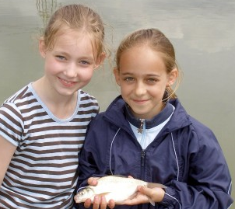 | “The only fish I’d seen before were in the supermarket. I never knew there real fish lived in the river in our town”  Rebecca Green and Sarah Lowther, Chesterfield

We believe that

What we want to see happen

Water supply / waste water treatment etc

<Text to follow – where we are now, what the problems are, what the Don Network would like to see happen>

Notes from Don Network meeting
Promote sustainable use
Supplies protected against pollution
Flood risk and drought linked
Zero pollution incidents
Urban drainage
Hydropower?
Management of reservoirs changed to benefit catchment as a whole

Where do people in the Don get their drinking water from?
Is there enough water – now and in the future?
Will Climate Change change things?

Waste water – how/where is it treated?
Improvements planned?
Objective of improvements?

We believe that

What we want to see happen

Culture and Heritage

<Text to follow – where we are now, what the problems are, what the Don Network would like to see happen>

Notes from Don Network meeting
Buildings restored and maintained
River festivals in many towns
Annual River Don Conference
Celebrate riverside heritage

Sheffield Waterways Strategy
Riverside as a venue for cultural events SWS

Waterside heritage – listed buildings? Conservation areas
Develop tourist potential

 | “River? I went to Sheffield University for three years and never saw a river”  Danny Howden former student

We believe that

What we want to see happen

‘Data and evidence’ need better title

The DN has flagged this up as a big issue. Improving understanding of WFD is just one aspect of this and one that can be addressed in the short term.

<Text to follow – where we are now, what the problems are, what the Don Network would like to see happen>

Notes from Don Network Meeting
Sharing information better
Accessible, available, integrated, simple
Decision making based on science
Better understanding of flood risk
Gaps in knowledge are identified and filled
A shred understanding of issues develops
Clarity about WFD objectives and reasons for failure, others able to take steps to solve them

Inform revision of the joint catchment plan
Freedom of access to information about the river
Openness in decision making

We believe that

What we want to see happen

Leadership – DNW1
<Text to follow – where we are now, what the problems are, what the Don Network would like to see happen>

Notes from Don Network meeting
Leadership lacking
Action not coordinated
Encourage joined up thinking
Join up good intentions
A board is established to manage the river
Resolving conflict between user groups
Management of river is fragmented
Promote an aspirational vision
Reduce duplication of effort and resources
The DN as a significant local voice could lobby for changes in legislation and development control rules
Promote collaborative working
Help share the costs of improvements
Maintain WFD improvements and resist any deterioration
Lobbies for and obtains political support
Monitoring and evaluation role
Role in fighting pollution
A voice for better access to river and banks
Work with media to create positive image of rives

Sheffield waterways Strategy
To ensure delivery have a City of Rivers declaration that leaders sign up to

Manage periodic revision of joint catchment plan
Oversee implementation of the joint catchment plan and hold others to account (see Tweed Forum)
Support achievement of WFD outcomes
A semi- official role for the DN – an ‘honest broker’. With own staff/secretariat
Maintenance – who? Who pays? RSC as an example
Not planning on including anything on funding. This is important but isn’t part of the catchment plan
We believe that

What we want to see happen

Want to find out more about the River Don catchment?

List supporting documents and how to obtain a copy

Don Network Action Plan

Summary leaflet version aimed at general public

Audit of activity – current and future projects, problems and opportunities

Sheffield Waterways Strategy
Rotherham Waterways Strategy

Annex - WFD data and maps

Annex – action plan including who is going to do what see SWS example. Some actions are local some are catchment wide. SWS version is for 5 years and organised geographically.

Back cover page single attractive image of the river e.g.
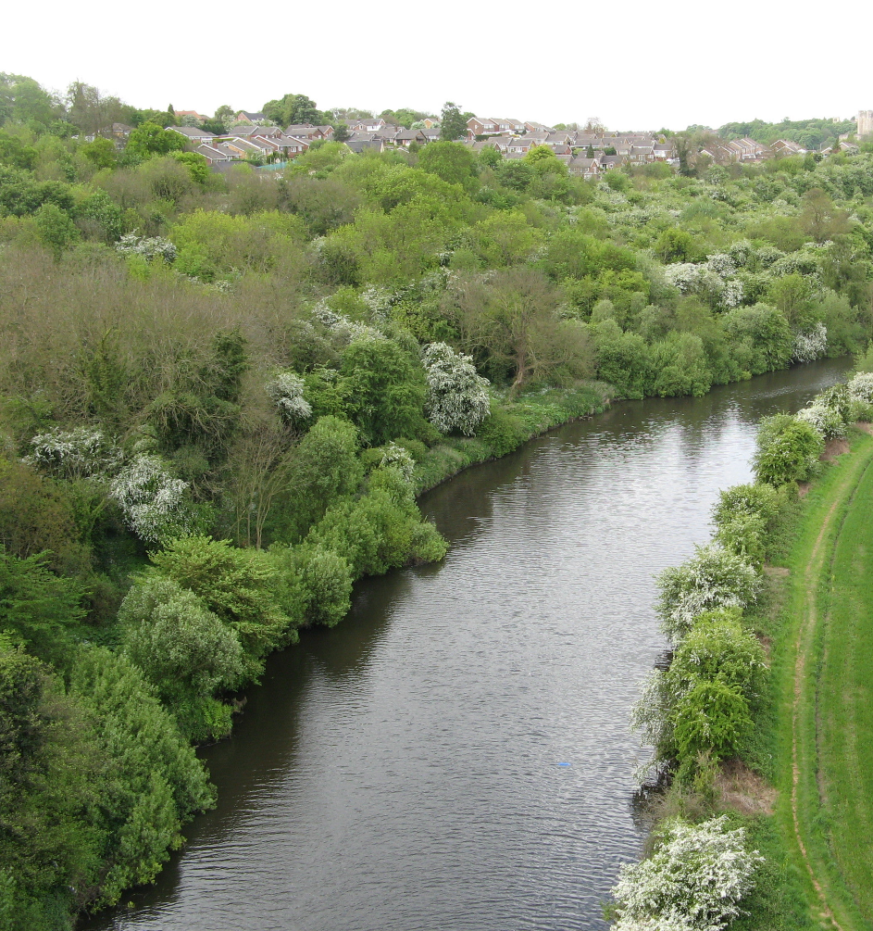

Skeleton draft 5 January 2012

