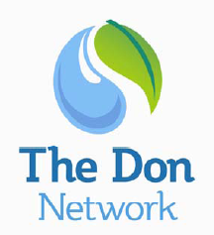 | Don Network  Catchment plan workshop  7 March 2012
Words that capture the essence of our plan

Inspirational | Informed | Achievable
Short | Implement-able | Proportionate
Enabling | Enthusing | Intelligible
Action orientated | Exciting | Bottom up
Integrated | Engaging | Life long
Ambitious | Exciting | Achievable
Deliverable
(includes resources for delivery / development of work)

