Baseline Action Mapping within the Leam
- Mapping being undertaken using online ArcGIS.
- All stakeholders currently populating map with the completed, ongoing and proposed actions that they are aware of.
- Idea is that stakeholders use this map to help plan and coordinate actions within the catchment and to identify potential stakeholders.
- Each point is populated with information about the action
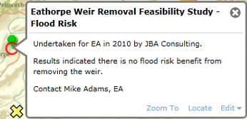

- A layer has been created for the addition of issues noted within the catchment (e.g. from site walkovers). This information is being collated separately and will be added to this map in the future.
- Current data is illustrated in the snapshots below.

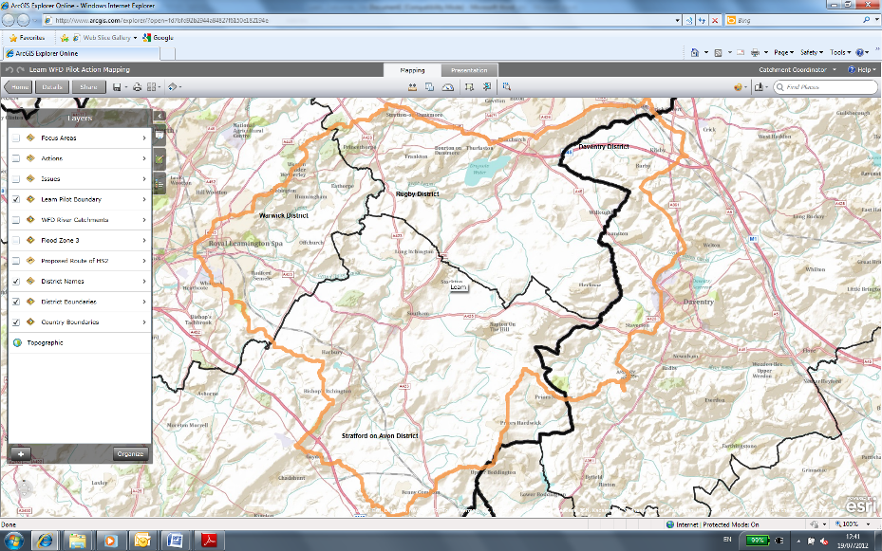
Political Boundaries
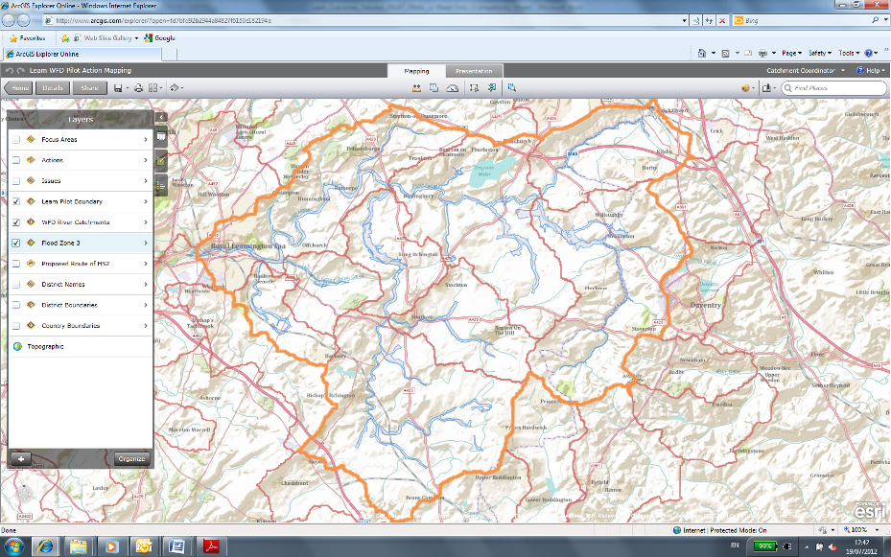
Environmental Boundaries
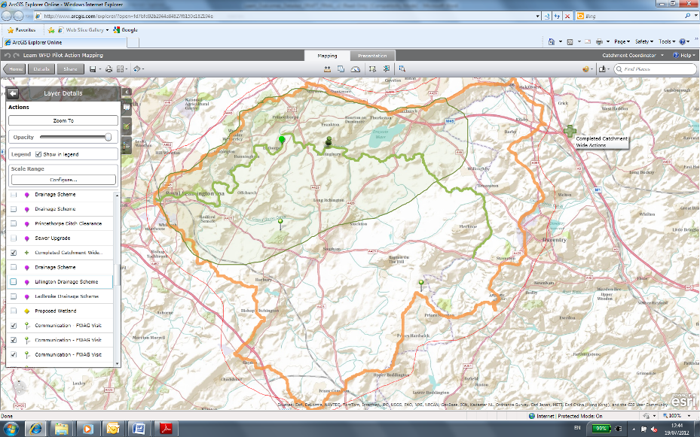
Completed Actions within Catchment
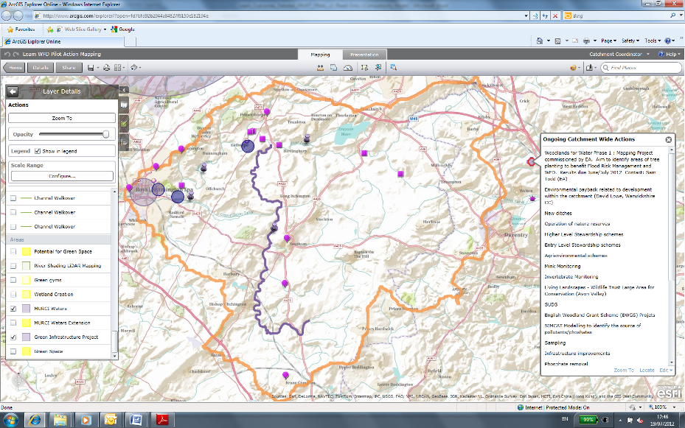
Ongoing Actions within Catchment
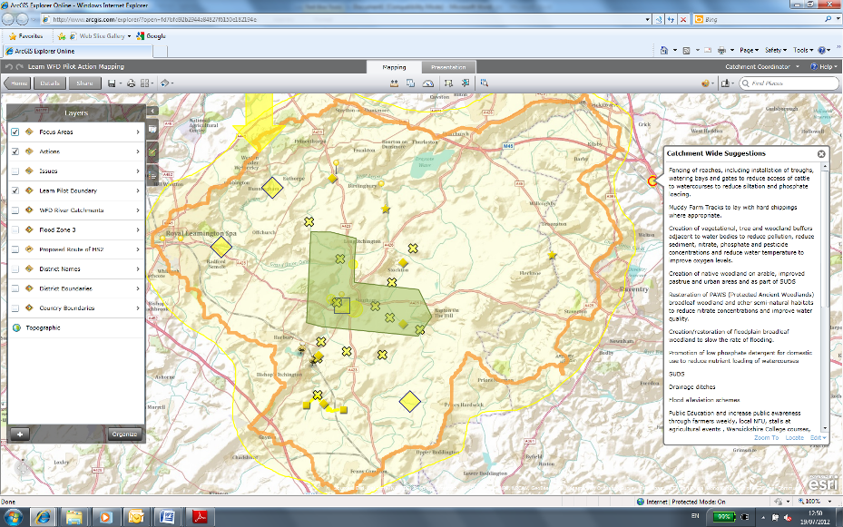
Proposed Actions within Catchment

