River Leam Pilot Catchment
Habitats Focus Group
Meeting 2: Thursday 14th June 2012
Venue: Warwickshire County Council, Ground Floor, Northgate House, Warwick, CV34 4SX
Attendees:
Rachel Ranger – Environment Agency
Gina Rowe – Warwickshire Wildlife Trust
Colin Sully – Environment Agency
Justin Milward – Woodlands Trust
Matt Jeffes – Warwickshire County Council (Flood Risk Management)
David Lowe – Warwickshire County Council (Ecology)
Giles Matthews – Environment Agency
Melissa Hoskings – Severn Rivers Trust
Matilda Beatty – Severn Trent Water
Lois Brown - Warwickshire County Council (Ecology)
Danielle Newman – Natural England

- Introductions

- Recap on the Outcomes

- Group ran through the Outcomes and adjusted/reviewed as appropriate.
- Agreed there was benefit in separating the final ‘Outcome’ from ‘Outputs’. The latter should be used as measured targets (‘measures of success’) towards achieving the final Outcome result.
- Discussion took place questioning whether we know that the proposed actions will achieve the final target Outcome. Agreement that although some monitoring tools do exist we can only really base the proposals on a best estimate of what we think is needed in the catchment. This can be reviewed over time as more information and tools become available.
- In the meantime we need to recognise the gaps/areas in which we don’t have confidence.
- Some outcome updates were supplied at the meeting – the latest version of the document is attached to these minutes (sincere apologies for the lack of proof reading in the previous version – it appears that the language settings for that particular document were set to Welsh, which meant spell-check didn’t flag up any errors!).

ACTION: All to review and update Outcomes spreadsheet and let myself and Gina know of any required amendments by 13th July 2012
Individual actions are marked in the Outcomes table, but in particular:
  - Habitats Outcome to be reviewed by Gina Rowe, David Lowe and Lois Brown
  - Baseline on which to review targets to be identified by EA/STW/Melissa
  - Pesticides to be reviewed by Matilda Beatty and Melissa Hoskings with a focus upon the reduction levels and target dates.
  - Matt Jeffes to clarify whether the reduction in flood risk by 30% is number of properties or level of risk. If it’s possible to give a target that is specific to the Leam that would also be very helpful.
  - Giles Matthews to consider the Fish Outcome.
  - Access target to be reviewed by Rachel Ranger and Colin Sully including consultation with County Council Rights of Way officer (Keith Davenport).

- Actions Mapping

- RR introduced the concept of ArcGIS mapping to collate actions and data between stakeholder organisations. Screen shot of the map is shown below.
- Basemap has been set up, including the completed, ongoing and proposed actions collated so far.
- Aim is for the mapping to be ‘live’ and constantly updated by group participants to enable data sharing, coordination of action implementation on the ground and improve recognition of joint funding opportunities.
- Instructions on how to access and update the mapping will follow separately to the Habitats group participants. Both shapefiles and points can be added.
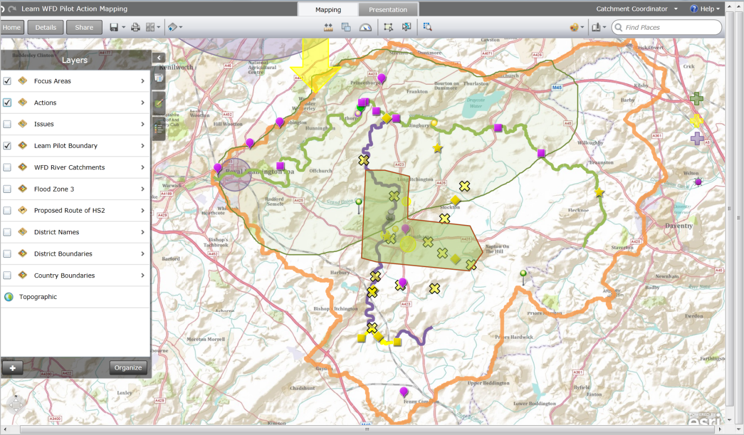

ACTION: All Habitats Group participants to review and update GIS Mapping by 29th June (to assist Melissa in her CRF bid)with:
- Completed actions
- On-going actions
- Suggested actions
- Issues
Please let me know if you have any technical difficulties accessing or operating the site.
Please accept there is more information that I need to add to the mapping, such as the WFD status of the waterbodies. I will try to update the mapping in advance of going on leave next Wednesday, if I don’t please accept my apologies and I will update the map on my return. If anyone has any suggestions of data that you think the EA may hold and would like to see mapped please let me know.

- Public Engagement

- RR introduced the concept of Crowdmap to encourage public participation.
- General agreement that it sounds like a good idea.
- Aim is to encourage wider stakeholders and public to map areas of concern within the catchment and append reports providing further detail.
- Group can then use this information to gain an understanding of public perception within the catchment, use the information to influence actions within the catchment and possibly encourage public participation in catchment improvements.
- Will need to consider how to disseminate and encourage use of this mapping, but for the meantime we need to develop the webpage. Immediate suggestions included:
  - Suggestion to remove the EA/Government Agency tag and make it more of a community set up.
  - Will need to consider the involvement of non internet users.
- The page can be viewed using the following link:
https://leamcatchmentwfd.crowdmap.com//
- Basic instructions regarding the navigation of the site and how it works are attached.
ACTION: All to review draft website and provide Rachel Ranger with suggestions of amendments / improvements by 13th July 2012
- Moving Forward

- Need to identify Quick Wins within the catchment. Following suggestions to be followed up:
  - Utilisation of the Warwickshire Biodiversity Offset Pilot (David Lowe)
  - Use of Woodlands Grant Aid – need to get Leam identified and targeted for funding (Justin Milward to advise/follow up)
  - Review of River Uck model of woodlands joint working (Justin Milward to disseminate Sussex Case Study)
  - Woodlands for Water Project review (Rachel Ranger/Colin Sully to send description of project around group)
  - Danny Newman suggested contacting the Worcestershire Wildlife Trust who have recently been using partnership working to deliver actions – contact is Caroline Corsy (Rachel Ranger or Gina Rowe to follow this up)

- 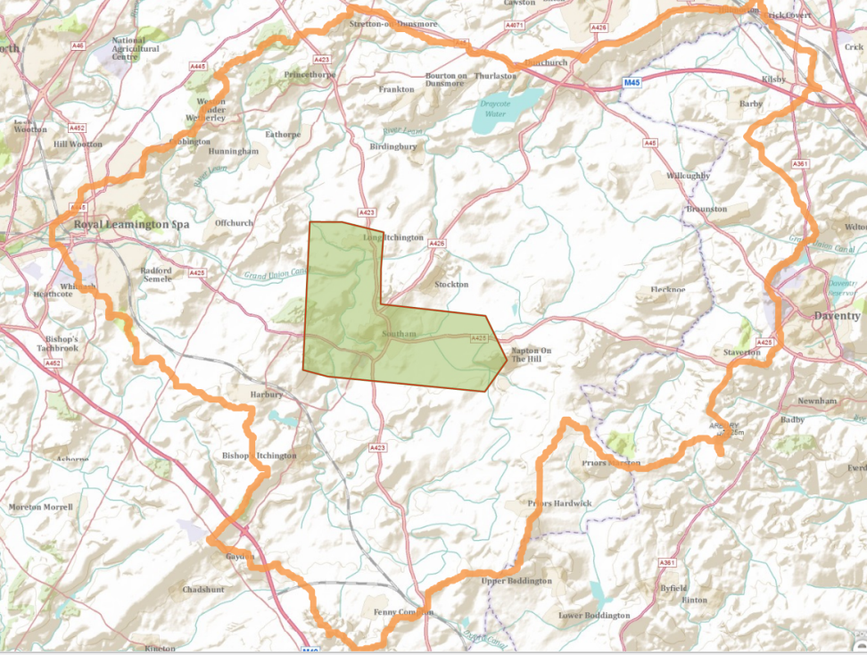Focus target area has been identified within the catchment, as shaded green on the map below (please let me know if this isn’t showing the expected extent). This will be the focus of the Habitats Group action implementation in the short term and matches with an area of interest of the Leam Catchment Partnership. Any other actions that can be delivered in the wider Leam should still be progressed, but the hope is this smaller target will act as a test case to determine how partnership working will operate to get actions on the ground.

ACTION: All to review this area, identify actions that could be implemented to assist in meeting the Outcomes, start contacting relevant contacts within the target area and identify any relevant funding streams by end July 2012.
  - Rachel Ranger to contact British Waterways and Southam Town Council
  - Melissa Hoskings to identify a contact within the Diocese regarding potential wetland area

- The aim for the next Habitats meeting is to determine how and when we can get actions underway in this focus area.
- Key steps were identified as:

1 | ID area for actions  ↓ | Completed - First area identified around Southam.
2 | ID additional contacts  ↓ | Underway – actions from meeting to identify and contact.
3 | ID ‘dream schemes’ within area  ↓ | Underway – action to map in ArcGIS
4 | ID Funding  ↓ | Underway – action from meeting
5 | ID Resources  ↓
6 | Implement Actions

- Funding
- Melissa Hoskings is leading a CRF bid for September submission – any assistance that can be provided for this would be gratefully appreciated.
- SETA (?) bid entry is the end of this month. David Lowe to provide further information. Please let the group know if you are keen to apply.
- If anyone else is aware of funding streams that have application deadlines coming up and would like to apply, please share with the group and hopefully we can all assist in getting the bid submitted.

- AOB
NEXT MEETING OF HABITATS GROUP IS PROPOSED FOR 2pm WEDNESDAY 15th AUGUST IN WARWICK

ACTION: Matt Jeffes to arrange room booking

