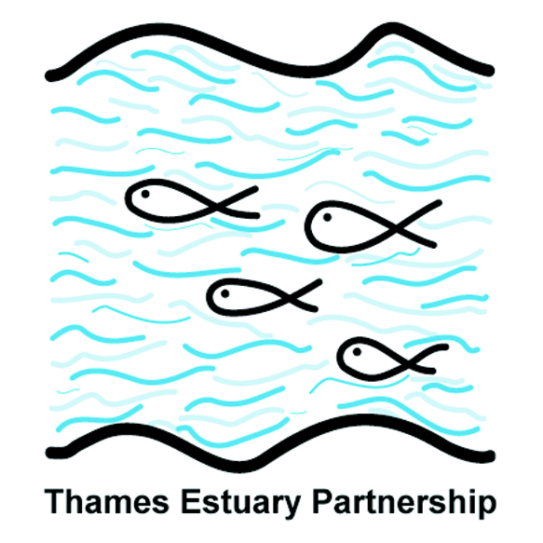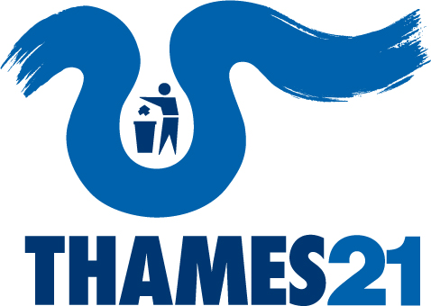
Your Tidal Thames

New Plan for the tidal Thames

Draft-in-Progress

Current version updated: 31st May 2012 - Final Plan to be submitted: 22 December 2012

Thames21 and the Thames Estuary Partnership are inviting people and organisations connected with the tidal Thames to help create a new Catchment Plan to look after the river.

The Your Tidal Thames project covers from Teddington Lock near Richmond-upon-Thames downstream to Haven Point on the north bank of the Thames Estuary in Essex and Warden Point on the south bank in Kent. The tidal Thames is one of the most high profile, complex and densely populated areas in the world. Our aim is to bring together its huge variety of people, businesses, public bodies and organisations to produce a realistic, practical and beneficial plan for the river which reflects the needs of its communities, wildlife, economy and future generations.

As well as contributing your views directly to the Plan, you can see it develop, via our websites, as more organisations, groups and individuals contribute ideas, knowledge, expertise and experience. We want this Plan to belong to everyone who values the river.

The problems the Plan will help deal with:

The tidal Thames is affected by:

- less fresh water flowing into the river
- pollutants from chemicals and sewage
- vertical wall flood defences and structures which influence the strength of the currents which in turn influence the plants and animals capable of living within affected areas
- loss of riverside habitat over many years of development

All of these and other factors have a huge effect on water quality in the river, upon its wildlife and biodiversity, and upon the people who use the river. Coordinated action by people, businesses, public bodies and organisations can improve and enhance our river environment. This Plan will be the first step.

How this will work:

You can add your ideas directly into the latest version of the developing Plan. Please feel free to add new ideas, or to build on or comment on the issues already raised by others. All issues raised will be assessed by a proposed Strategy Group – a group of key river users, managers and experts who will be able to prioritise all issues raised and discuss realistic and practical solutions which will be detailed in the final Plan. Any issues raised with no immediate practical solution will be put into an Appendix for further investigation.

An additional Appendix will be continually updated to list all the organisations and individuals who have contributed their thoughts and ideas into the Plan as we go along (if you would prefer this to remain private please indicate this at the end of the form).

Keep updated:

Sign up to receive the latest version of the Plan as it grows and develops in the coming months by providing your email address at the end of the form - or just look on our websites.
SECTION 1: IN YOUR VIEW, WHAT PROBLEMS ARE AFFECTING THE TIDAL THAMES?

You can be as technical, site specific or general as you like. Please add your views here. Then go to Section 2.

The Environment Agency has identified specific problems affecting the tidal Thames. Details of these issues are available on our websites. However, we would like to know about any concerns you or your organisation has. These might tie in with the problems identified by the Environment Agency or might be different.

Example 1. There are unacceptable levels of chemical pollutants in the river and despite routine and investigative monitoring, modelling and site inspections, the sources of many of these pollutants is still unknown.

Example 2. There are not enough boat pump out facilities for land storage of sewage

Example 3. I live next to a new housing development where they have created riverside terraces for wildlife – there is not enough of these initiatives along the riverside

Example 4. There are not enough places to launch my boat.

SECTION 2: WHAT CAN BE DONE TO ADDRESS THESE PROBLEMS?

If you have an idea of a solution to address a problem faced by the tidal Thames please add it here. Then go to Section 3.

Example 1. Carry out wider and more intensive investigating and water quality monitoring. Investigate the potential to train and organise community volunteers to carry out water quality testing for specific substances along the river, and help identify possible sources.

Example 2 Information on pump out locations and any plans to increase facilities

Example 3 A greater commitment from borough councils to require riverside developments to include habitat improvements in their design

Example 4. River access improved borough to borough

SECTION 3: ACTION PLAN

What should the target be to achieve and by when?
Who else can help deliver this target? What part can you (or your organisation) play?

Please indicate if you work for the organisation you talk about and whether a solution is just an idea or a commitment to complete the suggested action.

Please add your views here. Then go to Section 4.

Example 1. Train, deploy, manage, support and provide equipment to 100 volunteer water testers across the tidal Thames by 2015. Analyse results of testing and carry out additional testing in areas of concern (Thames21 and TEP can help deliver this, and also train other groups). Liaise with identified polluters to stop the pollution (TEP and the Environment Agency can help deliver this).

Example 2. PLA, Local borough councils and pump out facility managers could work together to provide information of existing pump out facilities and increase them across the tidal Thames by 2016.

Example 3. Local borough councils could use existing approved design guidance such as ‘Estuary Edges’ when working through planning applications; development agencies/contractors could work in partnership with community groups or NGOs to create habitat as part of design plans.

Example 4. Local borough councils and local community groups could liaise to identify funding and management options where a suitable place for improved river access is suggested.

SECTION 4: HOW DO YOU USE OR RELATE TO THE TIDAL THAMES?

Please provide some background about how you use, interact with and value the tidal Thames.
Then go to Section 5.

Please note: Original numbering may change as the plan grows, is developed and refined and sections and appendices added (such as the Ideas Appendix and List of contributing organisations). All contributions will be assessed by a proposed strategy group and no serious contributions will be deleted.
SECTION 5: YOUR CONTACT DETAILS

Name: ………………………………………………………………………………………………………

Organisation: ………………………………………………………………………………………………………

Email: ………………………………………………………………………………………………………

Postcode: …………………………………. Telephone: …………………………………………

Please provide your postcode. It will only be used to evaluate the distribution of individuals/organisations who have contributed towards the Plan.

Would you like to be kept updated with project progress? Yes No

Would you like your name and/or your organisations name to appear in an appendix of the Catchment Plan?
Yes, please include my name and my organisation’s name
Yes, please include only my name
Yes, please include only my organisation’s name
No, please do not include my name or my organisation’s name

Signature: …………………………………………………………… Date: ………………………...

Please note: Your details will be stored on a shared database managed by Thames21 and Thames Estuary Partnership. Under the Data Protection Act, we have a legal duty to protect all information we collect from you. We will not pass your details on to any other organisation. You can ask us to remove your details from our database at any time.

Your Tidal Thames project co-hosts

This plan is being co-ordinated in partnership by:

Thames21 Thames Estuary Partnership
Walbrook Wharf UCL – Environment Institute
78–83 Upper Thames Street Room G13, Pearson Building
London Gower Street
EC4R 3TD London WC1E 6BT
www.thames21.org.uk/yourtidalthames www.thamesweb.com

Alice Hall Amy Pryor
alice.hall@thames21.org.uk a.pryor@ucl.ac.uk
020 7213 0160 020 7679 0540

