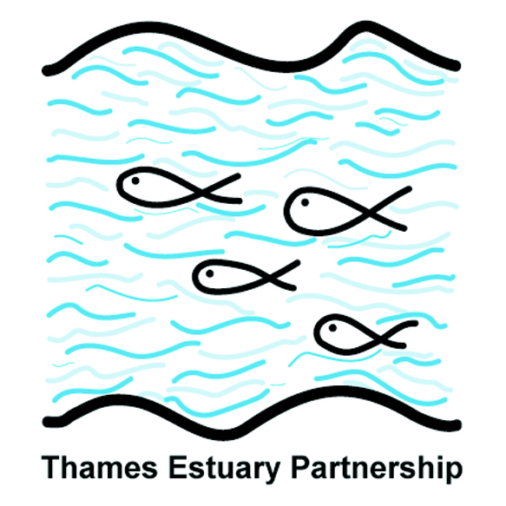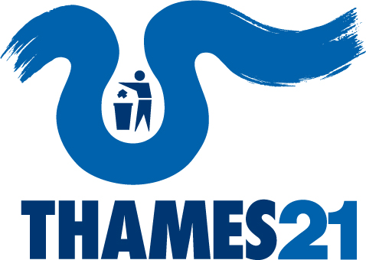
For immediate release
Your Tidal Thames:
Have your say on the future of the river
- Public input sought to develop shared vision for the tidal Thames in Defra funded project
The first community-led plan to improve the River Thames has been launched in a new partnership between Thames21 and Thames Estuary Partnership (TEP).
The two Thames charities have been tasked by the Government to help stakeholders and communities across the tideway build a plan for long-term improvements in the water quality and ecological health of the tidal Thames.
Public and stakeholder views will be sought at a series of pop-up workshops and one to one meetings. The first pop-up workshop, and chance for people to have their say will be held on June 1st.
The ‘Your Tidal Thames’ project follows the launch in January this year by Defra and the Environment Agency of a ‘catchment-based’ approach to working with people and organisations that can make a difference to the health of England’s water environments. 25 river catchments across England have been selected to test out this approach to river basin management planning, before it is expanded across the country. Your Tidal Thames is the only catchment pilot on a tidal river.
The initiative grew out of the Water Framework Directive, which commits EU member states to achieving ‘good status’ for all water bodies.
Water Minister Richard Benyon said: “Our rivers are vital for our health, well-being, leisure and the environment and we’ve all got a role to play in making sure they are as clean as they can be. People don’t always make the link between the water in their rivers and their own actions, such as how they use water at home. This type of collaborative, community led project will inspire people to value their local rivers and to take action to look after them.”
Thames21 Chief Executive Debbie Leach said: “The tidal River Thames was rightly selected as a Pilot Catchment. The Thames is the most complex and fascinating river in the country, and everyone who uses or benefits from it should have a say in its future well-being. By working together to co-host Your Tidal Thames, Thames21 and TEP can provide the reach, experience and expertise to involve and bring together the huge variety of stakeholders and interests in the Tidal Thames.”
Thames Estuary Partnership Director Jill Goddard said: “We’re looking forward to a productive year collaborating with the wide mix of partners who make up the Thames community to produce a plan that has genuine support and delivery.”
At present the status of the tidal Thames has been classified as ‘moderate’- the aim is that the river should work towards ‘good’ water quality and ecological potential, with reviews in 2015, 2021 and 2027.
Thames21 and TEP combined have 36 years’ experience working on the river and in stakeholder engagement. The engagement process will involve people and organisations from Teddington Lock downstream to Haven Point on the north bank of the Thames Estuary in Essex and Warden Point on the south bank in Kent. The plan will be developed over the next year and will lead to practical delivery and action to improve the tidal Thames.
The first pop up workshop and opportunity for people to have their say in the development of the plan will be on 1st June, 4pm to 7pm on the South Bank. Contact Thames21 for further details.
For more information, contact Alice Hall: alice.hall@thames21.org.uk/ 07824 692 592
or Amy Pryor: a.pryor@ucl.ac.uk/07917758851
Media enquiries, images and interviews: please contact Emily Braham on 020 7213 0166 or 07827 352675 or emily.braham@thames21.org.uk
Notes to editors:
- Thames21 is an environmental charity (registered number 1103997) working to bring London’s waterways to life. Each year, with the help of around 11,000 volunteers, Thames21 works to improve the capitals rivers, tributaries and canal networks with a wide variety of programmes and activities www.thames21.org.uk www.twitter.com/thames21 www.facebook.com/thames21

- Thames Estuary Partnership is a charity (registered number 1083199) which approaches the challenge of managing the Thames Estuary from a neutral viewpoint that values the contribution of all estuary users. We seek to learn from, work with and give voice to their knowledge and expertise through multi-sectoral action groups, practical projects, a bi-annual magazine and an annual forum. Our network runs from Tower Bridge in London to the Isle of Grain in Kent and Shoeburyness in Essex. www.thamesweb.com
- The Water Framework Directive: The Water Framework Directive (WFD) is the most substantial piece of EC water legislation to date and is designed to improve and integrate the way water bodies are managed throughout Europe. In the UK, much of the implementation work will be undertaken by competent authorities. It came into force on 22 December 2000, and was put into UK law (transposed) in 2003. Member States must aim to reach good chemical and ecological status in inland and coastal waters by 2015. http://archive.defra.gov.uk/environment/quality/water/wfd/

