Leam Catchment Pilot Stakeholder Mapping

Brainstorm of Potential Stakeholders
Severn Trent Water set up Upper Avon Strategic Partnership (pre Pilot)

Telephone Calls and Meetings with Key Organisations by EA to gauge interest

UASP Meetings underway with STW chosen stakeholders

EA Attendance at Upper Avon Strategic Partnership Meeting
Identification of numerous key Stakeholders as part of Upper Avon Strategic Partnership
Workshop 1 with UASP plus Warwickshire Wildlife Trust, Forestry Commission and Woodlands Trust
See Stakeholder_List.xls for stakeholder mapping at all stages
Workshop 2 with same initiation list but different attendees
UASP rebranded as Leam Catchment Partnership
Split to task-finish groups
Habitats Group set up
Continue own Stakeholder liaison reporting back to EA
Identification of additional Stakeholders to liaise with
Steering Group to be determined
Key Stakeholders

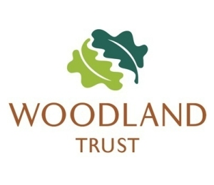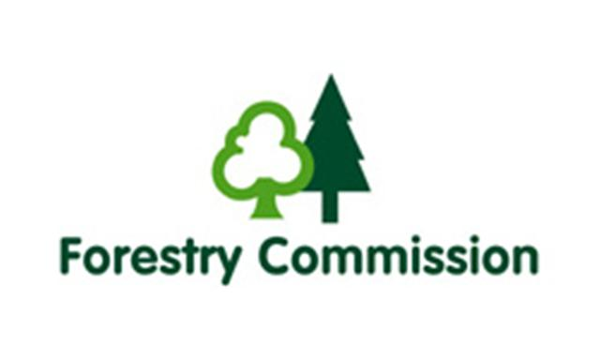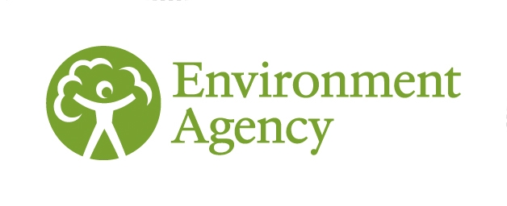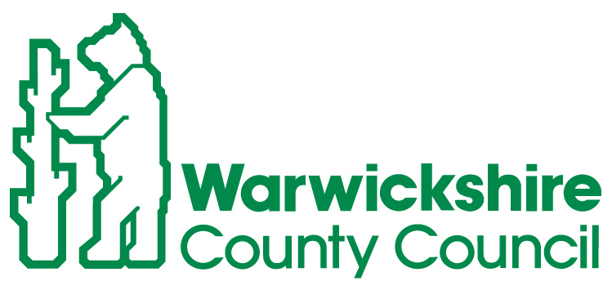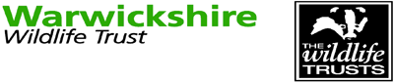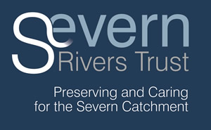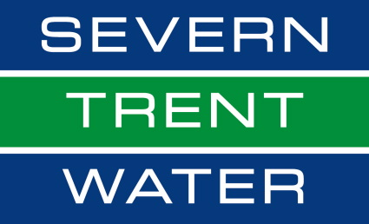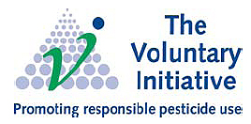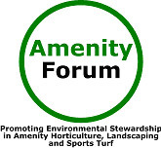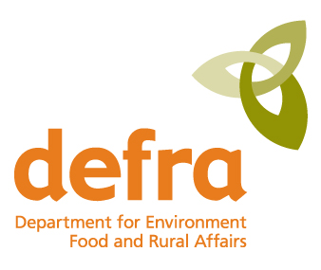

Envisaged Liaison Between Stakeholder Groups

Leam Catchment Delivery Steering Group
River Severn River Basin Liaison Panel ??
Leam Catchment Partnership Task and Finish Group

’Habitats’
Task and Finish Group

Defra
Any other Task-Finish Groups, if Identified
Additional Organisations
Delivery Groups
External Experts
Public

Habitats Group Stakeholder Mapping

Following Target illustration was used at initial Habitats Group meeting on 28th March 2012. The organisations in the centre of the red circle were present at the meeting, those touching the red were invited but did not attend.
WWT
WCC
EA
Forestry
Woodlands
SRT/LCP
(STW)
NFU
CLA
Natural
England
Warwickshire Rural Hub
Anglers
Riparian Owners
Landowners
Insurance Companies
Network Rail
Wider Community
Developers
Businesses
District Councils
Schools
Amenity
Forum

