Ribble Life project update
February 2012 edition
Welcome to the February edition of the Ribble Life pilot. Ribble Life is a project which focuses on the improvement of water environment in the Ribble Catchment for social and economic benefit for all. The cathcment is principally made up of the River Ribble, along with its major tributaries which include the Hodder, Calder and Darwen.
At the heart of the vision is a real appetite to bring people together and make a difference to the environment and help improve people’s quality of life.
What have we been up to?
Ribble Life goes live!
We are pleased to announce that the Ribble Life website is now up and running. You are able to view our website at www.ribblelife.org. Please feel free to mention this resource to friends, family and colleagues who have an interest in the local environment or who would like to get involved in volunteering or collaborative work. There is also an online survey which asks you what you think about your local river and how it could be improved. The information you give us will help us understand what people feel about rivers in general. The data will be used for statistical purposes only and your personal data will not be shared with partners. Please send us your feedback about the website and how you might use it in the future.
Meeting with Yorkshire Dales Millenium Trust
The Ribble Life project team met with the Yorkshire Dales Millenium Trust, a key delivery partner in the North Yorkshire part of the Ribble catchment. As part of Ribble Life, both trusts are committed to explore colloborative working opportunities such as landscape projects that will help deliver water environment improvements. Collaboratively, the trusts hope to develop these projects through a Heritage Lottery Funded Landscape partnership bid. If you want to know more about these projects or would like to get involved just get in touch.

River Loud and Chipping Catchment appraisal tour
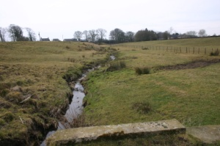
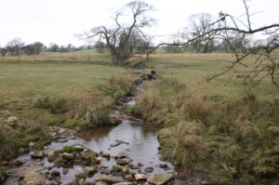
On Thursday 2 February, the Ribble Life project team took members of “Chipping in Bloom”, River Loud Anglers, staff from St Mary’s RC primary school, Brabins Endowed Primary School, Natural England and United Utilities on catchment tour of the River Loud.
The area was chosen as because the River Loud is classed as failing under the Water Framework Directive (WFD). For more information about WFD please visit: http://www.environment-agency.gov.uk/research/planning/33362.aspx.
The aim of the tour was to encourage people who live and work in and around the Loud catchment to work together to identify ways of improving the water quality of the river.
During the visit, the group were able to see at firsthand all the issues affecting the rivers and the watercourses in the surrounding area. Attendees also had the opportunity to ask questions to experts who were on hand on the day. At the end of the visit, a quick workshop was held to gauge views on whether there was any support for future collaboration with interested parties in this location. (where there any take ups?)
The tour was a great way for different groups and organisations to learn about the issues facing the River Loud. The attendees were also able to get new ideas and inspiration on how to improve the water quality.
Over the next few months, we will be hosting other tours throughout the Ribble catchment and will be contacting those of you on our mailing list. To find out which part of the catchment you are based in or interested in please visit the home page of our website. We would also like to hear from you if would like to organise or host your own catchment tour in the future.
Local Nature Partnerships and what it means for Ribble Life
Some of you may aware that Defra announced a new initative for local groups and organisations to form ‘Local Nature Partnerships’ (LNPs). They are a vision of self-sustaining strategic partnerships made up of a broad range of local organisations, businesses and people. They are designed to help local areas manage the natural environment as a system and to embed its value for the benefit of nature, people and the economy.
In Lancashire, the Lancashire Wildlife Trust have stepped forward to lead this initiative and have invited other partners, organisations and collaboratives such as Ribble Life to take part. The Ribble Life project team have welcomed LWT’s approach and are working closely them to ensure that our priorities are closely aligned and duplication of work is avoided. We fully support LWT in their aims and we are continuing to work with them as a key partner in the Ribble Life project. We are looking forward to working with them as part of a wider LNP.
Getting in touch
If you need any information about any aspect of the project or want to get in touch please contact Jo Spencer, Ribble Life Community Engagement Officer on 01200 444452 or by email at ribblelife@ribbletrust.com. You can also visit our website at www.ribbelife.org and follow us on twitter @RibbleLife.

