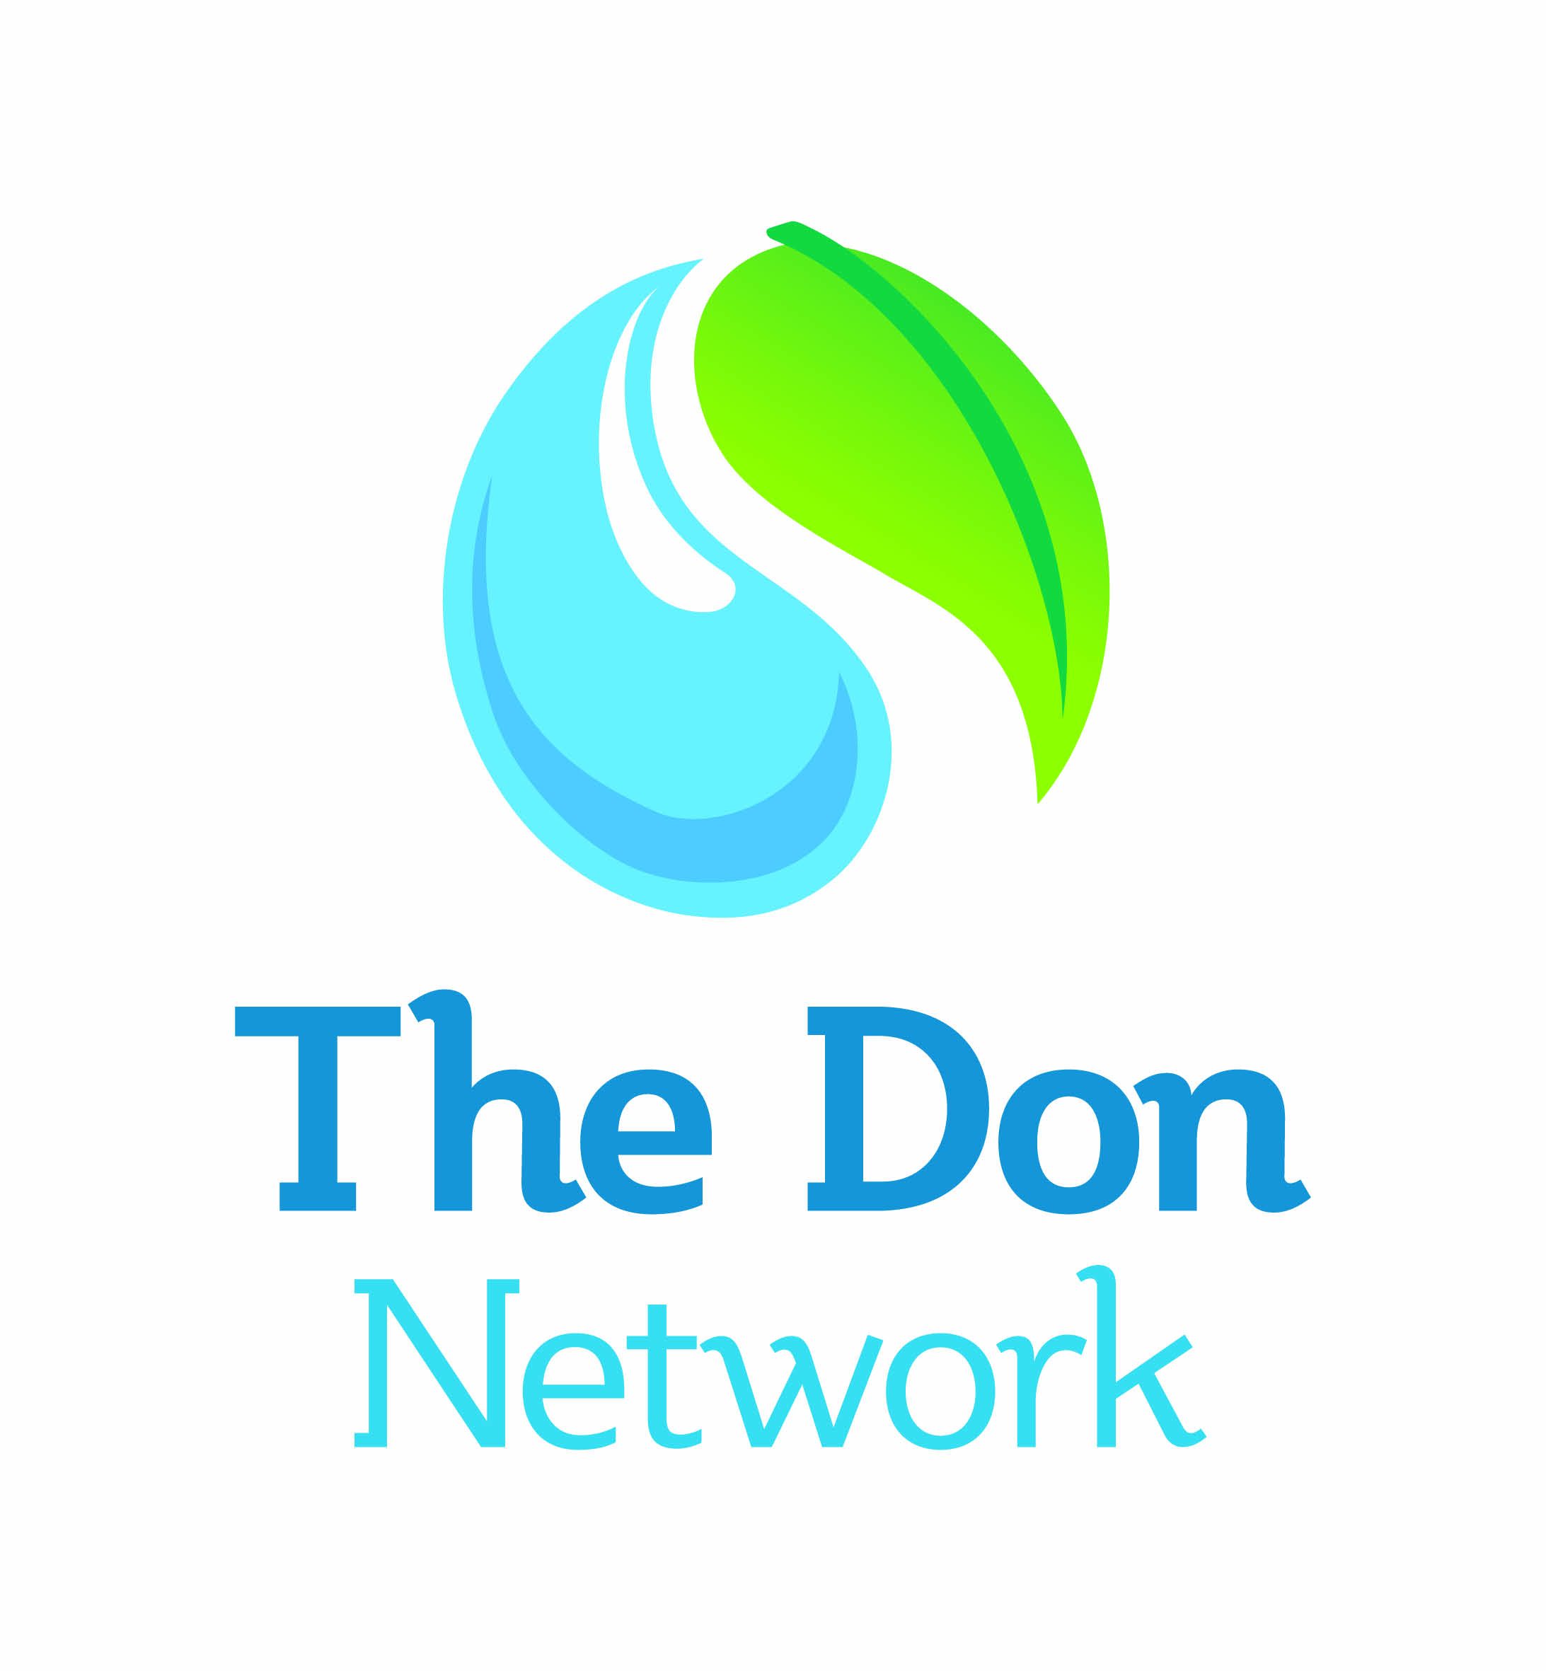
Notes from the Don Network
Water Quality meeting
5th July 2012

Agenda

10:00 Welcome & Aims for session

10:30 Reason for Failure presentation: Julie Dracup

11:00 Tea / coffee break

11:15 How the group should work

12:30 Lunch

13:00 What the group want to see in the plan

14:30 Recap

15:00 Summary and close

Agreed Ways of Working

- Request for the Don DNPG planning group to facilitate meeting rather than have a chair.

- Linda (YW) can provide scribe for future meetings

- Agreed that the WQ group would need another 2 meetings to complete the “chapter”.

- The Catchment Plan should be…
- High level strategic plan .
- Principles of collaboration.
- Working together to find alternative solutions .
- Bring principles of Don Network working .
- Present information (about WFD objectives) to influence others and decision making.‘’Catchment plan is an influencing tool’’
- Include Case studies.
- List of partners/contacts & their objectives.

Revised Water Quality Vision

Water Quality which supports a natural ecosystem and provides for public use and enjoyment.

Priorities for Water Quality Theme Group

Whilst STW/CSO are biggest/largest cause of failure, there is an existing regulatory mechanism to address this.

The WQ Theme Group will focus actions on issues outside the regulatory process and seek alternative flexible solutions within the regulatory framework.

Actions for the Catchment Plan

This section has been removed for the Cascade evaluation as it includes names of people attending the meeting.

Items for the Next Agenda: Sheffield

1) Detail for actions : How, who and add new ones.

2) Funding.

3) Feedback from other groups.

4) Comments/corrections/ improvements to document draft so far.

5) Additional ideas since been away & thought about it/ discussed with colleagues.

