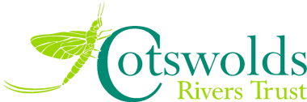
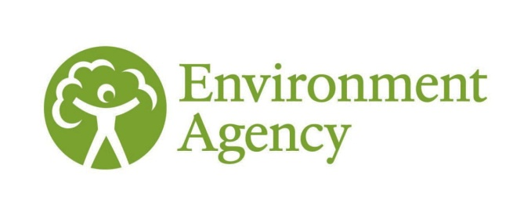
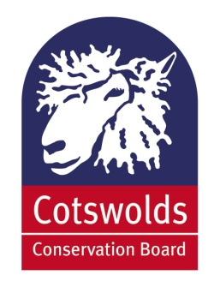
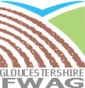
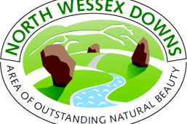
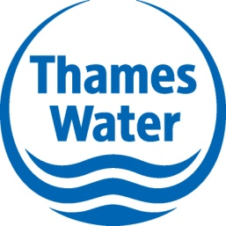
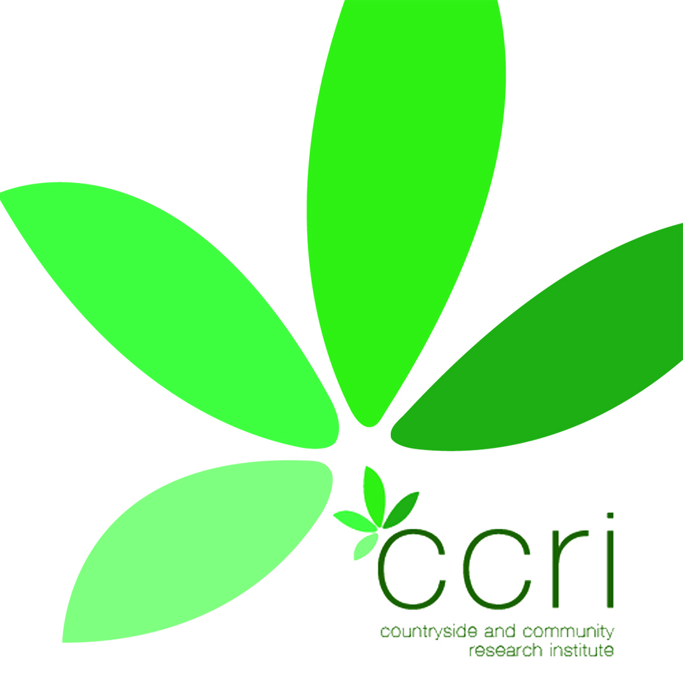
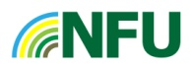

The Upper Thames Catchment Steering Group
Invite you to

Water Where You Live

The official Launch of the Upper Thames Integrated Catchment Programme for Consultation as part of the National Defra Pilot for Water Framework Directive
20th November 2012 at
2.00pm – 4.30pm

The Boutflower Hall
Royal Agricultural College Cirencester
Topics and Speakers
  - The key issues relating to the Water Environment – The Catchment Based Approach and why integrated delivery is essential – Defra/ EA Guest Speaker
  - Outline of the Upper Thames Catchment and the Integrated Local Delivery Framework (Countryside and Community Research Institute /Farming and Wildlife Advisory Group)
  - The importance of re-connecting rural and urban communities with farming and land use (National Farmers Union)
  - Community Case Study (Gloucestershire Rural Community Council/FWAG),
  - Local Authority – Planning for the Future Challenges for Water
  - Integrating strategies and directives – duties to deliver (EA/NE)
  - How you can get involved? – the GIS portal and rolling out a locally relevant delivery framework (FWAG SW/Gloucestershire County Council)
  - Q&A. Tea and refreshments.

For booking please email Jenny.Phelps@gloucestershirefwag.org.uk to reserve a place.
For further information regarding the Defra Pilot please see: www.environment-agency.gov.uk/catchments

