September 2008

Lancaster University Flooding Project Newsletter 2


Hello and welcome to our second newsletter! It’s been a busy summer for the project so we thought we’d keep you up to date with a brief summary of our progress over the past few months.


As well as outlining all the latest developments, this newsletter will also tell you more about our plans for the future of the project and explains how you can stay involved by continuing with your diaries and the group discussions. Remember, this project is about your voices and your opinions, so please get in touch if you’d like to ask a question or give us any feedback.

Thanks again for your continued support and we’ll look forward to seeing you soon!

Beccy, Will and the rest of the team at Lancaster

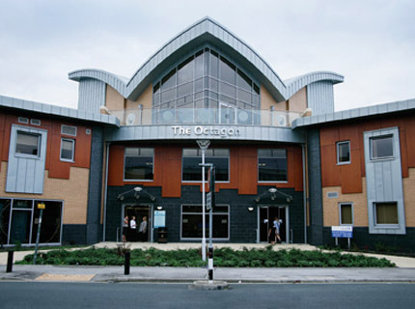
Findings

We’ve had a lot of media interest in the project over the past few months, so particular thanks to those of you who have talked to journalists for us. Thanks to you, we’ve been able to explain the problems of flood recovery to readers and viewers of the following:
- BBC Look North
- BBC Radio Humberside
- Real Radio
- Hull Daily Mail
- The Yorkshire Post
- The Times Online
- Burnley Express
- Skegness Standard
- The Star
- Buxton Advertiser
Progress so far…

Almost one year has passed since the project began in October 2007 and we’re delighted with how things are progressing.

We’ve already completed 48 interviews and hosted two lots of group discussions at the Octagon and these, combined with the ongoing accounts we’re getting through your diaries, have really helped to highlight some key issues about flood recovery and how it is managed.

Since the project started, we have presented at nine events for academics and policy makers across the country, including conferences run by the Environment Agency and DEFRA. Will has even been to speak to an All Party Parliamentary Group of MPs in Westminster about the work that we’ve been doing! We’re also very pleased that the Pitt Review (the government’s inquiry into the 2007 floods) used a lot of our material in its final report, which makes some important recommendations about how floods can be managed better in future.

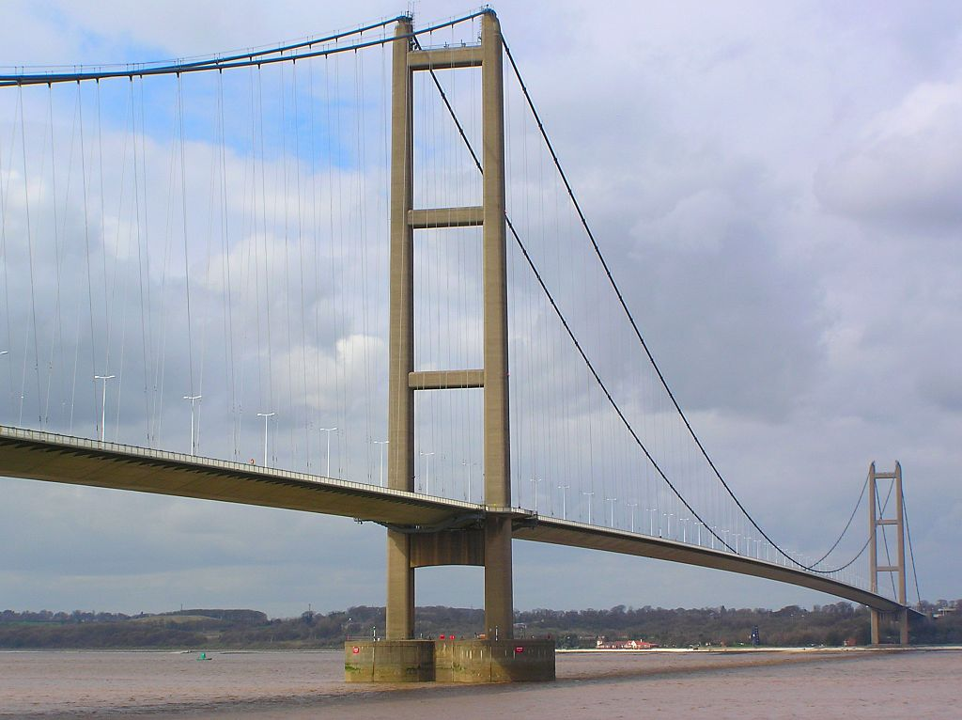
Goals for the future: Our work for the coming months

The diaries and group discussions are giving us some excellent ideas to work from and we are planning to take these forward this autumn. First on the agenda is our second project steering group meeting, which will take place later this month. As explained on the next page, we’ll be using this meeting to feedback policy recommendations to organisations such as Hull City Council, the Environment Agency and the Association of British Insurers. These are based on the things you’ve told us at the group discussions, so we’ll be presenting your ideas about flood management and recovery.

Later in the autumn, we will be interviewing those who were involved in the floods in a professional capacity – for example, City Council employees, health professionals and local councillors. We will also be looking at the diaries and group discussions in more detail so that we can start preparing some reports for policy makers and academics about your experiences of flood recovery. In the meantime, we’d like to continue collecting diaries and holding regular group discussions until next Easter – your continued input is really helping us establish a clearer picture of what flood recovery is like, so thank you again!

Exploring how children are affected by flooding

Flood research often ignores the thoughts and experiences of children. However, our work in Hull suggests that children have been badly affected by the events of June 2007, with many having to move schools as well as living in caravans or rented housing.

We would like to find out more about this, so we have applied for some extra funding. If we are successful, we will be starting a parallel research project in January which will look at children’s viewpoints – so watch this space!
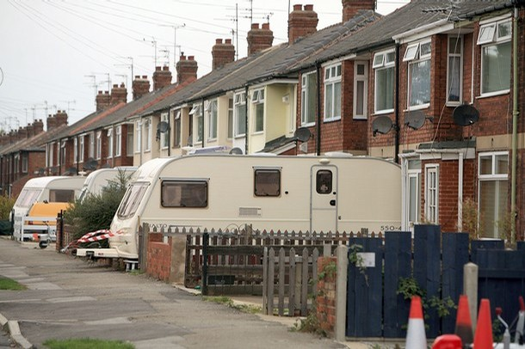

Visit our project website!

Our project website is now up and running. We will be updating this with more reports and findings over the coming months.

http://www.lec.lancs.ac.uk/cswm/Hull%20Floods%20Project/HFP_home.php

Your policy recommendations for our project steering group

Our research starts from the principle that you are the flood experts (not us!). Your experiences mean that you are in the best position to tell us how floods and flood recovery could be managed better. The following policy recommendations are based upon the things you’ve told us in group discussions – we’ll be presenting them to our project steering group later this month so, if there is anything that you would like adding or changing, please get in touch with us.

1. Things that helped during flood recovery
- Workers who responded quickly and flexibly to the situation
i.e. people who arrived quickly and were able to provide practical help (E.g. police, community wardens, bin men doing extra collections etc.).

- Supportive neighbours and community/residents’ groups
Support from neighbours and community groups was important. The floods helped people get to know neighbours better.

- Employing your own builders and making sure the building work was good quality
Those who got a cash settlement and employed their own local builders tended to have better experiences.

- The flood archive
People like the idea of the archive that is being created for this project. They want to make sure that their experiences aren’t forgotten.

- Appropriate use of the media
Local radio was a lifeline for many people. However, others felt that particular parts of the city were ignored in the media coverage.

2. Things that didn’t help during flood recovery
- It wasn’t clear what funding was available for flooded residents
Many people didn’t know what help was available, and from which bodies.

- Duplication of information collection
In the aftermath of the floods, many people were frustrated by having to give out personal information repeatedly before they could get any help.

- Impersonal approaches/insensitive handling of belongings
People were distressed by workers/companies who showed no sensitivity to their circumstances – for example, the lack of respect shown to flood-damaged possessions during waste collections.

- No continuity of service
It was frustrating to deal with different people all the time (for example, when dealing with insurance claims). Many people never spoke to the same person twice and had to repeat information/leave messages etc.
- Disrespect for property
Many workmen left rubbish all over people’s houses, left bathrooms in a mess and had little regard for security concerns (e.g. losing house keys, leaving doors and windows open at night, etc.).

- Unhelpful estate agents
People had bad experiences with estate agents hiking prices, breaking viewing agreements and being unhelpful to those with children or pets.

- Unhelpful utilities companies and other services
Utilities companies made no allowances for people’s circumstances e.g. refusing refunds, making reconnection charges and sending bills to wrong addresses. Some people also had difficulty getting refunds on Council Tax.

- Resentment between owner occupiers and council tenants
Perceived differences in levels of help given to owner occupiers and council tenants sometimes caused resentment locally.

- People being ignored/missed out
While some people were visited by workers offering help and support, others were not contacted by anyone.

3. Changes people would like to see in the event of a future flood
- Having a supportive intermediary who could explain the process and give advice
People wanted someone who could tell them how to manage their insurance claim and provide some continuity of contact over time.

- Someone to inspect the building work
Many people are concerned about poor workmanship and believe that the repairs should be inspected by a qualified person to ensure they are done properly.

- Greater use of local building firms, rather than ‘cowboy’ builders from outside the local area

- A local office in each neighbourhood where people could go to for advice on the flooding

- Someone to provide reliable and consistent advice
Conflicting messages and a lack of information can be confusing and distressing – people wanted consistent advice that they could trust.

- Better management of insurance claims
People wanted prompt settlements and were distressed by delays in sending cheques and constant disputes over their claim.

- Sensitivity to people’s situations
Vulnerable groups e.g. the elderly, disabled and young families should have had their repairs prioritised.

- Emotional support/recognition of emotional impacts
The flooding has been very stressful and upsetting and this should be taken into account when dealing with people.

- A rapid, practical response
In the immediate aftermath of the floods, people wanted help with practical tasks e.g. setting up temporary cooking and washing facilities. They did not want to have to fill in forms before they could get this help!

- Having a local office for the insurance company so discussions could be held face-to-face, rather than always over the phone.

- Need for flood resilience measures, not just expensive reinstatement
Many people wanted the repairs to include physical changes that would help their homes become more resilient to flooding in future.

- Need for a national system so that employers can allow people time off in the event of a disaster (similar to compassionate leave)

4. Changes people would like to be made now
- Information on what actions are being taken in the wider community
People want to know what is being done to a) prevent and b) prepare for future flooding.

- Need for a coordinated body that can oversee everything to do with flooding and drainage
E.g. An organisation that will ensure that all the different agencies communicate properly and fulfil their responsibilities.

- Public participation in policy responses – listening to local people and building confidence
Residents should have more involvement in decisions around drainage, flood and infrastructure management.

- Street level contingency plans for what to do in future emergencies

- A code of practice for estate agents to ensure that they behave fairly in the event of a future flood

- Someone to clean up the neighbourhood after the flooding and building work
People think that their streets have been left looking dirty and untidy.

- Better community education and preparation about flooding and how to help prevent it, so that everyone knows what can be done.

- Advice on flood resilience measures and their effectiveness
Householders have found lots of companies trying to sell them gadgets designed to help flood-proof their home, but are they effective?

