

Case Study

Catering and Hospitality Level 2:
Food and Drink Service NVQ2

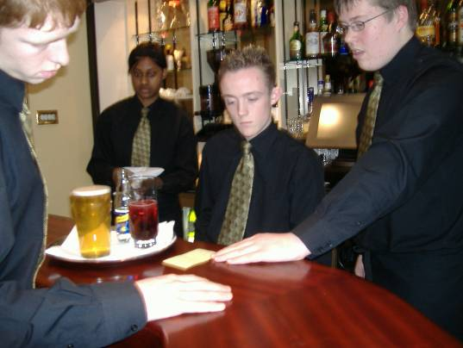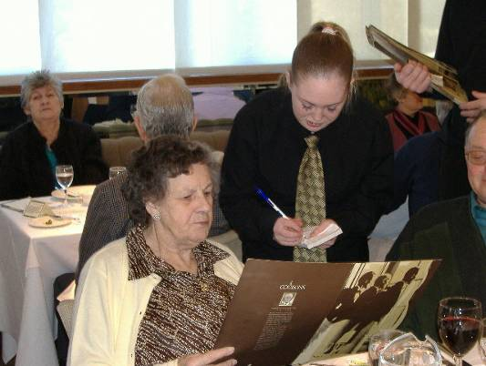



Unit Case Study for Catering and Hospitality Level 2
Food and Drink Service NVQ 2
Lancaster and Morecambe College
Author: Candice Satchwell

Overview of the Course for which the unit forms a part
The NVQ2 is delivered within the context of the Diploma in Hospitality. Until three years ago this course had been called a Chef’s Diploma, but this did not reflect the wider context of the Hospitality Trade, so it was repackaged to allow more flexibility, such as including elements related to ‘front of house’.

The Diploma runs over a period of two years and it is made up of a variety of units – students take 3 units in their first year and 4 units in their second year. The qualification incorporates:
ABC Certificate in Hospitality and Catering Skills (Restaurant Units)
NVQ Level 1 Food Prep and Service (Restaurant Units)
NVQ Level 2 Food and Drink Service
NVQ Level 2 Bar Service
NVQ Level 3 Hospitality Supervision

The NVQ Level 2 Food and Drink Service comprises four compulsory units:

- Maintain a save and secure working environment*
- Create and maintain effective working relationships*
- Customer care skills*
- Prepare and clear areas for table service*

And three units from the following:

- Maintain and deal with payments
- Provide a table service*
- Prepare and serve bottled wines
- Provide a carvery/buffet service
- Provide a silver service*
- Provide a table drink service*
- Provide and maintain a counter/takeaway service
- Prepare and serve hot drinks

* Units usually taken by students at LMC

Overview of the unit
Sarah chose the NVQ2 as the unit to research, but during the sessions she taught, students might be completing level 1, level 2, or level 3 qualifications, and covering a variety of different units. However, for the research, she focused on the log books being completed by Level 2 students. Within the NVQ 2 there are a number of different units (listed above), but these cannot easily be separated.
In an interview Sarah explained:

“It’s all of them, because they never concentrate on one Unit at a specific time. It’s always you know, always on assessment for all kinds of different things. There’s a lot of cross-referencing so when they do an assessment for example, if they’re on assessment for silver serving food then they would also get hygiene, Health and Safety assessments alongside that, clear and finish courses, all those kinds of things are all tied into it, so it’s never just straightforward one assessment, it’s always a band of them.”

This means that completing the log book is complicated. As Sarah explained:

“Yeah. Because … I mean it’s hard enough knowing that you’ve done one task and then you have to find the Unit that relates to that task but then to know that you’ve done that task and then find out what branches off that task and then what other Units go with that as well, it becomes quite a complex kind of thing.”

The course has a system of continuous assessment, but the achievement figure does not reflect the informal assessment of some elements, such as talking to customers, pouring water, etc.

Participants and Processes

In 2003-4, 23 students started the course and the retention rate
was 74%. Overall the success rate was 65%, and accounting for the
'drop-off' of students, the achievement rate was 88%.

The course is taught by Sarah and Amanda who share the responsibility of running the restaurant. This means they teach the students the skills they need to work in a restaurant of this standard, in particular, silver service, customer care and traditional service skills (serving from the left, clearing from the right, clearing a table professionally). They also need to make sure that all the students complete the necessary assessments in the time they have and write up these assessments in their logbooks as a record.
In 2003-4 they also had the help of a restaurant technician who took on the responsibility of placing orders for liquor deliveries, keeping track of bookings and focusing on the bar side of service. During some sessions they would also have a learning support assistant who was able to help the less able students when taking orders, writing assessments in their logbooks, etc.
This changed in 05-06 as there was no longer a restaurant technician and the learning support hours were cut. As a result, Sarah and Amanda now have to take on the other responsibilities mentioned above.

The four students involved in the research were:
Logan, Jimmy, Janet and Simon.

Janet was unusual in that she was a mature overseas student from Singapore. The others were aged 17-19. They were all keen to complete their course and all had work outside which related to the course.

See Student Case Studies for details. In addition, here are some details of texts brought into college by the students to represent their literacies in everyday life. Overwhelmingly, texts brought in by these students from their own lives were related to catering and hospitality. Their texts included: menus from restaurants, takeaways, internet sites, magazines such as Good Food, ASDA magazine, lists of cocktails and how to make them, coffee menus, beer mats, adverts for restaurants, food, etc. They also included texts produced at college, such as food orders, menus, etc., but Logan only included texts from college, namely a print out of a powerpoint for Valentine’s day and his Valentine’s day menu insert. For Janet, her texts from everyday life were mixed up with documents from college, ranging from “How to manage your password” to food orders from the restaurant. She also collected documents related to passing her driving test, including information downloaded from the internet, information relating to local libraries and community learning centres. She included several pages of lists of favourite authors throughout her life, and included poems and passages from books she has enjoyed. Her reading includes a lot of Christian literature. Also she had made a steering-wheel-shaped piece of card and handwritten across it extracts from books about what constitutes happiness. Mixed up with all of this were extensive notes for her college course, including handwritten notes written up at home, completed logbook pages, and research from books and the internet. She kept an extensive personal journal at home, but for obvious reasons did not bring this into college.

Aims

For the students on the course, the aim is usually to become a chef but there are some who would prefer to take the front of house route and become a restaurant manager, or supervisor. These tend to be in the minority though.
For the tutors, the aim is to primarily pass on the skills they have in order for the student to be better prepared when they go out to work. However, this is governed by the need to keep statistics above bench mark so they tend to teach around the qualification structure and are not really able to use any of their own input. This is due to the design of the NVQ in that it is rigid and prescriptive.

The HAB Unit Records for the NVQ says that:
“NVQs and SVQs at Level 2 cover work that is more varied and less routine. Candidates at this level need to be able to work well on their own and also as part of a team.”
And
“You should do an NVQ/SVQ that best matches the kind of work you already carry out or one which covers the area of work you are training for.”

This suggests that the aim is simply to acquire a qualification for what you are doing or what you are going to do. It does not indicate that it involves “learning”. However, the qualification does require “Underpinning knowledge”, which, according to the Unit Records, “lists the things you need to know and understand about your work”.
The Unit Records also include reference to:
“Elements”, which are “the standard you need to meet in a particular area of work”;
“Performance Criteria”, which “describe the things you need to achieve when carrying out your work”; and
“The Range”, which “specifies the different things you need to be assessed on”.

Place and space

Although kitchen theory has a dedicated computer classroom, for restaurant theory they use a normal classroom (or sometimes the restaurant is turned in to a classroom) and they use pen and paper with workbooks. All practical classes for Catering and Hospitality take place in the restaurant, kitchens or the meeting/conference room which also has a bar. This means that sometimes students are sitting at dining tables or around work surfaces to complete their work or their log books, and sometimes they are sitting at tables pushed together to create more of a classroom–type environment. It is interesting that the same places are used for different purposes (such as chopping vegetables and writing about the properties of knives), and the space is sometimes arranged accordingly, but other times is made use of as it is. The staff also use the same restaurant space for formal and informal meetings; for example, coffee and toast are always served (occasionally by students on Travel and Tourism for one of their qualifications, but usually by kitchen technicians) for tutors in the faculty at 10.30. This is one factor that contributes to the feeling of the space belonging equally to both students and staff.

Time and timing

The unit is taught during a period from 9am to 9.30pm on Wednesdays and Thursdays. This covers time in the restaurant working on log books, but also time preparing tables, cooking, and serving in the restaurant. Theory classes also take place on Mondays. The sessions used for the research were in the restaurant on Wednesdays from 3pm to 9pm, and although the level 2 students were focused on, there would be students from level 1 to level 3 working together. The students have two 3 week rotations per year and those in their second year should complete the 8 mandatory units by the end of the second rotation in the second year. Those that have completed the level 2 units during the first 3 week rotation of the second year can go on either to do further units of that qualification, or to start looking at level 3 work during the second rotation. Those that are only starting the level 2 will be expected to complete some of the 8 units by the end of the second rotation in their first year, having got at least one assessment for each element during the first rotation.

Description, with examples, of the literacy practices associated with the unit

The literacy events during a typical restaurant session, running from 3pm to 9pm, include:

1. A student completes a powerpoint presentation to be used on the TV screens to promote Christmas. As an example, the slides include:

Information

Bookings are still being taken for our
Festive Fayre, Be quick as spaces are
being filled quicker than Old St. Nicks
Sleigh!!!
The dates range from the 1st Dec. till the
16th Dec.
Ask at reception for further details.

Student’s power point for Christmas – to be displayed on TV screens at college.
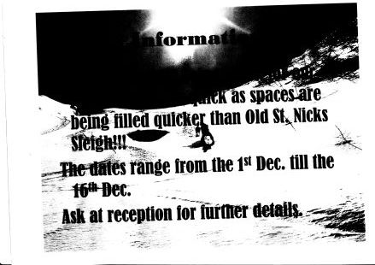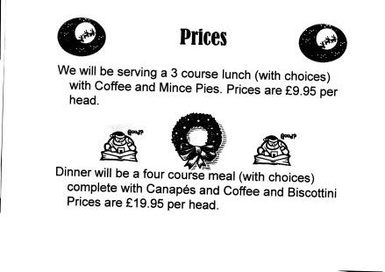

2. A student reads and completes a ‘Stillroom Duties’ checklist. This involves reading the sheet, which is a double-sided “standard” text used in all restaurant sessions, designed to help the students remember what they need to do as well as set standards for how things should be completed. When they have completed each duty, the student ticks a box, and then a member of staff will sign next to it once it has been checked. The text was designed by a tutor at the college with the aim of simplifying the still room job, and enabling the students to begin the still room work independently as it lists each thing that needs to be done. It is also useful in that it enables students to put evidence in their log book by referring to the sheet.
The tutor reflected that students do not always read the instructions carefully enough, but that they do find it useful. It will also help them to be able to design something similar if they needed to in their own workplace.

Stillroom duties checklist (double-sided)

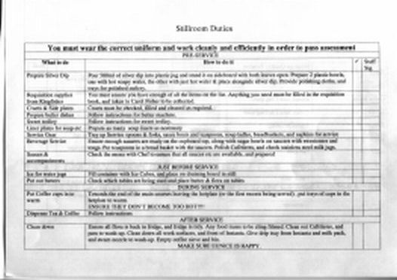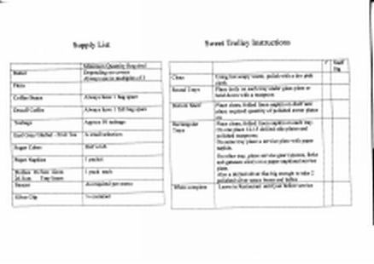

3. Still room duties include putting in requisitions for food items. This involves using a small commercially produced (Challenge) duplicate pad which includes an instruction on the front: “Please don’t forget to use this card … under each pair of identically numbered pages to prevent successive tinted sheets becoming marked and therefore wasted. You will get clear, sharp copies on the tinted sheets if you use a ballpoint or pencil on the top original sheet.”
The student would need to check the stock already in the still room and then write an order in the book for the items needed. They would need to work alongside the still room checklist (above) which has a recommended stock list and the amounts needed.
Like many of the texts, this one is needed in a practical sense to keep the stock levels up in the still room, but it is also required as evidence for the assessment that students do in this area. A copy is also needed for the supplier as evidence of what has been taken. The intention behind it is that students can learn to order food and equipment internally and understand the importance of keeping records. There is no set way of writing out a requisition, but it must be clear and in duplicate. If students struggle with spelling they can refer to the still room checklist.
The text is similar to one which would be used in the students’ future careers. Sarah commented that there may be some difficulties for some students because it involves coordinating the stock in the still room along with the checklist and the order book. However, the students can complete the written task in their own way, and will not be under the pressure of completing it in front of customers, as with a food order.

Stock order book
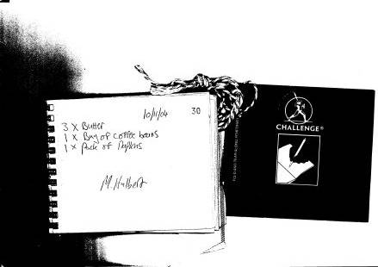

4. A student reads names and covers from the bookings diary in order to create a table plan. The bookings diary would be consulted by the student, which lists the numbers in each party and the name and telephone number, and the student would draw up a table plan accordingly. This is usually done by level 3 students but can be level 2 students on occasion. The level 2 students will definitely use the diary to create an arrivals list.

Diary page and table plan
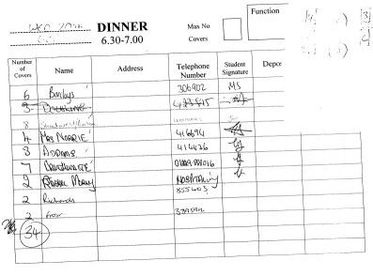

5. The students practise taking drinks orders in teams. The texts produced are handwritten in biro on scraps of thick yellow paper, and include the table number, the order e.g.
1 x pnt larger
1 x tom Juice
(leen perrins + Tobasco)
and the student’s initials.
These texts need to be understood by the person working behind the bar, making up the drinks.

6. The students need to lay up the tables, which includes menus, comment cards, wine cards, and indemnity cards.

Indemnity card, wine card, menu
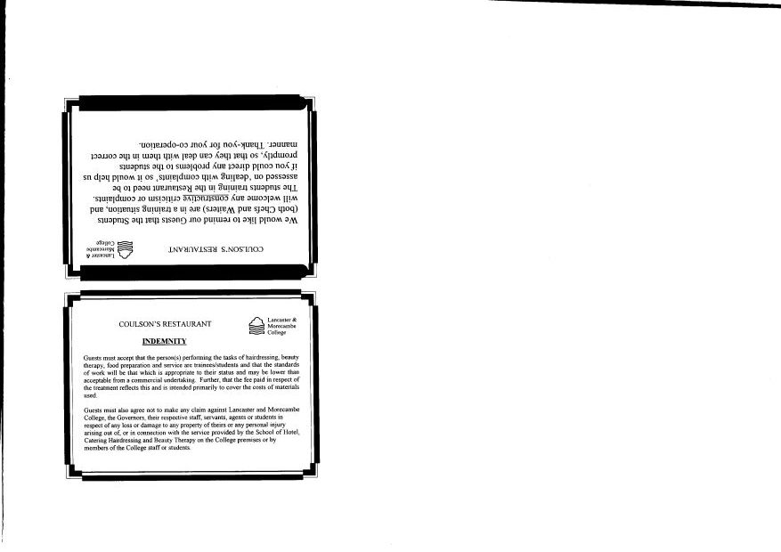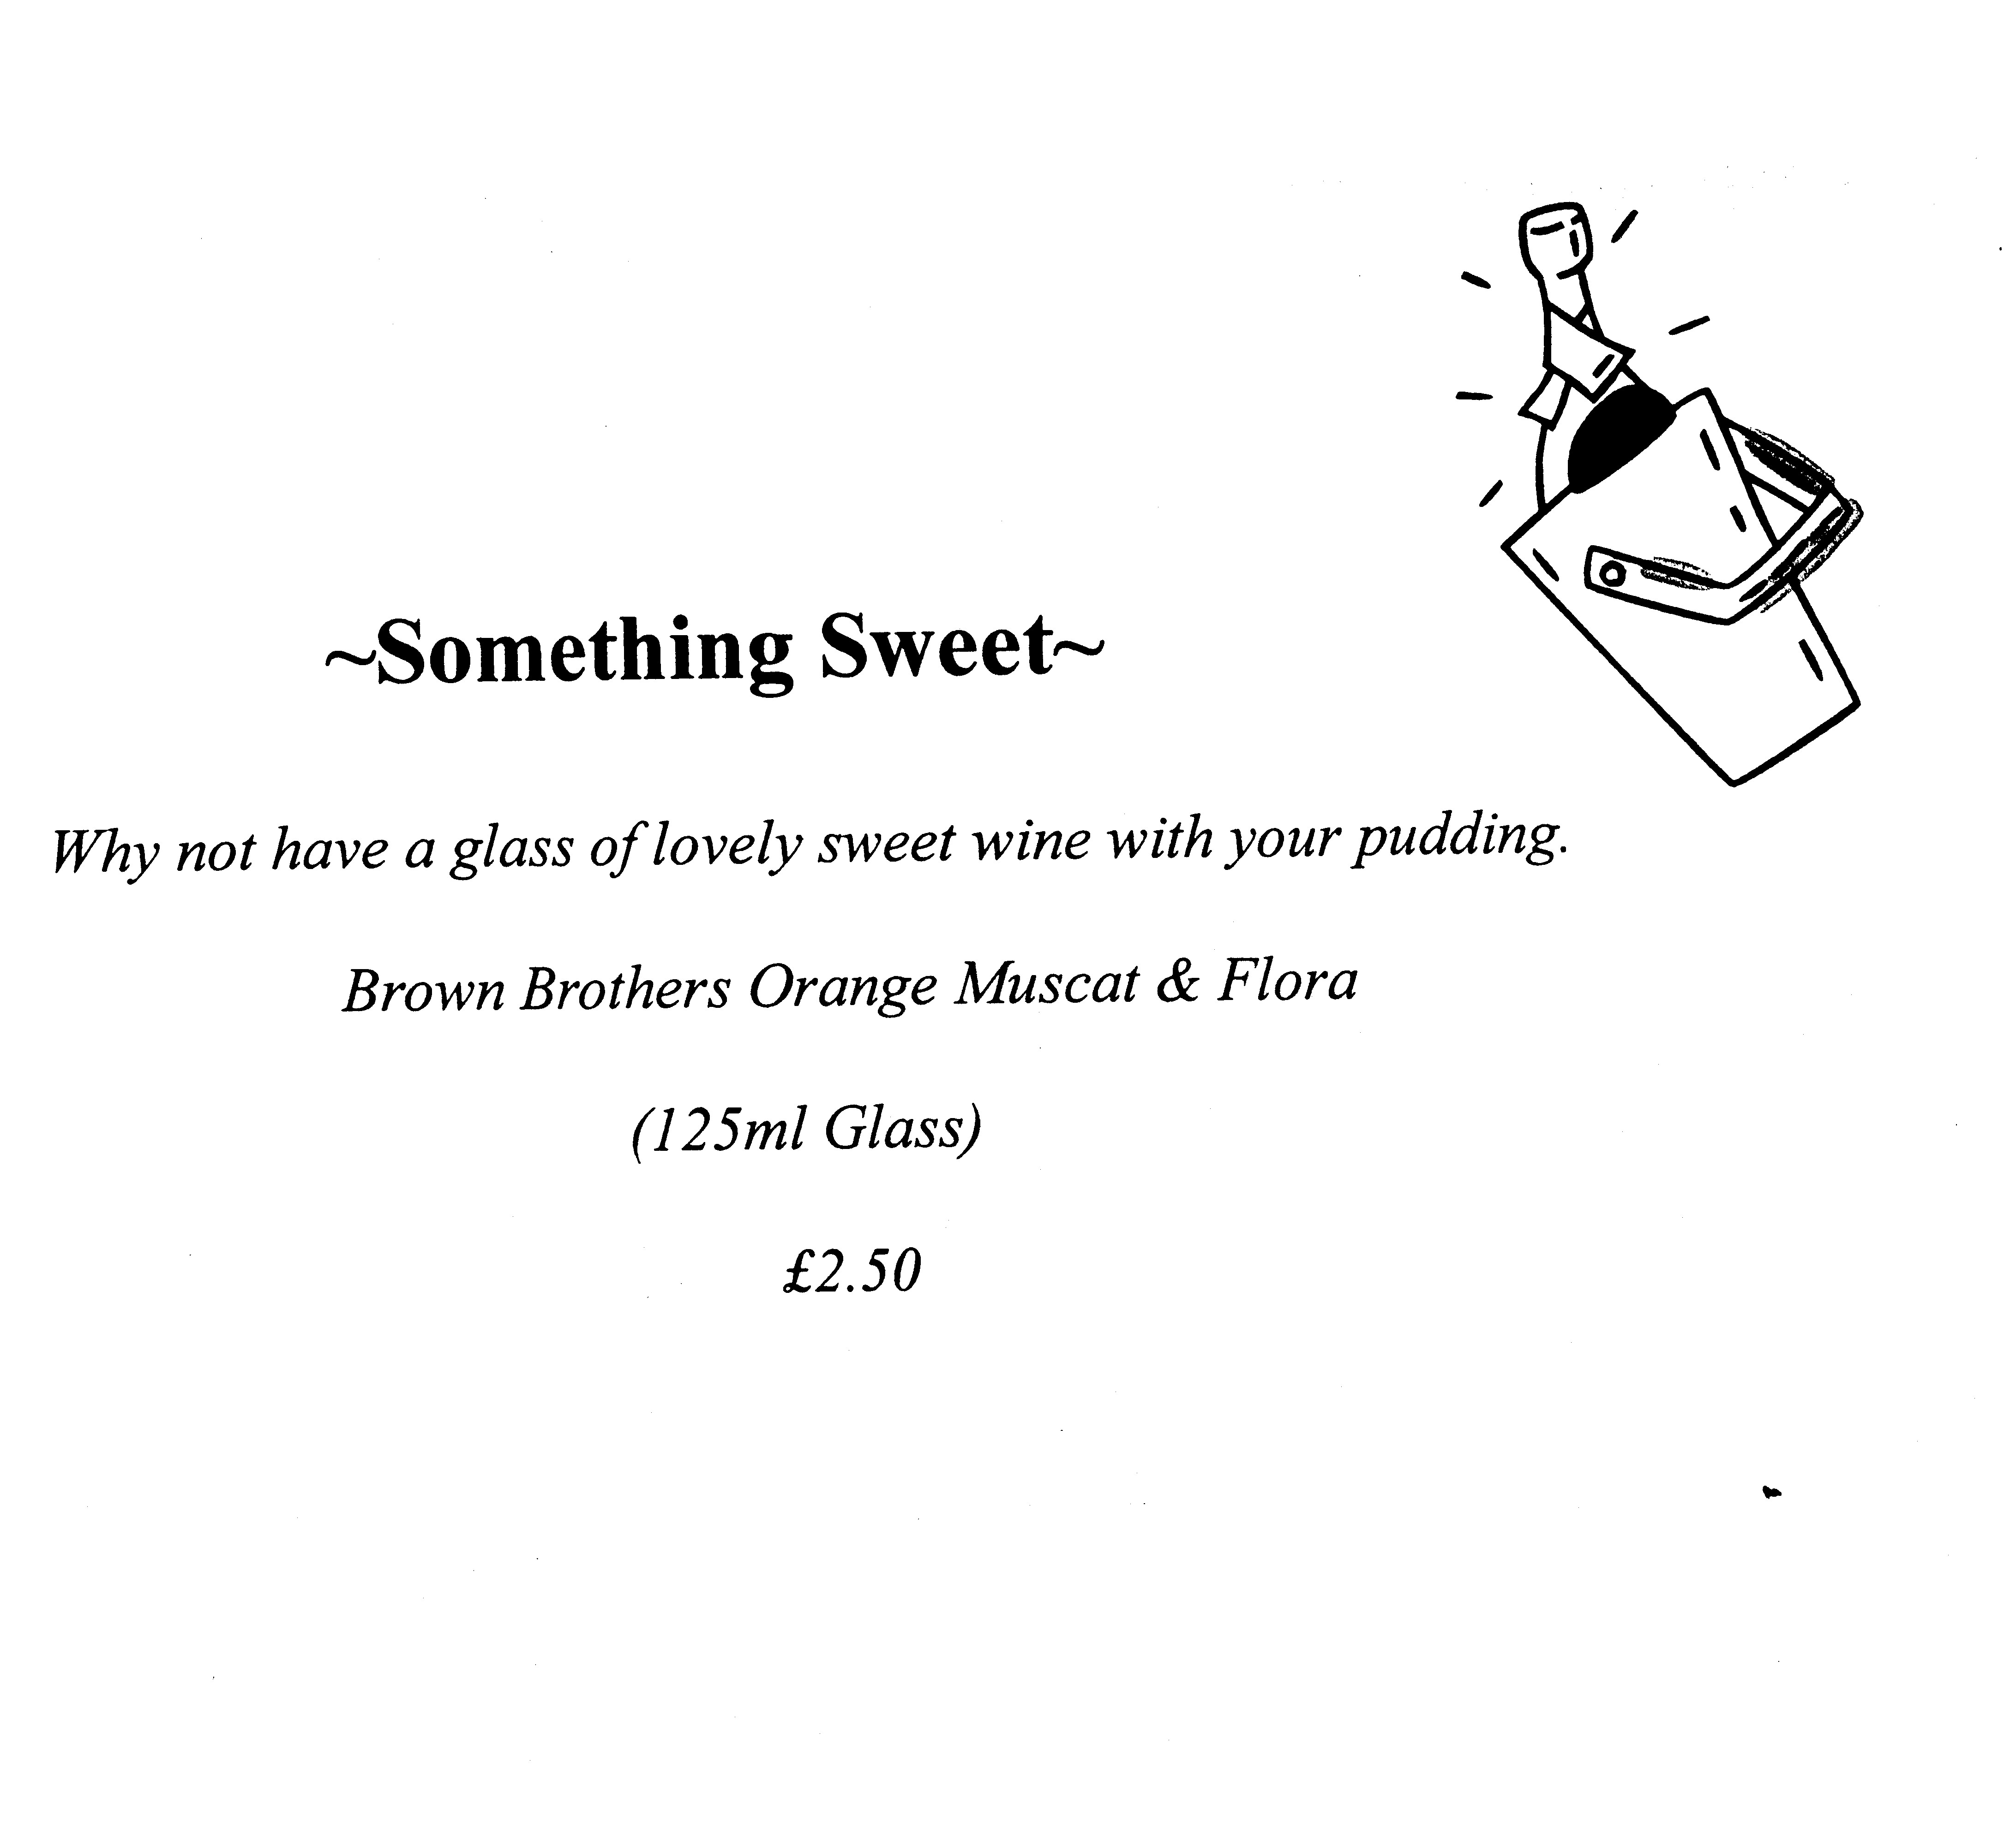
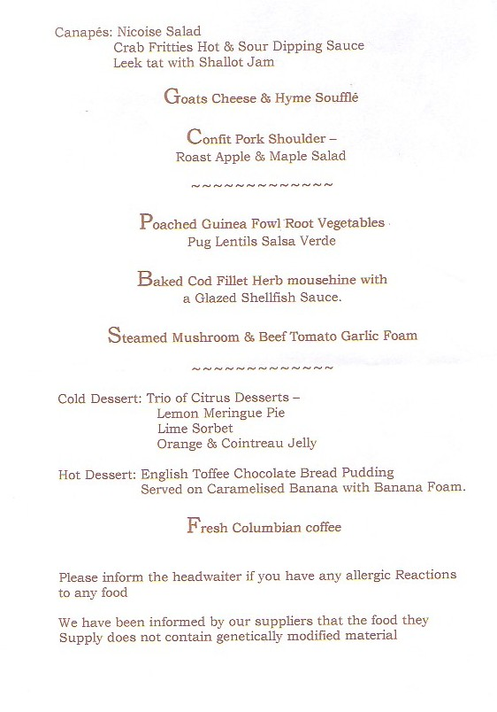

7. A student creates an arrivals and courses sheet based on the bookings in the diary. This involves filling in names on a template, which is headed “Daily Restaurant List”. This list is later updated by a student on the hotplate as courses are served – the sheet has columns by each name for each course.

Daily Restaurant List
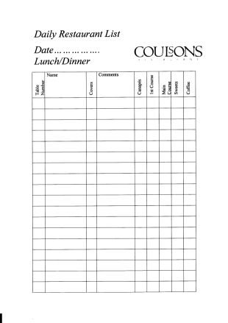

8. Students go through the menu as a group and check that they know what each dish consists of. This involves each student having a copy of the menu, and a tutor or the head waiter (student) explaining the contents and answering questions.

9. Students are informed of what the canapés are (by other students) and they write this down on a scrap of paper for themselves to inform customers.

10. Students take food and drinks orders from customers. This can involve explaining dishes to customers, dealing with questions, and writing orders.

11. Students need to read food orders for changing cutlery appropriately.

12. Students working on the bar need to read drinks orders, the bar till, and the wine list. They input information into the till, print off receipts, and send them to the customers or reception to contribute to making up the bills.

Bar till
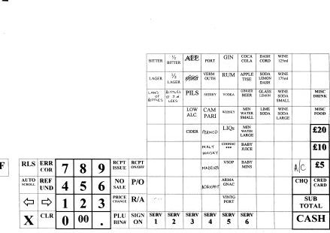

13. The wine waiter reads the wine list and writes wine orders.

Wine list
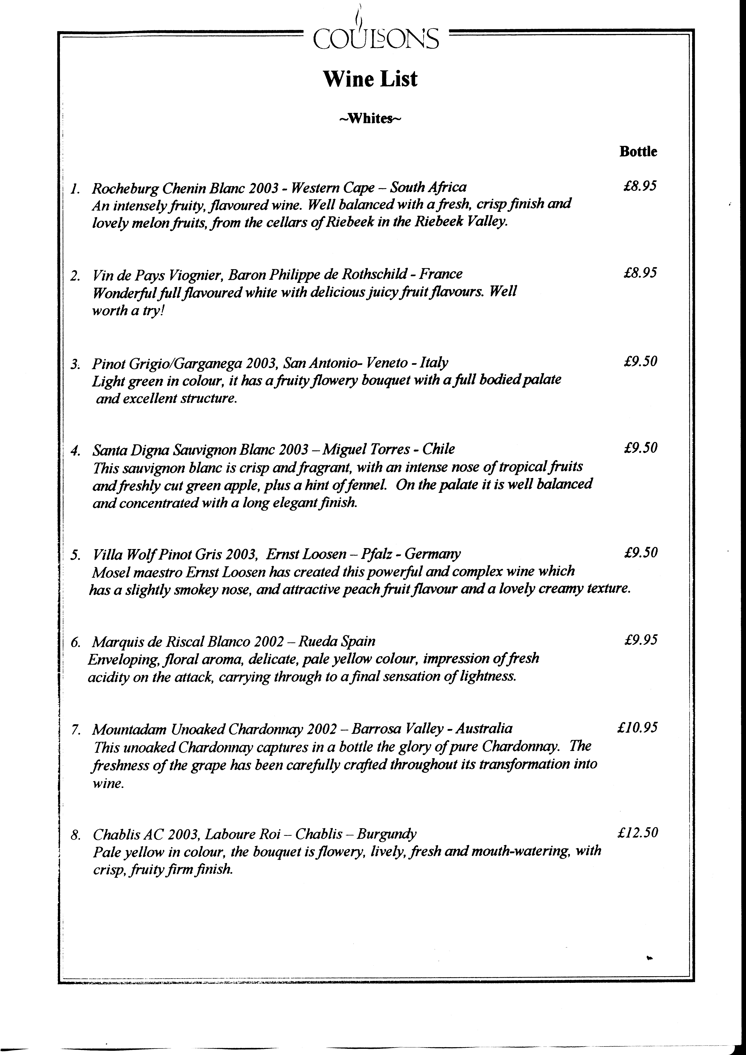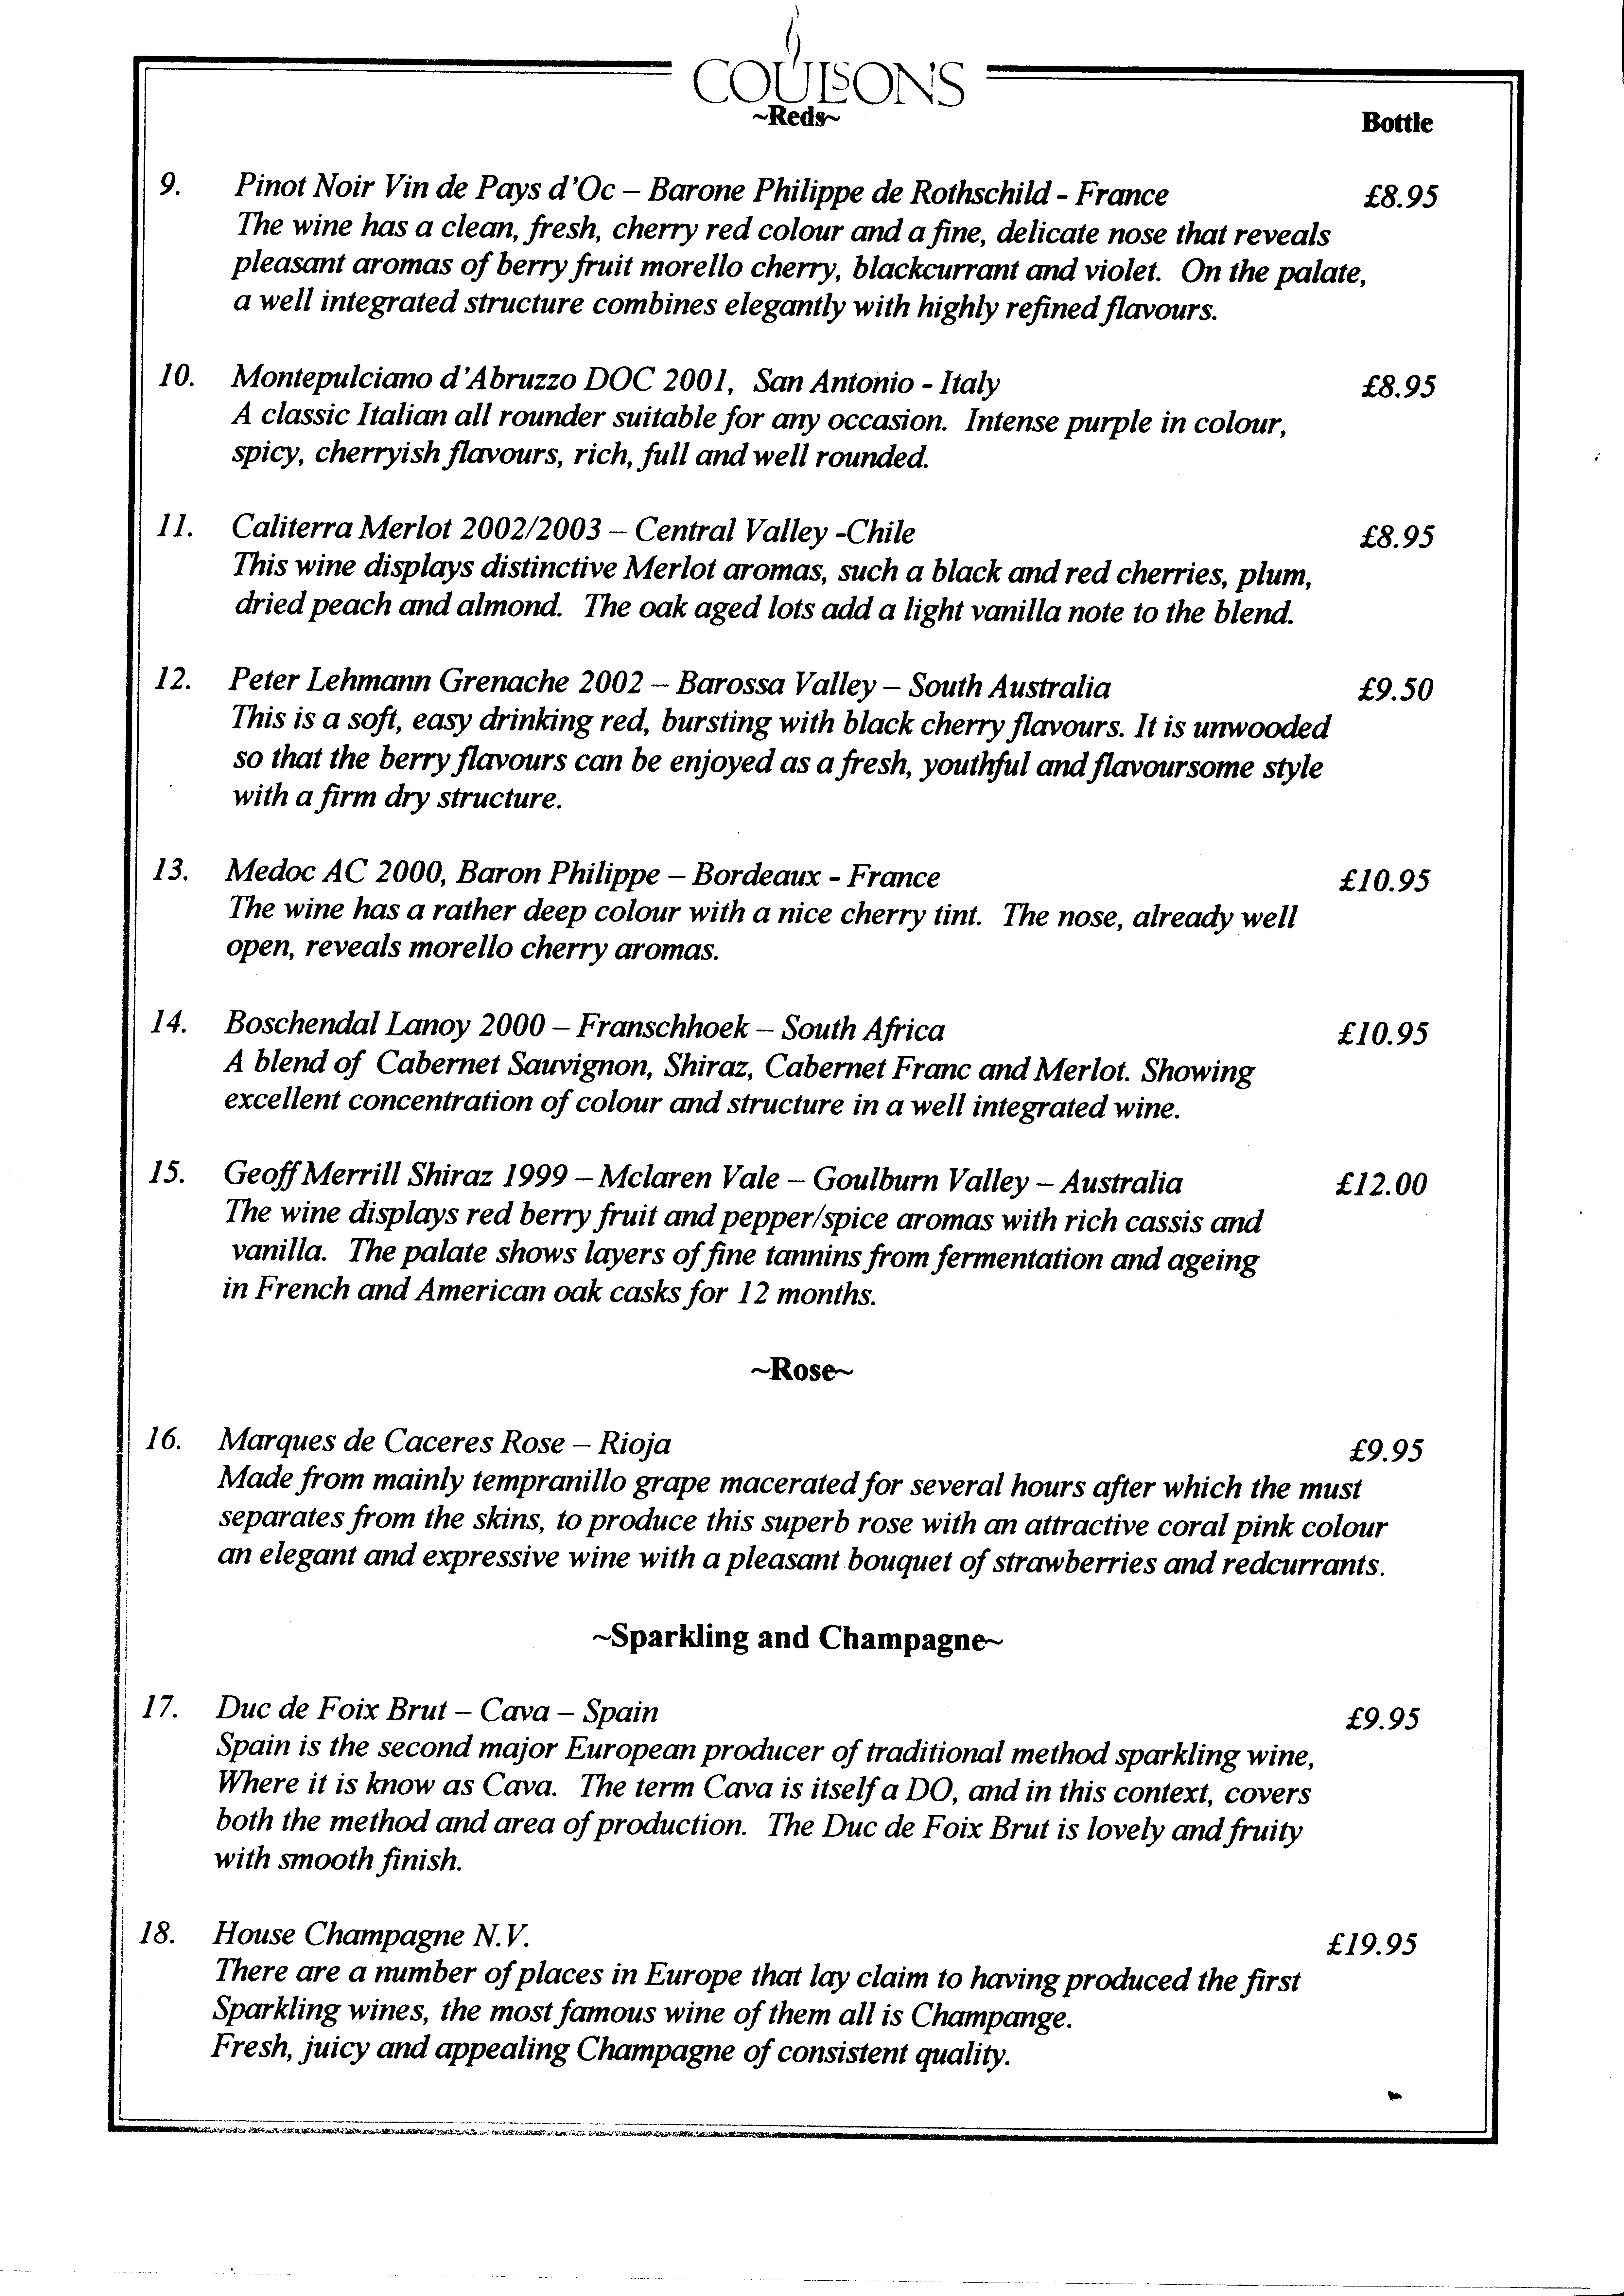

14. The head waiter records the number of portions available and the desserts list. The desserts list, relating to the sweet trolley, is written on the whiteboard in the kitchen and students need to read this.

Whiteboard in kitchen
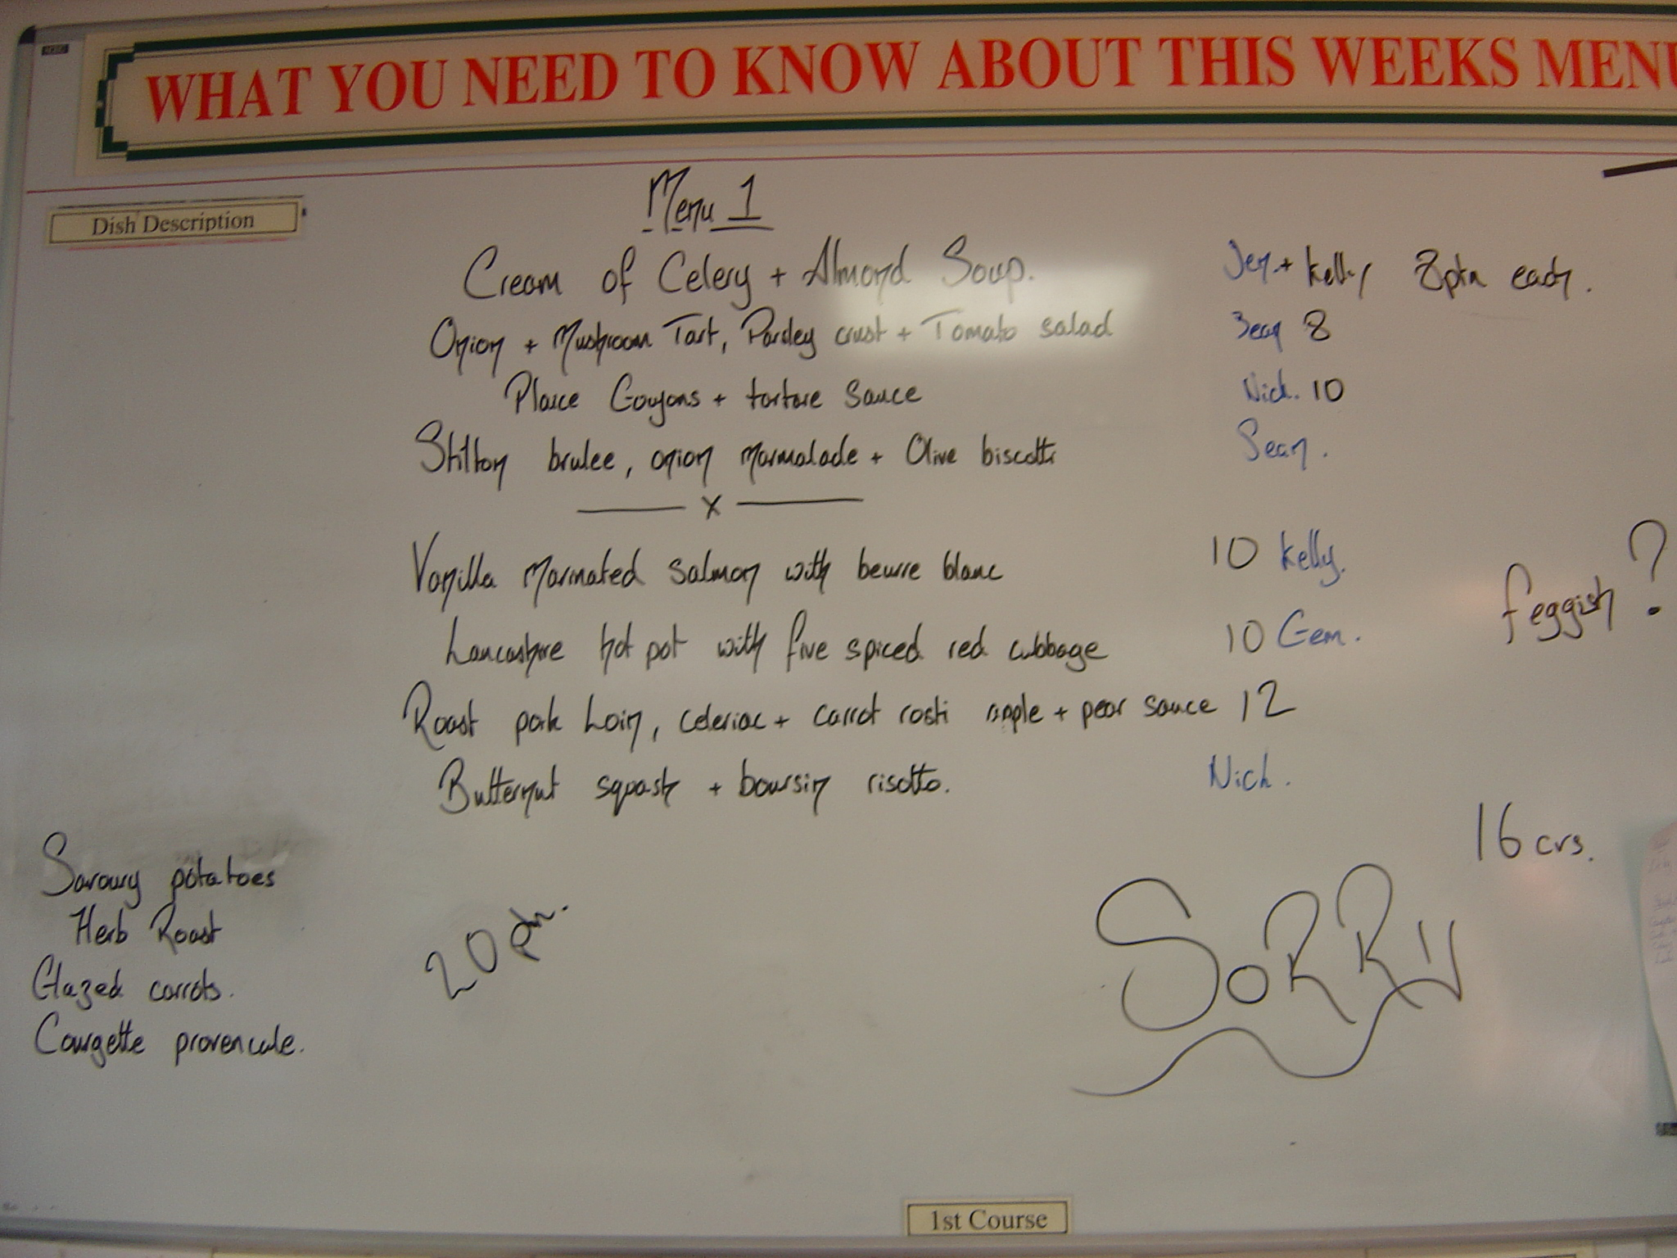

15. A student on reception completes the arrivals list, writes the bills and summary sheet, and reads all the drinks and food orders to complete the customer bills and the cash summary sheet. The bills are completed on the computer and printed out for customers. The Cash Summary Sheet is printed out and one section is completed by hand, filling in figures in boxes.

Cash summary sheet and customer bill
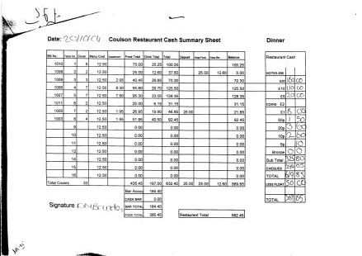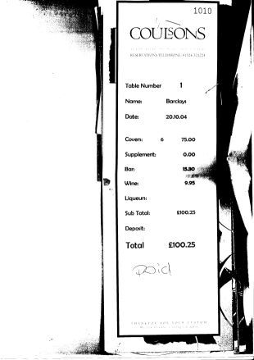

16. Students collect and read all comment cards completed by the customers.

Customer comment card (double-sided)
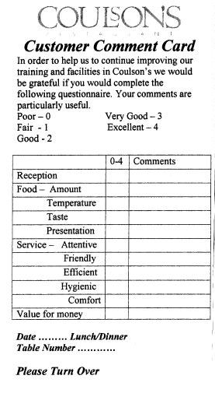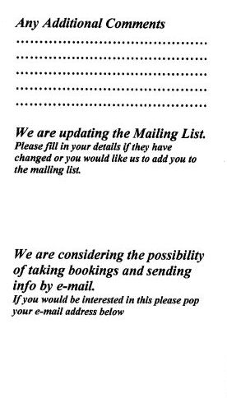

These literacy-related activities all occur during the course of one session. Some of the texts will be retained as evidence for students completing log books.

The completion of log books is another literacy-related activity, which involves the student reading the Performance Criteria (although students said in interview that they did not necessarily read these), filling in the date and writing in the activity carried out. The tutor will then tick the box according to what has been done to the correct standard for each performance criterion.

Pages from student log book

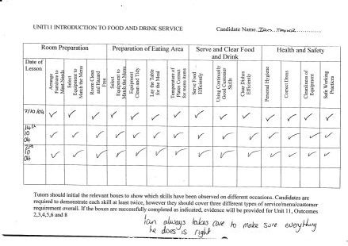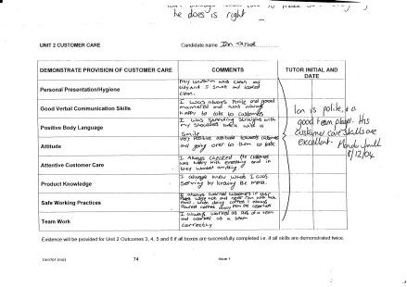

Some of Sarah’s written comments on the log book are:
“The students were expected to write some small pieces about the tasks they had carried out for which they had been assessed. They were also expected to know what to write in what unit. Outside the lessons the students are expected to keep their logbook up to date as there is not always time to complete all assessment write ups in the session.
The logbook is an essential part of the qualification and because there is so much to write up in order to achieve the qualification we need to write assessments up whenever possible.
The purpose of writing the text is primarily to gain the qualification. The completed and signed units are proof that the work has been done. A potential secondary reason is that the student may want to see (in black and white) what they have done whilst at college.
I have always felt that students have not fully grasped the logbook. They know that it must be completed but are not always sure how to go about it. This is more obvious when you look at a student who has certainly grasped the concept; they are able to move through the NVQ quite quickly but are not necessarily the best skilled at the task. In general, I think the students can feel quite daunted and put off by the logbook as it is not clear what task relates to what unit or element.
Often there are more complex words and phrases used where simple ones would suffice.
[In answer to whether the logbook relates to students’ past, present or future lives] I would like to give a more lengthy explanation but the only answer is no.
The average reading age of 16/17 year olds at LMC is 12/13; however, the logbook is written for a reading age of 16/17 year olds.”

The log book states that underpinning knowledge “must be assessed by oral or written questioning”.
It appears that this is never done orally. Sarah commented: “As yet I have never done oral questioning with a student and it is probably for selfish reasons. It would have to be recorded by me or another tutor and this would just add to the workload. Although, if I sat and thought about it, it would no doubt be easier to question the student and write it myself than it would be to try and coach the student in to writing the correct, answer, making it legible and understandable.”

The students are provided with Information Booklets relating to each unit, for example unit 2FDS5 is “Provide a Silver Service”, which has an information booklet headed Coulson’s Restaurant using the restaurant logo and contains:
5.1 Silver Serve Food
5.2 Clear Finished Courses.
This booklet contains 5 double-sided pages of information relating to how to provide a silver service. At the end of 5.1 and 5.2 there is a section headed “What have you learnt?”, each with three questions with space for them to be answered by the students. This was designed by Amanda as a way of introducing the Underpinning knowledge information which needs to be entered into the logbook.

There is also a booklet of 3 double-sided pages relating to 5.1 and 5.2 headed “Underpinning Knowledge Questions”. This contains questions which are taken from the log book, but which are expanded and/or reworded. For example, in the logbook,

“Q5. Why should you take care to avoid accidents happening when silver serving food?”

becomes in the booklet:

“Q5a. What potential hazards/accidents should you be aware of when silver serving food, and what can be done to minimise the risks?

Potential Hazard | Action to minimise risk

“Q5b. Why should you take care to prevent these accidents happening?

- “

The intention is for students to complete the questions in the booklets instead of in the logbook because the logbook is complicated and daunting to students. The booklet appears much more reader friendly than the log book, for example it contains pictures, tables, the pronoun “we” rather than “you”, simpler language, and self-explanatory layout.

For a Hospitality Action dinner, where Raymond Blanc came to work with the students, the “A la Carte 3 Course Menu” was written in English and in French, which students were required to understand. This was done through a group session looking at the menus. A separate sheet which students needed to read contained a list of canapés and petit fours, and included plates requirements for each course. Further sheets were headed “Le Manoir Repertoire” followed by a code, e.g. (MSALC-2002D), which contained the dish title both in French and in English, e.g. “Pan fried venison medallion, Grand Veneur sauce spiked with bitter cocoa, braised chestnuts”, with ingredients, portions, and recipe codes for each constituent. The sheet also contains a written description of the dish and a photograph next to a drawn diagram of a plate with all the ingredients as it would be served.
These were a one off for this night and not something the restaurant would normally use but out in industry there is a possibility that they will come across them. They are dish specifications which tell the kitchen exactly how to make and present it and it also allows the front of house team to see what the dish will be like in advance, therefore, they know what they are taking to the customer. They will also know ingredients if any customers ask. These are something that the kitchen crew are likely to produce.

On this evening, a leaflet for Hospitality Action was distributed to customers.

Other reading and writing activities involve Health and Safety information relating to maintaining a beer cellar, such as a Warning poster about “unauthorised keg spear removal”, warnings about gas cylinders and possible gas leaks, a Risk Analysis table for the Training Cellar. This session also included a poster produced by the brewery J.W. Lees entitled “8 Steps to a Perfect Pint of J.W. Lees Beer” and a sheet entitled “Cask Beer problem Chart”.
Students were also shown the safety label on silver dip for cleaning cutlery, and a ‘Cleaning Schedule and Checklist for the Coulson Cellar’.

In addition, students did the following:

- produced a coffee list and procedures for making the different kinds of coffee;
- produced a menu insert for Valentine’s Day;
- produced menus, such as for a Modern Apprentice Celebration of Achievement Dinner, and a Hairdressing Gala Dinner.

Students completing work like this at level 2 would only be those who wanted to get involved, e.g. Logan. Sarah commented: “In a level 3, things like this would contribute to assessment, but not a great deal at level 2. There is an element where students have to promote and support your organisation. Things like this could come in to that but this is only a very small part of the qualification. We are always producing things like this but it is usually myself, Amanda or the restaurant technician. Because we are a business, things need to be done quickly and we can’t always rely on students to produce things on time. Plus, they tend to need a lot of input so, potentially, we could have done it ourselves quicker in the first place. (I realise this sounds pessimistic and not very fair but it’s honest!).”

Insights emerging from a comparison of the case studies of the ‘project’ students for this unit

It is clear that the students all have a clear interest in Catering which is reflected in their outside reading and writing, such as researching recipes, reading cookery books, Caterer magazine, looking at cocktail menus, etc. Janet also does a lot of work related to her course in her own time. In this sense, the students appear to ‘live and breathe’ catering, confirmed by them all saying how little spare time they have because of long hours at college and part-time jobs. They feel they have little time for sustained reading, and Logan in particular finds that reading extended texts does not sustain his interest. He is an expert texter, however, and enjoys producing aesthetically pleasing texts such as Powerpoint presentations and posters. He will also spend time playing computer games which involve reading. The log book is unlike any of the texts they come across in their everyday lives, and is notably not aesthetically pleasing.

Insights emerging from the research on the literacy practices on this unit

The literacy events described above can be categorised according to whether they are:
- Part of the day-to-day business of running a restaurant, e.g. reading warning notices, drinks labels, leaflets, writing food or drinks orders, stock orders, etc., or part of assessment.
- Compulsory or optional, e.g. the production of powerpoint presentations for the TV screens; designing menu inserts; writing wine lists (all optional) as opposed to filling in the log book (compulsory).
- Produced by HAB or by the college, e.g. the logbook vs the booklets relating to the logbooks, the first of which is much less reader-friendly than the second.

It is significant that there is also a set of texts produced by the college to work alongside the texts produced by HAB or C&G. These are ‘simplified’, ‘explanatory’ texts which the staff felt were needed for the students to understand the requirements of the log book.

It is clear that the way students from different levels are working together means both that they learn from one another, but also that the teacher’s job is never clear-cut with regard to exactly what is being covered in one session.

Proposed explanations for why the literacy practices on this unit are the way they are

It is quite likely that the log book is intended to be an alternative way of assessment from the traditional ‘academic’ writing of essays, reports, etc. In this respect it might appear to be more appealing to the students, and indeed some have said that they prefer it to having to write essays. However, the literacy practice of completing the logbook is so far removed from any other literacy practice they have encountered before, or will encounter after the qualification, that it creates problems rather than solves them.
I believe it could well have been well-intentioned as a way for ‘practical’ people to complete an assessment – and it even contains the option of answering questions about underpinning knowledge orally rather than in writing. However, in practice, it appears to be that the log book causes problems for students when other activities such as producing posters and powerpoints, reading menus and wine labels, do not.

Sarah in interview 30.03.06, described the concept of ‘literacy priorities’. She explained that the logbook tends to get left because there are more immediate demands, such as setting up the restaurant, dealing with customers, etc. This links to the idea of ‘interactive’ literacies being more significant than those with no particular audience – they are more immediate and can be seen to be more relevant, particularly because ‘real’ people (customers) are involved.

Insights emerging from comparing ‘everyday’ literacy practices with the demands and practices of the unit

As above, the logbook is unlike literacies required elsewhere, whereas reading and writing menus, posters, etc. have more relevance to the future and the present lives of the students.

Innovations
LMC Catering and Hospitality level 2
NVQ Food and Drink Service

1) Description of innovations

The major difference this year is that the examining board is moving from HAB to City and Guilds, which is seen to be a more relaxed and flexible approach to the qualification. This is really an enforced innovation; we can see the reaction to the new style by researching the unit this year.
The layout of the logbook is different in that HAB provides a folder with all the units for food and drink service, where City and Guilds allow you to download the relevant units, copy them and create your own logbook. This means that when the student gets their logbook it is not as daunting because there isn't as much "irrelevant" paperwork in there.

Also, Manda has created a front sheet for each unit which gives a brief explanation of what the student needs to do in order to gain assessments for that unit.

The new log book therefore was hoped to be an improvement in that it allowed more flexibility and would possibly counter some of the criticisms from students (and staff) about the difficulties of filling in the HAB log book.

2) Justification for innovations

The C&G log book was a replacement for the HAB log book. The criticisms of the HAB log book were largely gathered during a ‘reflection on a text’ discussion, summarised below.
LMC
Catering level 2 LMC 23.6.05
Reflection on a text: NVQ Log Book
Sarah introduced the idea of reflecting on a text - the log book, which could refer to either the kitchen (Sam and Mark) or the restaurant (Logan).
Logan thought it was very very hard to understand the log book. Sam agreed it was hard to start with. He had come to it from the City and Guilds at level 1, which is different, although the NVQ was not harder to understand. They had to fill in every detail in the City and Guilds, and it was not as structured.
Logan commented on the small size of the space available – it was difficult to fit what you wanted to say into such a small space and so had to think about it carefully before writing. He didn't like the Performance Criteria, although Sam and Logan both said they would read them. The ticks have to be put in by a teacher, and Logan commented that the page looks better if there is no Tippex, so it is better to wait for the teacher to tick it because they know whether it's right or not.
Mark said that in the kitchen you can tick it yourself.
Looking at the 'range' - the range is more complicated in the restaurant than in the kitchen, so the teacher does it.
Logan said he would take his log book to an interview to show a potential employer what he had done. He tries to word it as well as he can. Sam appeared to be less committed - he wanted to get the ticks, but wasn't so keen to have it perfect.
It was commented that the style of assessment at level 3 varies, but not the logbook, but there is more prompt for tutor comments in level 3 (which the students will go onto next year).
When asked how they might change the log book, Sam said it should be made less formal. Working on identical sheets is very boring, so to make it more interesting it could be colour-coded (Logan).
When asked about assignments as done at school, they said that would be too much writing and effort, and agreed that the log book is good as it is only a bit of writing a day.
Logan thought it would be good to have distinction, merit and pass, but they don't at level 2. You have to have covered everything in some way or other.
Asked to elaborate on how to make it less formal, they commented on the wording which they found over-formal. Logan said "It's not the reading - it's the syllables - like machine-gun fire going into your brain". They discussed slang and so on, and thought it would be better if it used more of "their own language". On the subject of formality levels, I asked about why salmon would be "pan-fried" on a menu, not just "fried". They immediately thought this was justifiable because it is advertising - trying to sell something. The log book would be better if it was slightly less formal and easier to understand, at the moment it is hard to decipher. They agreed that it gets easier as it goes through the year and they get used to it. Their language is changing all the time, but the logbook is "not catching up too fast". They said they did not want to keep going up to the tutor to ask what the performance criteria meant and how to fill it in.
Sarah pointed out the "evidence requirements" which were in a box on the page. The students said they had never read these, although Sarah said they were really quite important. There are different boxes for students and for tutors, and it is not entirely clear which is which. Logan said he only read stuff in bold or that stands out. At the beginning of the unit it gives an overview of what is required, but the students also never read this.
They said there should be a logbook induction day, but there isn't one at present. They are expected to pick it up from having done the ABC unit last year, which had an easy to follow log book. Also the students go though the first units together with the tutor. They thought it was more interesting to be asked to draw a table layout etc. - more interesting and varied. Any rewritten version of the log book would have to go through HAB and would be expensive.
The good things are that it looks good when there is a page full of ticks and signatures and when the unit is finished, with the green sheet at the back completed. It is a relief when a unit is finished, although then they think they have to complete the next. When the whole thing is finished it is a great relief.
At the moment the students can complete 5 units at a time. It was agreed that this was the best way, as to do it unit by unit would mean that opportunities for assessment criteria in other units to be met at the same time would be missed. Logan commented that at the moment it is possible to pick up 8 assessments at a time. They also thought it was better to fill in the log book as they go, rather than doing a big chunk at a time. They all found it very boring writing up the log book, and their minds would wander. There was discussion about whether the students could fill in their log books during service. At the moment they do it at the end of the night, after “mains”, when there is less to do. The problem with filling it in as they go, however, is that there would need to be enough people to cover the service, and the students would have to know what they were doing – filling in the right boxes, etc.
Sarah mentioned that she had designed a table to show which assessments could be covered by what tasks, but this had never been used.
It was pointed out that the first box to be filled in is the date. This in itself could be a barrier to the task being completed, as students did not always know the date of the activity.
The students thought they could see the point of the log book – they thought it was for the Hospitality Awarding Body (HAB), and was easier for them to process than written assignments or other forms of assessment. The students thought they would prefer to fill it in themselves rather than have someone else fill it in.
Sarah mentioned that a new log book proposal had canvassed tutors for feedback but not students – interesting.
Asked whether the students would see anything similar in the workplace, they mentioned an accident book, and rotas, but this was something they would read and not write on. They might have to complete a fridge temperature chart.
Each student would complete only 12 units out of 24 in the whole log book, but a full log book would be sent to each student. Sarah thought it could be more cheaply downloaded from the internet and this could include colour.
In a later interview – 17.5.06, Sarah said:

S.: There is no way that a student could sit down with the entire log book and not have any guidance from a tutor
C.: right. Would you say that categorically about all students?
S.: yes
C.: from all backgrounds?
S.: yes
C.: so how do you know how to do it? Or how does Amanda know?
S.: years of experience, more than anything.

Comments
It is interesting that Sam had come from C&G and had to adapt to the HAB – so in some respects this might indicate that the change back to C&G would have similar problems. (This did turn out to be the case.)
Also, many of the problems were simply to do with having to fill in a log book at all. Amanda had already worked at making the HAB logbook as accessible as possible by creating Supplementary Evidence sheets of her own, which were more easy to understand and avoided repetition that was in the log book. I commented on this to Sarah:

C.: right. 'Cause when I was going through one of these and I came across this I wasn't- it seemed to me what you said that it was produced by the college, but it wasn't entirely clear, and it just seems such a lot of work for Amanda to have to do that
S.: but once you've done it, then that's it
C.: well except when you change exam boards
S.: well, yeah. But unfortunately you can't foresee things like that, so you've got to go along, you've got to assume that this is going to happen for a period of time and you need to make it as smooth as possible for that period of time.

The preferred innovation might have been to do the course without a log book at all. However, there was not the possibility of doing without one, so the innovation had to be to try a different one.
Sarah used many of the students’ comments on the log book to improve something she could control, which was the ABC workbook at level 1.

3) Evaluation of innovations

(a) Description of innovations in place

Catering and Hospitality Level 2
LMC 30.03.06
Observation of “log book session” in the restaurant by Candice
Tutor: Amanda Smith

9am Most students arrived early for their 9 o clock start, all dressed in Restaurant outfits. The class consisted of a mixture of year 1, year 2 and year 3 students, working on level 2 or level 3 NVQs.

Amanda admits that they do not often have time for these sessions – log books are usually fitted in wherever they can be. They are usually busy setting up the restaurant, and on Wednesdays they haven’t yet done anything that needs writing up.

They sat around a large round table in the restaurant that is often used for written work, but is also used for demonstrations of how to serve and clear, and is also sometimes used for coffee and toast at 10.30 for staff.

Amanda introduces the session as a log book session where they will be looking for how to fill gaps in their log books. She suggests they look through and find the gaps and then write on a piece of paper, “Today/Tonight I will … answer the phone …” etc. She tells them to “just shout” if they need “any help or advice”. Amanda sits at a table in the corner with students’ assessments, log books, etc around her. She then moves to help Jacob and explains to him he needs to look for where there is no evidence. She says to everyone, “Trawl through and see what’s missing.” She then advises Nick that he needs a “wider range of evidence” because he has tended to write the same thing in several different boxes about presenting himself neatly – which makes sense because they are asking for the same thing, but he is supposed to use a range of criteria. After this Nick moves on to answering some questions – “he has a question sheet to tackle.”

Amanda explains to me that she has designed a “cover cover sheet” for each unit to add into the log book provided by City and Guilds. She also said they need to reorder the pages for it to make sense, so p.56 goes at the front of a section instead of p.46.

During the morning students are handing in a set of questions they have answered, headed “Unit 601 2GEN1 Give customers a positive impression of yourself and your organisation”. She remarks that “They keep leaving that one out” – the question is: “State two ways that industry and professional codes of practice affects the products or services to be delivered to the customer.” This seems to be an example of a question which is worded in such a way that it is not clear to the students what is being asked for (not surprising).

Amanda tells the students that they need to be more proactive in helping customers – they have to have evidence of providing customers with answers to questions or requests.

The City and Guilds log book requires students to fill in a Restaurant Journal alongside the log book. However, C&G do not provide this book, so the staff have designed one. Amanda has a “Sample” journal filled in by herself, demonstrating how to fill it in. The journal is similar to the log book in that it has boxes to be filled. Amanda reminds them, “Only put stuff in that you’ve done.”

During the session George (Logan), as restaurant supervisor or head waiter??, is asking students if they need to be on assessment – working out who does what in the restaurant that day based on what gaps are in their logbooks.

A student referred to the Coulsons’ Practical Log at level 1, which he said was so much easier to understand and fill in than the level 2 one. There was less writing, although you still had to write. To fill in the journal you have to read all the contents of the boxes and locate the reference numbers for the units. He explained that what he was doing in the journal he would transfer to the logbook when he had enough information.

Amanda showed me a CDRom produced by C&G which suggests using Observation Reports which tutors fill in. She thought these were a good idea and designed some. But other tutors did not agree because it meant the students did not need to write things down. Amanda’s view was that although she believed that students who don’t like writing shouldn’t just not do any but should get over those barriers, she thought that this wasn’t the right environment to teach them how to write (and also is not her job).

(b) Students’ views on innovations

Interview with Mike and Frankie re. logbooks 30.3.06

Mike explained that they all understood the reasons for the log book, although they found filling it in to be boring. He had done the HAB log book last year and moved to C&G which was meant to be simpler. But it looked a bit different and he found it slightly more confusing – this was mostly because it was new. Frankie agreed that the most difficult thing was being in transition between the two log books. She had got used to HAB and now had to get used to the new one. C&G used K instead of ‘Knowledge’ – it was like learning a new language. Frankie had done level 1 in HAB and found it ok. She thought it was proof of having done the course. Mike pointed out that in the kitchen log book there was some room for individuality because you could include different food and recipes according to what you had done. Also, he said that in Pastry you could take photos of your work, but these were not used for the logbook, just for personal use. They thought that taking photos would be good in the restaurant and to liven up the log book. (Sarah pointed out later that it would be difficult to find time to do this while students were actually working, and there would also be issues of confidentiality for customers.)
Mike mentioned that the Little Book of Coulsons had photos in it.

Mike referred to the Key Skills sessions on Fridays with Mrs Glenn, where he is designing his own restaurant – ‘Fantasy Restaurant’. He was doing one on the theme of Cirque de Soleil, using pictures from the internet on a big piece of cardboard. They also have to do a written project with menus etc. Mike was enthusiastic about this.
Level 3 students do their own speciality night in the restaurant, e.g. Tom will be doing an Easter Special Night with cocktails and the students will be asked to wear white shirts. For speciality nights students produce the publicity, menus, etc, but they would not normally be expected to do this.

Mike said that he works as a chef in his mum’s pub (Snatchems). He works mostly on his own there and uses recipes from college sometimes. He finds the course very useful for his work in the pub. His mum and brother are trained chefs. Mike went to the grammar school 6th form, but couldn’t take the subjects he wanted so left and drifted into the family business. He is not sure he will continue to level 3 – he will be 19 and will have to pay, but also his family may be moving to Aberdeen to run a guest house.

Mike and Frankie said that they usually do their log books at dinner time (in the evening) after setting up. They said there was time to do the log books, but it was spread out.

In an interview with Agnes (Tracey 24.11.05), she said that she found the log book difficult because it is “not self explanatory”. She thinks that the instructions are vague, and relies on tutor support because “we haven’t got our heads round it yet”. She thinks the logbook would be improved with clearer language, and her major difficulty with the logbook is that she is unsure about which section of the logbook each piece of evidence should go in.

Comments
It is interesting that the students were also critical of the C&G logbook. The problem is much more to do with learning a new literacy practice (through years of practice, as Sarah says) than exactly how the log book is organised or laid out. Hence moving from C&G to HAB was as problematic as vice versa.

(c) Tutors’ views on the implementation of innovations

Source: 3-EL-CS-SW-30.3.06

Interview with Sarah re. log books

Sarah commented that she had been thinking about “literacy priorities”. The log book gets left because customer care takes priority. So preparing tables, putting out menus, dealing with customers comes first – this is the case because it is a ‘real’ business (a RWE).

She explained that last year all the logbooks were HAB, then Head of Faculty decided to change to C&G (although not entirely necessary as HAB being taken over by C&G). The tutors didn’t know how to do it, so, from their experience of HAB they made introductory pages for every unit made by LMC to help the students to write in the boxes. Sarah referred to p.94-95 and p.92-93. If a student wrote the same thing in every box (like Nick), the External Verifier might not approve.

Sarah and Amanda designed a journal to go with the log book to account for competence over time, rather than just on one occasion. They made this very simple, quick and easy, but the EV who came in February said this wasn’t enough and recommended reproducing pages from the log book itself. This seemed pointless, so Sarah and Amanda adapted a journal produced by the kitchen staff. The journal is a fuller account than the log book, and has to be done in the student’s own time.

Sarah decided that the innovation for this unit was really the LMC journal produced to go with the log book. We should talk to the students about this after Easter. Sarah produced the book and then Claire Tomlin who co-ordinates Learning Support trialled it with some students. She then suggested they needed to make some parts bold and underlined so that students would pay attention to those parts. Also the pages were numbered so that they could be referred to from the log book, e.g. see p.16 of journal could go into the log book.

Key Skills
After this interview I talked to Susan Glenn who works with the students on Key Skills. She was doing the Fantasy Restaurants with them. She had produced her own example to demonstrate what she wanted and the students had used their own ideas. She showed me these and I took photos. The students were apparently really enjoying doing it – however, they then had to do a written report, although Susan said she was “cheating” and giving them a proforma. Sarah and Susan agreed that the written report task was ‘unrealistic’, whereas the designing of menus etc. was relevant and useful to students.

Source: 3-EL-CS-SW-CH2-17.5.06
Summary
(SEE TRANSCRIPT FOR GOOD DETAIL AND QUOTES)

Sarah explained that for the NVQ2 Food and Drink Service, the innovations were forced by the Awarding Body being changed from HAB to City and Guilds. The innovations from Sarah’s point of view are the way they’ve chosen to deliver it.

3 stages –
Stage 1: last year HAB NVQ level 2
Every unit is in a plastic wallet.
The students did not read the first few pages.

It takes as long to explain what to tick and correct what they have ticked as to do it ourselves.
The staff can do it from years of experience – students only have one year to get to grips with it.

A few years ago Amanda put together a pack of Underpinning Knowledge and Supplementary Evidence.

Sarah felt they had looked at it from a design point of view rather than a literacy point of view when designing the log book.

Stage 2: change over to C&G
While the college had thought that the City & Guilds log book would be simpler, they did not account for a diary or journal being required in addition, to show consistency in students’ performance (competence).

Stage 3: Restaurant Journal
The student writes in this journal – as many times as they want. Then they can transfer the assessment to the log book. There is a journal page for each unit.
There are currently 3 different styles of log book in operation in the restaurant.

Sarah feels that the NVQ process is not in the best interests of the students. It involves students learning a new literacy practice – a painful process for students and staff.
Other ways might be going back to the old style – entrusting staff to come up with ways of assessing according to students. Colleges are in a position to adapt according to their environment. The NVQ is standardised – this is a good thing, but does not allow for individual or regional differences. It is not possible to demonstrate one student’s competence over another student’s. They all get the same qualification.

(d) Emerging insights on the innovations

It is significant that the envisaged improvement was not as simple as expected, because there are more literacy practices involved than ever! So, not only do the students have to negotiate a new log book, but they have to negotiate a Restaurant Journal as well. It has taken a lot of time and trouble for the staff to create the journal in a way which they feel will be easiest for the students. In the end, it is the creation of this which can be conceived of as the innovation for this unit.

The following comments from Sarah came after the innovation, but still refer to the HAB log book which was still being used by some students. The fact that the same could be said of the new C&G logbook indicates that the change in logbook in itself did not alleviate the problem.

Explaining why the tutor ticks the boxes, and not the student, she said:

“because it takes us as long to check that they've ticked the right things and to tippex out the things that they've ticked and they shouldn't have done than it would for us to just do it ourselves. Tried a lot of different ways to try and explain the logbook to students and get them to realise what they need to tick and what sections but it doesn't seem to matter which way we try it, they're still not- it still doesn't help unfortunately.”

“and this is a completely different literacy practice to anything else they would've done before. It's not necessarily something that comes naturally. Now I would imagine the people that wrote and designed this will have tried to make it as simple as possible, to try and make sure that everything's referenced properly, it all ties in together and everything's covered, but also to try and make it as simple and straight forward as they can. What I don't think they'd realise while they were doing it is they've looked at it from a design point of view, not from a literacy point of view. To have to look at that, just those two pages on their own, there's a massive amount going on and it's not- it doesn't flow either. You're moving from one page to another page, backwards and forwards, so it's not- from a literacy perspective it's not straight forward. From a design perspective you could say it is.”

Looking at the log book myself, as somebody not completely ‘in the know’, it is difficult to understand. Many of the references, such as ‘(*Knowledge statements are repeated in more than one element)’ – referring to asterisked items in a list depend on an understanding of abstract terms - ‘knowledge statements’ and ‘element’. Although the C&G is meant to be an improvement, it has its own difficulties, which are actually very similar to those of the HAB.

It is significant that the log book is probably the only significant problem on this course related to literacy. Apart from this factor, students enjoy the course and appear to find few problems. This must be a case for supporting the idea that students engage with literacy practices when they see them as relevant, purposeful, and with a real audience.

The fact that Key Skills is also seen as a problematic area – by both staff and students – indicates that this too is a set of literacy practices which are not valued and therefore not fully engaged in by the students.

Identities
Most of the students we talked to identified with being a chef or a waiter - the associated identities of the literacy practices relating to doing the course. But they did not identify with being the kind of people who could sit for a long time, or who enjoyed negotiating large amounts of paperwork, especially when it is linear and black and white.

Multimodality
The students did not identify with filling in the log book because they saw it as monomodal. Serving customers, on the other hand, and literacy practices associated with that, are multimodal, involving talk around texts, and being part of an interaction. This they saw as the priority – and, interestingly, so did the staff (tutors, but also responsible for overseeing the running of the restaurant).

Text-types
The log book is a text which is not found anywhere else, unlike menus, food orders, order books, etc. The Restaurant Journal is also not something that students would be familiar with – it is more like a log book than a diary, for example, because it requires students to provide very specific information, and often means they have to reword the same piece of information several times. So, although the topic is something they recognise and are familiar with, the way in which they have to write about it is not.

Participants
While the students work together as a team in their work serving customers, filling in the log book is very much an individual activity – not shared, and not collaborative – although they do help each other out, but the artefact of the log book itself, is individual.

Artefact
The log books all look identical, even when they are filled in, so appear very impersonal. This is also indicated by the fact that the students are not allowed merits or distinctions – they all come out with the same qualification. Only a very keen student like Logan would be interested in customising and making his log book personal – and he would like there to be differentiation in assessing the log book.

Time
There is generally seen to be ‘not enough time’ to do the log books, e.g. Amanda (tutor) said that they would not normally have a designated log book session because there isn’t time. The students also commented that they find it very boring sitting for several hours doing the log book. They prefer to be ‘doing’.

Purpose
The students saw a purpose in what they were doing, but it was a purpose not related directly to the present, rather to the possibility of a future in catering. There was no clear Audience, which meant that the students asked the tutors constantly for help, as they had more idea of the audience for whom it was being written.

Ultimately, although the Restaurant Journal was introduced to make life easier for the students, it still has the same kinds of characteristics as the log book itself, and is an example of additional documentation introduced as a means of easing the literacy load of an imposed practice.

(e) Suggestions for improvements or additional innovations

Sarah’s suggestion would be to do without a log book and go back to the ‘old style’ of doing the qualification, which involves giving colleges and tutors freedom to deliver it how they feel is appropriate. This would fit with the principles of the LfLFE project – that the context, which in Sarah’s view includes the individual students but also the area of the country, should influence the ways of teaching. She also suggests that the individual literacy practices preferred by students are different, and could be catered for using a different system.

S.: I think I've a bit of a bee in my bonnet about the NVQ process at the moment. And I'm not completely against it. I just don't feel as though it's serving a particularly great purpose. And from- to put it in literacy perspectives it is like learning a brand new literacy process, and a process that they'll never need to use again. And it's frustrating to think that they have to go through this. What in effect is a quite painful process for them. It's not an easy thing for them to do, and it's not an easy thing for us to see them go through either. They just have to go through that without very much benefit at the end, other than a certificate at the end that says this is what you can do. There are other ways of achieving that certificate and I don't think this is the best way.
C.: so give me other ways
S.: No it's- personally I think it would be better going back to the old style of doing things, and that is entrusting the college or departments or the tutors to come up with ways that are suitable to deliver a course to the students. So the awarding body will set criteria and certain achievements that the student has to have done, in order to complete the full qualification. So for example, the student in the restaurant would have to show that they are capable of silver serving food. How that's assessed, delivered and eventually achieved by the student I think should be more flexible, more down to the individual environment. Part of the reason that I think that as well is that every area of the country is slightly different as well, 'cause we're so close to the Lake District and the service style and the way that things are done from a hospitality point of view is different to London or Bristol or Cornwall or Wales. It's all- they've got a slightly different view and a slightly different way of doing things. And by allowing the colleges to kind of take on more responsibility, adapt what they do to suit their environments, I think it could potentially benefit the student. One of the good things about the NVQ, 'cause I don't want to diss it completely, is that it's standardised and it's quite formal and quite structured. So to a certain extent you know where you stand with it. That's kind of what the ticky box system does for you, which is great. But it's also very restrictive at the same time. And I've mentioned this before, but I'll mention it again, it's another bug-bear of mine, is that a student like this one here will leave with the same qualification as this student here and I know for a fact that in terms of competency they're at two completely different levels, and there is no way of demonstrating that to a future employer, and I don't think that's right.
C.: yeah ok. so the standardisation is taken to extremes. It standardises students as well as standardising modes of assessment.
S.: and from a literacy point of view it's conforming them all to the same thing. It's saying, like I said, "this is the literacy practice that you must do in order to complete this qualification". Now that's not adapted to every student. Every student is capable of different literacy practices, but we're forcing them into one, and there should be more flexibility than that.
C.: so it might actually suit some to be ticking boxes and filling in things. Other students want to demonstrate creativity and so on and they could be allowed to do it in other ways. Right. So when I make the point that I keep making in presentations and things, which is that it would be good if they could take photographs of their work, or they could draw pictures or make posters or do presentations, they do do some of that but it seems to me that it doesn't count for assessment in the same way that- there's no where in there that records "I did a lovely poster today". Is that- am I right in thinking that, or is there a way that those sorts of things can count?
S.: it can be incorporated.
C.: maybe they can be incorporated but because they don't need to be
S.: yeah that would
C.: why do it?
S.: yeah. You take something like 2 FS 1 "prepare your service area" basically and one of the things you have to do is lay the table. So in effect, what you could do, the student could lay the table and take a picture of that table and say "this is the table that I laid up". Which is great in terms of the student being able to show at the end of the qualification in their log book with pictures and things in, that say "look at what I've done" but it's almost that they're doing that in addition to whatever else they do, 'cause at the end of the day they would still have to write in the log book what they've done. They'd still have to get it signed off. So perhaps from our point of view we should suggest to the students that if that's what they want to do then by all means do it and we'll credit- make sure it's included in the log book, but it won't
C.: but it would be better if it was included in the City and Guilds log book rather than you sticking it in you know
S.: yeah
C.: so when- if we go back to what your advice would be, it's to go back to a system where the way that students are assessed is dependent on the environment, it's dependent on the students themselves and presumably with this project, it depends on what you know about the students' literacy practices in their everyday lives, which we now know is important. So that would just count instead of the log book, that's what you're saying?
S.: mm
C.: yeah. ok. And if that was the case then all of the things that I've just mentioned that here would be in addition, could count, in isolation, could count on their own as part of the qualification.

