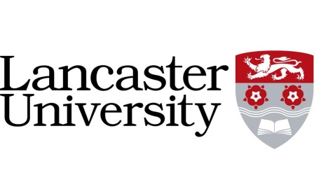

Lancaster University Friends Programme

Telephone Campaign Caller

**Description:**

The Lancaster University Friends Programme supports many different projects and research initiatives throughout the university through alumni fundraising. The primary goal of the Telephone Campaign Caller is to help Lancaster University to reach out and connect with our alumni (previous students who have now graduated). Student callers will be talking to alumni, updating them on Lancaster’s current news and activities, and asking them to support the University by making a regular contribution to the University’s fundraising programme.

**Hours:**

This year the fundraising campaign will last 6 weeks in Michaelmas term from 27th October and five weeks in Lent term, with an unconfirmed amount of weeks in Summer Term (no more than five).

Applicants must be willing to commit to working for the entire campaign. The Caller shifts will be 6.00-9.00 Monday through Thursday. Callers are expected to work at least two shifts per week in Michaelmas and Lent tem, and at least one shift per week in Summer term. The approximate time commitment is 8 - 12 hours per week, though this can fluctuate. Callers sign up at the beginning of the campaign to one or two set nights (depending on the term) each term. If the caller cannot make one of their shifts, they will use the Facebook group to find alternative cover and contact the Manager.

Two training sessions will be held during the week beginning 20th October and it is **essential** that the callers attend one of these sessions. Further ongoing training will be held during the year.

**Person Specification:**

Essential

* Highly refined communication skills, both written and oral
* Diplomacy and negotiation skills
* Approachable and enthusiastic member of a team
* A positive attitude and passion for helping Lancaster to develop its potential

Desirable Skills

* Experience of similar work e.g. fundraising, telephone sales, communications etc.
* Awareness of recent activities at Lancaster University

**Frequently Asked Questions**

*Will the work involve cold calling?*

Every person who is called has been made aware of the telephone campaign prior to the phone call being made. They will have been told in the mailing that we will be calling so it will not be “out of the blue”. We will match callers to the graduates being telephoned, so there are points of common interest; for example, you might be in the same college as the graduate you are calling, or be studying the same subject.

*Do I need previous experience?*

There will be full training for the caller jobs. Whilst previous experience can be useful, we find that what is more important is a person’s enthusiasm, communication skills, involvement in University life and belief in fundraising for their University.

*What will the work be like?*

The work will be rewarding, challenging, and good fun. The team will need to meet ambitious targets but in a lively call-room atmosphere and with an enjoyable team spirit. You will have strong support via helpful supervision and will be able to gain useful skills from the experience. Aside from allowing you to gain useful skills and experience for your future career, working as a caller will also contribute towards your Lancaster Award. There will also be social events for the caller team so it’s not a case of all work and no play!

*Will there be opportunity for further work?*

Yes, the telephone campaigns are normally run every year, if you are not in your final year, there will be the opportunity to be invited back to work on similar campaigns in the next academic year.

**Rate of Pay:**

£7.33 per hour

**Making an Application**  
  
You must tell Laura by **Tuesday 7th October** if you are planning to resume being a member of the call team.

**Further Information:**

If you have any further queries please contact Laura Slater in the Alumni and Development Office, University House on ext. 92376 or via email at [l.slater@lancaster.ac.uk](mailto:l.slater@lancaster.ac.uk)