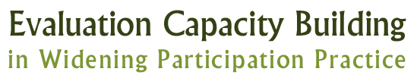
RUFDATA Planning Framework 3C
What are our Reasons and Purposes for evaluating ….
These could be planning, managing, learning, developing, accountability

What will be our Uses of our evaluation?
They might be providing and learning from embodiments of good practice, staff development, strategic planning, PR, provision of data for management control

What will be the Foci for our evaluation?
These include the range of activities, aspects, emphasis to be evaluated, they should connect to the priority areas for evaluation

What will be the range of Data and Evidence for our evaluation?
Numerical, qualitative, observational, case accounts

Who will be the Audience for our evaluation?

What will be the Timing for our evaluation?
When should evaluation take place, coincidence with decision making cycles, life cycle of projects

Who should be the Agency conducting the evaluation?
Yourselves, external evaluators, combination

RUFDATA Summary
Evaluation Name | Reasons and Purpose | Uses | Foci | Data | Audience | Timing | Agency

