Customising Web Pages

If you suffer from dyslexia, colour blindness or have low vision, you can alter your browser settings to suit your needs. You can change the colour of the text and background and enlarge or reduce the size of the font. You can also remove the "style" specified by the web designer.

(A) Changing Text Size

In Internet Explorer or Navigator, select View>Text Size

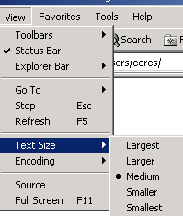

Change the text size as required. You may need to click the "refresh" button.

(B) Changing Text and Background Colours

1. In Internet Explorer, select Tools>Internet Options. A dialogue box will appear. Click on "Accessibility".
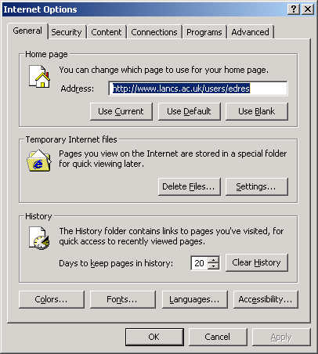

Colours
Accessibility

2. A second dialogue box will appear:

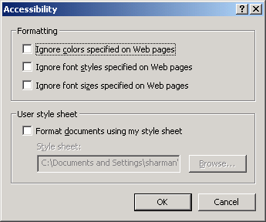

Click in the checkbox "Ignore colours specified on Web pages" and click on OK.

3. Click on "Colours" in the dialogue box that remains (see first diagram above).
A third box will appear (see over).

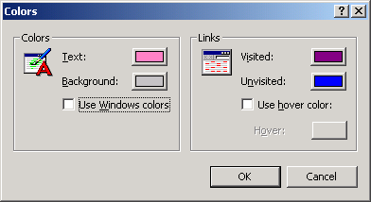

4. Uncheck "Use Windows colours".

5. Select new colours for the text and background by clicking on the colour chip and choosing new ones. Click on OK.

6. Check that your web page has changed. You may need to click on the "refresh" button.

Return your browser to its default settings by checking "Use Windows colours", click on OK. Click on "Accessibility" and uncheck " Ignore colours etc"

(C) Removing the Page Style

1. Select Tools>Internet Options and click on "Accessibility".

2. Check "Ignore colours", "Ignore fonts" and "Ignore font sizes".

3. Click on OK and see what effect this has on your web pages.

(D) Adding a Customised Style Sheet

You can replace the web page style with you own by following the steps above and by also selecting "Format documents using my style sheet". You will need to create your own style sheet file and store it on your computer hard drive. Please contact mailto:a.sharman@lancaster.ac.uk if you need assistance.

