Disability Studies Conference 2008 - Lancaster University, Great Britain

Project Presentation
The Painting of a Disabled Man – A Participatory Action Research Project

For more than 400 years the Painting of a Disabled Man has been part of the famous Chamber of Art and Curiosities at Ambras Castle near Innsbruck. It was the starting point of a major research project on the cultural representation of disability, financed by the Federal Ministry for Education, Science and Culture in Austria. The project was a cooperation of the Institute of Educational Sciences at the University of Innsbruck, the museum of Art-History in Vienna with its collection at Ambras Castle and the Center for Independent Living in Innsbruck.
In the course of the project two other historical paintings were found that are significant for the analysis of the cultural presentation of disability: a leaflet from 1620 showing Wolfgang Gschaidt, a carpenter with a disability, and a small picture from 1578, showing Elizabeth, a woman with a learning disability. The discussion and analysis of different gazes towards men and women with disabilities were at the center of attention.
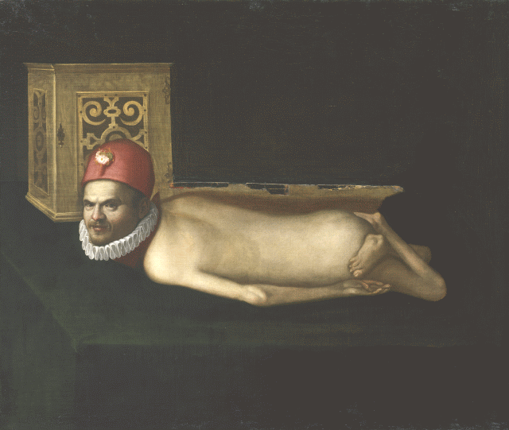

Painting of a man with a disability, 3rd quarter of the 16th century: Museum of Art History, Vienna - Collection at Ambras Castle, Innsbruck (GG 8344), 110 X 135 cm

Material available in English:
Documentary film: The Portrait of a Disabled Man - Gazes at the history of people with disabilities. A documentary film by Bernd Thomas and Volker Schönwiese (German with English subtitles). To be ordered at: info@abm-medien.de (abm - arbeitsgemeinschaft behinderung und medien e.V., Bonner Platz 1, D-80803 München, Germany) Cover-Text: A painting from the 16th century that has not yet been taken notice of is the starting point of an extraordinary project. Gazes at women and men with disabilities from the early modern times up until today – how can they be interpreted scientifically and artistically? How can women and men with disabilities contribute their knowledge to this today?

Report on the project and on the exhibition at Ambras Castle in the Internet:
Flieger, Petra; Schönwiese, Volker. The Painting of a Disabled Man – A Participatory Action Research Project. Paper presented at University of California, Berkeley, Feb. 27th, 2007. http://bidok.uibk.ac.at/download/handout_san_francisco.pdf

Books in German:
Mürner, Christian; Schönwiese, Volker (Hg.): Das Bildnis eines behinderten Mannes. Blicke, Ansichten, Analysen. Bildkultur der Behinderung vom 16. bis ins 21. Jahrhundert. Ausstellungskatalog und Wörterbuch. Neu-Ulm: AG SPAK Bücher, 2006.
Flieger, Petra; Schönwiese, Volker (Hg.): Das Bildnis eines behinderten Mannes. Bildkultur der Behinderung vom 16. Bis ins 21. Jahrhundert. Wissenschaftlicher Sammelband. Neu-Ulm: AG SPAK Bücher, 2007.
General information:
http://bidok.uibk.ac.at/bildnis.html

Petra Flieger, Free Lance Social Scientist, petra.flieger@utanet.at
Volker Schoenwiese, University of Innsbruck, volker.schoenwiese@uibk.ac.at

