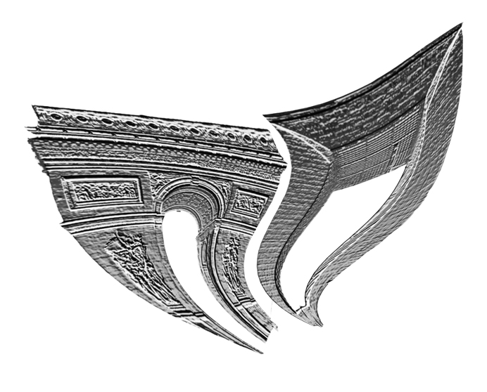 Registration Form
Nostalgia and Innovation in Twentieth-Century French Music

Lancaster Institute for the Contemporary Arts
Lancaster
8–9 May

Personal Details

Name: ____________________________ County/State: _____________________

Affiliation: ________________________ Postal/Zip Code: ___________________

Address: ___________________________ Country: _________________________

City: ______________________________ E-Mail: _________________________

Telephone: _________________________ RMA Membership: Yes; No; Join on day

Registration Options

Registration:
Lancaster Student/Staff; RMA Member/Join on day; Non-RMA Full; Non-RMA Fri; Non-RMA Sat
(Free) (Free) (£20.00) (£10.00) (£10.00)

Catering:
Full Catering; Friday Catering; Saturday Catering; No Catering
(£25) (£14.00) (£12.00)

Dietary Requirements:_________________________________________
Registration includes attendance at relevant paper sessions and the concert on Friday.
Catering includes lunch on relevant days, tea/coffee breaks, and the pre-concert wine reception on Friday.

Payment Options:

Method:
Cheque, Lancaster University (Sterling); Postal Order/Bankers Draft (Sterling); Credit Debit Card

Card Type (not Amex):______________ Name on Card: ____________________

Card Number: _____________________ Expiration Date (MM/YY): __________

Issue Number: _____ Security Number: __________________

Return to: Adam Greig; LICA: The Roundhouse; Lancaster University; Lancaster; LA1 4YW or submit electronically to a.greig2@lancaster.ac.uk

Completed forms, and payment, must be received by 31/03/09 or a £10.00 late fee will apply and catering cannot be guaranteed.

