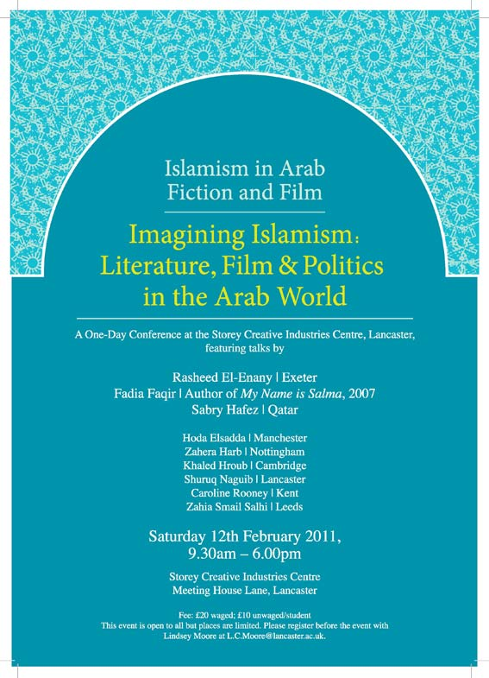

Imagining Islamism: Literature, Film & Politics in the Arab World

SYMPOSIUM SCHEDULE
Saturday 12th February 2011

9:15-9:45 Registration outside Lecture Theatre, Storey Creative Industries Centre
9:45-10:00 Welcome & Introduction: Dr Robert Appelbaum, Dr Lindsey Moore
10:00-11:00 Plenary, chaired by Dr Abir Hamdar
Professor Sabry Hafez (University of Qatar):
‘Islam in Arabic Literature: The Struggle for Symbolic Power’

11:00-11:20 Refreshment Break

11:20-12:30 Sub-Plenary: Islamism in Contemporary Arab Fiction & Film

-Professor Caroline Rooney (University of Kent): ‘Islamism, Capitalism and Mimetic Desire in the Terrorism Novel’
-Dr Khaled Hroub (University of Cambridge): ‘Islamism in the Arab World: Cultural and Literary Reflections’

12:30-1:30 Lunch
1:30-3:00 Sub-Plenary: Creativity & Politics in the Contemporary Arab World
-Dr Zahera Harb (University of Nottingham): ‘Al Manar and Hezbollah: Creativity, Ideology and Politics’
-Dr Shuruq Naguib (Lancaster University): ‘Literary Islamism and the Qur'an: The Project of Amin al-Khuli and Bint al-Shati'
-Dr. Abir Hamdar (Lancaster University): ‘The Poetics of Jihad in Selected Arabic-Islamic Fiction’

3:00-3:15 Coffee/tea break
3:15-4:15 Plenary, chaired by Dr Arthur Bradley

Professor Rasheed El-Enany (University of Exeter):
‘Representations of Islam in Arabic Fiction’

4:15-5:00 Plenary, chaired by Dr Lindsey Moore
Fadia Faqir (University of Durham) reads from her new novel At the Midnight Kitchen
5:00-6:00 Roundtable: Speakers and Project Team, chaired by Dr Arthur Bradley
6:00 End of Symposium

LOCATION AND DIRECTIONS

This symposium takes place in the Lecture Theatre in the Storey Creative Industries Centre on Meeting House Lane in Lancaster city centre. Please note: the Storey is not on Lancaster University campus, which is located some 3 miles away from the city centre! See the map at the end of this programme for directions.

If you are travelling by rail, there are direct rail links between Lancaster and London, Birmingham, Leeds, Manchester, Oxford and major cities in Scotland. The Storey is an easy 3 minute walk away from Lancaster Railway Station on Meeting House Lane, the main road into the city centre (see map below).

If you are travelling by car, leave the M6 motorway at junction 33 and take the A6 north towards Lancaster. Follow signs for the city centre and park. The Storey is located on Meeting House Lane, the main road linking the city centre to Lancaster Railway Station (see below).

FOOD AND DRINK
Tea, coffee and biscuits will be provided in the morning and afternoon. Lunch can be purchased either from the Storey Café or from one of the numerous pubs, cafes and restaurants in Lancaster city centre.

ACCOMMODATION
If you are planning to stay overnight, we would be grateful if you could book your own accommodation. In Lancaster city centre, you will find a variety of accommodation available to suit all budgets but we would particularly recommend the following, all of which are within easy walking distance of the symposium venue:
The Sun Hotel
63-65 Church Street
Lancaster, Lancashire LA1 1ET
Tel: 01524 66006
www.thesunhotelandbar.co.uk

Penny Street Bridge Hotel
Penny St
Lancaster, Lancashire LA1
Tel: 01524 599 900
www.pennystreetbridge.co.uk

Royal King’s Arms Hotel
Market Street
Lancaster, Lancashire LA1
Tel: 01524 32451
www.bestwestern.co.uk

Please see the following webpage for further information about accommodation in Lancaster:
http://www.hotels.uk.com/attractions-uk/Lancaster+University.htm

STOREY CREATIVE INDUSTRIES CENTRE
Meeting House Lane
Lancaster, LA1 1TH
Tel: 01524 509000
http://www.thestorey.co.uk

