Mick Short and Dawn Archer
Lancaster University

Designing a Worldwide Web-Based Stylistics Course and Investigating its Effectiveness

1. Introduction
At Lancaster University we are currently developing an introductory web-based course for students interested in the stylistic analysis of literary texts. The eventual aim is to run an experiment, in Lancaster and elsewhere, using two different versions of the same course (a lecture-seminar format and a web-based format, see sections 2 and 3 below), in order to compare student responses and learning outcomes to web-based and more traditional stylistics teaching.1 The course we are developing is a web-based equivalent of the lecture-seminar course that has been taught to first year students at Lancaster University for some years, but with some differences and additions. In this article we will focus mainly on the web-based version of the course and general character of the experiment. A description of the current lecture-seminar format and the philosophy behind it can be found in McIntyre (this volume). Those interested in the educational philosophy behind earlier versions of the course should consult Breen and Short (1988) and Short and Breen (1988).
The web-based course described here will be pilot-tested in Lancaster in January-March 2003. In 2004-5, the main experiment will be run in Lancaster and other Higher Education (HE) institutions in the UK and elsewhere. Colleagues in some other institutions worldwide have already “signed up” to take part in the experiment, but we are hoping that a few more stylistics teachers in other HE institutions will be interested in taking part in the experiment. This will involve providing the web-based and traditional lecture-seminar formats to parallel groups of students, and monitoring both groups using a common set of methods. After the experiment has been run, we hope to make the course available, free to all, on the web. But that depends on getting copyright clearance from authors and publishers for some of the texts we are using (this is proving to be a rather thorny and time-consuming issue). Anyone who is interested in taking part in the experiment in their own institutions is invited to contact us by email (m.short@lancaster.ac.uk).
2. The Traditional Lecture-Seminar Version of the Course
The present approach embodied in the lecture-seminar version of the course was originally conceived by Mick Short and Mike Breen (now Professor of Language Education at the University of Stirling). It was first run as a “long thin” course, with one lecture and one seminar per week for twenty-five weeks, running throughout the first year of study. Because of larger-scale changes to our first year English Language curriculum, for the last few years the course has been run as a “short fat” course (two lectures and one seminar per week), in one ten-week term. It has the following design features (which are discussed in more detail in McIntyre, this volume):
- The main aim of the course is to enable students to read literary texts sensitively, and, by the end of the course, be able to perform stylistic analysis on texts they are encountering for the first time (in this sense it follows on from, and shares some assumptions with, the less analytical “practical criticism” courses with which many will be familiar). All three literary genres (plus relevant comparisons with non-literary texts) are explored and a wide range of texts and textual extracts are used.
- We assume that students beginning the course will have little, if any, knowledge of the formal and pragmatic properties of the English language, and of stylistic analysis (though increasingly some, but by no means all of our students, will have done some elementary English language work at school or college in the two years before coming to university).
- Students should interact with literary (and non-literary) texts from day one and in each week of the course.
- Language description (e.g., grammar, phonetics) and analytical skills are not taught in “blocks” (which students on a previous version of the course found indigestible), but are “drip-fed”–i.e., introduced when they are needed to help describe a particular text or help explain a particular issue being discussed.
- Learning should be as “hands-on” and interactive as possible, with students doing tasks individually and in small groups in both lectures and seminars.
- Learning should be fun. Besides the acting out (by staff and students) of dramatic extracts etc., lectures have always involved “silly” moments (e.g., games, jokes, illustrative comic sketches) to illustrate and reinforce points being made.
- To hold learner interest, learning should be in digestible chunks, varied and appropriate, in terms of texts, analytical methods and pedagogical approach, both within and across sessions.
The checksheet approach developed in Short (Exploring the Language of Poems, Plays, and Prose) is used extensively (and will also be used in the web-based version of the course).
3. An Overview of the Web-Based Version of the Course
If the teaching experiment is to be able to compare like with like, we need to ensure that the course content and as many of the above design features as possible are present in the web-based version of the course. That said, the new format is bound to involve changes. To create the various effects we describe in this section, and section 4, we have used a combination of Macromedia © products (Flash, Dreamweaver) and Microsoft Agent. Below we list some of the salient features of this version of the course (which provides very similar, but not identical, content compared with the version just described):
- There is a heavy emphasis on students working with other students if possible, to help reproduce the “social” element of traditional teaching and to encourage them to learn from one another as well as from the computer and their reading. In the Lancaster version of the experiment, students will access the website in three computer laboratory workshop hours per week for ten weeks and will be able to “log on” outside these class hours. During the workshops they will work on the course and the various tasks within it in pairs (one pair of students per computer). The workshops will have a tutor present to give advice when students experience difficulties. We are currently considering the introduction of other forms of interaction in the workshops (see 4.4 below).
- Before we began work on the web-based course, we attended conferences in the UK related to electronic course design, and were surprised to find that the main academic use for computers seemed to involve the making of lecture notes and other written material available on the web, with a few photographs and links to other websites (see Mason for a useful overview of online course models). This kind of approach, although relatively easy for the academics concerned, was not going to be satisfactory for us if we were to provide an electronic equivalent of our traditional course, with its hands-on and “learning should be fun” philosophy. So we are trying, as much as we can, to utilize the advantages that modern computers have for illustrating points made. Hence we have (i) drawn (often humorous) cartoons and created moving pictures to help students understand concepts (e.g., deixis, the semantics of word classes and different basic sentential structures, and syntactic ambiguity), (ii) used color, as well as font size and style variation, to highlight particular factors (e.g., the differences between two different versions of the same text, or the foreground/background distinction basic to stylistics), (iii) used the “moving picture” possibilities of the computer to capture relevant factors (e.g. the foreground/background alternation, and the way in which, unlike other functional constituents, adverbials can easily be moved from one position in a clause to another), (iv) introduced sound-clips to illustrate pronunciations and provide on-line readings of poems, and (v) incorporated video-clips acted out by students of dramatic extracts discussed.
- Students are continually involved in doing tasks on texts and related matters, and then comparing their conclusions with ours, via a variety of “feedback” means (e.g., “guess and test” and “drag and drop” devices, or comparing an account of a text or text-part the students have produced and one we have). Besides encouraging active learning, with students trying things out for themselves, this kind of work introduces a form of interactivity because of the comparisons students make between the conclusions they come to and ours. Though it should be noted that this kind of work is essentially “pseudo-interactivity” compared with real class discussion, or the discussions between students described in (1) above, the to and fro of interaction with the computer does appear to feel more “live” than that involved in doing exercises in textbooks and then looking up answers. In this sense, working with a computer appears to come somewhere in between working alone on written interactive exercises and the real interactivity of traditional class discussion.
- Another way in which we are trying to introduce a “social” element to the web-based course is by using video-clips (at least one per topic) in which students can see us discuss, in “tutorial format” a computer-based activity they have just been involved in (for a discussion of the implications of the audio and video (AV) medium for distance and online learning, see O’Donoghue et al.).
- The Lancaster-run course will have an on-line “discussion room” where students (and staff) can ask questions and discuss issues, adding another “social” aspect. There are also opportunities for students to send us material, which can then be added to the website (e.g., their own invented words to add to the material on neologism).
- The web-based course is fairly extensive, and so it is important to provide (i) good navigation facilities and (ii) a sense of what we think is a sensible order for students to go through the course. We know that students are bound to choose alternative routes through the material, but we nonetheless feel that it will be helpful for them to know what ordering we feel is natural. The electronic version of the course is divided into thirteen topics, several of which have two “sessions.” This structure is laid out on a contents page, which can be reached via a button at the top and bottom of each page (the other permanent buttons on each page provide links to the welcome and introduction pages, a glossary, a course summary page, and the course homepage). The contents page color-codes the topics in terms of literary genre (e.g., the poetry section is color-coded blue, and the prose section is green), and indicates which order we think it makes sense to go through the various topics in the course. This color coding is then picked up in the styling of individual pages within the associated topics. In addition, each page of each “session” has a “click-on” menu at the left-hand side of the main screen, which (i) indicates the other “pages” in that session in an order we feel is natural, and (ii) links to a series of permanently useful areas: a topic-contents summary, the University College London Internet Grammar website (which is freely available to all UK students), and advice on reading for the particular topic involved. Besides aiding navigation and giving students a sense of our preferred ordering, the “menu” structure is like that used on other web-based courses being developed in our department, and so helps to make our own students feel that they are in a familiar environment.
- The “learning should be varied and fun” philosophy is achieved through a variety of means. The breaking up of the materials into a series of reasonably short web pages with interactive exercises on each page keeps our commitment to the idea that learning should be varied. It is difficult to do stylistic analysis without a fair amount of text, of course, but we do all that we can to break things up into small “bite-size” chunks, as attention spans in computer interaction are notoriously short (even shorter than the attention spans students appear to have in our lectures!). The audio and video-clips, cartoon presentations, variations in text color, size and shape and appropriate moving visual effects outlined in sections 2, and 4 above have also been designed with the “learning should be fun” philosophy in mind, as have the various forms of pseudo-interactivity described in section 3 above. Finally, it is intended that each page of the course will have a “smiley” button  leading to a joke or short fun activity designed to give students a brief mental rest before they move on to the next page of the site (we are using the Microsoft Agent Merlin Character and associated written character-to-speech software to “tell” some of the jokes). Where possible, jokes, quotations, and so on are chosen to be appropriate to the topic under discussion (although this is not always possible), and sometimes an analytical stylistic commentary is added to the jokes.
- Besides interactive links from one page to another within the website itself, there are also links to other sites (including sites about authors whose texts are being analyzed).
- We have developed a dedicated self-assessment mechanism so that students can practice stylistic analysis on extracts from three texts (one from each of the main literary genres) before undertaking their coursework assessment at the end of the course (which takes the form of a stylistic analysis of a chosen text). This self-assessment mechanism is based on extracts from the essays written by students on the 2000/2001 version of the course (see 4.5 below). 2
4. Illustrative Discussion of Some Examples of Language and Style Web Pages
Below we give illustrations of some of the mechanisms we use on the web pages to give more of an indication of the student experience on the course and describe how those pages work. We also describe in more detail the self-assessment mechanism referred to at the end of section 3 above. The examples are taken from the poetry section of the course but are representative of the course as a whole.
4.1 “Meeting” the Students
We believe that, for web-based courses to be maximally effective, there must be some simulation of the human “face-to-face” experience. We therefore begin the course with a “Welcome and Introduction” session, which includes a video clip of the two tutors discussing issues such as the course structure and what students can expect from the course. The tutors then appear from time to time throughout the course (either as a cartoon simulation or a video clip) in an attempt to build a similar rapport between tutor and student as one might expect in a traditional lecture/seminar-based course. A cartoon version of Mick Short also appears on the homepage of the web-based course (see below).

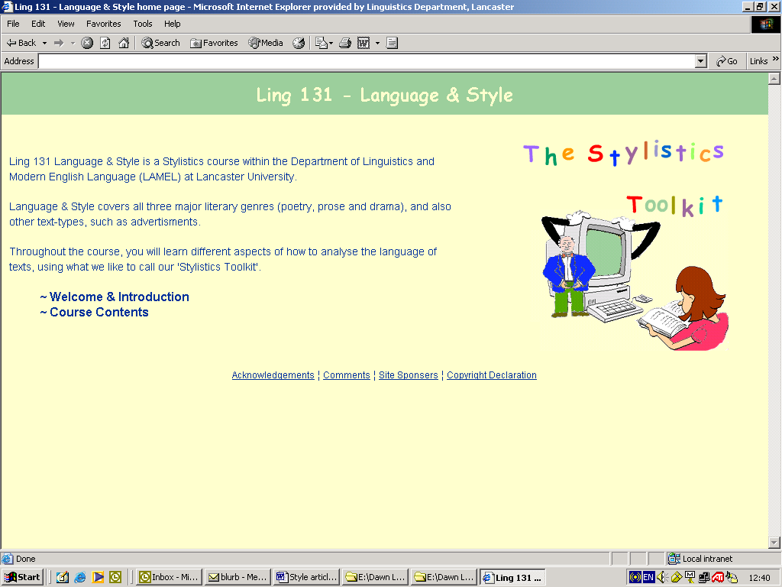
Figure 1. The Language and Style Homepage
4.2 Moving Illustrations
As a visit to our homepage highlights, the web-based interface allows for the possibility of “moving” illustrations to enhance particularly salient points. For example, when explaining the various language levels (e.g., phonology, lexis, grammar), students often fail to perceive that the word level is being used metaphorically. For example, they sometimes assume that the meaning level is more important than the other linguistic levels because it comes at the top of the standard linguistic-levels hierarchy. By providing a representation of linguistic levels that, at the touch of a button, can be transformed into a wheel, we are able to provide an alternative metaphor. The various language “levels” become “spokes of the wheel,” which are more easily seen as having equal importance (see figure 2 below), thus helping students to understand that the “levels” which linguists refer to are metaphorical, not literal.

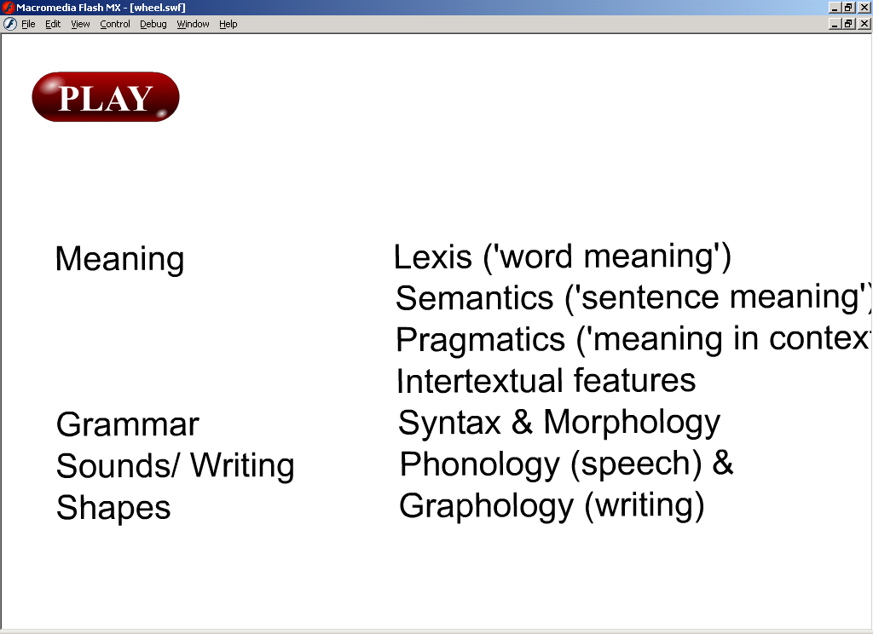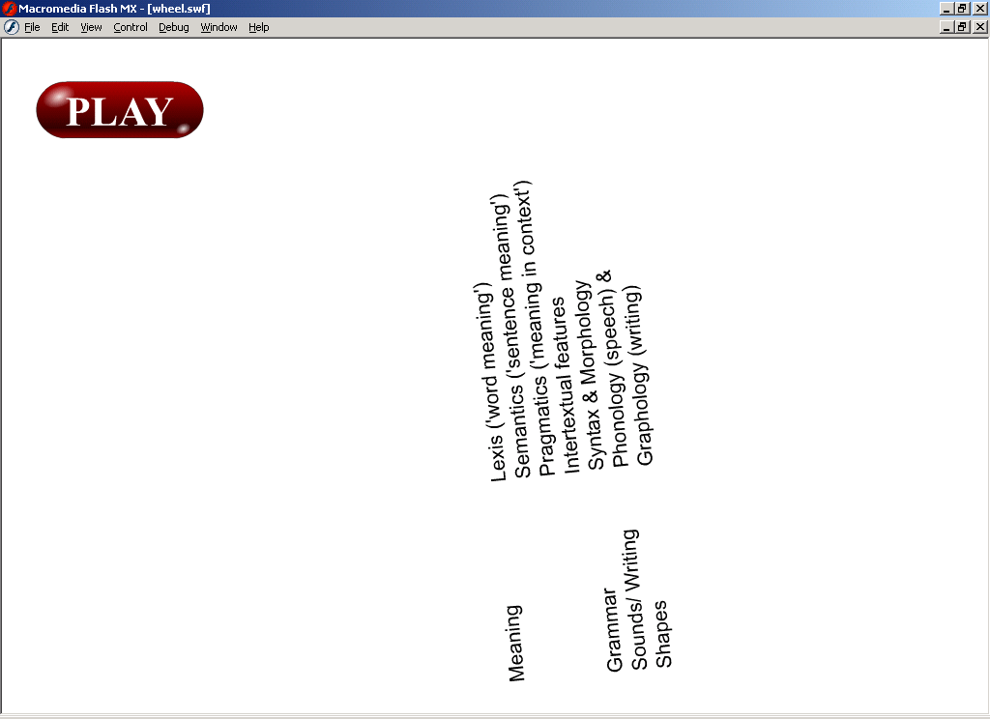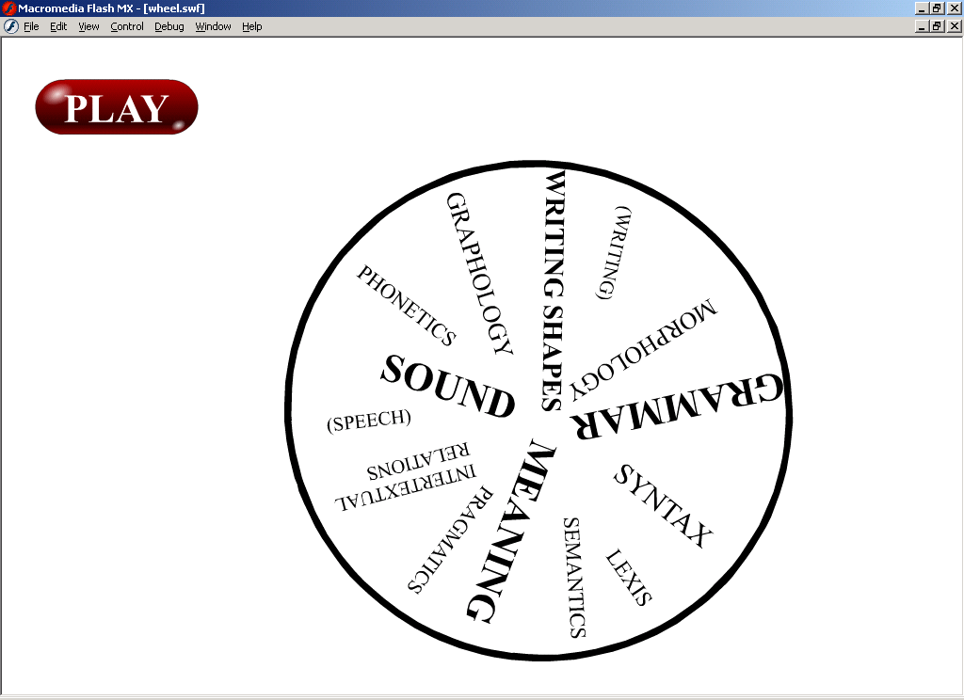
Figure 2. The Transformation of Language Levels: An Alternative Metaphor
Similarly, we illustrate the concept of foregrounding when it is first introduced by means of a simple moving illustration that uses two words, Foreground and background, in a repetitive sequence (see figure 3 below). In the paper-based version of Language and Style, we had not thought to introduce such a moving representation, and, given the technology, it would have been difficult to do well. However, we are thinking of making use of recent technological advances in future years, by having a moving illustration using PowerPoint (this is just one way in which the web-based version of the course is beginning to influence the teaching of the traditional lecture/seminar-based course):

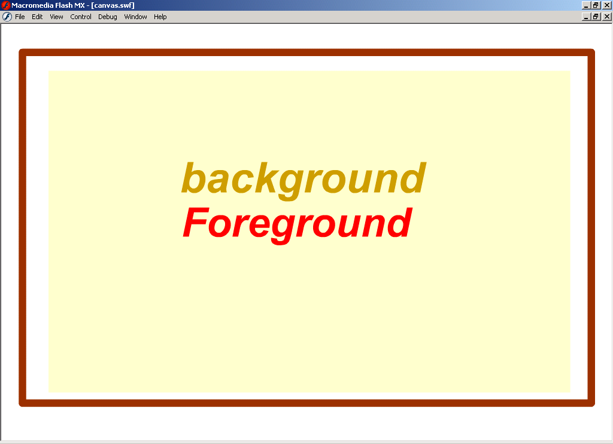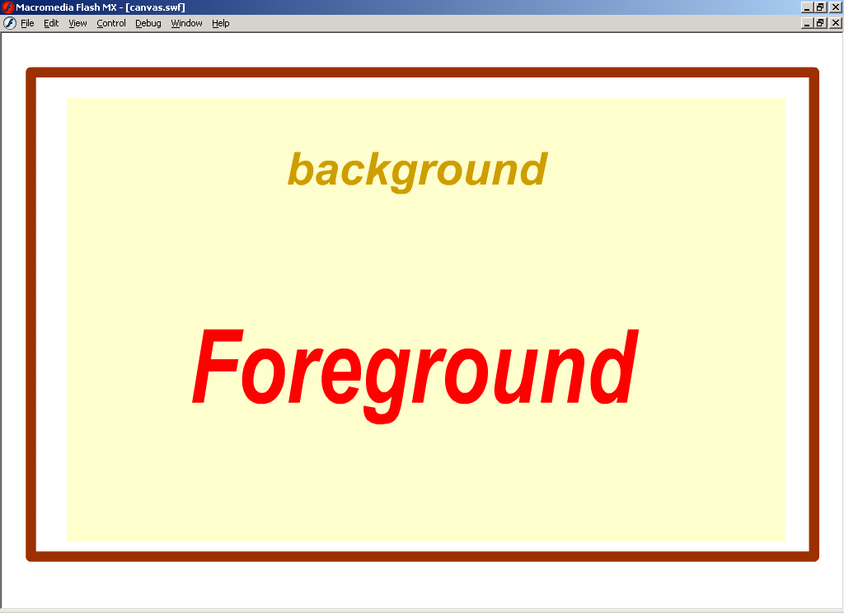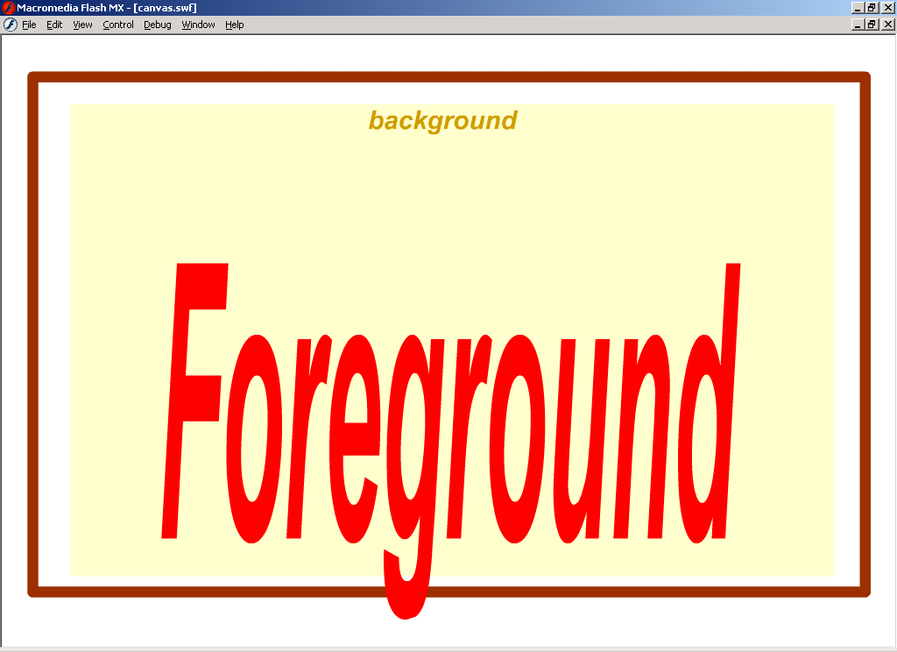
Figure 3. The Sequence of Slides Used to Represent the Concept of Foregrounding
We then go on from this visual representation to explain the different means of producing foregrounding (for a more detailed account of the general approach adopted, see McIntyre). As mentioned in 3.7 above, the various sections are broken up into “bite-size” chunks. Hence, we explore literary and non-literary examples of both deviation and parallelism on separate “pages.”
Another example of the use of visual illustrations can be seen on the “Deviation: Non-Literary Examples” page. We initially explain the concept of deviation by providing a visual representation of socially deviant behavior: a car driver who, on reaching a set of traffic lights at red, picks his nose while waiting for the traffic lights to change to green. We then introduce tasks that require students to explain the use of deviation in some advertising slogans and pop group names that we have previously examined for other stylistic purposes (to introduce language levels in the case of the former, and the manipulation of those levels in the case of the latter). This last point illustrates the way in which, as much as possible, we try to re-use texts and examples for different illustrative purposes. We find that students can take in new approaches and forms of analysis better if they are not also trying to understand a new example at the same time. In addition, we have made the advertisements active, so that students can click on them to access our analyses.
The “Deviation: Non-Literary Examples” page also contains a “fun” quiz and a “smiley,” both of which further illustrate the concept of deviation. For example, in the fun quiz, students are presented with three pictures of Mick Short and asked to vote for which seems most “Mick-like” (the point being that Mick is well-known in Lancaster University for wearing a bow-tie, and any other “look” may therefore seem out of character). The “smiley” contains a joke about a man who, on visiting a friend who is an abbot of a monastery, is confused by the behavior of the monks at mealtime. One occasionally breaks the silence by standing up and saying a number, an action that reduces the rest of the group to the giggles. When the man finally discovers why (they are so familiar with their repertoire of jokes that they now tell them by numbers), he asks if he might join in. When, on saying “twenty-four,” the desired response is not forthcoming, he is told that it must be “the way he tells them.” The joke depends, in part, on both discoursal and phonological deviation, of course, as our analysis goes on to explain:
First of all, the discoursal situation where people laugh at numbers referring to jokes, rather than the punch lines of the jokes themselves is very odd. Secondly, once the joke is reduced to a numerical reference it is very difficult to imagine how different pronunciations or styles of delivery of the number could possibly be relevant in the way that such performance features can be relevant to the dramatization of a real joke.
We also make use of illustrations to make palatable concepts that students tend to find difficult and/or unexciting initially. A good example of this is our creation of word class characters to “represent” the semantic aspects of word class. “Mr. Solid” represents nouns, for example, and “Mr. Shift” verbs. We then use the same characters to explain the concepts of adjectives and verbs, by showing how (i) describing words turn Mr. Solid into “Angry Mr. Solid” (see figure 4 below), and (ii) adverbs can be used to “tie Mr. Shift down” (see figure 5).

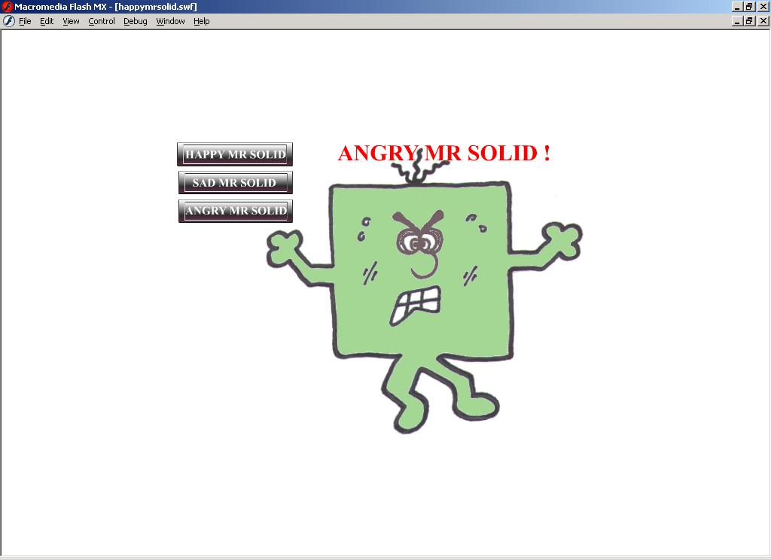
Figure 4. An Illustration of the Ways in Which Adjectives Affect Nouns

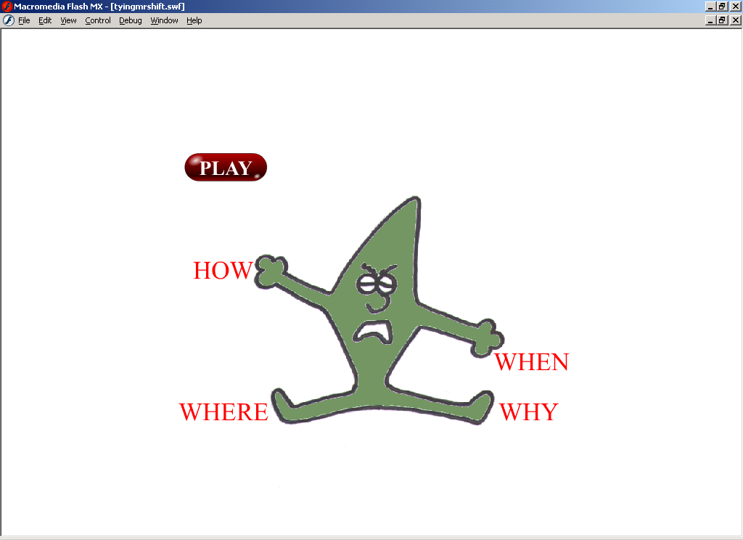
Figure 5. An Illustration of the Way in Which Adverbs “Tie Down” Verbs
Something like the above, which is relatively easy to produce using a web interface, can be difficult to mirror in the traditional lecture/seminar-based course. At present, we overlay OHP slides to try to represent the same concepts, but the process is rather cumbersome, less effective and less memorable. We are therefore considering possible ways of bringing some of the benefits afforded by multi-media products into our traditional lecture/seminar-based course (e.g., the embedding of video clips and moving displays with PowerPoint).
4.3 Illustrative and Interactive Aspects of the Web-Based Course
Some elements of the web-based course serve both an illustrative and an interactive purpose. For example, we compare an early draft and the final version of Wilfred Owen’s “Anthem for Doomed Youth.” Using color and font changes to indicate the changes Owen made to the early draft, we ask the students to explore the different meanings and effects created by those changes. The students are instructed to begin with the title, determine which aspects of language they think are being exploited in the changes from the earlier draft to the later one, and consider what stylistic effects these changes have upon both the text and them as readers. They then type their comments in the box provided before submitting their answer (by clicking the “done” button). At this point, a new window reveals our comments, allowing students to compare their answer with our impressions.
A similar “guess and test” mechanism is used for an examination of Edwin Morgan’s “Spacepoem 3: Off Course,” a poem that attempts to represent an astronaut drifting uncontrollably off-course (see Carter for a published discussion of this poem). In this instance, we have also tried to add to the graphological effect of the original printed page (where the poem is off-set on the page) by creating an "outer space" feel to the visual representation. The poem first appears in the distance at the top right-hand side of the screen and moves, apparently aimlessly, through space towards the viewer, while a voice-over reading of the poem can be heard over some atmospheric background music. The visual poem moves across the screen, increasing in size, until the audio representation comes to an end. The final resting place of the poem mirrors the graphological layout of the poem in Junior Voices: The Fourth Book (see Summerfield).
Those students who want to listen to the poem again can do so by clicking an audio link, or replaying the "movie" (created using Flash software). Alternatively, they can access a text version, again by clicking a link. Working in pairs, students then answer a series of questions about the poem. The questions are designed to encourage them to apply what they have learned so far on the course, and cover areas such as the type of phrases utilized, the poem’s internal structure, and the graphological features that may contribute to the poem’s overall interpretation.
Other interactive features include multiple choice and drag-and-drop devices. By way of illustration, in order to encourage students to think about style, meaning and choice in poems, we adapt a cloze-version presentation of “I Stood upon a High Place,” a six-line poem from R. S. Crane’s “The Black Rider and Other Lines,” based on a version devised by Faulstich (see van Peer). Students are asked to choose among three possible one-word alternatives in four places in the poem, indicating the choices they think Crane originally made. Working in pairs, they are then encouraged to work out (i) why they think those choices are preferable and (ii) what effects one choice (as opposed to another) has in relation to the rest of the poem, before submitting their answers and comparing them with our own (this approach is thus in the spirit of what Pope calls “textual intervention”).
An example of our use of drag-and-drop devices can be seen in our “Uncovering Your Intuitions about Phrases” page. Students are asked to rearrange four words–Mary, amorous, quickly, became–into appropriate sequential orderings in the boxes provided, and then click the “check answer” link. When they do so, a second box appears with what we regard as acceptable answers and a request that they choose which of these sentences they consider to be the most natural. They do so by dragging a tick and dropping it next to their choice. The movement of the tick makes visible a hidden frame containing an explanation as to why some sentences feel more natural than others and the linguistic convention for marking unnatural sentences.
We could continue to provide examples of the approach we are using in creating our web-based stylistics course, but limitations of space forbid. We invite those who are interested in seeing more to contact us.
4.4 The Form of the Web Course Workshops
When we first began working on the web-based course, we assumed that students would be left to their own devices as they worked. But as we have come to realize the importance of the social element in learning, we have begun to think about adding more social elements to the workshops we originally thought of mainly as a mechanism for making sure that students were working consistently on the course. One possibility is to experiment with so-called “virtual learning environments” (VLEs), with students sometimes working on workshop-style tasks cooperatively on-line, debating issues, and so on. At present we do not have enough experience of VLEs to use them well, but we do intend in the pilot version of the course to experiment with some whole-group workshop discussions so that we can ask students whether they prefer to work partly in this “whole group” way or to be left to work in pairs at each computer (see point 1 in section 3, above). We are also providing them with a discussion site that they can use to discuss and debate aspects of the course electronically. This work should help us to judge whether the addition of VLE work would be helpful or not. Whole-group discussions and VLE work would increase the “social” element (though in different ways). The pair work-only option, on the other hand, makes it easier for students to access the elements of the course in the order they prefer.
Another aspect of the VLE format that we may explore in the future is the use of electronic marking of coursework that has been submitted electronically. Although such a procedure will seem unnatural to most teachers, it has a number of administrative advantages. Students could submit work with a recorded submission time outside office hours. There would be no ambiguity over submission times, and penalties for later submission could be applied automatically. Marked work would have legible comments, and students could receive returned work as soon as it has been marked and without having to go pick it up. In addition, marks could be recorded automatically.

4.5 The Self-Assessment Mechanism
The idea of the self-assessment mechanism is for students to be able to practice stylistic analysis before doing their coursework assessment and examination at the end of the course, both of which will involve them in text-analytical work. They can increase their sense of what constitutes good analysis by comparing their own efforts with that of previous students in the course. In addition, they can read the commentary that we have written on these past students’ scripts and use it to assess their own work. We believe that such formative assessment enhances learning by providing learners with clear criteria with which to assess their own and others’ performance and thus check what learning has taken place (cf. Stone Wiske 241; Cowman and Grace 306).
The self-assessment mechanism has three modules, one at the end of each of the poetry, prose fiction, and drama sections of the course. In each module, students are invited to perform a stylistic analysis on a text (George Herbert’s “Easter Wings,” the opening of David Copperfield by Charles Dickens, and an extract from The Importance of Being Earnest by Oscar Wilde) in relation to some pre-set aspects of analysis which are important for an adequate analysis of the relevant text and to which they have to relate to their own general interpretative remarks (see “general impressions” below). The pre-set areas are:

Poetry
- general impressions
- graphological deviation
- syntactic parallelism
- vocabulary

Prose
- general impressions
- point of view
- speech presentation
- syntactic parallelism

Drama
- general impressions
- turn-taking and power relations
- politeness
- Grice’s co-operative principle
Students can type directly into the self-assessment mechanism or, preferably, produce the work elsewhere using a word processor and paste their efforts directly into the relevant parts of the mechanism. They are then able to estimate what mark they think their effort is worth and compare their answer with that of real students marked at that level or at other levels. The answers that they are provided with for comparison with their own efforts were selected from a set of anonymized essays produced for coursework assessment on the Language and Style course in the 2000-01 academic year. Fifty-three students made their essays available for the creation of the self-assessment mechanism, and the final material used on the website came from twenty-four essays (eight on each of the above texts) on which there had been good inter-rater agreement and for which there were a representative spread of marks for each text. The essays were marked independently by five people who had experience of teaching on the Lancaster course (including the two tutors who taught the course in 2000-01) and three other markers from other HE institutions in the UK. Below is an example of a student response in relation to the syntactic parallelism in “Easter Wings” pasted into the self-assessment mechanism and being compared with an answer marked in the 60-69% range. The student’s answer is in the upper box and the answer marked in the 60-69% range is in the lower box (see figure 6).
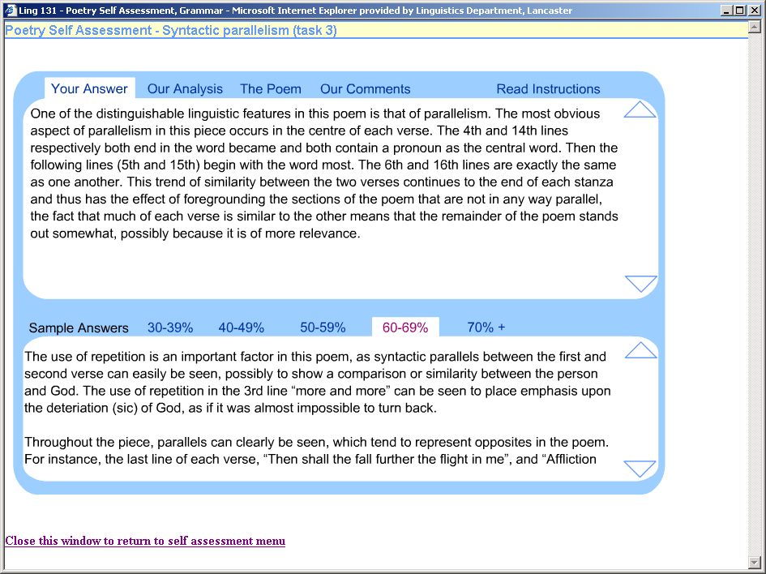
Figure 6. Student Response to Syntactic Parallelism Task on “Easter Wings” Compared with a Sample Answer
Students can compare their answers with answers marked at different levels by clicking on the relevant levels just above the lower window. By clicking on the horizontal “menu” just above the upper box, they can change the view in the upper box (and back again, if desired) to reveal marker comments (“Our Comments”) on the sample answer in the lower box or a model answer (“Our Analysis”) prepared by tutors on the course. If students click on “The Poem,” a separate window opens up containing the text that is being analyzed so that they can compare the text and the various analyses. If they click on “Read instructions,” a drop-down box with instructions appears over part of the text in the upper box. We hope that the students will find the self-assessment mechanism useful in developing essay writing and analytical skills and a better sense of the quality of their own work. We will be monitoring how they use the self-assessment mechanism and asking for their views on it when we do the pilot test on the web-based course in January-March 2003.
5. The Teaching Experiment
5.1 An Invitation to Join the Experiment
We will be pilot testing the web-based course, including the self-assessment mechanism in Lancaster in the academic year 2002/3. The main comparison of student reactions to the web-based and lecture-seminar modes experiment, in Lancaster and elsewhere, will take place in 2003-04. Although the Lancaster students will be first year undergraduate students taught in one term, there is no requirement that this should automatically be the case in other institutions. Similarly, although in Lancaster all students in any one year will do either the web-based or the lecture-seminar version of the course, this structure is not necessary. The course may be appropriate in terms of level to different kinds of students in different institutions, and different institutional contexts may require different timings, formats, and administrative arrangements. However, if readers are interested in joining the experiment, it will be important to discuss possible variations with us in order to make sure that the materials and arrangements put in place are appropriate to their needs as well as ours.
The monitoring of both student and staff reactions to the two different versions of the course will be conducted via questionnaires, recorded interviews, and recorded focus group sessions (conducted at the beginning, in the middle, and at the end of the course). It is intended that the questionnaires will be given immediate preliminary analysis so that information from them can feed into the interviews and focus group discussions.
Clearly, the comparison of students’ achievement levels and reactions to the two different versions of the course cannot be precise. Even though the course content has been kept as similar as possible between the two versions of the course, there are too many uncontrolled variables for the results to be more than indicative. But we hope that the quality of response from the investigative instruments (see 5.2 below) will be revealing, and that the correlation of results from different institutions will also reveal valuable insights.
5.2 Support for Collaborators

Teaching materials
Besides having access to the web-based version of the course (which is currently password protected), collaborators will also be given a master set of handouts to use in the lecture-seminar version of the course and videotapes of the lectures on the 2001-02 version of the course, so that they can have a flavor of the approach we use. Those who want to collaborate in the experiment will be allowed access to the website straight away, so that they can monitor development and give comments on the materials as we produce them and change them in the light of the 2002-03 pilot test. They will be able to run the web-based course in their institutions during the experiment (and hopefully thereafter, though we are still trying to clear copyright issues with respect to some of the texts we want to use on the site). Of course, we cannot guarantee that the site will remain exactly the same, as we are involved in an ongoing project. Similarly, we have no control over the quality of internet access in other institutions and so cannot guarantee that links to our site will always be maximally operable.

Investigative instruments
Collaborators will be given access to sample questionnaires and lists of questions and prompts to use in the tape-recorded data-collection sessions. These will be the investigative instruments used in Lancaster. We would hope that they can be used by our collaborators without too much change, but we understand that different contexts may require change, and we are happy to discuss what variations might be necessary. We will also have an on-line discussion group for collaborators to use as well as direct email contact with us.
In Lancaster, at least, we will also be videotaping students working together at computers during the workshops, so that we can gain a better understanding of how they interact with the web pages (e.g., which material they spend a long time on, and which material they skip over more quickly). We then intend to discuss any observations we make with the students during their interviews and focus group discussions.
6. Concluding Remarks
The course we are developing is for first year students straight from school. We feel that modern humanities students who have grown up with interactive computer games and a relatively intuition-based approach to the discussion of literary texts in school need an interactive and fun course to ease their entry into the more analytical approach that undergraduate stylistic analysis uses. We need to use a fun approach to help them over the initial hurdle of coping with what they may well feel is “analytical grind.” Experience on our lecture-seminar course suggests that an interactive, fun approach in stylistics teaching works well initially. When students have become more familiar with the approach, they can then take part more easily in more precise textual understanding and discussion and the more academic and abstract enjoyment which analysis engenders. It is this increased understanding and enjoyment that we are trying to replicate on our web-based course.
As computer-assisted learning grows in popularity, a number of papers advocating and decrying its use have appeared (cf. McEnery et al.; Katz; Oliver and Omar; Mason; Laurillard). Interestingly, a problem frequently identified by skeptics of the e-learning approach is that of quality. Mason, for example, suggests, "Many computer-based teaching programs whether stand alone, on an Intranet or the Web, fall into one of two categories: all glitz and no substance, or content which reflects a rote-learning, right/wrong approach to learning" (4). Laurillard concurs, arguing that universities seem to be pursuing the use of computers at all costs, rather than investigating the best way of teaching a particular topic. She also believes that hypertext has little to offer as an educational medium and that “the claims made for its potential in education should [therefore] be examined with care” (122). A lack of empirical evidence means that such views are difficult to disprove or substantiate. Indeed, as far as we are aware, there has been no direct comparison between a traditional university course and a computer-based version of it (but cf. Packard, who carried out an examination of a vocabulary package that used concordances).3 This is why we believe our comparative experiment will be of benefit. It is designed to produce empirical evidence in relation to the perceived advantages and disadvantages of web-based and more traditional delivery modes in the teaching of stylistic analysis. Moreover, we have made every effort to ensure that content is given the primary focus that it deserves, whilst including interactivity and feedback to facilitate learning, factors which, as Laurillard rightly points out, are crucial to the teaching experience.
Of course the experiment we are conducting is not one involving the kind of precision seen in the natural sciences. Such precision is difficult to achieve in social (including educational) contexts: there are bound to be many uncontrolled variables in comparing student reactions to different kinds of course delivery. No two versions of the “same” course can be exactly the same, nor are two student groups exactly equivalent, even in successive years in the same institution. And, even if teachers remain the same from year to year, they do not always teach with exactly the same enthusiasm or effects. This inconsistency is why we are interested in encouraging others to replicate our experiment in different institutions and with different sets of students. With all the variables involved, it is difficult to be able to generalize from two student year-groups in one institution. But if patterns of response experienced in different HE institutions and contexts push in the same direction, we will be able to attach rather more weight to the findings. And, in any case, there seems to be considerable merit in encouraging investigative research cooperation across institutions and countries.
For these reasons, we are very interested in hearing from anyone wishing to take part in the experiment. We are happy for potential collaborators to publish their own findings and also to share their findings with other collaborators, including ourselves. We have already talked through our plans, demonstrated our website and given others a chance to try out the materials so far developed (i) at UK Learning and Teaching Support Network sessions for Modern Languages and Linguistics, (ii) at the Poetics and Linguistics Association (PALA) conferences in London (August 2000), Budapest (April 2001) and Birmingham (April 2002), and elsewhere.

Notes
^{1.} Mick Short is using the prize money from his UK National Teaching Fellowship Scheme 2000 fellowship (sponsored by the UK's Institute for Learning and Teaching) to finance the development of the website. Dawn Archer has been working with him on this project since its inception, acting as Mick's first research assistant. Although now employed on a different departmental project, Dawn is still involved in the course. Mick's current research assistant is Stephanie Strong. She is responsible for the design of the web pages reproduced below.
^{2.} The self-assessment mechanism is a development based on a self-assessment approached used by our colleagues Charles Alderson and Graeme Hughes in the EU DIALANG project. DIALANG provides language learners with a set of free web-based self-assessment instruments for each of fourteen different European Languages (www.dialang.org). Our self-assessment mechanism has been produced in collaboration with Charles and Graeme, and with financial support from Lancaster University's Teaching Quality Enhancement fund. Dan McIntyre has acted as a research assistant producing the self assessment materials and Stephanie Strong has been responsible for the interactive electronic format for the self-assessment mechanism.
^{3.} Students familiar with the vocabulary package were asked whether they had found it “not very useful,” “not at all useful,” “quite useful,” or “very useful.” Interestingly, students tended to be split across all four of these categories, with about equal numbers in each. Packard therefore concluded that such a package would only appeal to a limited number and type of students and that concordance-based exercises should be viewed as an addition to other vocabulary learning techniques, not a replacement.

Works Cited
Breen, Michael, and Mick Short. “Alternative Approaches in Teaching Stylistics to Beginners.” Parlance 1.2 (1988): 29-48.
Carter, Ronald. “What is Stylistics and Why Can We Teach It in Different Ways?” Ed. Mick Short. Reading, Analysing, and Teaching Literature. London: Longman, 1988. 161-77.
Cowman, Krista, and Sue Grace. “Key Aspects of Teaching and Learning in Arts and Humanities.” Ed. Heather Fry, Steve Ketteridge, and Stephanie Marshall. A Handbook for Teaching and Learning in Higher Education. London: Kogan Page Ltd, 1999. 289-308.
Faulstich, Werner. “Die relevanz der cloze-procedure als methode wissenschaftlicher text-untersuchung.” Lili. Zeitschrift für Literature-wissenschaft und Linguistik 6 (1976): 81-95.
Katz, Yaacov “The Comparative Suitability of Three ICT Distance Learning Methodologies for College Level Instruction.” Educational Media International 37.1 (2000): 25-30.
Laurillard, Diana. Rethinking University Teaching. London: Routledge, 1993.
Mason, Robin. “Model of Online Courses.” Ed. Sheena Banks, Celia Graeber, and David McConnell. Networked Lifelong Learning: Innovative Approaches to Education and Training Through the Internet. Sheffield: University of Sheffield, 1998. 1-11.
<http://www.aln.org/alnweb/magazine/vol.2_issue2/Masonfinal.htm>.
McEnery, Anthony, Paul Baker, and Andrew Wilson. “A Brief Report on a Statistical Analysis of Corpus-Based versus Traditional Human-Teaching Methods of Part-of-Speech Analysis.” Computer Assisted Language Learning 8.2-3 (1995): 259-74.
McIntyre, Daniel. “Using Foregrounding Theory as a Teaching Methodology in a Stylistics Course.” Style 37 (2003).
O’Donoghue, Mike, Steve Childs, and Michael Barber. “AV Streaming Media: A New Distance Learning Tool?” 1st DIVERSE International Conference on Videoing and Videoconferencing, University of Derby, (2001): 1-17.
Oliver, Ron, and A. Omar. “Students' Responses to Collaborating and Learning in a Web-Based Environment.” Journal of Computer Assisted Learning 17.1 (2001): 24-47.
Packard, Vance. “Producing a Concordance-Based Self-Access Vocabulary Package: Some Problems and Solutions.” Ed. Lynne Flowerdew and Anthony Tong. Entering Text. Hong Kong: Hong Kong University of Science and Technology, 1994. 215-26.
van Peer, Willie. “How to Do Things with Texts: Towards a Pragmatic Foundation for the Teaching of Texts.” Ed. Mick Short. Reading, Analysing, and Teaching Literature. London: Longman, 1988. 267-97.
Pope, Rob. Textual Intervention: Critical and Creative Strategies for Literary Studies. London: Routledge, 1995.
Short, Mick, and Michael P. Breen. “Innovations in the Teaching of Literature: Putting Stylistics in Its Place.” Critical Quarterly 30.2 (1988): 1-8.
Short, Mick. Exploring the Language of Poems, Plays, and Prose. London: Longman, 1996.
⎯. “Stylistics ‘Upside Down’: Using Stylistic Analysis in the Teaching of Language and Literature.” Textus 6 (1993): 3-30. Reprinted in Ronald Carter and John McRae. Language, Literature and the Learner. London: Longman, 1996. 41-64.
Summerfield, Geoffrey. Junior Voices: An Anthology of Poetry and Pictures. Harmondsworth: Penguin Books Ltd, 1970.
Stone Wiske, Martha. “What Is Teaching for Understanding?” Ed. Jenny Leach and Bob Moon. Learners and Pedagogy. London: OUP/Paul Chapman Publishing Ltd, 1999. 230-46.

