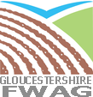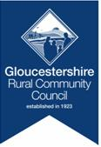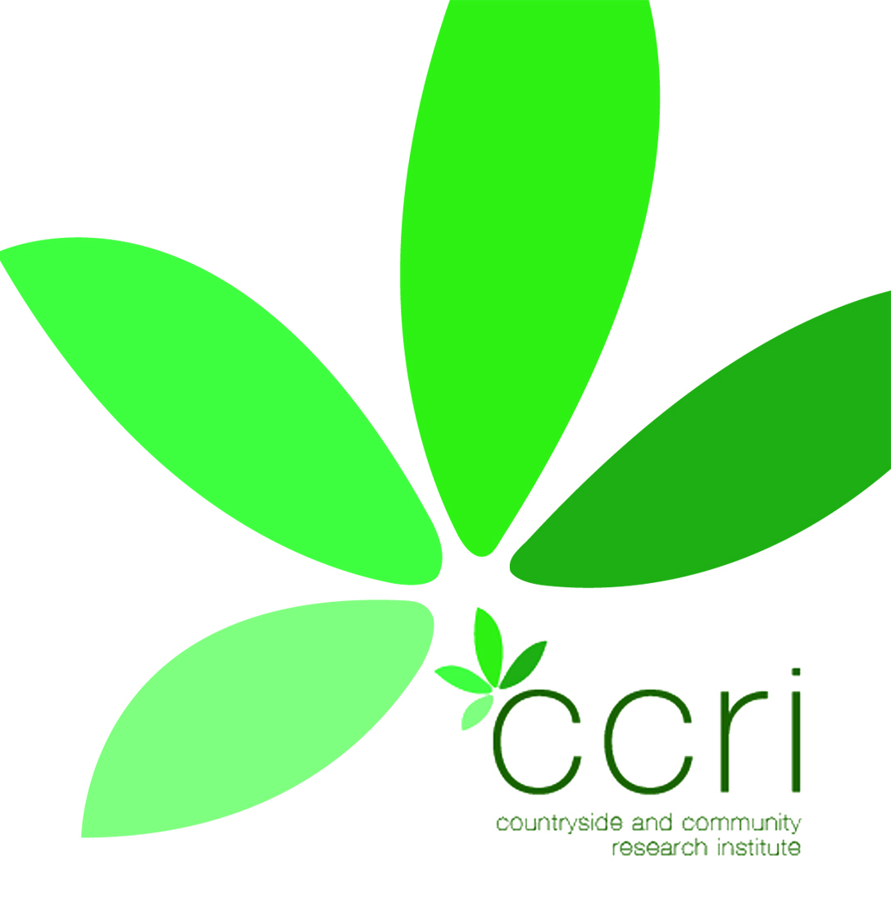

**REPORTING PROGRESS**

People’s enthusiasm maintained by being valued and respected in the protection of their local area; engaged in shared problem solving; feeding back successes to stakeholders and celebrating achievements

ILD Step 6

* FIELD Advisers could be accredited by Natural England (CCRI/FWAG) from any organization or independent, such as FWAG SW, Wildlife Trusts, Rivers Trusts etc but must be able to represent, support and value the role of the farming community. FIELD Advisers must value and respect, and sign post to, the role of all organisations and their areas of expertise to help facilitate multi objective delivery that benefits all stakeholders and achieves WFD and cross cutting environmental delivery on the ground.

~ WFD <http://www.environment-agency.gov.uk/research/planning/33106.aspx>

ILD Step 5

**Develop and monitor progress on an action plan**

* What partnership support is required for local expertise and resource to be enabled to deliver action ‘on the ground’?
* What can the community do themselves and how can the partnership help consent and fund action together so that social capital be released and supported?
* GRCC/ FIELD Advisers to facilitate all opportunities for partnership working and local delivery, and encourage alignment with current project monitoring processes used by the main project team (locally and nationally)

ILS Step 5 – Establish capacity and role of local management group; identify and prioritise tasks

ILD Step 6 – Implement proposals and embed management group and support

**External Engagement (by GRCC/ *FIELD Advisers)**

* Community contacted about rivers project, setting out aims for improved water quality, species recovery and the opportunity to improve their local water courses.
* Initial contact with parishes in targeted/priority water bodies where there are known ~Water Framework Directive (WFD) failures, and where communities have completed a parish plan and have actions relating to environment, flooding or land access.
* Communities asked to help facilitate links between FIELD Advisers and local landowners to help further develop community resilience plans
* Community provided with all information including maps about their water catchment area

ILD scoping flower identifies partner conttacts

**Internal engagement/consultation**

* Once information available has been checked and altered, communities to lead on local engagement and consultation to gather evidence of interest, need and involvement
* GRCC/ FIELD Advisers to inspire local community and facilitate action as required and create a framewprk for people to offer their contribution, not have it imposed upon them.
* Information exchange between agencies and  local communities – shared problem solving and prioritisation of actions
* Create management group and email circle for shared communication between communities, farmers and partners organisations.( Can build on existing local groups)
* Carry out open meetings, walks and talks to items actions and tasks

ILD Step 2

Farming and Integrated Environmental Local Delivery (FIELD) advisers (following IlD steps 1 – 6) visit local farmers and small holders in the parish to see how they can help strengthen farm business and offer support with regulation and information on all relevant opportunities and grants. FIELD Advisers sign post to all partners expertise and initiatives; learn about the land use, and the socio economic aspects of land ownership, and start to join the landscape of the parish/water body together like a jigsaw, actively seeking and valuing farmer’s land management knowledge within the water catchment area.. FIELD advisers seek NFU representative in each water body in each parish.

ILD Step 1

* ILD Step 1 – Once invited begin initial scoping to determine area, individuals and statutory frameworks involved

ILD Step 3 – Develop a management group around key local and statutory stakeholders

ILD Step 4 – Encourage linkages and opportunities for local contribution and adoption of responsibilities

ILD Step 2 – Map the management tasks and verify these in an all inclusive and open format

**Information review**

* FIELD advisers to provide information and data available to communities for verifying, confirming and correcting. (Targeting is based on WFD failure data and in relation to natural assets found within the parish and by targeted GIS over layering all agency and NGO strategic objectives that could be delivered within the parish, including species data.)
* Farmers and local land owners requested to assist in the checking and adding to data
* FIELD advisers provide locally relevant contacts from all relevant agencies/ NGOs community and cross check with existing contacts known to community and ratify contact list.

**Using local information to inform**

* Adding local knowledge to the existing information held and provided, enhancing overall understanding of the area
* FIELD Advisers/GRCC to support this process

**Cotswold Catchment: Pilot projects – community engagement methodology**

ILD Step 3 and 4