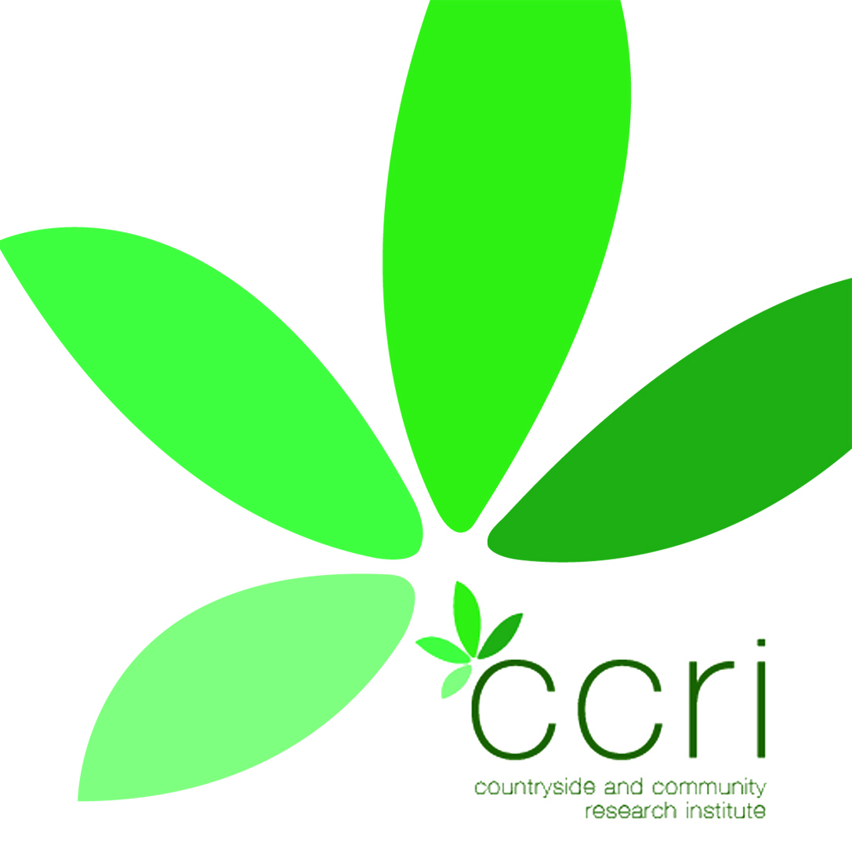

Cotswold Catchment Pilot NFU proposal
Call for WFD Farmer River Representatives
The Cotswold Catchment Pilot has been set up with DEFRA funding to further test the Integrated Local Delivery (ILD) framework that has been developed in Gloucestershire by FWAG (with ILD partners CCRI and NE) which values farmers and communities in the role of environmental delivery with an all inclusive partnership of organisations working together in support. The full CCRI report ‘Inspiring and Enabling Local Communities – A delivery model for Localism and the Environment’ can be found at the following link: http://www.ccri.ac.uk/Projects/HeritageandLandscape/Images/IntegratedLocalDelivery.pdf
The Cotswold Catchment Pilot aims to use the ILD delivery framework to deliver Good Ecological Status (GES) in surface and ground waters in line with the EU Water Framework Directive. Many of the GES failures in the Cotswolds Pilot area particularly in ground water are thought to be due to Diffuse Water Pollution from Agriculture (DWPA).

Proposal:
The Upper Thames catchment is comprised of 55 parishes and 4 market towns, and the pilot would like to invite the NFU to assist in the appointment of a Farmer River Representative for each water body in each parish (or group of parishes). The pilot is working with the Gloucestershire Rural Community Council that has links into every parish for community led planning. Each parish already has a resilience plan to show what to do if it floods, but not why it floods and quantity of water in water bodies is very integral to achieving GES. Flooding and drought are key issues for the farming industry and local resilience is something that needs to be further developed. The aim is to piece the landscape together working individually farm by farm (while maintaining individual confidentiality as required) to look at opportunities for landscape scale solutions and infrastructure.

The Farmer River Representative would represent farmers in each individual water body, in each parish. Actions would be developed specifically in relation to GES failures in that water body. To complement this, all organisation would come together to signpost and promote all opportunities to support Cross Compliance and uptake of Catchment Sensitive Farming grants, Axis 1 opportunities
( FISS,REG S4P,R4F) and Environmental Stewardship, FATI and ETIP. The farmer river representatives would feed back to the NFU County representative who would then facilitate opportunities at a county level, such as LNPs and LEPs, and possible future Axis 4 funding from RDPE to compliment and facilitate local action and the join up of Axis 1, 2 and 3 in delivery in conjunction with the Catchment Pilot Partners.

The aim is that the pilot should build on the success of Campaign for the Farmed Environment and the Voluntary Initiative, to demonstrate that by integrating local land management knowledge with that of the specialists from partner organisations that there is greater opportunity for problem solving and to demonstrate that delivery is more effective through valuing and supporting farmers rather than through increased regulation and enforcement.

Background to the Defra pilots can be found at www.environment-agency.gov.uk/catchments.
For further information contact Jenny Phelps on Jenny.phelps@gloucestershirefwag.org.uk 07876687272 or Chris Short CCRI cshort@glos.ac.uk

