Live Document – last updated by CNelson 16/5/12

Water Body Summary Sheet

Water Body Summary Information (Data based on SERBMP Dec 2009)

WATERBODY ID | WB NAME | CATCHMENT | WB TYPE | HMWB
GB107042011400 | Hatchet Stream | New Forest | River | Yes
WB COORDINATOR/TEAM |  | AIG LEAD |  | DESK STUDY AUTHOR
TBC – Elliot Tinton – Area Environmental Planning Team Leader |  | Catherine Patel / Cathryn Nelson |  | Grant Miller

Designations
Bathing Water | Drinking Water | Shellfish Water | Freshwater Fish | Nitrates Directive | Urban Waste Water | Wildlife and Birds | Habitats and Species
No | No | Yes | No | No | No | Yes | Yes

Overall Ecological Status/Potential | Confidence WB is less than good | Elements Driving Classification | Other Failing Elements  (element status) | Elements Passing
Moderate | Uncertain | Phosphate  (Moderate)  Mitigation Measures Assessment | None | Ammonia (Phys-Chem)  Dissolved Oxygen  pH  Temperature  Copper  Zinc  Ammonia (Annex 8)

Relevant Monitoring Points
Diatoms | Macrophytes | Fish | Invertebrates | Physico-Chemical | Chemistry
Not Monitored | Not Monitored | Not Monitored | Not Monitored | G0004151  Hatchet Stream at St Leonards | G0004151  Hatchet Stream at St Leonards

Photographs of catchment
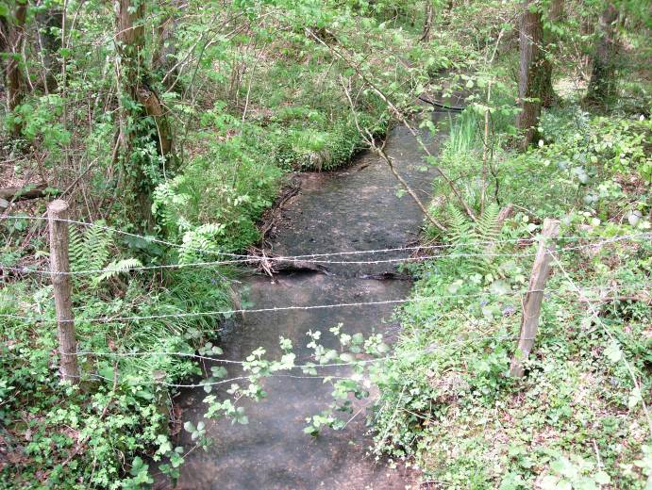
Photograph of Cripple Gate Lane invertebrate sampling site on the Hatchet stream. © Analysis and Reporting Team, Environment Agency. Date unknown.

Situation
BACKGROUND = The Hatchet Stream runs for approximately 8.9km through a rural area, upon Headon Beds and Osborne Beds. Hatchet Pond (Lake water body ID: GB30745652) is at the top of this water body. It is the presence of Hatchet Pond that means this water body is designated as Heavily Modified. The reasons for this designation are Flood Protection and Water Regulation – Impoundment Release.

STATUS = Current Ecological Potential is moderate. The objective is for good ecological potential to be achieved by 2027. Having undertaken this desktop investigation, it is not thought likely that this water body will achieve good potential by 2015.

PRESSURES = New Zealand Pigmy Weed (Crassula helmsii) is present around Hatchet pond so, therefore, Hatchet stream is probably at risk from Alien species. The IRBM database states that this water body is at risk from combined source nutrients and probably at risk from diffuses sources, such as agriculture. This water body also is physically and morphologically altered.

FAILING ELEMENT OVERVIEW = The following is a summary of the current situation for each failing element. This was last updated on 11th June 2010.

Phosphate – Phosphate has been classed as moderate for this water body and predicted to remain so in 2015. Phosphate has been of moderate status since 2007 and the annual mean of phosphate has been rising since 2007. The most likely source for this phosphate is from East Boldre Sewage Treatment Works. Hatchet Pond is not considered to be a major source of Phosphate, as it achieves high phosphate status under WFD. There is some agricultural and horticultural practice within the catchment, but this is of low intensity and it is not believed that they are major sources of phosphate. Looking at the phosphate trends over a year, the phosphate levels at the physico-chemical site do appear to be correlated with the peaks and troughs of Phosphate discharge from the sewage works. Currently there are no phosphate limits on East Boldre’s consent discharge. As site specific regulatory action is potentially expensive, further evidence is needed to identify and confirm that East Boldre STW is causing the Hatchet Stream to fail WFD Phosphate standards. Actions tied into SE0200 will investigate phosphate levels above and below East Boldre STW.

Mitigation Measures – There are currently no mitigation measures in place and suggested measures need to be scoped for feasibility:- Action SE0233 - 1 will address this.

Designations – There are three protected areas within this water body - Solent and Southampton SPA, Solent Maritime SAC & The New Forest SAC . These protected areas are not meeting the requirements of Natura 2000. Measures have been identified to address the issues for the these protected areas and are detailed within the appendices and, also, are mentioned in annex D of the South East River Basin Management Plan. There are three designated sites (New Forest SPA, Ramsar and Solent & Southampton Water Ramsar) that haven’t been included within Annex D. Action NA3 will review these sites for inclusion into Annex D and thereby give further actions to improve/protect these areas.

Alien Species – This water body has been identified as at risk from Alien Species, due to the presence of such species around Hatchet Pond. Actions to deal with these species associated with the pond will be covered in the Hatcher Pond Summary Sheet GB30745652. A walk-over survey of the Hatchet Stream would determine if there are aquatic alien plant species present within the Hatchet Stream (Action SE0201-1).

WATER RESOURCES =
WR WFD Stage 1 is a desktop study to confirm the flow compliance result is correct and ascertain whether the ecological monitoring sites are suitable for assessing abstraction impacts. The ecological status of suitable monitoring sites are noted. Those where flow non-compliance is confirmed and the ecological assessment indicates there is a potential hydroecological problem, progress to WR WFD Stage 2. WR WFD Stage 2 assesses the reasons for the failure and the water resource abstraction pressure upon the failing ecology.

Water Resource WFD Stage 1
The flow compliance result in this water body has been assessed as compliant indicating that it supports ‘Good’ status. The ecology is assessed as failing but there is no clear evidence that this is due to flow.

This water body will not pass to WR WFD investigations Stage2 (Identify cause of failure)

KEY PARTNERS – Potentially Southern Water, if enough evidence is collected to confirm that East Boldre Sewage Treatment Works is having an ecological impact. Natural England are also a key partner, in regard to measures addressing issues with Natura 2000 sites - Solent and Southampton SPA, Solent Maritime SAC and The New Forest SAC; Natural England will also be a partner in determining if the New Forest SPA, Ramsar and Solent Ramsar Sites should be included within Annex D.

Water Body Action Team (to include external stakeholders where appropriate)

Action ID | Action Description | Resource Estimate (FTE or £) | Target Date | Progress | Name | Team / Organisation
RBMP Actions
SE0233 | Identify priorities for second round of 'Regional Better Rivers Programme’. Outcome: Second planning cycle schemes improve habitat and ecology in waters agreed from a pool of 53 candidates totalling 545 km, building on monitoring and lessons from the first round. |  | 2015 | This Project is not as far reaching as initially identified. Mitigation measures will cover this |  | New Forest EA Virtual Group
Sub Actions
SE0233 - 1 | Scoping what mitigation measures need to be implemented to deliver Good Ecological Potential and identifying leads/functions/projects/partners to implement. |  | 31 Dec 2011 | This Project is not as far reaching as initially identified. Mitigation measures will cover this |  | New Forest EA Virtual Group
WB Add on RBMP Action
SE0200 | Carry out additional riverine sampling into the origins, causes of and solutions to pollution where we need to improve certainty. Outcome: Improve our understanding of problems, in order to take effective action to address them. |  |  | See below | See below | See below
SE0201 | Contain and control invasive non-native species at priority sites through partnership working. Agree sites and action with the South East England Non-Native Invasive Species Action Group. Outcome: Spread of problem invasive species stopped and reversed, protecting important nationally and internationally designated habitats under threat from this pressure. |  |  | See below | See below | See below
Sub Actions
SE0200-1 | Determine WFD-I programme to investigate phosphate from East Boldre STW. Decide what parameters to measure and where |  | 2011 |  | Grant Miller | A&R, EA
SE0200-2 | Carry out the above WFD-I and associated sampling |  | 2011/12 |  | Angie Vigor | S&C, EA
SE0200-3 | Analyse samples from investigation |  | 2011/12 |  | TBA | A&R, EA
SE0200-4 | Analyse and interpret data from above investigation |  | 2011/12 |  | Grant Miller | A&R EA
SE0201-1 | Conduct walk-over survey of the Hatchet Stream – are there any Alien Plant Species present? |  | 2012 |  | G. Miller & E. McSwan | A&R, EA
New Actions
NA1 | Classify this water body for invertebrates using 132364 Cripple Gate Lane as historic data is suitable for WFD classification. |  |  |  | National | EA
NA2 | Water resources WFD investigation (Stage 1) |  | 31/12/2010 | Done | Jim Whatley | A&R  EA
NA3 | Work with Natural England to populate Annex C Remedy Spreadsheet for the New Forest SAC & SPA |  | 2012 |  | T. Sykes | FRB, EA &  Natural England
Sub Actions
NA1-1 | Inform National of invertebrate data suitable for classification |  | 2011 |  | Adam Fulton | A&R, EA
Redundant RBMP Actions (Of those listed above)
Action ID | Action Description | Reason no longer relevant
Mitigation Measures (MM)
MM ID | MM Description | Resource Estimate (FTE or £) | Target Date | Progress | Name | Team / Organisation
47 | Appropriate techniques to align and attenuate flow to limit detrimental effects of these features (drainage) |  |  | Not in place |  | EA
44 | Provide flows to move sediment downstream. |  |  | Not in place |  | EA
37 | Retain marginal aquatic and riparian habitats (channel alteration) |  |  | Not in place |  | EA
29 | Maintain sediment management regime to avoid degradation of the natural habitat characteristics of the downstream river. |  |  | Not in place |  | EA
20 | Operational and structural changes to locks, sluices, weirs, beach control, etc |  |  | Not in place |  | EA
16 | Structures or other mechanisms in place and managed to enable fish to access waters upstream and downstream of the impounding works. |  |  | Not in place |  | EA
6 | Increase in-channel morphological diversity |  |  | Not in place |  | EA
Map of Catchment –
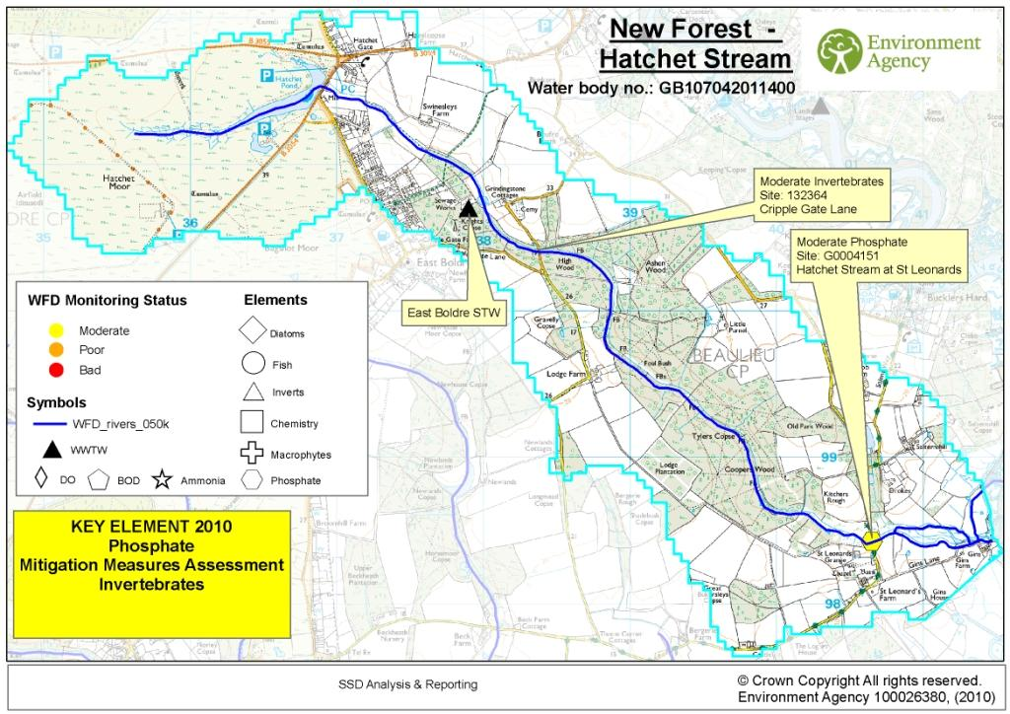
Glossary
A&R | Analysis and reporting team
ASPT | Average Score Per Taxa
BIOSYS | Our main database for storing, manipulating and reporting data from freshwater and marine biological surveys at any taxonomic level
BMWP | Biological Monitoring Working Party
CEO | Combined emergency overflow
CSF | Catchment sensitive farming
CSM | Customer Self Monitoring (of STPs/WIMS sampling points)
CSO | Combined sewer overflow
D/S | Downstream
DO | Dissolved oxygen
EM | Environment management team
EP | Environmental planning team
FCS2 | Fisheries Classification Scheme version 2
FRB | Fisheries recreation and biodiversity team
HEVI | HydroEcological Validation tool
LIFE | Lotic Invertebrate index for Flow Evaluation
NFPD | National Fish … Database
NTAXA | Number of taxa
P | Phosphate
RIVPACS | River InVertebrate Prediction and Classification System
RIVPACS | predicts the macro-invertebrate fauna at any site on a river from a small number of environmental parameters derived from maps or measured at the site.
SERBMP | South East River Basin Management Plan
SS | Suspended solids
STP | Sewage treatment plant
STW | Sewage Treatment works
U/S | Upstream
WB | Waterbody
WQIP | Water Quality Improvement Plan
WWTW | Waste water treatment works

