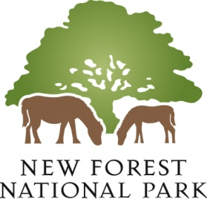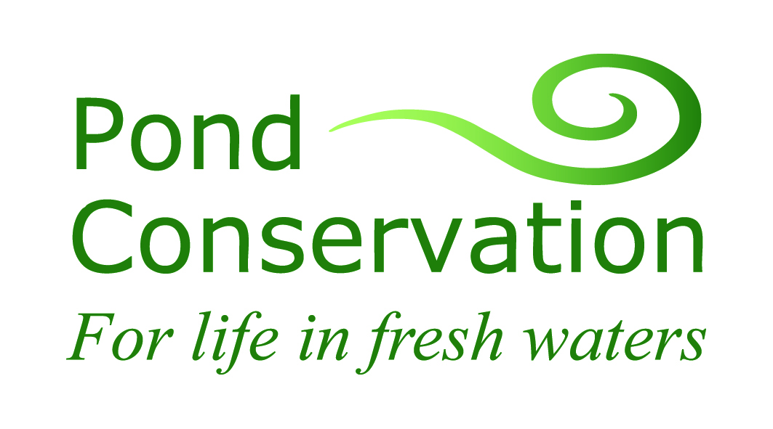

New Forest Catchment Pilot

Project Plan

Version 1.0
04 July 2012

Version History
Version | Author | Date | Reason for Change | Superceded Documents
0.2 | Jim Whatley/Naomi Ewald | 18/06/12 | Re-structured | 0.1 Naomi Ewald
1.0 | Jim Whatley | 04/07/12 | Final version | 0.2

Production and Contacts
This document has been produced by Jim Whatley. All questions relating to it are to be addressed to:
Jim Whatley
New Forest Catchment Pilot Co-ordinator
New Forest National Park Authority
Tel: 01590 646675
E-Mail jim.whatley@newforestnp.gov.uk

Project Approval
Document Approved by: Ian Barker (NFNPA)/Naomi Ewald (Pond Conservation)
Signature  (Copy No 1) |  | Date:  04/07/12

Project Closure
Closure confirmed by: <<name>>
<<position>>
Signature  (Copy No 1) |  | Date:  <<date>>

Distribution
Copy No. | Holder | Media
1 | Ian Barker | Electronic
2 | Naomi Ewald | Electronic
3 | Maxine Elliot | Electronic
4
5

1 Introduction 4
1.1 Purpose of Document 4
1.2 Background 4
1.2.1 Why the project was initiated 4
1.2.2 Previous stakeholder work 4
1.2.3 Environment Agency – Programme of Investigations 5
1.3 Catchment Description 5
1.3.1 Geography 5
1.3.2 Issues 6
2 Project Definition 6
2.1 Aims 6
2.2 Objectives 7
2.3 Success Criteria 7
3 Organisation 7
3.1 Steering Group 7
3.1.1 Terms of Reference 8
3.1.2 Membership 8
3.2 Resources 8
3.3 Catchment Development Group 8
3.3.1 Terms of Reference 8
4 Planning 9
4.1 Project Milestones 9
4.2 Detailed Project Plan 9
4.3 Consultation Plan 9
4.4 Communications Plan 10
4.4.1 Web 10
4.4.2 Newsletter 11
4.4.3 Media 11
5 Products 11

Appendix 1
Project Gantt Charts

Introduction

Purpose of Document
The purpose of this document is set out why the New Forest Catchment pilot was initiated, what it is trying to achieve, how it seeks to do this, who is involved and what will be delivered.

Background

Why the project was initiated
In 2011 Defra announced that it would be exploring new ways of collaborative working to achieve the objectives of the Water Framework Directive (WFD). They have appointed the Environment Agency and other host organisations to test approaches to improved engagement, information sharing and co-ordination of action at a catchment level to assess how we can improve the health of the water environment. This information will underpin the development of stakeholder-developed catchment plans, to assist in the restoration of WFD waterbodies to Good Ecological Status.

… by bringing together partner organisations, statutory agencies, landowners and local communities, we can achieve much more for the water environment than we can working separately ...

The New Forest National Park Authority, with technical support from Pond Conservation, has been selected as a pilot catchment host under the Defra / Environment Agency ‘Extending the catchment-based approach’ programme. This programme is testing approaches to improved engagement, information sharing and coordination of action at a catchment level to assess how WFD Delivery can be improved at a local level. Work in the pilot catchments will inform the roll-out of river basin planning that will underpin the second cycle of River Basin Management Plans.

Previous stakeholder work
This project will build on the WFD stakeholder liaison work undertaken in the New Forest catchment by the Environment Agency prior to the publishing of the South East River Basin Management Plan in December 2009.
Day-long workshops were held in March 2008 and February 2009 to understand stakeholder and interested parties’ needs, aspirations and priorities together with initial views on what local actions could be taken. These workshops were attended by representatives of many of the Forest’s organizations.
This project builds on that work and will move to concentrate on developing collaborative actions with local stakeholders at the smaller sub-catchment level to encourage ownership.

Environment Agency – Programme of Investigations
The Environment Agency are currently engaged in investigating the majority of waterbodies which are failing to meet ‘Good Status’ to feed into the next South East River Basin Management Plan. This involves confirming that a waterbody is failing where there is uncertainty, investigating the cause of failure and what action to take. This work is due to be completed by December 2012 and the technical information which results is feeding into this project.

Catchment Description

Geography
The New Forest catchment (Figure 1) covers over 300km² and largely overlaps with the New Forest National Park. The boundary is that shown within the South East River Basin Management Plan 2009.
The catchment includes a number of urban centres on the park’s periphery and extends into the transitional and coastal waters of The Solent. It contains 30 WFD river water bodies within a dozen or so sub-catchments which drain south and east into Southampton Water and the Solent. Some are substantial rivers, such as the Beaulieu and Lymington Rivers which have been divided into two or more waterbodies. Many however are unconnected small streams which are less than 10km in length. There are also 2 WFD lakes in the catchment and many hundreds of smaller pond water bodies which are not covered by the Water Framework Directive at all. The catchment does not include those streams flowing west into the River Avon or east into the River Test (ie. River Blackwater at Whiteparish)
Figure 1 New Forest WFD Catchment

Issues
These freshwater habitats are known to be amongst the richest and most near natural freshwater habitats in the UK, a fact widely recognised by the high level of national and international protection given to the landscape. Despite this, using the definitions of the Water Framework Directive, only 40% are currently considered to be at ‘Good’ status (on the scale of Bad, Poor, Moderate, Good and High).

Investigation work is already underway by the Environment Agency to determine the cause of the failures, but initial findings suggest that the major issues may be:

- Nutrient enrichment caused by effluent from sewage treatment works, inadequate septic systems and runoff from urban and rural sources.
- Alien species including Himalayan Balsam, Giant Hogweed, American Skunk Cabbage, Canadian Pondweed, Rhododendron and New Zealand Pigmyweed.
- Physical modifications such as channel alteration, culverts, flood protection measures, obstruction to fish passes around impoundment works, etc.
- Water quantity at times of low flows, leading to depleted oxygen levels.

The New Forest Catchment also includes a number of WFD transitional and coastal water bodies (TraCs). Both the Beaulieu and Lymington Rivers support internationally important estuaries for biodiversity and along with a number of transitional lagoons and the shoreline of the Solent, they are afforded the highest level of protection. Less data was available at the time of WFD assessment for these TraCs but expert judgment suggests that the majority are at Moderate status. Reasons for these failures are likely to include:

- Physical modifications relating to coastal defence works and flood management, an issue which has been fully investigated through the development of the North Solent Shoreline Management Plan.
- Dissolved inorganic nitrogen illustrating the clear link between the WFD river waterbodies and the WFD TraCs.
- Marine pollution including toxic substances such as TBT.

In addition to these surface waters the New Forest catchment encompasses 2 WFD groundwater bodies which are currently both considered to have Good WFD status for both water quantity and water quality.

Project Definition

Aims
The aims of the project are to:
- Develop a stakeholder-led shared catchment plan of action for the WFD New Forest catchment’s inland and coastal waters
- Increase the extent and effectiveness of practical work subsequently undertaken under WFD to bring waterbodies to at least ‘Good Status’, than would have been possible with a ‘top down’ approach
- Pilot local approaches to engaging and collaborating with people and organisations to improve the water environment that can be evaluated by Defra and used to inform best practice nationally.

Objectives
The emphasis of this project is to begin to develop a stakeholder-led plan of action for the WFD New Forest catchment focusing at the sub-catchment level. It is hoped that this will engender better local ownership and commitment. The objectives are to:

- Develop a shared understanding with stakeholders of the current issues and problems
- Identify what projects and initiatives are already in place or planned that will contribute to improving waterbodies to ‘Good Status’
- Agree priorities with stakeholders that require action
- Develop co-ordinated cost effective activities that will deliver multiple benefits
- Develop a plan of agreed practical collaborative actions
- Endeavour to obtain a commitment to act from relevant stakeholders
- Identify and plan which actions could be better undertaken on a catchment or wider basis
- Produce a report detailing a plan of action for the sub-catchments addressed together with actions that can be taken on a catchment-wide basis
- Test a stakeholder liaison approach that is relevant to the New Forest Catchment for sharing information and developing a shared catchment plan that can inform national best practice

It is clear that it will not be possible to develop plans for all the New Forest sub-catchments during the life of this project. It is intended to provide a model for stakeholder liaison and action which can be used to develop further sub-catchment plans at a later stage.

Success Criteria
The project will be considered successful if it:
- Increases participation to improve the water environment
- Reaches a shared understanding of the catchment’s priorities
- Results in commitment to action from partners
- Participants feel the pilot made a difference to what can be achieved
- Delivers a range of environmental benefits for the community
- Provides value for money
- Identities components that can be replicated elsewhere

Organisation

Steering Group
This purpose of this group is to deliver the Defra project only and will cease on the completion of that project. The Environment Agency will continue the catchment co-ordination after the completion of the project.

Terms of Reference
- Ensure the project’s objectives are delivered within budget and the stated timescales.
- Ensure that existing information and current remedial activity is shared with key stakeholders
- Establish the format and structure of the initial catchment vision
- Ensure that a stakeholder led initial vision for the New Forest catchment is established by the Catchment Development Group
- Report progress to Defra/Environment Agency

Membership
For the duration of the project the Steering Group will comprise:
Ian Barker - New Forest National Park Authority
Jeremy Biggs - Pond Conservation
Naomi Ewald - Pond Conservation
Maxine Elliott - Environment Agency

Resources
The New Forest National Park Authority will lead the project’s planning, engagement and stakeholder development work. Pond Conservation will lead on analysis and presentation of technical water management issues, supported by the Environment Agency.
Project Co-ordinator - Jim Whatley (New Forest National Park Authority)
Technical/General - Ian Barker (New Forest National Park Authority)
Technical - Naomi Ewald (Pond Conservation)
EA Co-ordinator - Maxine Elliott (Environment Agency) -
Facilitation - James Martin-Jones (Dialogue by Design)

Catchment Development Group
The purpose of this group is to agree an initial plan of action to protect and improve the WFD New Forest catchment water environment. It will form the core of a dynamic Catchment Stakeholder Group that will build and extend that work to all sub-catchments after the completion of the project.

Terms of Reference
- Review currently available information and remedial activity in relation to the catchment
- Share their hopes and concerns for the catchment
- Establish priorities and influence how resources are used and targeted within the catchment
- Develop and agree a stakeholder led shared initial plan of action for the catchment
- Identify other interested parties who can assist in developing and achieving the catchment plan of action
- Identify collaborative actions that can be contribute to the plan of action
Membership
The New Forest catchment differs from many other catchments in that it comprises a number of discrete relatively small rivers, streams and lakes rather a major river with connected tributaries. This means that, although many of the problems and issues are shared across the catchment, many pertain to sub-catchments. A number of potential practical solutions are therefore likely to be very localised and have little impact on other parts of the catchment involving stakeholders who only have an interest in that local area.

The main Catchment Development Group will therefore comprise a number of key individuals and organisations with a stake in the water environment who can develop an initial plan of action. When the present project is completed, this group will form the core of a larger Catchment Stakeholder Group which will take ownership of and further develop the catchment plan of action with the Environment Agency.

Two to three sub-catchments will be chosen for more detailed attention each of which will have a working group of directly involved stakeholders and interested parties. Each group will attempt to agree collaborative practical remedial actions to improve its sub-catchment’s waterbodies.

Planning

Project Milestones
The main milestones for the project are:
27 July 2012 - Catchment Development Group workshop completed
21 September 2012 - Sub-catchment workshops/walkovers/one to ones completed
16 November 2012 - Draft initial catchment action plan completed
14 December 2012 - Final initial catchment action plan complete

Detailed Project Plan
See separate Gantts at Appendix 1.

Consultation Plan
The main consultation for this project will be through the Catchment Development Group who will develop the plan of action for the catchment with the assistance of several sub-catchment working groups.

To facilitate this we will be collating information and making it available in an appropriate format so that stakeholders can see what data tells us about the quality of the water environment, where there are currently gaps in our knowledge of particular water bodies and what solutions are cost effective in terms of time and money to achieve improvements.

All information will be made available as a technical report and short non-technical plain English summaries to engage as wide an audience as possible. We will:

- Begin by reviewing technical information including existing WFD plans, water body status, main impacts and currently planned programmes of measures. This will help stakeholder identify the main issues in the catchment and agree priorities.

- Provide a review of potential measures (including cost-benefit tradeoffs) which could achieve Good WFD status. This will help stakeholders decide what may or may not work under different scenarios and identify locations where work could be implemented to achieve multiple benefits for the water environment.

- Use worked-through examples in workshops (or other forums) where we provide participants with appropriate levels of technical information to debate and make catchment decisions themselves. We expect that this will also provide a degree of training for participants, building capacity locally to manage catchments.

- Undertake catchment walkovers with key stakeholders to identify where measures can be implemented that are most likely to achieve improvements in the catchment.

- One to one meetings with relevant stakeholders and interested parties

- Summarise the outcomes of stakeholder meetings and catchment walkovers to provide an overview of the development of the shared plan of action, to ensure that it is built through stakeholder engagement rather than the traditional top-down approach.

- Production of plan of action report including vision, issues, priorities, targets, estimates of outline costs of solutions and cost/effectiveness, and commitment of implementers where possible, will be made available for consultation at the end of the year.

Members of the public will be able to contribute through online web-pages on both the New Forest National Park Authority and Pond Conservation Trust websites.

Communications Plan
This project is principally directed towards relevant stakeholders and other interested parties but will cover information and opportunities to contribute for the general public.

Web
There be no dedicated website but rather web pages within the New Forest National Park Authority(NFNPA) and Pond Conservation Trust websites.
NFNPA
The web page on this site will be focused mainly towards general members of the public who are interested in the project. It will have a limited detail and no technical information.
There will an opportunity to contribute via a dedicated email address and some examples of types of contribution will be given.
A link will be given to the Pond Conservation trust website pages for those requiring more technical detail.

Pond Conservation
The web page on this site will be of a fuller nature regarding details of the project and contain more technical information.
There will be a link to the NFNPA website.

Newsletter
A single sheet news letter will be produced after the July Catchment Development Group meeting which outline the project and introduce the catchments on which we will be focusing during the project. It will be distributed to the consultative panel in the WFD New Forest catchment and be made prominent in those sub-catchments on which we are focusing. It will provide details of who to contact for those who wish to contribute or be involved.
A further newsletter will be distributed on the completion of the draft plan of action and invite comments.

Media
A media release will be made to coincide with the initial newsletter and on completion of the project.

Products
The following products will be delivered by the project:
- Series of non-technical papers
- Project webpages
- Sub-catchment workshops
- One to one meetings
- Sub-catchment walkovers
- Initial catchment plan of action (will initially not include all sub-catchments)

The Water Framework Directive : ec.europa.eu/environment/water/water-framework/index_en.html

