**River Basin Management Plan   
Catchment Plan for the Upper Thames**



Introduction 3

Executive Summary 5

1. Characterisation of the catchment 6

1.1. Introduction to the catchment 6

1.2. Freshwater protected areas 7

1.3. Important additional features and pressures 8

1.4. Overview of water bodies and WFD characterisation 9

1.4.1. Overview of current status – surface waterbodies 9

1.4.2. Overview of current status – ground waterbodies 10

1.4.3. Overview of current status –summary 11

1.4.4. Review of information quality and new data requirements 11

1.4.5. Uncertainty and further investigation 14

2. Addressing the Problems of the Upper Thames catchment 15

2.1. Overall catchment priorities 15

2.2. Significant issues 16

2.2.1. Invasive non-native species 16

2.2.2. Urban and transport pressures 17

2.2.3. Phosphorus in rivers and streams 18

2.2.4. Physical modification 21

2.3. Investigations 23

2.4. Field actions 25

3. Catchment programme management 37

3.1. Predictions for the Upper Thames catchment 37

APPENDIX 1: Schematic of the catchment 39

APPENDIX 2: Bibliography of current research (to be completed) 39

APPENDIX 3: Overall estimated costs (to be completed) 39

APPENDIX 4: Abbreviations and glossary 39

Table 1 Factors determining waterbody classifications 12

Table 2 RBMP actions relevant specifically to the Upper Thames catchment 15

Table 3 Actions to address development and transport pressures 18

Table 4 Actions to address the significant issue of phosphorus in the Upper Thames catchment 20

Table 5 Actions to address the significant issue of physical modification in the Upper Thames catchment 22

Table 6 Programme of investigations in the Upper Thames catchment – surface water bodies 23

Table 7 Programme of investigations in the Upper Thames catchment – ground water bodies 25

Table 8 Field actions in the Upper Thames catchment 26

Table 9 Predictions for Good Ecological Status for the Upper Thames catchment 37

Figure 1 Flowchart showing process to achieve Good Ecological Status 4

Figure 2 The Upper Thames catchment 7

Figure 3 Land use in the Upper Thames catchment 9

Figure 4 Overall status of surface water bodies in the RBMP 10

Figure 5 Overall status of groundwater bodies in the RBMP 11

# Introduction

This plan sets out how the measures in the Thames Region River Basin Management Plan (RBMP) can be turned into actions to achieve good ecological status in the Upper Thames catchment at the earliest feasible time. It builds on the RBMP published in December 2009 for meeting the requirements of the EU Water Framework Directive.

River Basin Management Plans are strategic documents that set out what will occur in the river basins. They set out in general terms how the water environment will be managed and provide a framework for more detailed decisions to be made. River basin management is based on cycles of planning and action, and will be reviewed every six years.

River basin planning requires integration across four planning scales:

* National (England and Wales),
* River Basin District (e.g. Thames River Basin)
* Catchment (e.g. Upper Thames catchment) and
* Local (i.e. waterbodies or groups of waterbodies).

The Environment Agency (EA) will work with individuals and organisations at all of these levels to ensure that information and decisions taken at one level inform planning at another.

This plan is based at Catchment level and summarises the programme of work to achieve good ecological status in the catchment. This includes investigations and individual actions at waterbody level.

The flowchart in shows the process for achievement of Good Ecological status for the waterbodies within the catchment.

This plan contains information about the assessment of the current status of the waterbodies within the Windrush catchment, and the initial identification of issues that are either;

* Contributing to the current failure of a waterbody to achieve good ecological status
* May prevent a waterbody attaining good ecological status, or
* May arise as an issue during the life of this plan (i.e. potential issues that need addressing to prevent deterioration in the waterbodies over the life of his plan).

The plan goes on to include details of local actions already in place that will address these issues and, where there are currently no actions, investigations to confirm the reasons for failure and determine what actions are appropriate to address them.

Using these investigations, actions and local knowledge a prediction for each waterbody of when good ecological status will be reached is included in . This effectively provides a target against which progress can be monitored as investigations and actions are implemented.

The extent of the catchment plan at present is indicated by the blue shading over the flowchart in below.

The key to successful completion of the programme will be the availability of funding. The EA will manage the programme of investigations and actions, although individual actions may fall to other parties within the local area. We will monitor, co-ordinate and report on RBMP delivery within this catchment and across the South East Region.



Figure 1 Flowchart showing process to achieve Good Ecological Status

Once the initial Upper Thames Catchment Plan is completed, the need to create a steering group for this catchment will be evaluated in the light of management arrangements for the delivery of the RBMP in the rest of South East Region.

Log of updates

|  |  |  |
| --- | --- | --- |
| Author | Date | Major alterations |
| Ross Agutter | 02/02/2012 | Field Actions updated with aspirational actions (in bold) identified during 28/10/2011 WFD meeting |

# Executive Summary

To be completed

# Characterisation of the catchment

# Introduction to the catchment

The Upper Thames catchment includes stretches of the River Thames extending from it’s source to the South East of Cirencester at Kemble to Lechlade in the Cotswolds. The largest tributaries are the Coln, the Ray (Wilts), the Churn and the Cole.

The north of the catchment is within the Cotswold local authority area, whilst the area to the south of the catchment is within Wiltshire, Swindon and the far south west borders are within South Oxfordshire District area.

The catchment is predominantly rural in character. The northern part of the catchment falls within the Cotswolds Area of Outstanding Natural Beauty and the southern catchments fall partly within part of the North Wessex Downs Area of Outstanding Natural Beauty.

The principal towns are Swindon and Cirencester, however there are many smaller market towns located throughout the catchment.

The area contains a wide variety of habitats and landscapes and provides high quality game and coarse angling in both rivers and still waters. The limestone streams to the north of the area, including the Rivers Coln, Churn and the Ampney Brook, contain predominantly wild brown trout and grayling populations. Many of the watercourses are stocked by their owners and angling associations, to supplement wild stock levels. The River Thames and its tributaries to the south are predominantly coarse fisheries, as are the still waters that form the Cotswold Water Park.

The central area of the catchment, extending from Purton in the west to Lechlade in the east is characterised by Oxford clay. The northern area in the Cotswold hills is characterised by Oolitic limestone which is a store of groundwater. A line of Kimmeridge clay stretches from the south east to the north east of Swindon and out into the Vale of the White Horse hills.

The River Coln originates on the Upper Lias but is mainly spring fed as it crosses the Oolitic Limestone on its way to meet the Thames to the west of Lechlade.

The River Churn is a spring fed river, with its source originating on the inferior Oolite Limestone. Its middle and lower reaches are influenced by the Cirencester urban area as it passes through the town. A number of mills and weirs have affected the channel. The Churn eventually joins the Thames at Cricklade.

The River Cole is a highly modified clay river which has been subject to considerable flood defence and land drainage engineering in the past, a condition exacerbated by the impact of rapid and at times poor quality run-off from the substantial urban area of Swindon at its headwaters. The majority of land management in the catchment is intensive although there are a number of semi-improved pastures and wetland habitats, the latter on the fringes of Swindon. Perhaps as a result of its flashy nature, the Cole does show some geomorphic features such as berms, earth cliffs and slumps, but in the upstream reaches tends to be shaded by bank-side and bank-top vegetation precluding much in the way of aquatic and marginal plants. A number of smaller streams of variable ecological quality flow into the Cole, the most interesting of which is the downstream section of the Tuckmill Brook which has a diversity of channel features meandering through marshy floodplain between river terrace features.

The River Ray is a heavily modified clay river that rises at the large conurbation of Swindon. Unlike the Cole, the River Ray receives effluent from a large sewage treatment works (STW) which serves to sustain flows. Until recent improvements the STW effluent was a significant factor in limiting the ecological value of the watercourse. All the main river tributary streams of the Ray are small watercourses flowing in part or wholly through urban areas and in the most part heavily shaded by bankside vegetation. The Ray, downstream of Swindon, flows through a mainly pastoral floodplain landscape with improved hay meadow grasslands. There is moderate diversity of channel and marginal vegetation in the lower Ray, and the river does display a number of geomorphic features despite the highly modified nature, and *Ranunculus* (restricted to flow-dependent habitat) occurs on a number of reaches.

It is likely that the greatest pressure on the water environment now and in the future will be from growth and housing development. The large quantities of houses proposed around Swindon (4,500 homes in the south, 10,000 to the north and 12,000 homes in the east) and the expected increase in population have the potential to increase the pressure on the water environment during and post construction phase.

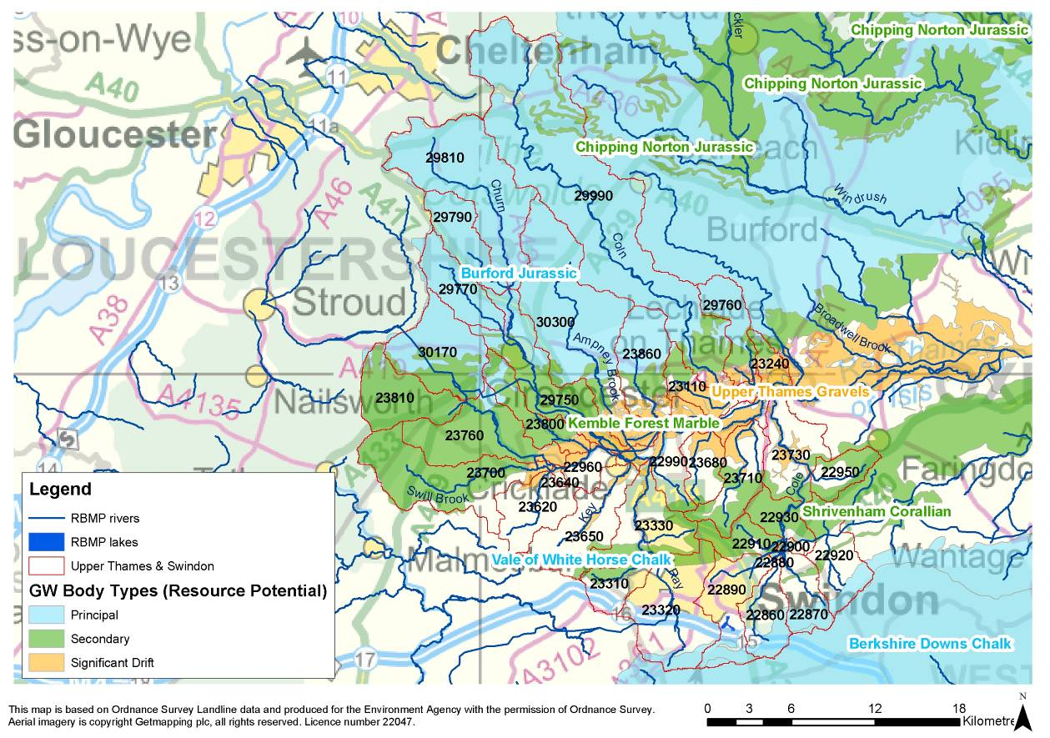

Figure 2 The Upper Thames catchment

* 1. **Freshwater protected areas**

There is one Special Area of Conservation within the catchment North Meadow and Clattinger Farm’ located near Cricklade and Ashton Keynes. There are 38 Sites of Special Scientific Interest (SSSI) in the Upper Thames catchment. Two of these are for groundwater-fed waterbodies - Coate Water in Swindon and the Cotswold Water Park near Ashton Keynes. The remaining 36 SSSI’s are meadows, woods and quarries.

The condition of Coate Water SSSI was assessed by Natural England as “unfavourable no change” in 2004. The reasons for the unfavourable assessment were siltation and water pollution from discharges. However, the condition of biota for which this SSSI is designated is deemed to be healthy and further investigation into the pollution from a domestic septic tank is underway, but is not deemed likely to be having a significant impact.

The condition of the Cotswold Water Park SSSI was assessed by Natural England as “unfavourable declining” in 2003 and on a number of occasions in 2009. The reasons given for the unfavourable assessment were water pollution from agriculture, run off and discharges, eutrophication and shading from trees.

There are 25 freshwater fish directive designations on six rivers within the catchment. The Ampney Brook and Cole are both designated for 3 reaches. The Churn has four designated reaches. The Coln, Ray and Thames all have five reaches designated. These stretches are designated because they have been identified as being capable of supporting fish populations. They have water quality and monitoring standards set that will be superseded by the Water framework Directive in 2013. All 25 designations are passing the imperative standards.

There is one bathing water within the catchment, located in the Cotswold Water Park. This is currently passing Bathing Water Directive standards and is expected to be assessed as ‘good’ under the revised Bathing Water Directive.

There are no drinking water protected areas at risk of failing the requirements of the Drinking Water Directive in the catchment.

Shellfish Waters are designated areas to protect and maintain high quality shellfish. Standards for water quality are set in areas where shellfish grow and reproduce. There are no Shellfish Waters within the catchment.

Nitrate Vulnerable Zones are areas of land draining into waters polluted by nitrates from agriculture. Farmers with land in these areas must follow mandatory rules to tackle nitrate loss from agriculture. The whole Upper Thames catchment has been designated a Nitrate Vulnerable Zone since 2002.

The Urban Waste Water Treatment Directive (UWWTD) aims to protect the environment from the adverse effect of waste water. All UWWTD discharges in nutrient sensitive areas within the catchment are compliant with the required standards.

* 1. **Important additional features and pressures**

Land use in the Upper Thames catchment is predominantly Agricultural with arable land use making up 43% of the catchment. 29% of the land is grassland and a further 15% urban.

Figure **3** shows current land use.

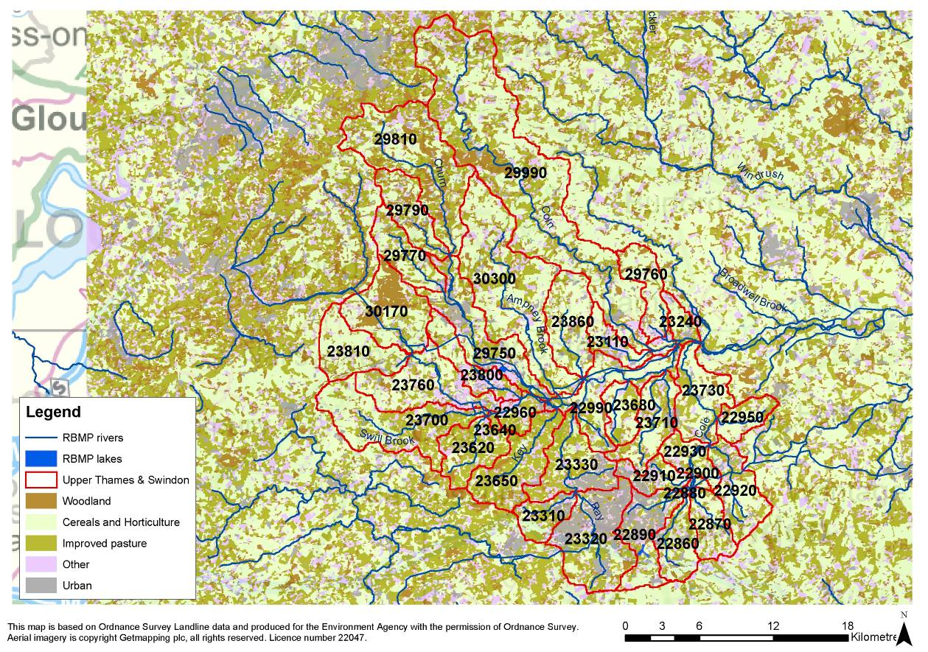

Figure 3 Land use in the Upper Thames catchment

Eight river stretches within the catchment are identified as ‘at risk’ or ‘probably at risk’ from diffuse pollution from agriculture. These are the River Key (Source to Thames), the Thames (Churn to Cole), the Share Ditch and the river Cole (Liden Brook to Lenta Brook, Acorn Bridge to South Marston, Cole and it’s tributaries at Sevenhampton and Bower Bridge to Thames).

Reductions and changes to some Thames Water Utilities Ltd water abstraction licences (at Latton, Meysey Hampton and Baunton respectively) were made during the period 2000-2005. These changes are expected to have improved flows in the Ampney Brook and River Churn.

There are pockets of contaminated land within the catchment. These areas are at a higher concentration around the larger towns of Swindon and Cirencester.

* 1. **Overview of water bodies and WFD characterisation**
     1. **Overview of current status – surface waterbodies**

The Upper Thames catchment has 34 surface water bodies.

Two water bodies, are designated as ‘heavily modified’ under WFD criteria.

* Waterbody No: 22890 Cole and Dorcan Brook (Source to Liden Brook confluence), which is heavily modified because of flood protection purposes. This waterbody is at good status. and the Thames (Coln to Leach), are designated as ‘heavily modified’ under WFD criteria.
* Waterbody No: 23240 Thames (Coln to Leach ), heavily modified because of Navigation reasons is currently at moderate status. Mitigation measures to secure good ecological potential in this waterbody are being addressed although it is technically infeasible for these to be implemented by 2015.

Of the 32 water bodies not designated as ‘heavily modified’ under WFD criteria, three have been classified as ‘bad’ status, seven as ‘poor’ status, 13 as ‘moderate’ status and 9 are classified as ‘good’ status. This is illustrated in .

The classifications have been based on the available monitoring data for the four WFD biological factors (fish, invertebrates, macrophytes and phytobenthos) and a suite of water quality factors as shown in

Table **1**.

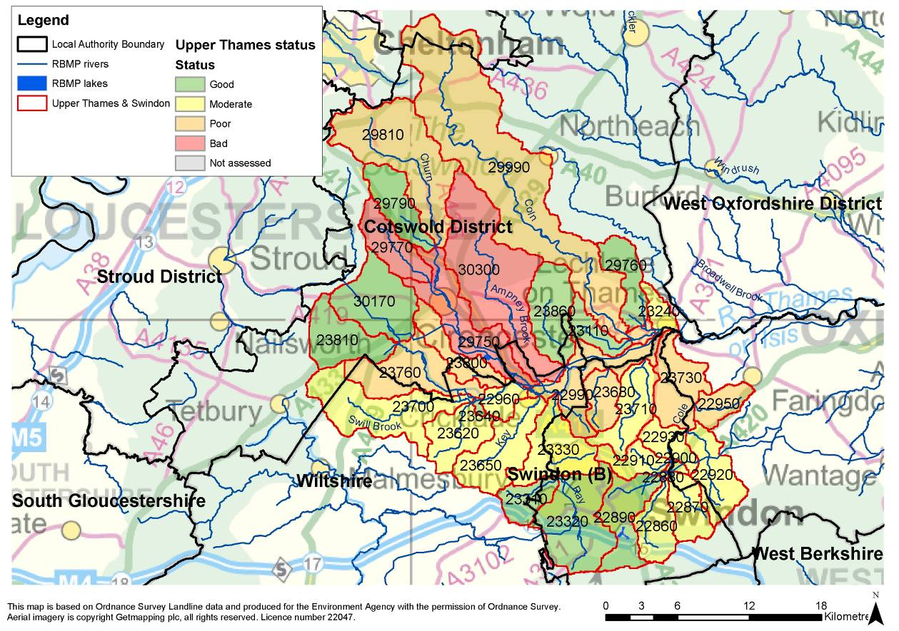

Figure 4 Overall status of surface water bodies in the RBMP

# Overview of current status – ground waterbodies

Of the four groundwater bodies, three are classed as being Poor Chemical Status (with failures relating to nitrates and ammonia). The Burford Jurassic ground waterbody is classed as Poor Quantitative Status although the majority of groundwater abstraction.

Overall status ground waterbodies is determined as the worst case for both qualitative and quantitative measures (i.e. Good qualitative and poor quantitative status will lead to an overall status of Poor). shows a map of the groundwater bodies and their status.

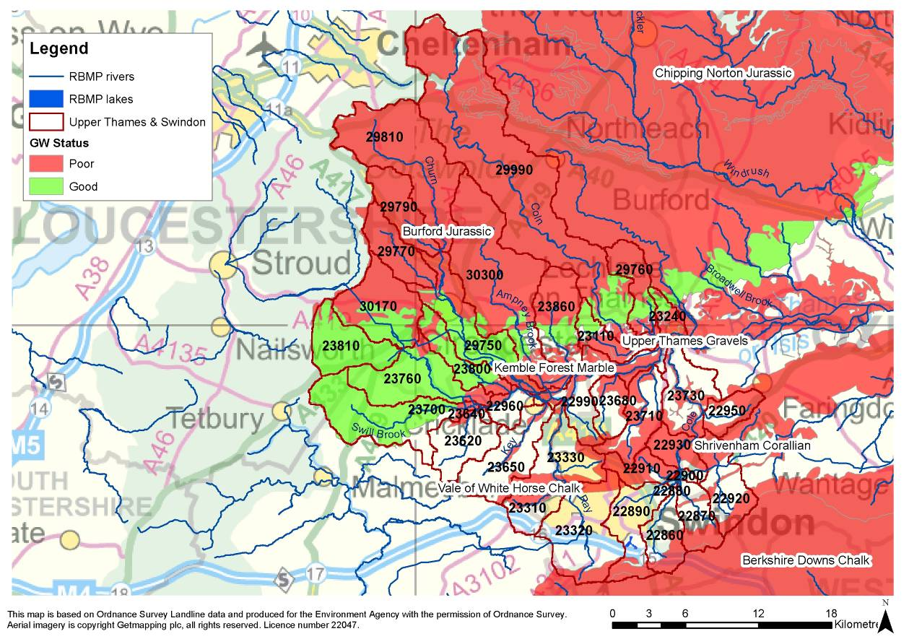

Figure 5 Overall status of groundwater bodies in the RBMP

* + 1. **Overview of current status –summary**

On the basis of the WFD monitoring information, the condition of the Upper Thames catchment can be summarised as below:

* There is great variation in the condition of the rivers within this catchment.
* The headwater streams of most (70%) rivers are in good or moderate condition.
* There is great uncertainty over both the condition of the rivers and the actions needed to improve them.

# Review of information quality and new data requirements

Table **1** demonstrates that as reported in the fRBMP, failure to meet good ecological status is primarily a result of the status of the following:

* Orthophosphate concentrations
* Fish
* Invertebrates
* Hydromorphology
* Phytobenthos

Table 1 Factors determining waterbody classifications

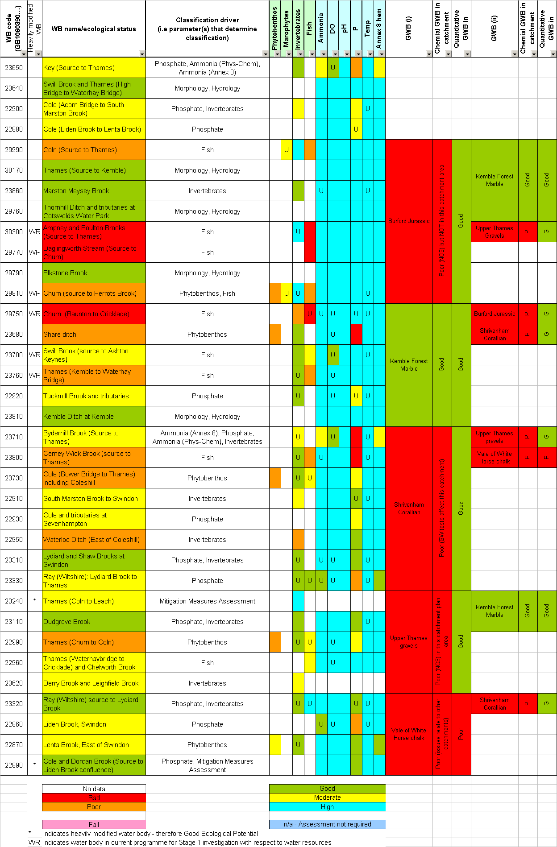

The water quality information is reasonably comprehensive. 94% of the water bodies have been analysed for the full water quality suite of chemicals. There is no data available for two water bodies – the Thames (Coln to Leach): No 23240 and the Derry Brook and Leighfield Brook: No 23620.

The biological information is sparse for macrophytes and phytobenthos. Just two water bodies have been measured for macrophytes and five waterbodies for phytobenthos.

The lack of monitoring information for some biological elements is an issue, both for understanding the problems and for identifying what actions are needed to deal with them. This can be addressed through additional monitoring and investigation to be pursued through this plan, in order to provide a robust evidence base.

Where monitoring data exists, the classification has been assessed as ‘uncertain’ in over 64% of cases where certainty has been statistically determined.

Conclusions

* The water bodies to the north and east of Swindon all indicate phosphates as the reason for ‘moderate’ status.
* The three water bodies with ‘bad’ status are all located around the Cirencester area in the Cotswolds. The reason for the classification of all three water bodies is due to fish failures.
* The Lydiard and Shaw Brooks at Swindon, and the Ray (Wiltshire) source to Lydiard brook need further investigation to improve the confidence in their current ‘good’ ecological status

The RBMP indicates that Good Ecological Status can be achieved by 2015 in 11 of the waterbodies in this catchment. Nine of these are currently at GES, the 2 remaining waterbodies being No 30300 Ampney and Poulton Brooks (Source to Thames)) and No 23700: Swill Brook (source to Ashton Keynes). For the remainder, achievement of good status by 2015 is likely to be either disproportionately expensive and/or technically infeasible. At these waterbodies GES will be achieved by 2027.

* + 1. **Uncertainty and further investigation**

The current analysis of the condition of the catchment has identified some uncertainties which will require further investigation. Uncertainties for each waterbody are illustrated by a ‘U’ in Table 1.

The greatest level of uncertainty lies with the parameters of temperature, dissolved oxygen levels and invertebrate populations.

* Uncertainties with Temperature and Dissolved Oxygen - There are 18 sites with uncertainties for either temperature or dissolved oxygen, or both. Five sites have ‘operational monitoring’ planned to collect data which should help to address these uncertainties. Twelve sites do not have any further monitoring planned at this stage, however we believe we hold enough information on these sites to be certain of their status in the future.
* Uncertainties with invertebrate populations - Ten of the twelve sites with uncertainty over invertebrate status have biological investigations planned. These investigations should help to address the uncertainties with invertebrate populations.
* Three sites currently achieving good ecological status have uncertainties relating to biological and chemical status. Further investigation is likely to involve the analysis of information already held by the Environment Agency. This should help to increase certainty in future.

# Addressing the Problems of the Upper Thames catchment

* 1. Overall catchment priorities

There are a number of universal actions listed in the RBMP covering the whole Region which are relevant to the Upper Thames catchment. There are just 6 RBMP actions targeted to the Upper Thames catchment specifically. These are as follows:

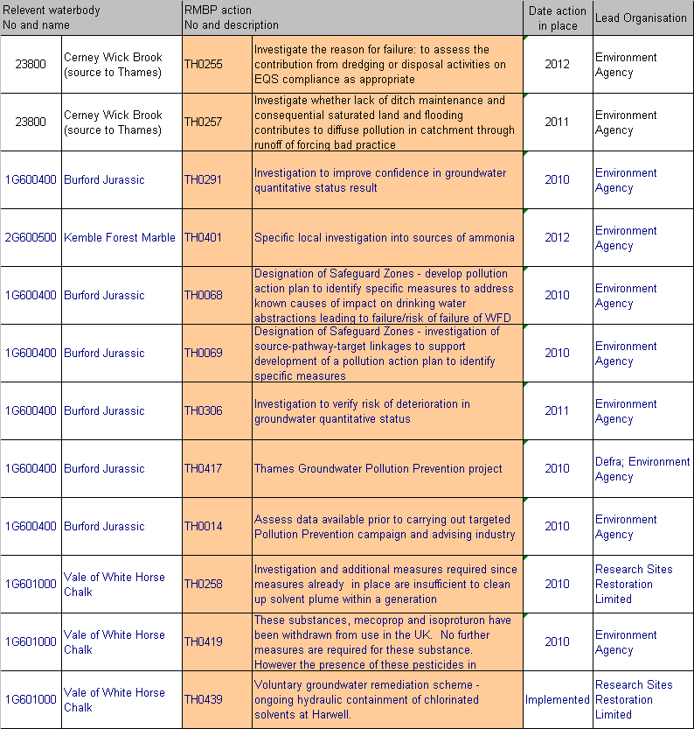

Table 2 RBMP actions relevant specifically to the Upper Thames catchment

In addition to these actions there are a number of local actions being taken to address the failing elements, These “field actions” are shown in the tables below. After completion of these actions a period of further monitoring is required to enable determination of their success in improving ecological status.

* 1. Significant issues

Identification of significant issues has been carried out by assessment of the reasons that waterbodies are failing WFD criteria. A significant issue may

* be causing failure of the WFD target of Good Ecological Status (or potential),
* prevent achievement of Good ecological status or potential or
* present a risk to the current WFD status (and therefore need actions to prevent deterioration).

This assessment shows that the following issues are significant across this catchment, these issues are prevalent across the whole South East region,

* Invasive non-native species
* Urban and transport development
* Phosphorus in rivers and streams

Both of these tables identify the over-arching Thames River Basin Management Plan measure that they are addressing as well as the locations of the action. Together these represent a programme of works for the catchment that will deliver good ecological status as quickly as is feasible.

* + 1. Invasive non-native species

Invasive non-native species are plants and animals that have deliberately or accidentally been introduced outside their natural range, and by spreading quickly threaten native wildlife and can cause economic damage.

Some species pose serious threats to our natural biodiversity and have economic impacts for example, for flood risk management, water transfer schemes, disposal of soil as waste and fisheries management. Their presence and unabated spread can represent an important pressure on the ecological status of many water bodies. Once established they are difficult or impossible to control. Examples include the plant Japanese knotweed, the mammal American mink, the fish topmouth gudgeon and the crustacean American signal crayfish.

In this catchment there is a significant presence of American signal crayfish. These organisms have been recorded in a substantial proportion of the catchment. The American crayfish competes for habitat and food with native invertebrate species and therefore may prevent GES as a result of their impact on our native invertebrates (or the fish that eat them). As mentioned above there are few effective control measures and therefore they represent a risk to the achievement of good ecological status in this catchment. We are developing a region-wide strategy for addressing invasive non-native species.

We are collaborating with Wiltshire Wildlife Trust on a non-native invasive plants project on the Ray and Thames, by providing advice and guidance and support control actions by selected local fora. (This corresponds to the RBMP action ref TH 404.)

* + 1. Urban and transport pressures

Urban development and transport can give rise to many issues that may impact on the ecological status of the catchment. These can vary from pollution arising from urban drainage, changes to river corridors, pesticides for highway maintenance or transport, to water resource issues and pollution due to pressures on the wastewater treatment infrastructure.

This is a significant issue across the Region, and in this catchment especially as large quantities of houses aer proposed around Swindon (4,500 homes in the south, 10,000 to the north and 12,000 homes in the east) and the expected increase in population have the potential to increase the pressure on the water environment during and post construction phase.

Within the Upper Thames catchment at least one site has been identified as under pressure from over-abstraction; the Churn (Source to Perrots Brook).

To promote sustainable development in this catchment we will support the local authorities through the planning process to ensure that the optimum location, design and infrastructure for new development are achieved. In this catchment these actions include the following table:

Table 3 Actions to address development and transport pressures

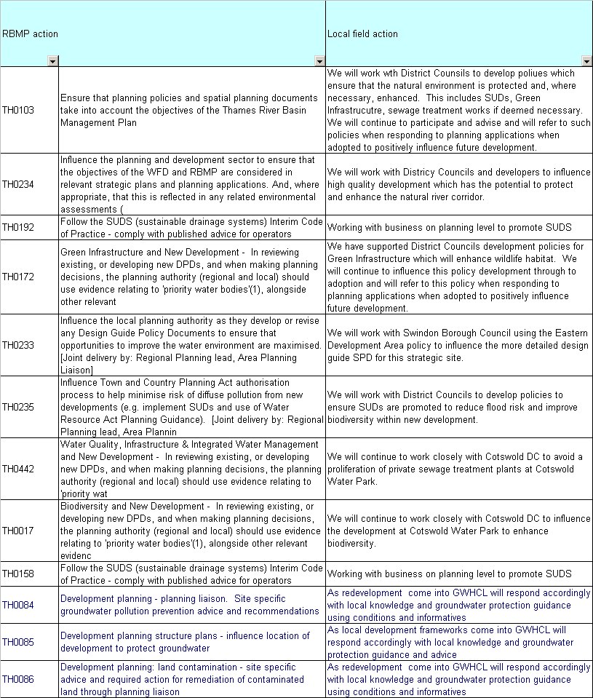

* + 1. Phosphorus in rivers and streams

High phosphorus concentrations are the main cause of eutrophication in fresh waters (the enrichment of waters by nutrients causing excess plant/algal growth and leading to undesirable effects on the ecology, quality and uses of the water). Activities that can be affected include water abstraction, water sports, angling, wildlife conservation and livestock watering. In standing fresh waters, blue-green algal blooms can occur; many such blooms are toxic and pose a hazard to humans involved in water sports and to animals that drink the water.

Defra has identified phosphate standards to support Good Ecological Status in fresh waters. They will be applied such that measures will be targeted to water bodies where there is evidence that nutrient levels are causing undesirable ecological impacts.

High phosphorus concentrations are a problem in 66% of the waterbodies in the Ock catchment. Diffuse inputs and sewage discharges are both sources of orthophosphates in the catchment, although the exact sites are still only suspected. All major sewage treatment works in the area are confirmed inputs, but are awaiting assessments on potential biological impacts.

Actions to address these issues are shown in

Table 4 Actions to address the significant issue of phosphorus in the Upper Thames catchment

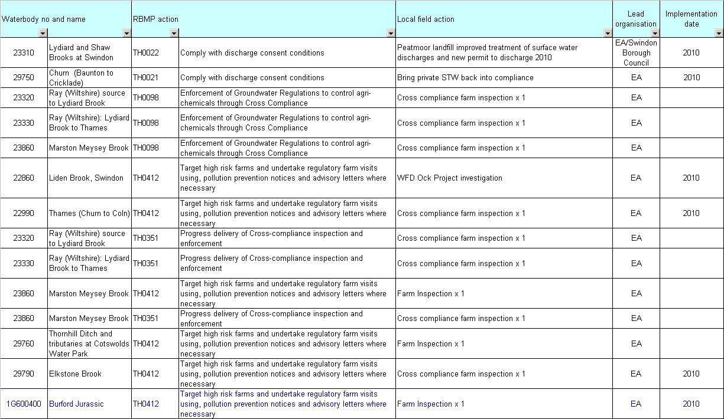

* + 1. Physical modification

Many lowland rivers in England and Wales have been subject to physical alteration of the river channel. These modifications include channel straightening, bank re-profiling and dredging for flood prevention, drainage or navigation purposes, as well as the creation of new channels for mill streams or irrigation. Such pressures may result in ecological habitat damage or loss that results in a decline or loss of species.

The existence of weirs, sluices and other impoundment in the river network may restrict the migration of fish such as eels, salmon and trout, impede sediment movement, promote siltation, and disrupt the interconnectedness of accessible habitat, particularly during periods of low flow.

Although some habitat restoration work has been undertaken on a number of waterbodies in this catchment over the last ten or more years, these have been rather ad hoc opportunistic works. A priority will be to develop a restoration programme which identifies the most degraded sections of rivers and those which present the greatest opportunity for restoration, in order that proportional progress can be made, in partnership with others, to restore the ecosystem functioning of the rivers in this catchment.

Actions to address these issues are shown in .

Table 5 Actions to address the significant issue of physical modification in the Upper Thames catchment

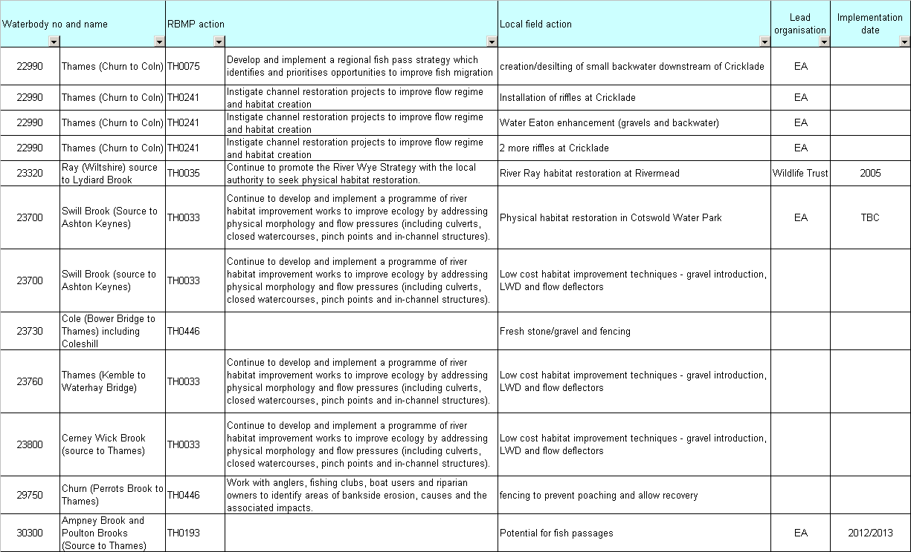

* 1. Investigations

There are 3 stages to investigations for WFD as follows:

* Stage 1: confirm failure – to ensure that the reported failure is a real result
* Stage 2: identify reason for failure
* Stage 3: identify measures (field actions) to address the failure

Investigations in the Upper Thames catchment under WFD are in as follows

Table 6 Programme of investigations in the Upper Thames catchment – surface water bodies

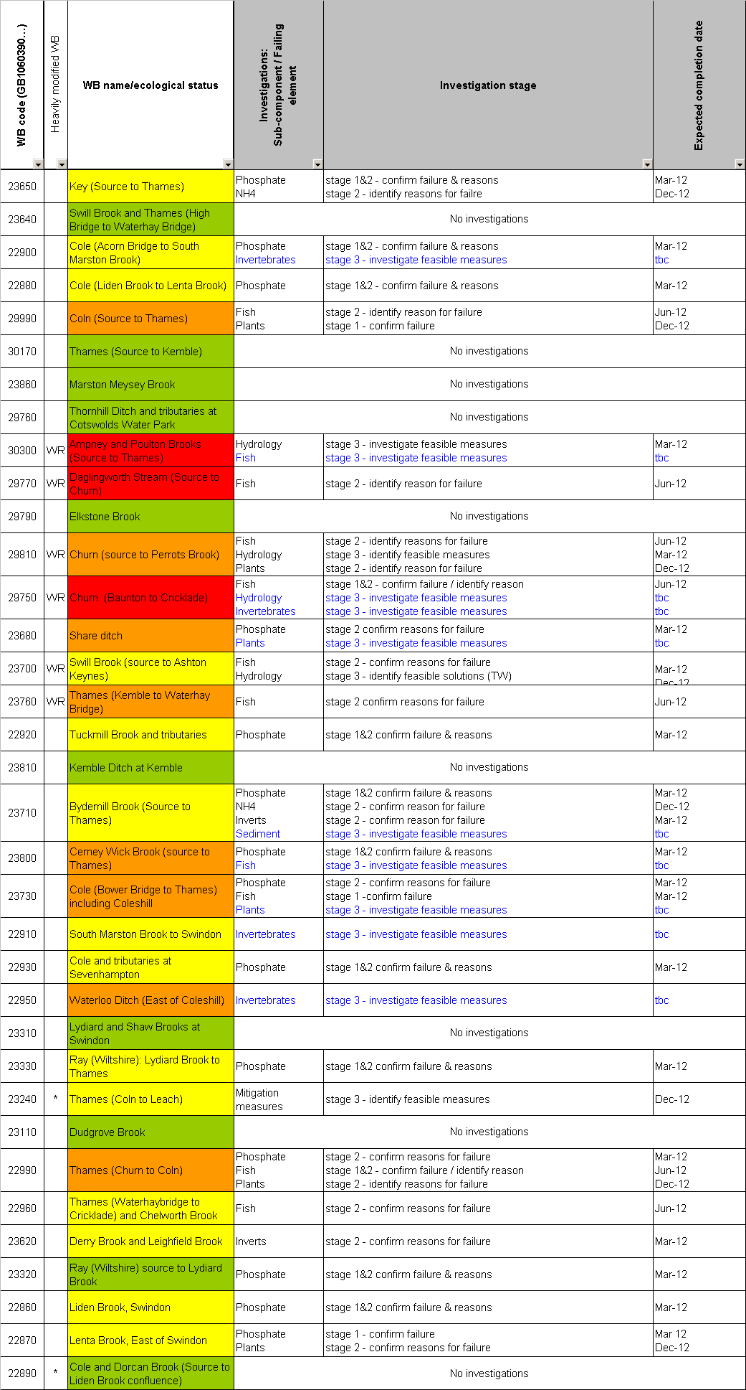

Table 7 Programme of investigations in the Upper Thames catchment – ground water bodies

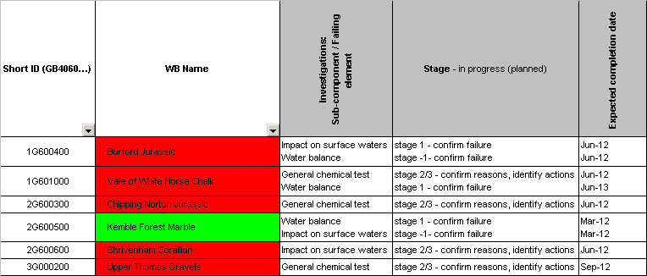

* 1. Field actions

Field actions underway in this catchment in addition to those addressing the significant issues given above are listed in . These address local issues of pollution risk, abstraction issues, groundwater pollution and along with the investigations shown in , an the actions in Tables 3, 4, and 5 represents the programme of activity in this catchment to deliver Good Ecological Status.

Table 8 Field actions in the Upper Thames catchment (bold actions are currently aspirational)

| Waterbody no and name |  | RBMP action | | Local field action | Lead organisation | External partners **(Potential Partners)** | Implementation date |
| --- | --- | --- | --- | --- | --- | --- | --- |
| **22860** | **Liden Brook, Swindon** | **TH0104** | **Environment Agency and Highways Agency Memorandum of Understanding (MoU) and associated initiatives** | **Develop and implement MOU with Highways, for use during incidents and day to day work** | **TW/Ea** |  |  |
| **22860** | **Liden Brook, Swindon** | TH0344 | **Pollution and prevention campaigns and advice, particularly targeting industrial premises in the catchment where copper may be used. Check for use of other metals and hazardous substances. Also investigate possible inflow from river to groundwater at abstraction** | **Pollution prevention targeting hazardous waste** | **EA** |  |  |
| **22860** | **Liden Brook, Swindon** | TH0344 | **Pollution and prevention campaigns and advice, particularly targeting industrial premises in the catchment where copper may be used. Check for use of other metals and hazardous substances. Also investigate possible inflow from river to groundwater at abstraction** | **Workshops for catering companies to promote pollution prevention** | **EA** |  |  |
| **22860** | **Liden Brook, Swindon** | **TH0099** | **Enforcement of Sludge Regulations through Cross compliance** | **Wanborough STW audit** | **TW/Ea** |  |  |
| 22860 | Liden Brook, Swindon | TH0190 | Implementation of 'oil-filled cables' operating agreement with electricity transmission companies | talking to and promoting the code of practise to all companies using oil filled cables in the area of work | TW\Ea |  | 2010 |
| 22870 | Lenta Brook, East of Swindon | TH0190 | Implementation of 'oil-filled cables' operating agreement with electricity transmission companies | talking to and promoting the code of practise to all companies using oil filled cables in the area of work | TW\Ea |  | 2010 |
| **22900** | **Cole (Acorn Bridge to South Marston Brook)** | **TH0099** | **Enforcement of Sludge Regulations through Cross compliance** | **Compliance visit to private STW** | **EA** |  |  |
| **22900** | **Cole (Acorn Bridge to South Marston Brook)** | **TH0033** | **Continue to develop and implement a programme of river habitat improvement works to improve ecology by addressing physical morphology and flow pressures (including culverts, closed watercourses, pinch points and in-channel structures)** | **Habitat improvements to combat low flows, which are likely to arise from morphology and drainage pressures.** | **EA** |  |  |
| 22910 | South Marston Brook to Swindon | TH0124 | Fire service Memorandum of Understanding (MoU) on implementing pollution control measures in emergencies | Visiting all fire stations for PP Visits | TW\Ea |  | 2010 |
| **22920** | **Tuckmill Brook and tributaries** | **TH0099** | **Enforcement of Sludge Regulations through Cross compliance** | **Low priority visit - Shriverham Works STW.** | **TW\Ea** |  |  |
| 22920 | Tuckmill Brook and tributaries | TH0104 | Environment Agency and Highways Agency Memorandum of Understanding (MoU) and associated initiatives | Develop and implement MOU with Highways, for use during incidents and day to day work. | TW\Ea |  | 2010 |
| 22950 | Waterloo Ditch (East of Coleshill) | TH0358 | Promote good practice to avoid pollution from construction sites. | undertook around 11 SWMP Visits in this area over the course of the year. | TW\Ea |  | 2010 |
| **22960** | **Thames (Waterhaybridge to Cricklade) and Chelworth Brook** | **TH0165** | **Further investigations to improve understanding of habitat restoration required to achieve GES. Improve understanding of the scale of habitat restoration required to achieve GES / GEP.** | **Fish survey to see if current habitat improvements have worked.** | **EA** |  |  |
| **22960** | **Thames (Waterhaybridge to Cricklade) and Chelworth Brook** | **TH0033** | **Continue to develop and implement a programme of river habitat improvement works to improve ecology by addressing physical morphology and flow pressures (including culverts, closed watercourses, pinch points and in-channel structures)** | **More habitat work possibilities, for instance including digging out backwater again.** | **EA** | **Cotswolds water park/ Cotswolds river trust** |  |
| 22960 | Thames (Waterhaybridge to Cricklade) and Chelworth Brook | TH0104 | Environment Agency and Highways Agency Memorandum of Understanding (MoU) and associated initiatives | Develop and implement MOU with Highways, for use during incidents and day to day work. | TW\Ea |  | 2010 |
| **22990** | **Thames (Churn to Coln)** |  |  | **Stocking of barbel to create a "viable" population** |  |  |  |
| 22990 | Thames (Churn to Coln) | TH0358 | Promote good practice to avoid pollution from construction sites. | undertook around 15 SWMP Visits in this area over the course of the year. | TW\Ea |  | 2010 |
| 23110 | Dudgrove Brook | TH0190 | Implementation of 'oil-filled cables' operating agreement with electricity transmission companies | talking to and promoting the code of practise to all companies using oil filled cables in the area of work | TW\Ea |  | 2010 |
| 23240 | Thames (Coln to Leach) | TH0358 | Promote good practice to avoid pollution from construction sites. | Undertaking SWMP visits on all construction sites in the area. Raising awareness via on site visits, new guidance and advise and guidance to business | TW\Ea |  | 2010 |
| 23310 | Lydiard and Shaw Brooks at Swindon | TH0358 | Promote good practice to avoid pollution from construction sites. | Undertook PP at various Sites in the Swindon area. Including Elgan, Techno. | TW\Ea |  | 2010 |
| 23320 | Ray (Wiltshire) source to Lydiard Brook | TH0099 | Enforcement of Sludge Regulations through Cross compliance | Cross compliance farm inspection x 1 | EA |  |  |
| 23320 | Ray (Wiltshire) source to Lydiard Brook | TH0109 | Environmental Permitting - waste disposal | Shaw Farm Landfill improvements to prevent leachate breakouts to surface water | EA | Swindon Borough Council | 2010 |
| 23320 | Ray (Wiltshire) source to Lydiard Brook | TH0358 | Promote good practice to avoid pollution from construction sites. | Undertook around 30 SWMP Visits in this area over the course of the year. | TW\Ea |  | 2010 |
| **23330** | **Ray (Wiltshire): Lydiard Brook to Thames** | **TH0084** | **Development planning - planning liaison. Site specific groundwater pollution prevention advice and recommendations** | **Pollution Prevention Control Team to look into opening up flood plain near landfill site?** | **EA** | **Chaple Farm Landfill Site Owner** |  |
| **23330** | **Ray (Wiltshire): Lydiard Brook to Thames** | **TH0075** | **Develop and implement a regional fish pass strategy which identifies and prioritises opportunities to improve fish migration** | **EA gauging weir needs looking into for fish passage.** | **EA** |  |  |
| 23330 | Ray (Wiltshire): Lydiard Brook to Thames | TH0099 | Enforcement of Sludge Regulations through Cross compliance | Cross compliance farm inspection x 1 | EA |  |  |
| 23330 | Ray (Wiltshire): Lydiard Brook to Thames | TH0358 | Promote good practice to avoid pollution from construction sites. | Undertook around 30 SWMP Visits in this area over the course of the year. | TW\Ea |  | 2010 |
| **23620** | **Derry Brook and Leighfield Brook** | **TH0014** | **Assess data available prior to carrying out targeted Pollution Prevention campaign and advising industry** | **Diffuse NH4 and DO issues need sources (habitat review report see bio)** | **EA** |  |  |
| 23620 | Derry Brook and Leighfield Brook | **TH0241** | **Instigate channel restoration projects to improve flow regime and habitat creation** | **Habitat restoration to tackle morphology and land drainage pressures on invertebrates** | Landowners/Ea |  |  |
| 23620 | Derry Brook and Leighfield Brook | TH0104 | Environment Agency and Highways Agency Memorandum of Understanding (MoU) and associated initiatives | Develop and implement MOU with Highways, for use during incidents and day to day work. | TW\Ea |  | 2010 |
| 23640 | Swill Brook and Thames (High Bridge to Waterhay Bridge) | TH0124 | Fire service Memorandum of Understanding (MoU) on implementing pollution control measures in emergencies | Visiting all fire stations for PP Visits | TW\Ea |  | 2010 |
| **23650** | **Key (Source to Thames)** | **TH0241** | **Instigate channel restoration projects to improve flow regime and habitat creation** | **Habitat restoration required for fish** | **TW\Ea** |  |  |
| **23650** | **Key (Source to Thames)** | **TH0099** | **Enforcement of Sludge Regulations through Cross compliance** | **Purton STW compliance check (EM) - medium priority** | **TW\Ea** |  |  |
| 23680 | Share ditch | TH0104 | Environment Agency and Highways Agency Memorandum of Understanding (MoU) and associated initiatives | Develop and implement MOU with Highways, for use during incidents and day to day work. | TW\Ea |  | 2010 |
| 23700 | Swill Brook (source to Ashton Keynes) | TH0124 | Fire service Memorandum of Understanding (MoU) on implementing pollution control measures in emergencies | Visiting all fire stations for PP Visits | TW\Ea |  | 2010 |
| **23710** | **Bydemill Brook (Source to Thames)** | **TH0099** | **Enforcement of Sludge Regulations through Cross compliance** | **Audit visit to Highworth STW** | **TW/Ea** |  |  |
| **23710** | **Bydemill Brook (Source to Thames)** | **TH0412** | **Target high risk farms and undertake regulatory farm visits using, pollution prevention notices and advisory letters where necessary** | **Possible farm visit required near survey site** | **EA** | **Landowner** |  |
| **23710** | **Bydemill Brook (Source to Thames)** | **TH0033** | **Continue to develop and implement a programme of river habitat improvement works to improve ecology by addressing physical morphology and flow pressures (including culverts, closed watercourses, pinch points and in-channel structures)** | **Habitat improvements to tackle invertebrate/sediment failures** | **TW/Ea** |  |  |
| 23710 | Bydemill Brook (Source to Thames) | TH0124 | Fire service Memorandum of Understanding (MoU) on implementing pollution control measures in emergencies | Visited all Bucks fire station and gave PP advice | TW\Ea |  | 2010 |
| 23730 | Cole (Bower Bridge to Thames) including Coleshill | TH0241 | Instigate channel restoration projects to improve flow regime and habitat creation | Coles Hill River restoration project completed (survey sites are around this site) | EA |  | Implemented |
| 23760 | Thames (Kemble to Waterhay Bridge) | TH0358 | Promote good practice to avoid pollution from construction sites. | undertook around 15 SWMP Visits in this area over the course of the year. | TW\Ea |  | 2010 |
| **23800** | **Cerney Wick Brook (source to Thames)** | **TH0099** | **Enforcement of Sludge Regulations through Cross compliance** | **Audit visit to Cirencester STW** | **TW\Ea** |  |  |
| 23800 | Cerney Wick Brook (source to Thames) | TH0124 | Fire service Memorandum of Understanding (MoU) on implementing pollution control measures in emergencies | Visited all Bucks fire station and gave PP advice | TW\Ea |  | 2010 |
| 23860 | Marston Meysey Brook | TH0099 | Enforcement of Sludge Regulations through Cross compliance | Cross compliance farm inspection x 1 | EA |  |  |
| 23860 | Marston Meysey Brook | TH0358 | Promote good practice to avoid pollution from construction sites. | talking to and promoting the code of practise to all companies using oil filled cables in the area of work | TW\Ea |  | 2010 |
| **26380** | **Share Ditch** | **TH0099** | **Enforcement of Sludge Regulations through Cross compliance** | **Low priority compliance visit to Blunsden STW** | **EA** |  |  |
| **29750** | **Churn (Baunton to Cricklade)** | **TH0241** | **Instigate channel restoration projects to improve flow regime and habitat creation** | **Habitat Restoration to combat morphology and physical modification pressures on fish** | **TW** | **FWAG/ Landowners/ Cotswolds river trust** |  |
| 29750 | Churn (Baunton to Cricklade) | TH0124 | Fire service Memorandum of Understanding (MoU) on implementing pollution control measures in emergencies | Visiting all fire stations for PP Visits | TW\Ea |  | 2010 |
| 29760 | Thornhill Ditch and tributaries at Cotswolds Water Park | TH0104 | Environment Agency and Highways Agency Memorandum of Understanding (MoU) and associated initiatives | Develop and implement MOU with Highways, for use during incidents and day to day work. | TW\Ea |  | 2010 |
| **29770** | **Daglingworth Stream (Source to Churn)** | **TH0075** | **Develop and implement a regional fish pass strategy which identifies and prioritises opportunities to improve fish migration** | **Solve hydrology and fish passage issues in urbanised downstream WB** | **EA** | **FWAG/Cirencester Open Green Strategy/**  **Cirencester Town Council** |  |
| 29770 | Daglingworth Stream (Source to Churn) | TH0104 | Environment Agency and Highways Agency Memorandum of Understanding (MoU) and associated initiatives | Develop and implement MOU with Highways, for use during incidents and day to day work. | TW\Ea |  | 2010 |
| **29810** | **Churn (source to Perrots Brook)** | **TH0241** | **Instigate channel restoration projects to improve flow regime and habitat creation** | **Habitat Restoration to combat morphology and physical modification pressures on fish** | **EA** | **TW/ Cotswolds River Trust/**  **Gloucestershire Wildlife Trust/ FWAG** |  |
| 29810 | Churn (source to Perrots Brook) | TH0124 | Fire service Memorandum of Understanding (MoU) on implementing pollution control measures in emergencies | Visiting all fire stations for PP Visits | TW\Ea |  | 2010 |
| 30170 | Thames (Source to Kemble) | TH0104 | Environment Agency and Highways Agency Memorandum of Understanding (MoU) and associated initiatives | Develop and implement MOU with Highways, for use during incidents and day to day work. | TW\Ea |  | 2010 |
| 1G600400 | Burford Jurassic | TH0291 | Investigation to improve confidence in groundwater quantitative status result | Desk Exercise to review underlying data in WRGIS and CAMS that gave initial quantitative status result and risk. Check existing or amended data with ecological evidence. Carried out by area Hydrogeologists. | EA |  |  |
| 1G600400 | Burford Jurassic | TH0306 | Investigation to verify risk of deterioration in groundwater quantitative status | Desk Exercise to review underlying data in WRGIS and CAMS that gave initial quantitative status result and risk. Check existing or amended data with ecological evidence. Carried out by area Hydrogeologists. | EA |  |  |
| 1G600400 | Burford Jurassic | TH0272 | Investigation of Groundwater Dependent Terrestrial Ecosystems (GWDTEs) to assess if they have been significantly damaged as a result of groundwater pollution | Priority GwDTE . Lack of monitoring data. BH drilling required, subject to funding. Initial investigation. | EA |  | 2012 |
| 1G600400 | Burford Jurassic | TH0068 | Designation of Safeguard Zones - develop pollution action plan to identify specific measures to address known causes of impact on drinking water abstractions leading to failure/risk of failure of WFD Article 7.3 objective. | Work with agricultural EOs on Pollution prevention and farm visits, particularly wrt nitrates (fertilisers and manures) within SPZ3 and beyond if relevant for the following PWS: Fairford, Seven Springs, Pinnock, Syreford. Of these Pinnock is a priority where we need to work closely with ST Water who are using this as a pilot catchment. JT has further information. | EA |  | 2010 |
| 1G600400 | Burford Jurassic | TH0027 | Comply with Local Authority Contaminated Land Remediation Notices - Make use of site specific notices to remove pollution risk to groundwater | As specific pollution risks arise. None identified at present. GWHCL W knowledge to be used to update this as appropriate. | EA |  | Ongoing |
| 1G600400 | Burford Jurassic | TH0182 | Implement Groundwater Protection: Policy & Practice - External education on groundwater pollution prevention | GWHCL wiil use opportunities such a seminars, informal meetings, LA cluster groups, industry forums to inform people about our policies | EA |  | Ongoing |
| 1G600400 | Burford Jurassic | TH0014 | Assess data available prior to carrying out targeted Pollution Prevention campaign and advising industry | No further work required | EA |  | Implemented |
| 1G600400 | Burford Jurassic | TH0069 | Designation of Safeguard Zones - investigation of source-pathway-target linkages to support development of a pollution action plan to identify specific measures | GwQual Lead Area and West Area work together developing conceptual model for following SPZ3: Fairford, Seven Springs, Pinnock, Syreford. National guidance currently being developed. | EA |  | 2012 |
| 2G600300 | Chipping Norton Jurassic | TH0272 | Investigation of Groundwater Dependent Terrestrial Ecosystems (GWDTEs) to assess if they have been significantly damaged as a result of groundwater pollution | Lack of monitoring data. BH drilling required, subject to funding. Initial investigation. | EA |  | 2012 |
| 2G600300 | Chipping Norton Jurassic | TH0068 | Designation of Safeguard Zones - develop pollution action plan to identify specific measures to address known causes of impact on drinking water abstractions leading to failure/risk of failure of WFD Article 7.3 objective. | Work on with agricultural EOs on Pollution prevention and farm visits, particularly wrt nitrates (fertilisers and manures) within SPZ3 and beyond if relevant for Old Chalford PWS. | EA |  | 2010 |
| 2G600300 | Chipping Norton Jurassic | TH0027 | Comply with Local Authority Contaminated Land Remediation Notices - Make use of site specific notices to remove pollution risk to groundwater | As specific pollution risks arise. None identified at present. GWHCL W knowledge to be used to update this as appropriate. | EA |  | Ongoing |
| 2G600300 | Chipping Norton Jurassic | TH0182 | Implement Groundwater Protection: Policy & Practice - External education on groundwater pollution prevention | GWHCL wiil use opportunities such a seminars, informal meetings, LA cluster groups, industry forums to inform people about our policies | EA |  | Ongoing |
| 2G600300 | Chipping Norton Jurassic | TH0069 | Designation of Safeguard Zones - investigation of source-pathway-target linkages to support development of a pollution action plan to identify specific measures | GwQual Lead Area and West Area work together developing conceptual model for SPZ 3 for Old Chalford. National guidance currently being developed. | EA |  | 2012 |
| 2G600300 | Chipping Norton Jurassic | TH0358 | Promote good practice to avoid pollution from construction sites. | undertook around 2 SWMP Visits in this area over the course of the year. | TW\Ea |  | 2010 |
| 2G600500 | Kemble Forest Marble | TH0291 | Investigation to improve confidence in groundwater quantitative status result | Desk Exercise to review underlying data in WRGIS and CAMS that gave initial quantitative status result and risk. Check existing or amended data with ecological evidence. Carried out by area Hydrogeologists. | EA |  |  |
| 2G600500 | Kemble Forest Marble | TH0306 | Investigation to verify risk of deterioration in groundwater quantitative status | Desk Exercise to review underlying data in WRGIS and CAMS that gave initial quantitative status result and risk. Check existing or amended data with ecological evidence. Carried out by area Hydrogeologists. | EA |  |  |
| 2G600500 | Kemble Forest Marble | TH0272 | Investigation of Groundwater Dependent Terrestrial Ecosystems (GWDTEs) to assess if they have been significantly damaged as a result of groundwater pollution | Lack of monitoring data. BH drilling required, subject to funding. Initial investigation. | EA |  | 2012 |
| 2G600500 | Kemble Forest Marble | TH0401 | Specific local investigation into sources of ammonia | Chemical status is good but fails due to upward trend in ammonia, expected to affect surface water by 2021. However, relevant monitoring point - Dudgrove Fm (PGWU0786) is from Gt Oolite with Oxford Clay cover so impact on surface watercourse will be small | EA |  | 2012 |
| 2G600500 | Kemble Forest Marble | TH0206 | Improvements to 1 water company sewage treatment works to protect groundwater quality. (PR09) | Coates, meet new quality condition of 5 mg/l for ammoniacal nitrogen by 2014 | Thames Water Utilities Ltd |  | 2014 |
| 2G600500 | Kemble Forest Marble | TH0027 | Comply with Local Authority Contaminated Land Remediation Notices - Make use of site specific notices to remove pollution risk to groundwater | As specific pollution risks arise. None identified at present. GWHCL W knowledge to be used to update this as appropriate. | EA |  | Ongoing |
| 2G600500 | Kemble Forest Marble | TH0182 | Implement Groundwater Protection: Policy & Practice - External education on groundwater pollution prevention | GWHCL wiil use opportunities such a seminars, informal meetings, LA cluster groups, industry forums to inform people about our policies | EA |  | Ongoing |
| 2G600500 | Kemble Forest Marble | TH0358 | Promote good practice to avoid pollution from construction sites. | undertook around 2 SWMP Visits in this area over the course of the year. | TW\Ea |  | 2010 |
| 3G000200 | Upper Thames Gravels | TH0272 | Investigation of Groundwater Dependent Terrestrial Ecosystems (GWDTEs) to assess if they have been significantly damaged as a result of groundwater pollution | Lack of monitoring data. BH drilling required, subject to funding. Initial investigation. | EA |  | 2012 |
| 3G000200 | Upper Thames Gravels | TH0027 | Comply with Local Authority Contaminated Land Remediation Notices - Make use of site specific notices to remove pollution risk to groundwater | As specific pollution risks arise. None identified at present. GWHCL W knowledge to be used to update this as appropriate. | EA |  | Ongoing |
| 3G000200 | Upper Thames Gravels | TH0182 | Implement Groundwater Protection: Policy & Practice - External education on groundwater pollution prevention | GWHCL wiil use opportunities such a seminars, informal meetings, LA cluster groups, industry forums to inform people about our policies | EA |  | Ongoing |
| 3G000200 | Upper Thames Gravels | TH0358 | Promote good practice to avoid pollution from construction sites. | undertook around 3 SWMP Visits in this area over the course of the year. | TW\Ea |  | 2010 |

# Catchment programme management

* 1. Predictions for the Upper Thames catchment

In order to enable progress monitoring towards good ecological status we have predicted, based upon the programme of investigations and actions, when each of the waterbodies may reach good ecological status.

Part of this activity involved the reclassification of waterbodies using the very latest data available. This reclassification has lead to a number of changes in the waterbody classifications and predictions for future status.

The table below represents our best view of the status of the waterbodies in the future assuming that the programme of investigations and actions goes ahead as planned. It may be that we will not have appropriate monitoring in place to provide evidence of a change in status for every individual waterbody, but it is reasonable to forecast expected status as a result of completed actions.

Our view of progress towards GES are shown in the table below.

Table 9 Predictions for Good Ecological Status for the Upper Thames catchment

|  |  |  |  |  |  |  |  |  |  |  |
| --- | --- | --- | --- | --- | --- | --- | --- | --- | --- | --- |
|  | WB name | RBMP  classification | 2010  reclassification | 2011 | 2012 | 2013 | 2014 | 2015 | 2021 | 2027 |
| Surface water bodies: GB1060390 | | | | | | | | | | |
| 22860 | Liden Brook, Swindon |  |  |  |  |  |  |  |  |  |
| 22870 | Lenta Brook, East of Swindon |  |  |  |  |  |  |  |  |  |
| 22880 | Cole (Liden Brook to Lenta Brook) |  |  |  |  |  |  |  |  |  |
| 29990 | Coln (Source to Thames) |  |  |  |  |  |  |  |  |  |
| 22890 | Cole and Dorcan Brook (Source to Liden Brook confluence) |  |  |  |  |  |  |  |  |  |
| 22900 | Cole (Acorn Bridge to South Marston Brook) |  |  |  |  |  |  |  |  |  |
| 22910 | South Marston Brook to Swindon |  |  |  |  |  |  |  |  |  |
| 22920 | Tuckmill Brook and tributaries |  |  |  |  |  |  |  |  |  |
| 22930 | Cole and tributaries at Sevenhampton |  |  |  |  |  |  |  |  |  |
| 22950 | Waterloo Ditch (East of Coleshill) |  |  |  |  |  |  |  |  |  |
| 22960 | Thames (Waterhaybridge to Cricklade) and Chelworth Brook |  |  |  |  |  |  |  |  |  |
| 22990 | Thames (Churn to Coln) |  |  |  |  |  |  |  |  |  |
| 23110 | Dudgrove Brook |  |  |  |  |  |  |  |  |  |
| 23240 | Thames (Coln to Leach) |  |  |  |  |  |  |  |  |  |
| 23310 | Lydiard and Shaw Brooks at Swindon |  |  |  |  |  |  |  |  |  |
| 23320 | Ray (Wiltshire) source to Lydiard Brook |  |  |  |  |  |  |  |  |  |
| 23330 | Ray (Wiltshire): Lydiard Brook to Thames |  |  |  |  |  |  |  |  |  |
| 23620 | Derry Brook and Leighfield Brook |  |  |  |  |  |  |  |  |  |
| 23640 | Swill Brook and Thames (High Bridge to Waterhay Bridge) |  |  |  |  |  |  |  |  |  |
| 23650 | Key (Source to Thames) |  |  |  |  |  |  |  |  |  |
| 23680 | Share ditch |  |  |  |  |  |  |  |  |  |
| 23700 | Swill Brook (source to Ashton Keynes) |  |  |  |  |  |  |  |  |  |
| 23710 | Bydemill Brook (Source to Thames) |  |  |  |  |  |  |  |  |  |
| 23730 | Cole (Bower Bridge to Thames) including Coleshill |  |  |  |  |  |  |  |  |  |
| 23760 | Thames (Kemble to Waterhay Bridge) |  |  |  |  |  |  |  |  |  |
| 23800 | Cerney Wick Brook (source to Thames) |  |  |  |  |  |  |  |  |  |
| 23810 | Kemble Ditch at Kemble |  |  |  |  |  |  |  |  |  |
| 23860 | Marston Meysey Brook |  |  |  |  |  |  |  |  |  |
| 29750 | Churn (Baunton to Cricklade) |  |  |  |  |  |  |  |  |  |
| 29760 | Thornhill Ditch and tributaries at Cotswolds Water Park |  |  |  |  |  |  |  |  |  |
| 29770 | Daglingworth Stream (Source to Churn) |  |  |  |  |  |  |  |  |  |
| 29790 | Elkstone Brook |  |  |  |  |  |  |  |  |  |
| 29810 | Churn (source to Perrots Brook) |  |  |  |  |  |  |  |  |  |
| 30170 | Thames (Source to Kemble) |  |  |  |  |  |  |  |  |  |
| 30300 | Ampney and Poulton Brooks (Source to Thames) |  |  |  |  |  |  |  |  |  |
| WB code (GB4060..) | | | | | | | | | | |
| 1GB600400 | Burford Jurassic |  |  |  |  |  |  |  |  |  |
| 2GB600500 | Kemble Forest Marble |  |  |  |  |  |  |  |  |  |
| 2G600600 | Shrivenham Corallian |  |  |  |  |  |  |  |  |  |
| 1G601000 | Vale of White Horse chalk |  |  |  |  |  |  |  |  |  |
| 3GB000200 | Upper Thames Gravels |  |  |  |  |  |  |  |  |  |

# APPENDIX 1: Schematic of the catchment

# APPENDIX 2: Bibliography of current research (to be completed)

# APPENDIX 3: Overall estimated costs (to be completed)

# APPENDIX 4: Abbreviations and glossary

**Abbreviations**

AMP(5 or 6) Water company Asset Management Plan (2010 to 2014 for AMP5, or 2015 to 2019 for AMP6)

AONB Area of outstanding natural beauty

ARK Action for the River Kennet

BW British Waterways

CEH Centre for Hydrology and Ecology

HMWB Heavily modified water body

HOP Hatches Operating Protocol

EA Environment Agency

K&A Kennet & Avon canal

KCRP Kennet chalkstream restoration project

Ml/d Megalitres (million litres) per day

NE Natural England

RSPB Royal Society for the Protection of Birds

SSSI Site of special scientific interest

TW Thames Water

WFD Water Framework Directive

WLMP Water level management plan

μg/l Micro-grams per litre – millionths of a gram per litre

**Glossary**

Diatom A mobile plant of microscopic single cell or colonial algae – a type of phytobenthos

Macro-invertebrates Invertebrates (without a backbone) which are visible to the naked eye, eg river flies

Macrophytes A macrophyte is an aquatic plant that grows in or near water and is either emergent, submergent, or floating

Q95 flow The flow rate that is exceeded for 95% of the time, typically a low summer flow

Perennial A stream or river which flows all year round

Perennial head The point at which a winterbourne becomes a perennial river

Phytobenthos Algae that grow on the bottom of rivers

Water body A sub-division of the Thames river basin, typically 10 to 20 km of a river or stream

Winterbourne A stream or river which is dry during the summer months