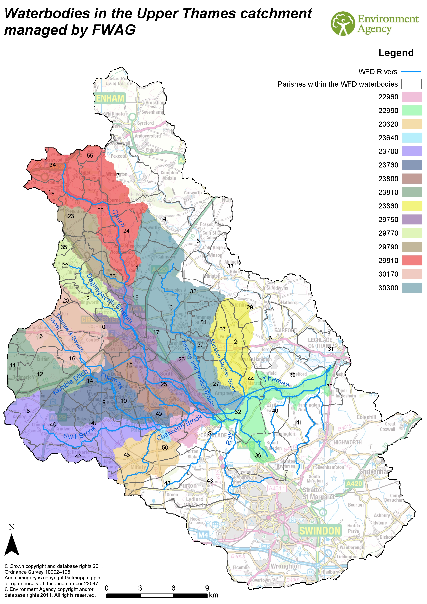

Number | Name of Parish | Number | Name of Parish
0 | Cirencester CP | 28 | Poulton CP
1 | North Cerney CP | 29 | Quenington CP
2 | Maiseyhampton CP | 30 | Kempsford CP
3 | Ampney Crucis CP | 31 | Lechlade CP
4 | Chedworth CP | 32 | Barnsley CP
5 | Coln St. Dennis CP | 33 | Bibury CP
6 | Fairford CP | 34 | Coberley CP
7 | Withington CP | 35 | Winstone CP
8 | Ashley CP | 36 | Bagendon CP
9 | Poole Keynes CP | 37 | Ampney St. Peter CP
10 | Somerford Keynes CP | 38 | Inglesham CP
11 | Cherington CP | 39 | Blunsdon St. Andrew CP
12 | Rodmarton CP | 40 | Castle Eaton CP
13 | Sapperton CP | 41 | Hannington CP
14 | Kemble CP | 42 | Hankerton CP
15 | Siddington CP | 43 | Purton CP
16 | Coates CP | 44 | Marston Maisey CP
17 | Preston CP | 45 | Minety CP
18 | Baunton CP | 46 | Crudwell CP
19 | Cowley CP | 47 | Oaksey CP
20 | Duntisbourne Rouse CP | 48 | Braydon CP
21 | Daglingworth CP | 49 | Ashton Keynes CP
22 | Duntisbourne Abbots CP | 50 | Leigh CP
23 | Elkstone CP | 51 | Cricklade CP
24 | Rendcomb CP | 52 | Latton CP
25 | South Cerney CP | 53 | Colesbourne CP
26 | Driffield CP | 54 | Ampney St. Mary CP
27 | Down Ampney CP | 55 | Dowdeswell CP

