Don Pilot open event, Meadowhall Sheffield 15 June 2012

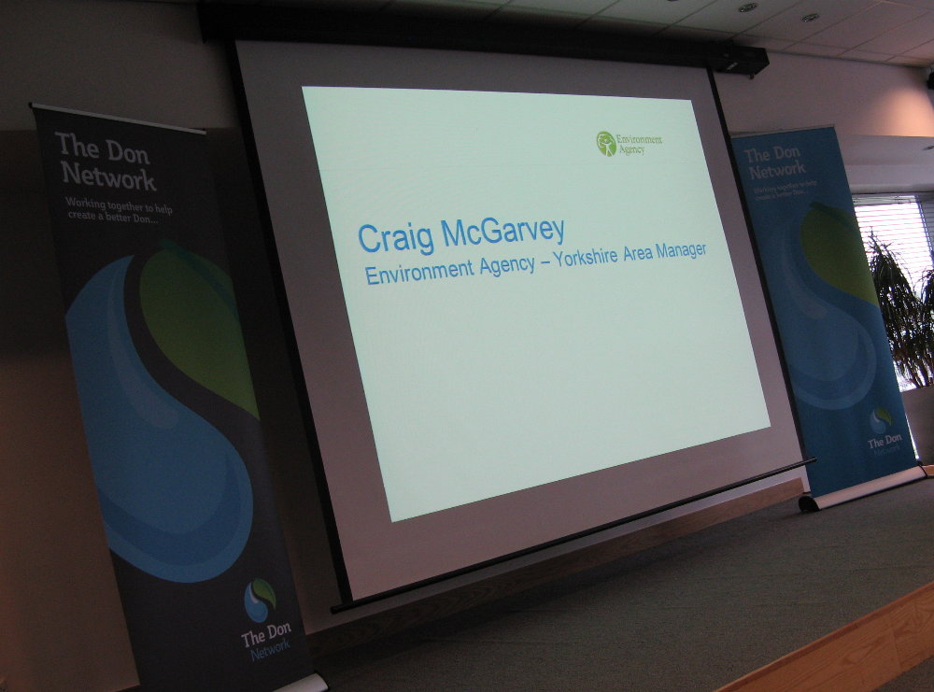
The event was professionally presented

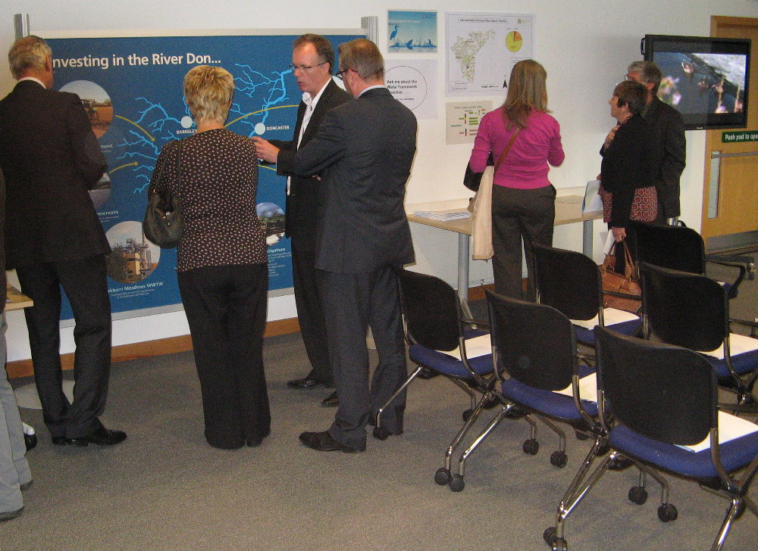
EA Area Manager Craig McGarvey talking to Angela C Smith MP
about the pilot project



We were keen to explore imaginative techniques to raise awareness of the
Don Pilot initiative.....

