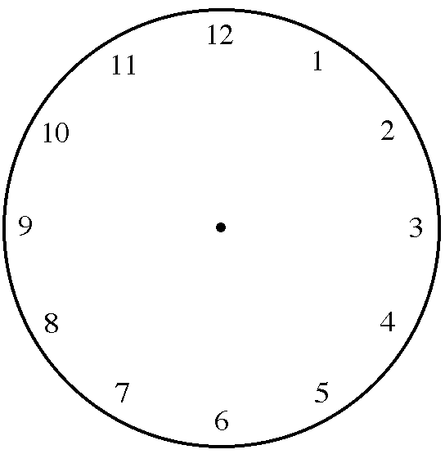
Name: | ________________________
Day: | ________________________

