

Case Study

Pauline
Level 3 BTEC
National Certificate Childcare student
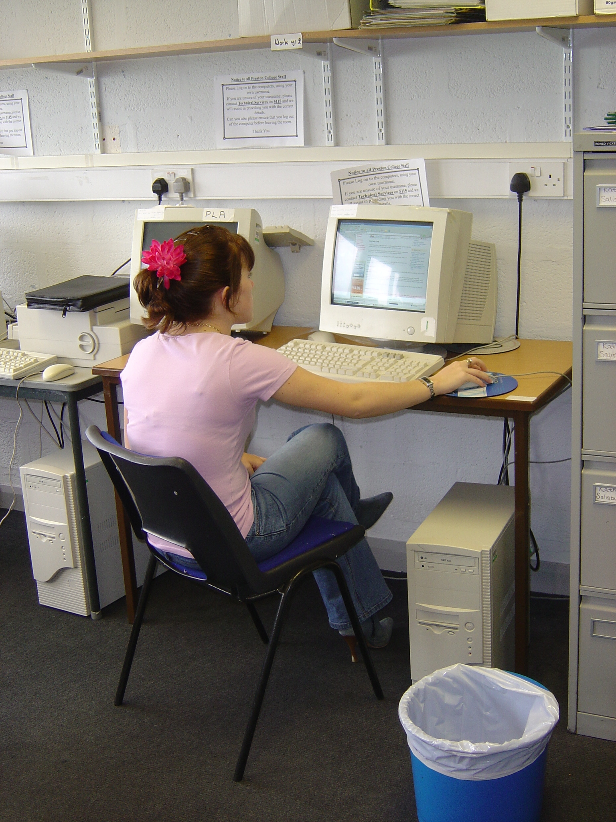



Electronic code: | 2-EP-PL-ZF-27.07.05
Pseudonym of student: | Pauline
Author of case study: | Zoe Fowler
Date: | 27.07.05
Sources drawn upon in this case study: | - Student interview  - Student clock

Section A: Pen Portrait
Pauline is a student on the Level 3 BTEC National Certificate Childcare course at Preston College. She lives with her parents and brother, and her boyfriend sometimes lives in the house as well. Pauline spent a year taking AS Levels at Preston College after she left school. She then began the BTEC Childcare course at Runshaw College for just over a year. Then she worked in a variety of office jobs.

Pauline is finding the balance between work and college to be difficult because of the long hours that she works: “I know that college is important, but at the same time because I’ve been used to so much money working full-time then I’ve dropped to virtually nothing…” She does not get paid for the work that she does which is classed as her college placement.

Section B: Literacy Practices
- Private Leisure
Pauline downloads CDs and prints out track lists on her home computer.

Pauline enters internet competitions. At home she uses teletext a lot, recently using teletext to confirm the flight arrival times for her parents so that she could collect them at the airport.

On her clock, Pauline talks about reading magazines and brochures. She reads the TV Times, Elle magazine, hair and beauty magazines. She enters competitions through these magazines. She doesn’t look at the magazines on health and fitness that her brother receives through the post.

Pauline enjoys swimming and she is about to join a gym with her mum. She likes going out for meals or saving up and going out for the day. She walks her boyfriend’s dog around Blackpool.

Pauline likes reading books.

- Organising Life
Pauline makes lists of things that she needs to do and leaves sticky note reminders for herself at work. She says that she always records homework in her diary in case she forgets.

Pauline has a current account. She keeps all her receipts and checks her balance through telephone banking or internet banking. She keeps all her paper statements together.

Pauline contrasts her own organisation with her boyfriend’s lack of organisation. She explains that she has had to organise their holiday rather than leaving it to him. She booked her holiday through a travel agents’ where her friend works. They looked through a few brochures to choose this holiday.

Pauline has a monthly payment to make on her car. She keeps all the documentation relating to her car by the side of her bed. Her father helps her out financially when she gets “stuck”.

Pauline and her boyfriend recently travelled down to Devon to see his relations. They planned the journey using a road atlas and sorted out accommodation and expenses. They shared the driving. When her boyfriend is driving, Pauline reads the map.

Pauline likes looking through clothes catalogues, making lists of what she would like and then buying things when she can afford them. She likes Argos Additions and Grattans. She usually looks through the catalogues when she is “bored” or when she wants something to do. She sometimes uses the index to find the section of the catalogue that she wants to look at.

- Personal Communication
Pauline’s main form of keeping in touch with her friends is through text message. She texts more than phone because it is cheaper. She uses abbreviated language in her text messages, but she tends to write words in full when she is using email. Pauline touch-types and thinks that it is quicker to type words out in full on email. Pauline sometimes texts her dad – although her mum has a mobile phone, she doesn’t send her messages because she isn’t sure how to use the phone.

Pauline receives emails from her friends – she reads these at work or at college because she does not have internet access on her home computer. She also receives emails advertising things or informing her of competitions that she has entered through the internet.

- Documenting Life

- Sense-making
Pauline drives and refers to this on her student clock. She prepared for her driving theory test by getting a book from the DVLA and the Highway Code and asking her friends and parent to test her on this.

Pauline likes cooking but is generally too tired when she gets home from work. If her mum doesn’t cook she might make a microwave meal – she observes that she can’t cope with the timing of a meal such as a Sunday Roast. Pauline particularly loves baking: “I can bake anything.” She says that she knows most of the baking recipes but she might use recipe books.

- Social Participation

Section C: Emerging Themes
- Domains
  - College
On her clock, Pauline had been reading the notes in the text book. She prefers to get notes on a photocopied sheet that she can read through and highlight, rather than making her own notes during the lesson – “I find it boring writing down each piece”. In class she is expected to take notes of what the tutor is saying as well as making notes on what the tutor might write down. Pauline contrasts her own note-taking with that of Katy – whereas Katy makes copious notes, Pauline tends to bullet point. Pauline finds it easy to take notes and she relates this to previous employment she has had in office jobs – she has experience of minute-taking and other administration skills, although she has not been trained in this.

Pauline prefers to do college work when there is a background noise and she tends to play music through her computer when she is working at home.

  - Work
Pauline works in a private nursery attached to a private school. She has been able to use this setting as her placement for the course as well as working there already. She works every day, except college days, from 7.30 – 6.30. She finds it “difficult” to fit in her college work. She thinks that she is coping but admits that this is sometimes a bit of a struggle. She enjoys this kind of work.

Pauline’s work environment is literacy-rich (these are detailed on her clock): registering the children; planning and reading the plans (the headmistress checks these plans for before and after school care); accident forms; putting names on art work; reading stories to children; keeping children’s personal daily charts up to date – she finds this time-consuming when she does it for 17 children but there is a system of abbreviations e.g. wn for wet nappy; reading medicine bottles, making sure that children have a medicine form filled by parents, and getting someone to counter-sign the medicine form following administration; checking the names in children’s shoes and clothes; looking at posters on the walls and using Letterland books. Pauline hadn’t realised how much reading and writing she did during a typical day at the nursery until she did the clock exercise.

Pauline links her previous office experience to her current course and work, she particularly thinks that being organised is something that she gained from her admin work and which is now valuable: “I find it easy writing a lot of lists, like if I’ve got a lot to do for homework I write a big list and tick it off as I do it, or if I know I’ve got to do things in nursery I’ll put stickers – sticky notes up places”.

  - Religion

  - Other [please provide heading]

- Technology
Pauline has a home computer. They are not connected to the internet at the moment – they used to but it broke and they haven’t renewed it. She also uses her home computer for writing assignments. She goes on the internet when she is at “school” (work) and she takes the older children to the ICT suite as part of their after-school provision so that they can go on the internet, play games, do research or whatever.

- Family attitudes

- Identification
Pauline wants to move into primary teaching and thinks that it is a shame that they haven’t got a course to go straight into primary teaching rather than having to do all the nursery-nurse stuff first and then going to university.

Pauline identifies herself as an organised person and links this to her previous office experience. She thinks that her systems of organisation are useful for both her college work and her employment.

Pauline plans to go to university part-time when she has completed this course. She contrasts herself with her brother who sees himself as practical – Pauline says that she can do practical things but likes academic things like teaching as well.

- Other [please provide heading]

Section D: Other thoughts for future data collection or analysis

Section E: Comments from other readers [please date and initial]

