

Case study

BTEC National Certificate in Childcare:
Human Growth and Development Unit
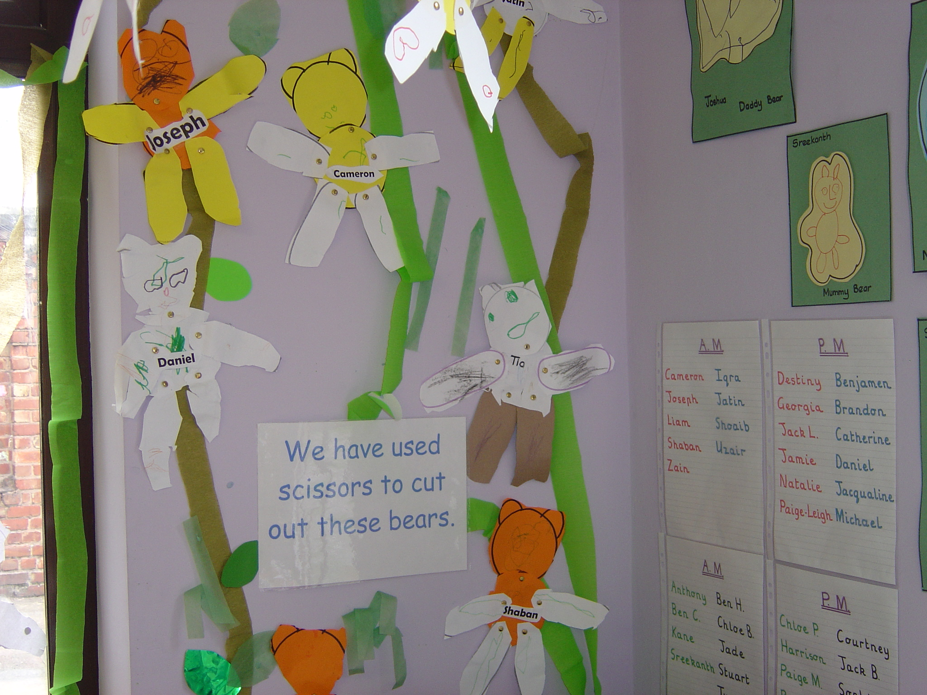

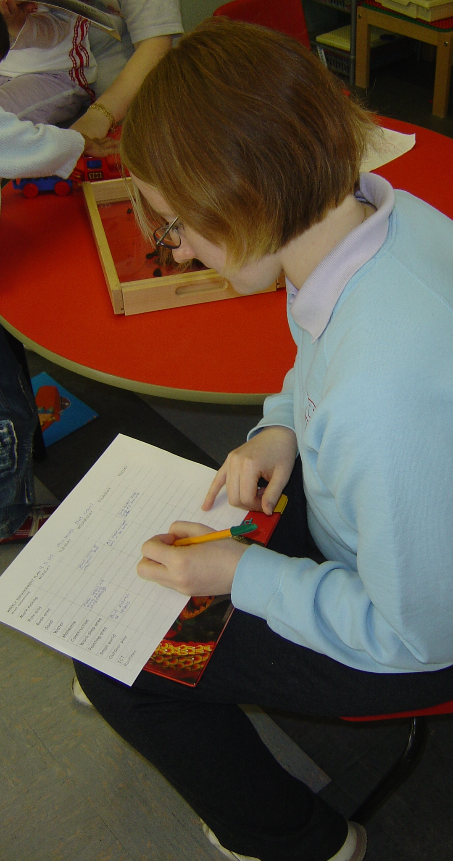
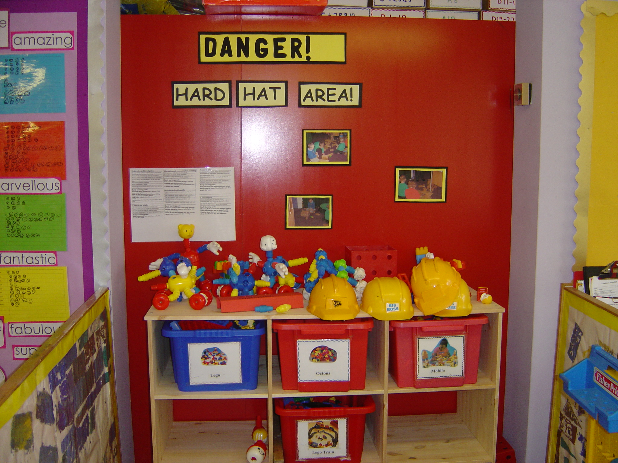

Interim descriptions of unit:
BTEC National Certificate in Childcare: Human Growth and Development Unit
Preston College

General description:
The BTEC National Certificate is a Level 3 course, equivalent to two A Levels. The students work on 12 units over 2 years. Six units are equivalent to one A Level. The students work on their Professional Practice unit over the two years, the other units are taught within semesters. Twelve units do not result in twelve assignments – some units give the students two or three assignments. The students are given 5 years to complete the course – this recognises that some students might leave for personal reasons, for example to have babies, and then come back to complete at a later time. The students also need 800 hours in placement over the two years. It is the placement element that is related to the license to practice – if the student passed all the other units with distinction but failed their work-based practice unit, they would not achieve their BTEC –“we’ve got to say they are capable in the setting”. Some students aim to achieve merits and distinctions so that they can progress to university, but students can pass the course by achieving passes for each unit. The students have the opportunity to upgrade their work during learning review week.

This is the first year that this course has run using this format. Part way through the course the structure of teaching was changed to bring the students into some classes with 16-19 year old students. Joanne did not start teaching this unit until they were already 5 weeks into the unit, taking over from a new member of staff who “wasn’t following the scheme of work… so the students were a little bit disadvantaged” (2-EP-AB-JK-040505). The consequences of this tutor’s lack of understanding of the course is referred to at several points in many of the interviews – Joanne feels that this is particularly a consequence of this tutor lacking experience herself in childcare settings rather than lacking experience in FE (a distinction in experience which might be worth investigating further). This has meant that Joanne has needed to provide much more theory and allow for less discussion than she would normally use. She had previously taught this group a unit on professional practice unit and she contrasts her pedagogic approach in the professional practice with her more didactic approach to this unit.

The grading for the BTEC is “a quite complicated system” (2-EP-AB-JK-040505) consisting of assignments and placements. It is sometimes difficult for the students to pick up all the criteria for a unit at any one time – for example, one unit requires the students to do one-to-one work with a two year old, but this might not be possible until the students are on placement. Therefore the units tend to overlap one another (this is returned to in the assignment section of this paper).

The file of work that Joanne is using in teaching this unit is one which has been developed by Karen Pecsvaradi, who taught the unit the previous semester. There is a clear scheme of work. Unlike other units that Joanne teaches, she did not develop her own resources for this unit but used the materials that had already been produced. This related to Joanne’s perceived lack of time to cover all of the information adequately with this class and contrasts with Joanne’s teaching on the other FCC unit being researched for this project where Joanne has tended to produce her own resources and amend other people’s.

Available Resources from data collection:
Data:
2-EP-AB-JK-04.05.05 – recording of conversation following Angela’s observation of Joanne’s class.
2-EP-AB-JK-25.05.05 – tutor’s detailed reflection on a text – the recording consists of two interviews.
2-EP-AB-JK-13.06.05 – recording of general conversation between Angela and Joanne (this is mainly on the professional practice unit).
2-EP-AB-JK-05.09.05 – handover interview (quite a lot of additional information on student placements on this recording)
2-EP-AB-JK-SB-AD-0405/2704 – first part of this is Shaheen discussing her day based around the clock face; followed by Katy discussing her clock; at 16:38 this then changes to a conversation between Joanne and Angela about an observation Angela made on 20/04/05. This is a duplicate recording of 2-EP-AB-JK-04.05.05.

Participants:
- Staff
Joanne started teaching part-time at Preston College three years ago; she now works full-time for the college combining teaching with visits to students on placement. She was also undertaking her Certificate in Education during Phase Two of the research. Joanne had a major operation shortly before Christmas and subsequently spent three months on sick leave. Joanne works closely with other members of the department and shares resources with them. At the start of 04/05 she was teaching this class the professional practice unit, but after returning from sick leave she was asked to take over the unit on Human Growth and Development (which was 5 weeks into the teaching). She taught this unit purely to fulfil the assignment criteria, which she does not consider to be ideal: “because you don’t just teach a unit to fulfil an assignment, you teach a unit so that they get the concept of human growth and development, not just to pass the assignment” (2-EP-AB-JK-04.05.05). While teaching this, because she was the PLA (personal learning advisor) for these students, it became apparent that over things hadn’t been covered in another unit which had a knock-on effect on the lesson that Joanne taught. Joanne felt that this put more pressure on her than on her students.

- Students
The students are adults. Originally the group consisted of 11 students but by the time that Joanne returned following her sick leave there were only 3 remaining students. Because of the small number of students they are incorporated in some classes with 16-19 year olds, but Joanne teaches the 3 students as a separate class three times a week (in 2-EP-AB-JK-040505 Joanne explains that it is difficult to get a good discussion going with only 3 students). Although they are expected to have a minimum of 4 GCSEs including a C grade in English, the college does not ask for proof of qualifications. Joanne wonders if the college is therefore enrolling students onto the course who are not capable of this level of study: “they could talk it but they might not be able to do it” (2-EP-AB-JK-13.06.05). Because of Joanne’s concerns at the start of the course, the students were screened, but only one student was identified as having difficulties. This student chose not to have support from the Learning Support Centre. Joanne thinks that the screening is inconclusive. She thinks that the students might drop out because they are struggling with the course because of the demands of the course, or because of the demands of the written work: “if they’ve not wrote an assignment or any written work for so long and then they’re being asked to hand loads in, because it’s very academic and I know that time as well, running a family, childcare issues came into it, travelling here came into it” (2-EP-AB-JK-13.06.05) To try and support the students, they are given a schedule of the different assignment deadlines and the different members of staff co-ordinate their work together. But Joanne thinks that there are other issues that are out of their control. She also recognises that this is the only part-time way the students can get a Level 3 qualification in childcare without doing an NVQ. Joanne also thinks that at first the students don’t understand how to “get past” the systems that are in place (I think here she means things like the language and format of the assessment front sheets – this might be worth further clarification with Joanne). She thinks some things look as though they are “loads and loads of work” when they are not really. Some of the students dropped out for personal reasons – one student got pregnant, another had family commitments to care for an elderly relative, one was struggling with transport to college.

Pauline has left employment in the secretarial sector to return to college. At the time of data collection she was struggling with the course because she had fallen behind with her work and she was also struggling with the financial consequences of being a student, working as an unqualified nursery nurse to make money alongside doing her college course and placement. Pauline failed to complete the assignment for this unit and subsequently failed the unit. She had previously studied part of this BTEC course at another college (more is written on Pauline in the section on the literacy demands of the course) and Joanne thinks that she sometimes becomes disengaged during lessons because she thinks that she knows the work because she has already done it once. In May, Pauline had texted Joanne at half past ten at night to let her know she hadn’t done a presentation for the next day’s lesson. There is a conflict between Pauline’s perception that she knows the work already and doesn’t need to engage or make notes and her struggles to complete things because she is overcommitted. Pauline is not up-to-date with her homework. Unlike her two peers, Pauline tends not to copy everything down in lesson time. Initially Joanne had thought that Pauline was a “strong” student but during the phase two data collection she started to think that Pauline was just telling her what she thinks Joanne wanted to hear. Pauline has a computer at home but she doesn’t have email or internet access. Pauline submitted one assignment to Joanne but she had written 5000 words rather than 1500. Joanne explained that she could not mark this because it had not met the word criteria and she recommended that this student should go away and break this down. When Pauline resubmitted her assignment it was “still massive” but Joanne agreed to read it “and instantly I could see that she was going too deep too quick”. Joanne told Pauline the assignment was still too big and advised her to write in less detail. Because she was behind in other areas as well she decided to drop out of the course shortly after this. She had not written her professional practice log. “She couldn’t get the time management side right but because she was telling people she could, when it became apparent it was too late.” (2-EP-AB-JK-05.09.05).

Shaheen is an Asian bilingual learner who has English as her second language. Following this data collection, Shaheen dropped out of the course due to personal reasons. At the end of Phase Two, it was not clear whether she would return to the course or not. Shaheen has two children. Joanne observes that Shaheen needs some “pushing” to complete her homework assignments. In another lesson, Joanne had observed these students presenting information – Shaheen had prepared for this on her computer and used PowerPoint, but Joanne felt that sections of this had been copied out of a book “she’d just wrote what she’d read” (2-EP-AB-JK-040505). Shaheen brings a “USB pen” to save her work from the college computer when she uses the computer during lessons. In the discussion below on plagiarism, Joanne is referring to Shaheen as a student who struggled to understand that she could not manipulate an author’s words to fit into her writing but should quote exactly what was written.

Katy has a young son. Joanne observes that she always completes her homework and hands it in on time. When Joanne observed Katy’s presentation in another class, she used flip chart paper because she does not have access to a computer at home. The quality of her presentation was high and Katy clearly understood the major concepts. Katy wants to get a home computer. She saves her college work in her computer area at college and sometimes works later at college so that she is able to do research for her assignments on the computers in the college library, but she tends to also handwrite everything which Joanne realises means that she needs to do a lot of rewriting. All of her assignments were submitted in handwritten form. Joanne feels that Katy is the most organised and strongest of the students. In the session where the students accessed national curriculum information from the internet, Joanne also provided hard paper-based copies because she did not feel that Katy was as confident as the other students in accessing the internet because she does not have access to this at home. Joanne provided additional support to Katy in this lesson.

Place and space:
Although this unit is taught within college, the course is delivered through college and through work-placements. One of Joanne’s lessons on this unit is taught within a small classroom which has computer access so the students are able to go on-line. In other sessions, Joanne has used tablet PCs with the students because they are such a small class.

When the timetable changed, the students did not have a classroom for their weekly session on professional practice so they used to use a small staffroom within the Academy which had a few computers in. They didn’t have an access to a printer in that room.

Time and timing:
The course had been running for a full day, from 9.30 – 5.15, but it was felt to be “an awful lot to do in a day”: Joanne links this particularly to the fact that the students have been out of education for a long time (2-EP-AB-JK-13.06.05). The students attend college on a Wednesday and Thursday morning, and spend two full days a week in practice. At the start of the data collection, the college intended that in 05/06 the course would run for one day and one evening to provide the students with more time. Joanne particularly thinks that they need the time for developing things like key skills: “because we are asking them to write at an academic level at A Level standard but some of these students might only – they might say ‘it’s 16 years since I wrote anything down’.” (2-EP-AB-JK-13.06.05) However, due to the changes in adult funding which were announced midway through this data collection, the college took the decision to not run this course at all in the future.

The students are expected to do homework and complete assignments in their own time. Joanne observes that the adults struggle to fit the college work into their complex lives – two of the students have their own children and Pauline is working long hours as a paid unqualified nursery nurse.

Joanne is anxious to cover the theoretical knowledge within this unit and she is concerned by the lack of time to do this due to the previous teacher’s inefficiency. She thinks that this results her in doing more teaching from the front and using more OHTs that she would ideally like – “I don’t particularly like teaching like that” (2-EP-AB-JK-040505). She would prefer to do lots of practical activities as a way of understanding the theory rather than having to teach this from the front. She would also have liked to use videos. Joanne does not think that she has had a choice to use her preferred pedagogic styles because there is not enough time before the students need to complete their assignments.

The deadlines for the assignments for each of the units are agreed prior to the start of the college year so that these are spread out and students know what to expect from the beginning of the course. Joanne thinks that this has benefits for the students but it disadvantaged her teaching of her unit because she would have liked to have delayed the assignment once she had taken over this course but was unable to do this because of the knock-on effect it would have had on the other courses.

Literacy activities related to learning:
The teaching on this unit was constrained by the amount of knowledge that Joanne had to cover: “it wasn’t practical, everything was just facts and overheads and handouts and not, where I would have liked to have if we’d looked at a theorist done a bit of practical with the theory so that I could tell that the students understood, time just wouldn’t allow for anything like that.” (2-EP-AB-JK-05.09.05) Later she explains that the resources that she used were limited because of the time constraints on the course. Joanne told the students that she didn’t like teaching in this way. She deliberately made very strong links with all of the assignment criteria.

Texts used in Angela’s observation of class (04.05.05)
During her observation of the lesson (2-EP-AB-JK-040505) Angela noted that Pauline started to make notes during the class activity whereas Shaheen wanted to take the information away and type up her notes at home using a computer. Joanne observed that Shaheen prefers to do work on a word processor. Angela observed that all the students brought pads and pens to the lesson that she observed. Pauline was asked to copy up the notes from the previous lesson that she had missed due to illness – Pauline made a note of this in her diary. Joanne notes that Pauline “says that she uses her diary a lot” (2-EP-AB-JK-040505) but Joanne has recently observed that Pauline is struggling a little bit and is behind with all her work due to absences when she was on jury service and when she was “off sick”. Joanne had a “quiet word” with Pauline about this in the lesson previous to that observed by Angela. In the lesson where Angela was present, Joanne noticed that Pauline made hardly any notes during the class whereas the other students “were writing loads down”. When Joanne asked why she wasn’t taking notes, Pauline said that she had done this section of the course before. Joanne had voiced her concerns to Pauline that she has hardly any work written down from the lessons. Joanne has only recently started teaching this unit, but she recalled that Pauline had made more notes during the previous unit she taught this group on professional practice.

In the lesson observed by Angela, Joanne provided the students with a handout on the stages of language development. This was an activity where the students needed to match the stage of development with the age of the child – the students wrote their answers to this in pencil. Angela noted that Shaheen was reading aloud to herself during this activity. Joanne wonders if this is related to the fact that English is Shaheen’s second language. Angela also noticed that Shaheen was significantly slower to complete this task than the other two students. Joanne observes that Shaheen has a slightly lower ability level than the other two students. Joanne then went through the responses with the students and set some questions for homework related to research. To do this research the students would be expected to use a book called The Age and Stage of Development to help them to find the answers. This is a recommended book for the course. Pauline and Shaheen have bought this book and Katy gets the book out of the library.

In the lesson observed by Angela, Joanne then presented some information using OHTs which the students immediately copied down. The students were also interacting verbally with Joanne during this process. Angela observed that some of the OHTs had quite a lot of text that needed to be written down. Joanne notes that the students like to copy down information – she refers to an earlier lesson where she had presented the same information in two different formats, but the students had wanted to copy down both sets rather than accepting that the information was duplicated. She thinks that particularly Shaheen and Katy write things down all the time – Joanne contrasts their method of doing this “word for word” with her own preference which would be to make more “notes” (2-EP-AB-JK-040505).

In the lesson observed by Angela, the students then took part in an activity related to bilingual children. Joanne went through the needs of the children in the different scenarios and told the students that they could write notes onto the handouts – none of the students did write on the handouts or make notes. Angela found it surprising that “they copied all that text down from the OHT, but yet all that information which I would have thought would be really useful information for them about the bilingual children, none of them made any points at all on what you [Joanne] said or what anyone else said” (2-EP-AB-JK-040505). Joanne thought that maybe they thought they had got enough information from copying out the OHT. Angela distinguishes the demands of copying things down and making notes from a discussion, which she considers to be a “harder skill”. The students then took it in turns to “have a go” at the scenarios.

Following this activity, the students were given a Vygotsky handout. Shaheen started to make notes at the top of this handout. The students took it in turns to read out sections from this handout. Angela noticed that Pauline seemed to have “switched off” at this point and wasn’t looking at the handout at all. Joanne thinks that this might be related to her tiredness or because she thinks she has done this before. Joanne then went through the zones of proximal development and the students immediately copied this down “because they know that they need this for their assignments” (2-EP-AB-JK-040505). During this activity, Joanne encouraged the students to key in the name of the theorists to the internet during their own time. Joanne thinks that the students are competent and confident in using computers.

The students then went through another OHT. At one point Joanne left the lesson but the students continued copying down the information from the OHT. Angela asked Joanne about the images on the OHTs – this is not something that Joanne tends to do, but the slides have been produced by her colleague Karen who tends to use images.

Detailed reflection on 2 texts by Joanne – planning an activity (25.05.05)
One of these texts is a handout (headed ‘Activity Plans’) – the students were asked to highlight the headings to help keep them focussed and so that they could identify them more quickly. Having highlighted the headings, the students then talked as a class about the things that they would need to put into each highlighted area. Joanne felt that highlighting kept the different sections discrete in the students’ minds rather than the text being seen as one large amount of information. Joanne expects them to use these headings when writing up their activities. Some of the things were self-explanatory, but some sections needed to be stressed in more detail. For example, Joanne stressed that they would need to include short sections of information in the aims section because she had noticed when marking work submitted by these students (the professional logs) that they tended to include too much information in the aims and this then meant that too much information went into the other sections. In other areas of their professional logs, for example the evaluations, where the students were expected to include more information, they were not tending to write enough.

None of the students recollected having seen this handout before during the session. However, when Joanne checked their notes on this unit she found that they had been given this guidance before but she felt that it had not been explained to them. The purpose of this activity was to improve the ways that students write their activity plans – this is something that the students need to do for their placements, and these need to be written in a certain way to meet the assessment criteria: “by writing it this way they get all the criteria in without realising it”. Joanne is keen that this process should become “natural” to the students. This exact format might not be necessary to their future workplace but they will need to do some kind of planning.

Joanne told the students that they could write all over the handout. At points in the lesson she dictated information to the students and at other points she wrote things on the white board and used OHTs that the students copied down. She expected the students to write down a lot of things because it was very important that they understood things: “I couldn’t afford for them not to get it this time”. This first handout linked to the whole lesson.

The second text reflected upon from this session has “Aims and Objectives’ in the middle and then lots of square boxes around the side. This linked in to the earlier handout used in this section and would help the students to provide better plans for their logs and to improve their practice in the workplace. Each of these boxes is further broken up into bubbles – Joanne describes this as “like ideas storming”. She showed this to students for ideas on how to break down aims into smaller, more manageable sections. Joanne is not suggesting that this sheet contains all the aims that students should use, “it’s just a worksheet to help them think about it”. The titles on this are not specific for the curriculum, they link to developmental targets. This is to promote the students’ understanding of the child’s development. Joanne expects that students would be familiar with the terminology on the sheet – no students queried this when she handed out this worksheet. Joanne expected the students to refer to this sheet but not to copy this down. Joanne thinks Shaheen would have been the student most likely to copy sections from this handout rather than using these to stimulate her own thinking, “Shaheen finds it harder to understand, I don’t know whether that’s because English is her second language or she isn’t working [in a childcare setting]”. Joanne worked through the handout separately with Shaheen. The other two students do additional paid work in childcare settings where they are expected to plan – the students are not expected to produce plans for the placements in their roles as students on placement.

Joanne didn’t design this handout – it is one that they use a lot in her Academy. She thinks it looks “quite fun” and it makes sense to her because she uses a lot of spidergrams. The students readily understood how this works. Joanne realises initially that it looks as though it is a lot of information, but that this isn’t the case when one looks more closely at the sections. She wonders whether the use of colour for the different sections might make it look initially more manageable. She thinks she would change the vocabulary and colour the design if she was using it with a lower ability group. She doesn’t think that any students struggled with the handout, but she also felt that if they did they also had the text book to help them. This uses the same words as the handout, with one or two exceptions.

When going through this Joanne talked about what she would do/had done in practice – for example, in terms of differentiation.

Detailed reflection on text by Joanne – planning with the National Curriculum (25.05.05)
Joanne reflected on a handout she has used with the class which has been taken from the National Curriculum framework for children (English 1 Speaking and Listening). This lesson followed the session where she had used the planning documents she referred to in the previous section. This handout is a print out from the internet of the curriculum links. She provided the students with this printout and another relating to Art and Design. Because the national curriculum consists of 10 subjects, Joanne provided the students with “tablet pcs” at the start of the lesson, and then used an OHT to tell them how to identify curriculum links and provide relevant web addresses. Joanne had designed the top bit of the OHT and had then copied some further information from a book onto the slide. She thinks this is “easy on the eye” and finds the 3 columns useful. “It gives all the information but in a short context”. She had planned a more complex slide to communicate this information but when she saw this layout in a book she thought that this was more effective at communicating the information and therefore decided to use this format instead. The students asked Joanne whether they should copy down the information from this OHT and she told them that it would be useful – both of the students then copied down the information. The students would be familiar with the notion of using curriculum links because of the work that they have done with the foundation stage, in this session Joanne was introducing new curriculum links rather than introducing a completely new concept. She felt that the students were therefore quite competent with this – it was building on something that they already knew about.

The students went on-line and found other relevant national curriculum material and printed it off: “but first of all we found the one we’d already given them the handout from so that they could see it was the same information just in a different format” (2-EP-AB-JK-250505). The students therefore looked at the information on the paper-based handout and through the internet. Joanne related this to the different computer knowledge of her students – she felt that they were not equally confident in accessing the internet. There were only two students in this session so it was possible for them to work separately on the wireless tablet PCs and to print off information. Because Joanne had never used these computers to print before, they needed to spend some time in the session finding the relevant printer – this was quite complex because the computer called up all the wireless printers in the college. The students printed off “quite a lot” of information. Joanne provided Katy with additional support because she was not as confident in the use of the computer. Katy reflected to Joanne that she was quite proud of the IT skills she had used in this session. Pauline was very quick in the task – identifying relevant sites and printing off information.

Joanne had amended her planning for this session because there were only two students. Because of the low attendance she felt happy in borrowing 3 tablet PCs from the staff room so that the students could work independently. If the class had been larger, the students would not have had individual access to a PC. If there had been more students she would have asked the students to plan an activity at the end of this session, but she felt that this lesson was more effective than her plan. The students will plan an activity for her for homework instead.

Because she had provided a handout of relevant information for English at the start of the session, Joanne felt that they were more confident in accessing the English curriculum links on the website – they knew what they were looking for, “they were able to access the information because they were aware that they were focusing on key stage 1”. Joanne also explained that the information on the internet is more complex because it has a fourth column – for the handout that she used at the start of the session, Joanne removed this fourth column to make the information less complex and easier for the students to be able to access. Joanne does not think that there were any things in this activity that these two students struggled with.

Joanne had planned this session after it became apparent when she was visiting students on placement and when she was marking the professional practice unit that they did not know how to make curriculum links in their planning as this had not been covered by another tutor – Joanne referred to using this session as “to catch up on something else that they have not received”. In the previous session they had broken down what the students should do when planning, this session then built on the knowledge from this previous session. If the students don’t get planning right they will “fail it every time in their log” (their weekly work-placed log while on placement). Joanne explicitly linked this activity to the assignment that the students would need to do the following year on literacy and numeracy – especially pointing out the other links from the national curriculum that relate to ideas for activities and resources.

Reflections on texts from handover interview
An overhead relating to APGAR scores which related directly to task 2 of the assignment – where they needed to describe how children’s growth was measured – was talked about by Joanne in 2-EP-AB-JK-05.09.05. Joanne put the OHT up on the screen and the students “copied it exactly how it was, they did the chart, they drew lines and everything”. Joanne reflected that two out of the three students tended to copy everything that they saw and they thought that this really helped them. The student who didn’t copy everything (Pauline) was the student who didn’t manage to complete this assignment or pass this unit.

A handout headed “physical development” was used for an activity. Joanne provided the students with a description of what the different words meant, and then the students had to relate the words to actions and which were listed underneath and group these. Following this, Joanne put up another OHT which categorised what they had just done and the students copied this down, even though they had just written down the same information in a slightly different way for their activity. Joanne explained that they didn’t need to copy this down as they had all of the information, but the students responded that the information looked clearer in this new format so Joanne left the OHT on display and they copied down all of the information.

In the handover interview, Joanne reflected on the student’s use of quotes – they were too perfect for the work and Joanne couldn’t imagine them being written in a book in this way. Joanne asked the student to bring in the book that she had quoted from, when the student did this Joanne was unable to find one quote at all and the other quotes had been slightly reworded to fit with the tone of the assignment. Joanne recognised that this might be seen as plagiarism, but she doesn’t think that it was plagiarism but rather an inappropriate use of quotation. Joanne spent some time one-to-one with this student to explain how to use quotations. This student had not understood the protocol of using quotations. Angela felt that this was often a classic difficulty of English as a Second Language students. Another student struggled to incorporate quotes because she wrote in a very descriptive way and tended to paraphrase rather than directly quotes. It was clear that the students had done lots of research and lots of reading, but not understood how to put this reading down in their assignments.

Literacy activities related to demonstrating competence etc. for assessment
The assessment for the course is a complex mix of theoretical assignment-based and practical placement-based. The students do lots of different types of writing relating to their assessments – Joanne lists (2-EP-AB-JK-13.06.05) essays, reports, statements for their IVA (a unit that is marked outside of college). Tutors write their assignments for BTEC (expect for the professional practice) so the literacy demands depend upon different tutors. Spelling and grammar are part of the criteria for the assignments, and if words are used in the wrong context.

To meet the different criteria for units, the units tend to overlap one another; for example, for some assignments they “pull in things” from different units (2-EP-AB-JK-13.06.05). To manage this the students have a ring binder file – when something has been marked the students the colour in this section so that by the end of that unit all the Ps, Ms, and Ds (passes, merits, and distinctions) should be coloured in – although this colouring in might have taken place over the two years because the unit interlink. This is so that the students can keep track of what they have completed. This colouring of boxes cross-references with the front sheets provided for each assignment which state the criteria that are to be covered in that assignment. When the assignment has been marked the criteria that have been met are stated on this front sheet which enables the students to colour in their sheets – they cannot do this until the assignments have been marked. Because the areas that they have not met are not coloured in, it should be visible to students what they have yet to achieve. Joanne considers that this process of colouring in is “straightforward” (2-EP-AB-JK-13.06.05) but she recognises the need for the students to “keep on top” of this practice. In this group, two of the students have been colouring in the boxes and one student hasn’t. To catch up with this process not being followed while she was away on sick leave, Joanne led a session in class on colouring in these boxes - Joanne hopes that “now they’re more aware of it, they’ll be able to do it” (2-EP-AB-JK-040505). At the end of the first year summer term, Joanne is intending to go through these sheets with students again. This process is made more complicated because some of the assignments have been internally verified and marked down, so students have not achieved things that they thought they had achieved in some cases. Joanne wonders if students should only be told to colour things in after things have been internally verified. Joanne always goes through the criteria with the students. She thinks that the mature students have found it more difficult to understand the cross-referencing that they can do. Students develop different strategies for dealing with this – some students who have been working on the computer print things off twice. At several points in the same interview, Joanne draws attention to the fact that once the students have done one assignment, it becomes easier in the future. The students need to do it to be able to understand it: “It’s very in depth and complicated really but once they get used to it, it’s ok” (2-EP-AB-JK-13.06.05)

Some of the assignments have substantial criteria to achieve a pass – on 2-EP-AB-JK-13.06.05, Joanne and Angela discuss in detail the criteria for one of the assignments for the Professional Practice unit and recognises the significant literacy demands for this unit. Because this unit is not being analysed for this research I have not documented their discussion here, but further information can be found on their recording (7:02 and 52:04). Joanne draws examples of terminology that students might not understand within this unit. Joanne thinks that if she doesn’t paraphrase the terminology, they wouldn’t meet all of the criteria. She also talks about her procedures when she visits students on placement. Joanne demonstrates how everything links together – the specifications, the requirements for the visit, and the assessment criteria that students need to achieve. During the observation, Joanne tries to make her comments relevant to the assessment criteria. Joanne draws attention to the fact that in placement “it is not a lot of written work that they having to do, they are just having to interpret and understand it”. The students need to write their own comments on the assignment sheet for this professional practice – Joanne works through this with the student.

For this unit (Human Growth and Development), the students have two assignments to meet their criteria. Joanne refers to the students not understanding what they had to do for this unit because of the previous teacher they had – she feels that “now they understand it, they’ve got that knowledge for all their other setting and all their other activities” (2-EP-AB-JK-13.06.05). She encouraged the students to reference what they were doing against the assessment criteria. This previous tutor had also set up an activity but not recognised this as an assignment; Joanne felt that this had disadvantaged the students. Joanne feels that this tutor is a good teacher but she does not come from a childcare practice and she had not fully understood things like curriculum links. For the first assignment the previous tutor asked them to write a 2500 word life cycle story and Joanne then explained this to the students when she took over the class. Joanne linked with the film Look Who’s Talking – the narrative voiced the experience of the child from the moment of conception and related this to theorists. Joanne observes that the students had no problem writing in first person and felt that they enjoyed this (2-EP-AB-JK-05.09.05). Joanne provided advice for one student who was struggling by text message – this student had used up her word limit but had only reached her narrator being two and a half years old. She texted Joanne at a weekend. Joanne responded saying she must be bringing in too much detail, and advised that she should stick to the facts and check the assessment criteria. This text conversation continued for a few more messages. The student then produced an excellent assignment with some merits. Joanne notes, however, that although this life story became quite personal as the narrator moved into her teens; she tells Angela that if she read the assignment she would know which student wrote it because she brought her own life into it. The student observed that she was aware when the developmental theories reached a stage she could remember from her own life that she became more personal. This did not affect her mark for this assignment.

The second assignment for this unit was a 1500 piece of writing on ways of measuring children’s development. The students needed to write about 3 different ways of measuring so Joanne recommended that they spent 500 words on each one. This relates to the APGAR score overhead discussed in previous section.

During Angela’s observation, Joanne talked with the students about the upgrading process. For this the students would need to look at the assignments that they have got, making sure that they have met all the pass criteria and taking the opportunity, for example, to provide extra written work to meet missing distinction or merit criteria. The students do not need to rewrite the whole assignment; rather they complete the sections relevant to the marking criteria they have not yet managed to satisfy. This enables their assignments to be upgraded. All assignments have a front cover which tells them what they have achieved in that assignment. There is also a scenario for that assignment and another sheet that tells them the actual marking criteria. Whether students are motivated to do this depends on their level of motivation – Joanne observes that many students leave this process until the second year of their course when they have, for example, decided that they need to get all merits to be able to get into university.

Non subject-specific literacy activities related to belonging to the college / being a college student:
Pauline uses a diary.

Literacy activities related to intended future of students:
In her detailed reflection on a text (2-EP-AB-JK-250505) Joanne talked about teaching the national curriculum to her students. They needed this information because the students were currently in school placements which expected the students to be able to plan according to the national curriculum. For some materials related to their placements, the students have been able to send off for free materials through the post, but the National Curriculum hard copies cost £25. However all this information is freely available on-line. In her session on the national curriculum (reflected upon in 2-EP-AB-JK-250505), Joanne modelled how to provide abbreviated national curriculum links in their school planning documents – rather than writing out curriculum links in full they could use the number reference to the particular part of the curriculum. She explained to the students that this would save them time on their placements and in their future practice. Joanne thinks that all the units are chosen because they link in to what the students will need to once they are working in a nursery.

The students need to be able to understand the theory which they learn on the course so that they are able to understand a lot of the policy and child development things that they will be expected to read in the workplace.

At the start of the course, as part of their Professional Practice unit, the students are taught how to structure an observation. They will be expected to carry out observations in their work placements and this is seen to be a practice that they will later need in the work place (although different nurseries might use differing formats for observations).

In the work setting each assessment criteria for the Professional Practice log needs to be signed off by a member of staff within that setting – this is to make sure that what the student is saying is true, to show that they have correctly interpreted and understood the information they have read and understood. They wouldn’t need to write a log when working in a nursery but would need to be able to read and understand the different nursery policies. Some nurseries require staff to read these things and then sign that they have read them.

Other:
During the observed session, Katy brought out a magazine from her placement that related to the work she was doing on the Hungry Caterpillar. She is developing a story sack for this book in a different lesson. Katy said to Angela that she regularly reads through the magazines delivered to nursery (2-EP-AB-JK-040505).

Reflecting on the VLE mycourse, Joanne felt that if a student missed a session on this course that the information was so complex that the student would still need Joanne’s input, rather than being able to catch up by remotely accessing the resources. However, the students also benefit from having things explained to them by their peers in the class.

Thoughts on interventions and innovations for Phase 3
Because the course was so demanding, it is not going to be run in Phase 3. It was felt to be too much work for adult learners who have other constraints within their lives (for example, paid work, family commitments etc.) Changes in adult funding also meant that it wasn’t feasible to run this course again. If they had run it again extra time would have been provided for key skills, particularly around academic writing and study skills. The college will be offering the DCE Level 3 course instead which is the existing full-time course offered at Preston. Adult students might otherwise choose to take an NVQ through their workplace. The BTEC is slightly more academic than the DCE and requires a higher GCSE points’ tariff. Joanne feels that the BTEC better prefers students for university because of the way the assignments need to be written because they need to do more of their own research. The DCE is more prescriptive and CACHE allow for less freedom and flexibility for student interpretation. Joanne thinks that in her experience as a nursery manager the best team would consist of people who had each taken different qualification routes because each of the qualifications offers something different. For example, the BTEC person might be the one to write things down while the DCE might have better practical experience.

