STUDENTS AS RESEARCHERS: CHALLENGES AND BENEFITS

Synopsis
Our research project worked collaboratively with Further Education students to explore the reading and writing that they undertake within their college courses and as part of their everyday lives. Here we reflect upon our experiences of this research process, identifying both the advantages and disadvantages of this approach.

Introduction
Students within Further Education read and write in all kinds of ways and for all kinds of purposes outside of college, and this repertoire of literacy practices can be drawn upon as a useful resource within the students’ college courses. The LfLFE project has been working with over 100 students at four FE colleges to find out more about their everyday literacies and the relevance that these might have to the students’ FE learning. Underpinning our research is a social practices approach to literacy. Rather than seeing literacy as a discrete set of skills to be acquired by the individual, our conceptual approach understands literacy as a social practice involving people, places, values, purposes, and a range of artefacts and media (Barton and Hamilton 1998). While we are able to observe people doing things with reading and writing, to understand literacy practices in more detail requires an understanding of what is going on from the perspective of those who are involved in them. In this article, we are examining and reflecting upon some of the advantages and disadvantages of involving students as co-researchers within the research process, rather than the students simply being respondents.

Recruitment of students as co-researchers
Our research project worked with a wide variety of students aged between 16 and 58 who were studying on a range of courses. At Preston College, one of the four colleges involved, the research was carried out across four curriculum areas – business administration, childcare, construction, and science; the other colleges involved in the research were all investigating the childcare curriculum and a range of other vocational and non-vocational courses. In each curriculum area, two courses at different levels were selected for research. We aimed to recruit four students from each of the courses in each curriculum area (that is, approaching students from different age groups, genders, backgrounds and ethnicities). Amongst the students who volunteered to become involved in the research were administrators who were seeking professional qualifications, a retired FE lecturer who had decided to study Painting and Decorating with no previous experience in this field, and a variety of younger students with varied vocational and academic ambitions. Some students were extremely keen to become involved in the work: one group of 16-19 year old childcare students were so enthusiastic that the whole class ended up being recruited as co-researchers. Other students, however, expressed reservations, primarily due to the intensive workload of their courses triggering the fear that taking part in the research would create even more work and worry.

In addition to co-opting students as researchers of their own lives, the research team included practitioners seconded from the college teaching teams. These practitioners have a variety of backgrounds and range from part-time lecturers who are relatively new to teaching in further education to experienced full time lecturers who also have responsibilities for curriculum management. In addition, there is a co-ordinator of the research at each Further Education college who is seconded for two full days per week, plus both part-time and full-time researchers at both universities who work with the college-based team. This diversity of perspectives maintains sensitivity to a diversity of interpretations of events and practices.

Principles guiding the Research
When working with people to research their uses of reading and writing in their lives we need to understand these activities and their value from the individuals’ points of view. Rather than constructing an impersonal,‘view from nowhere’, we seek to work with students, paying attention to their views and opinions. Our aim is holistic, aimed at capturing whole phenomena rather than only aspects of literacy.

Initially many students stated that they didn’t “do” reading and writing but during their involvement in the research process it became clear that there were many literacy practices which underscored the activities of their lives: from navigating the menu on their Digital television through to studying the Qu’ran, through to dealing with the junk mail which cluttered their letter boxes. As one co-researcher from a Forensics Science class observed midway through her involvement with the project:
“… by looking more closely at what you actually do read and write every day, and not just in class, it’s made me realise how much I do read! I always thought of ‘reading’ as someone sitting down and reading a novel, but I read at work when I am helping people to decide what they want for their meal, or explaining to them.”
This sensitisation to the extent and diversity of textual mediation in different areas of their lives required the student co-researchers to take a journey of reflection, and to facilitate this journey we developed a range of research methods that we worked through with the students over the period of between one term and one academic year.

The Research Tools
- Clock Faces
Soon after the beginning of their involvement with the research, students were asked to reflect on a day in their lives and record all of the reading and writing that they had been involved with during that day. The students were free to choose a typical college day or a day from the weekend. They then sketched two clock faces, one depicting am and the other pm, and broke these clocks down into segments showing their activities during this day, for example shopping, watching tv, cooking, working in part-time jobs, or texting friends using their mobile phones (see figure 1 for examples of these). Once the students had identified these activities, they were encouraged to think of the reading and/or writing they had undertaken during these activities, either through conversations with other student co-researchers or with college-based or university researchers. These reading and writing activities were annotated onto the clockfaces by the students or by other researchers. Conceptually this activity marked the beginning of their journey into understanding that ‘literacy’ is part and parcel of everyday life.

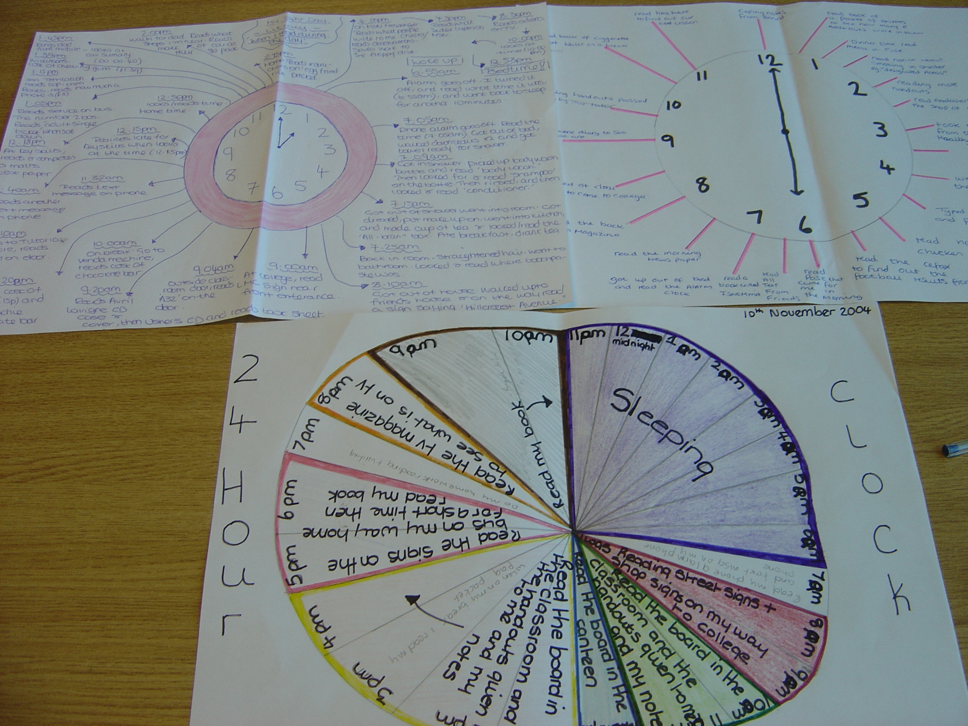
Figure 1: Example of students’ clock faces

Photographs
Following the clock activity, and to expand and enrich the data already collected, students were provided with disposable cameras and asked to take photographs of the activities which involved reading and writing within their everyday lives, for example at home, at work, in their places of worship etc. The brief for these photographs was left as open to interpretation by the students as possible, although we encouraged students to take photographs of texts being used in real-life contexts rather than just photographing the texts in isolation. By providing the student co-researchers with cameras, we were using photography as a collaborative research tool (Hodge and Jones 2000). This approach to research challenges power relationships between ‘researchers’ and the people ‘being researched’, by developing collaborative and participative ways of working. We were not carrying out research on these students, but we were working with them to understand the role of reading and writing in their lives from their perspective. This process potentially generates a greater understanding of the range of social meanings associated with the literacy practices that appeared within the photographs.

The range of photographs taken by these students was remarkable and often offered surprising insights into students’ lives. One childcare student, who had been adamant that she hated computers and never used them, photographed her on-line loan application on her home computer screen. A Painting and Decorating student photographed a friend’s web page and then critically evaluated the web server’s capacity in a subsequent conversation.

- Research Conversations
After the photographs had been developed, they were used as stimuli in recorded conversations between the students and university or college researchers. Together the student photographer and the interviewer talked through the photographs, making sense of and beginning to analyse the role of reading and writing within these pictures. The interviewer encouraged the students to move from talking about the events captured in the photographs to discussing the literacy practices that these activities involved: why were reading and writing being done in this way? What were the purposes involved in this kind of reading and writing? Who was the reading and writing for? What were the values attached by the student to these kinds of reading and writing? And, importantly, what possible relations might exist between these types of reading and writing and the things that they were asked to do on their college courses? The interviews were seen as a means of building on the data provided for the research by the clocks and the photographs. Following the interview and the writing-up, further areas and topics were identified with a view to these being a focus of future interviews.

As understandings developed of the literacy practices of the students’ lives, aspects of literacy began to be identified that might be mobilised into the FE college to enable the student to better succeed on their course of study. Changes in practice based on these insights are currently being piloted within the four colleges.

Ethical Concerns
We experienced some ethical dilemmas over how ethnographic research can evolve within a situation where the subject of the research is students’ lives and some of the investigators are students’ current teachers. The research process needed to challenge existing power relationships between students and their teachers. It is absolutely crucial to be non-judgmental during ethnographic research in order to build collaborative relationships with the students involved and to ensure that the research does not have a negative impact on their self-esteem. If students sense that relationships are equal and non-judgmental, they are likely to afford greater insights into their lives (Brzeski 2003). We felt the need to make clear to these students from the very start of the research process that we had no interest in trying to measure or evaluate their reading and writing. Our focus was very much on the practices in which they participated. This reassurance was particularly needed by some students whose experiences of schooling, whether a recent experience or one from several decades previously, had damaged their confidence in their ability to read or write.

A very positive outcome from the research process was that many of these students began to realise the extent and sophistication of their reading and writing practices. One of the innovations that is being trialled in some of the classrooms as an outcome from this research is for teachers to find out more about the kinds of reading and writing that they do outside of college as a means of enhancing students’ confidence that they will be able to meet the literacy demands of their FE course.

Another area of ethical concern was the potential imbalance between paid college and university researchers working alongside unpaid students to research the students’ lives. The students were, on the whole, generous with their time, their opinions, and in the access that they offered into their lives. The research team knew from the start that no financial payment could practically be made to the students involved in the research; however, all the team were determined to continually recognise and value the contribution of the students as co-researchers. A variety of motivational techniques were employed to express this value. These included respecting the students’ concerns about involvement in the research project by providing details of what their involvement would be: each researcher took time to explain very carefully to the students concerned about their role in the research and pointed out the benefits of being a part of such a huge research project, for example through being something that might be included on a CV. Students were always asked to carry out the research activities at times which were convenient primarily to the students, for example, some students were interviewed just before a class or just after a class. Students were invited to meetings with the Senior Management teams at their colleges where they were awarded personalised ‘letter of thanks’ from Lancaster University, signed by the Director of the LfLFE project. Several of the students particularly welcomed the opportunity to meet Senior Management teams, as they felt that this provided their involvement with a symbolic recognition of the importance of the project: as one student commented, ‘the work I am doing must be really important as so many people here are thanking me’. The students were also invited to a celebratory lunch at the university and this afforded some students their first experience of HE (one of our students who had had motivational problems on his course enjoyed the experience of visiting Lancaster University so much that he has now set his ambitions on progressing to HE and this has positively influenced both his behaviour and his identity on his course). And all students were given small presents as tokens of thanks for taking part in the project.

Reflections on involving students as co-researchers
The contribution of the co-researchers has been variable, which gives rise to dilemmas about engaging students as researchers in this type of project. The varied contribution is due to the fact that our co-researchers are at different levels within the education system and come from a variety of backgrounds. This gives rise to a variety of different motivations for wanting to be involved in the research. These varied motivations were very much apparent during the interview process. For example, one co-researcher is a BTEC science student aiming to go on to university to undertake a degree in physiotherapy. In the interview, this student was articulate and bright, understood the conventions of the interviewing process and was keen to express herself. By contrast, another co-researcher is currently a member of a Level 1 course, having progressed on to this course from an Entry Level programme. In this second interview, the co-researcher clearly found the conventions of an interview challenging. This student did not adhere to the turn taking conventions of the usual interview situation, resulting in the student, for example, talking at the same time as the researcher, going off on tangents, and not fully responding to questions asked. However, it must be stressed at this point that this lack of formal conversational skills does not in anyway diminish the value and validity of the data that has been collected from this co-researcher.

One of the particularly positive outcomes from adopting this collaborative approach to research with students has been some of the personal benefits experienced by students through being involved in the research. The positive effects of being involved in the research can be clearly seen in the case of one of our childcare co-researchers, referred to as ‘Blondy’. ‘Blondy’ has substantially gained confidence and has made excellent progress on her course, primarily due to her involvement in the project. Initially, ‘Blondy’ was very nervous about being recorded or photographed and thoroughly disliked reading aloud in class. However, she now admits to liking reading aloud, will allow her interviews to be recorded and is taking her new-found voice into her placement by reading stories out to children. The reflection by ‘Blondy’ on her uses of reading and writing in her life has enhanced her confidence in her own abilities and this has transferred into her learning. Here, Blondy has been able to accrue greater benefits from her involvement in the research as a co-researcher than would be possible if she had been simply a respondent.

Conclusions
In summary, the LfLFE project team are very much of the opinion that the co-researchers are pleased and happy to be part of the research process. It is clear that the co-researchers feel valued and appreciate that their contributions are absolutely vital to the success of the project as a whole, and will contribute to its overall aim of the research, which is to help students in Further Education classrooms to be more successful. It is even more motivating to be working with some of the students who may directly benefit from the LfLFE research. Despite some of the challenges and dilemmas of working with students as co-researchers outlined earlier in this paper, the project team are left in no doubt that the benefits of researching with students by far outweigh any possible challenges.

Bibliography
Barton, D. and Hamilton, M. (1998) Local Literacies: Reading and Writing in One Community, London: Routledge
Brzeski, A. (2003) The causes and effects of disruptive behaviour in the classrooms of Further Education colleges and what can be done to eliminate/reduce this behaviour, Preston, MA: Unpublished
Hodge, R. and Jones, K. (2000) ‘Photography in collaborative research on multilingual literacy practices’, in M. Martin-Jones and K. Jones (eds) Multilingual Literacies: Reading and writing different worlds, Amsterdam/Philadelphia: John Benjamins Publishing Company

Authors
Mrs Angela Brzeski, LfLFE Project, Preston College
Dr Zoe Fowler, LfLFE project, Literacy Research Centre, Lancaster University

Correspondence to Dr Zoe Fowler, Literacy Research Centre, Institute for Advanced Studies, Lancaster University, Lancaster, LA1 4YD. z.fowler@lancaster.ac.uk

The project is part of the Teaching and Learning Research Programme (TLRP) in the U.K., funded by the Economic and Social Research Council (ESRC), Grant no RES -139-25-0117. The research is being conducted by a team which includes Richard Edwards, Roz Ivanič, Greg Mannion, Kate Miller, Candice Satchwell, and June Smith as well as us. For further details, see www.lancs.ac.uk/lflfe

