Study Trip to China

Please email ci@lancaster.ac.uk if you are interested.

What will you be doing?
- The group will visit two cities (Beijing and Guangzhou) across 11 days, exploring both cities and enjoying a number of world-famous attractions.
- You get a chance to enjoy the culture, meet and talk with local people, and take part in Chinese language and cultural classes to enhance your visit.
- We have a huge itinerary, including visits to markets, museums, performances & shows, taking in Guangzhou at night on a river cruise, walking along The Great Wall of China, and much, much more!

When will this be?
- 11 days during the University Easter holiday, typically from the Saturday immediately after the University term ends for the Easter Break in March.
- Concludes early April, depending on where the University Easter Break. We can offer recommendations and help with your travel plans, but they are yours to make!

How much will this cost?
- You only pay for your flights to/from China, and your visa (typically around £600-800).
- All accommodation, meal & travel costs in China are covered by Hanban.
- Travel insurance for Lancaster University students is covered by LU’s insurance policy. Staff and members of the public may need to find their own insurance- please enquire with us and the University to find out more.

We have an Information Evening for the trip in November each year.
Please come along, even if you don’t intend to come on the trip in the following year.
Email ci@lancaster.ac.uk to find out when this session will be.

Requirements:
- You need to be studying- or have previously studied- Chinese with the Confucius Institute (either as part of a degree at Lancaster University, or on the Confucius Institute’s Extracurricular Language Classes).

- You need to have studied Chinese with the Confucius Institute for no less than 3 months or 40 hours, to be taken by the time of the trip. This is 2 term’s worth of the Extracurricular Classes.

- You cannot have already taken part in a trip organized by Hanban, e.g. Study Trip, Scholarship, etc.

- People who are not currently eligible, but who will be eligible by the time of their trip are welcome to apply.

- We ask for feedback in the form of a follow up report- an account of your experience on the trip! This can be as long or short as you want. If you’d like to submit something more official, Hanban requirements ask for a 3000 word report, but don’t worry if you don’t have time to make something this long!

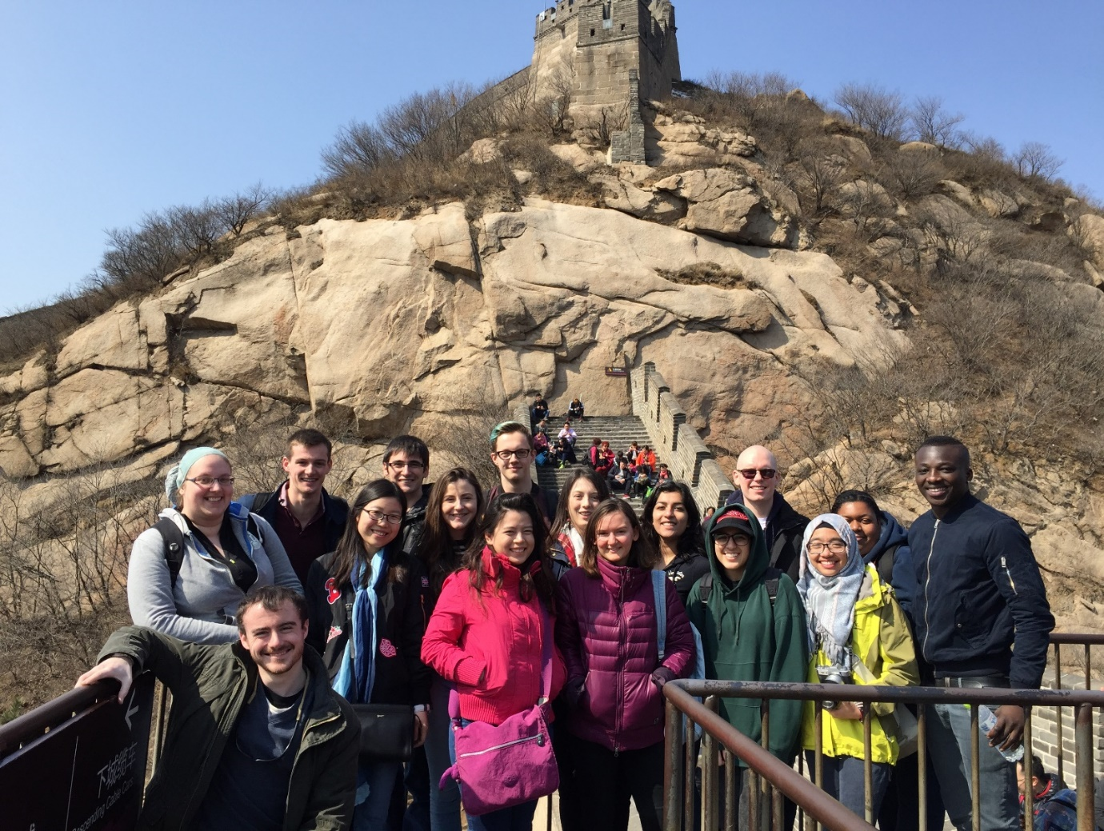
Participants on the 2017 Easter Trip enjoying the Great Wall of China

