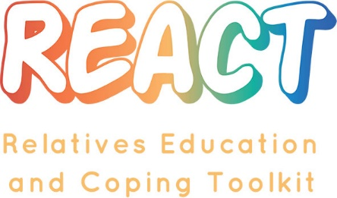
Maximising the success of Relatives Education And Coping Toolkit (REACT) in our Trust
The REACT website is an online resource that you can offer through your service to help you deliver information and support to relatives of people within the EIP service. It will be easier for REACT to become part of what you offer as a service to relatives if:
- Managers and key staff team members understand exactly what REACT is and the benefits it offers to them, relatives, and service users
- REACT clearly fits into the existing care pathways for relatives, so it is clear when and how it should be offered and does not create extra work
- There is strong and clear support for REACT at all levels of the organisation and using REACT is reviewed during staff case supervision
- Staff team members are clear about their individual roles and responsibilities regarding REACT
- Leaders and Staff team members receive feedback about how much REACT is being used, how well its working for relatives,
- Staff team members can provide feedback to inform the future development of REACT and its use in the Trust
- Carers sign up to use the REACT website and generate resources / provide feedback and develop the site
The following questions are designed to help you develop a plan and actions needed to facilitate the above:
Why are we offering REACT in the service? What key targets or aims will it help us meet?
How will staff team members be introduced to REACT?
- What key messages about the potential benefits of REACT will be given to motivate staff to use REACT and offer it to relatives?
- Who will give these messages?
Where does REACT fit into the existing care pathway for relatives?
- Who should introduce relatives to REACT?
- When should this happen? Can we offer this via existing contact opportunities with relatives e.g. on initial assessment, as part of care planning and review processes
- How should this happen? Can we help relatives with the login process as this may be new to them? Who will do this? Will we do this in the relative’s home or where/how can we do this?
- How will we document whether or not a relative has been offered REACT?
- How will we monitor the number of relatives offered REACT and when
What structure could the leader (IMPART lead or team lead) use to make offering REACT an ongoing process rather than a series of one-off events?
- How will you persuade people to action their intentions?

Which people in the team/service will do each of the following roles?
- Introduce REACT to new and existing staff team members
- Create accounts for staff team members on REACT
- Train and support new staff to use REACT (and appropriate IT skills to ensure staff can successfully register, log in, navigate the REACT module pages and confidently use REACT)
- Monitor and update the team on how REACT is being used (this data will be provided on the REACT site) and provide feedback about how well it’s working for relatives - how will we get feedback from relatives about how well REACT is working for them?
- Take on the role of REACT Supporter to moderate the online forum and respond to relatives’ direct messages
- Provide training and supervision to the REACT Supporters and support them to manage workload
- Be the point of contact between the REACT team at Lancaster, and the NHS Trust

Who may be in the best position to take on these different roles? How will these people be supported What monitoring can be put in place to ensure these tasks are happening?

Are there any other parts of the Trust who need to know about REACT and be involved in any way e.g. Clinical Governance, Communications, R&D?
[Please add any other questions you think would also be useful]

