Forever Frontier?
Identity and Insecurity in Chinese Central Asia
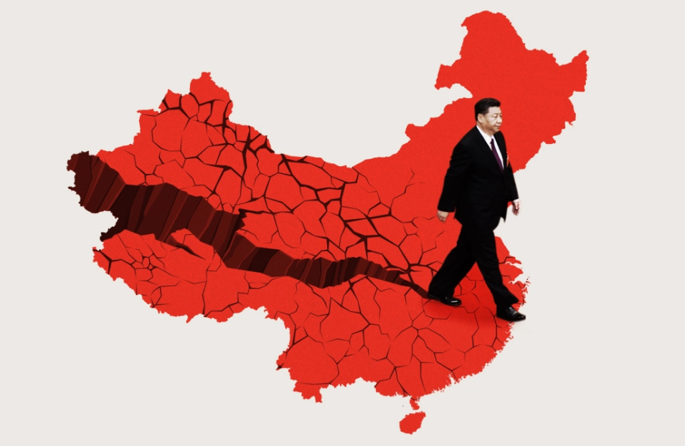

China’s “Great Revival” (weida fuxing, 伟大复兴) tells a story of the Chinese people uniting and rising to reverse ‘national humiliation’ by the West and return to their pre-modern, rightful place at the centre of world affairs. However, while China’s leading thinkers euphorically celebrate the Great Revival on the global stage, they simultaneously construct anxious, nightmarish mirror-images that foretell China’s collapse if non-Han groups do not identify as Chinese ethnic minorities. Since outbreaks of ethnically targeted violence in Tibet and Xinjiang between 2008-2009, a shared national identity based on Han culture and ‘ethnic unity’ (minzu tuanjie, 民族团结), has been officially described as a “zero-sum political struggle of life or death” and prerequisite to China’s rise. Towards dreams of unity and revival, China has operated mass extra-judicial internment camps as “Education and Transformation Centres” since 2017 in the Xinjiang Uyghur Autonomous Region (XUAR), interning approximately 10% of the adult Uyghur population. This state of exception in Xinjiang is a logical conclusion of official ethnocentric national narratives, analysed in this talk, which target Uyghur identities as obstacles to China’s revival. This talk focuses on the social and political dynamics that led to a shift in ethnic minorities policies towards a “fusion” (jiarong; 交融) model, culminating in mass extra-judicial internment camps and the “One-Belt-One-Road” foreign policy initiative to secure Chinese identity in Xinjiang. The talk draws from ethnographic fieldwork during the riots of 2009 and the latest official documents from the Xinjiang Working Group meetings. It argues that the CCP securitises an ethnocentric model of China and governs Xinjiang as a frontier, which provokes resistance to official policy and Chinese identity amongst Uyghurs based around tensions between inclusion and exclusion of minority identities.

Dr David Tobin - Bio
Dr David Tobin is Hallsworth Research Fellow in the Political Economy of China at the University of Manchester. He is currently researching how postcolonial relations between China and the West shape foreign policymaking and ethnic politics in contemporary China. He is particularly interested in how "anti-hegemonism" in Chinese theories of world order drives the One-Belt-One-Road initiative and security policies in frontier regions. His forthcoming book with Cambridge University Press, Securing China's Northwestern Frontier: Identity and Insecurity in Xinjiang, analyses the relationship between identity and security in Chinese policy-making and ethnic relations between Han and Uyghurs in Xinjiang.

