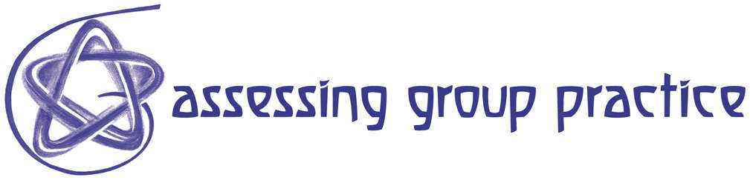
Resource 82: Goal Ranking & Matching Exercise

What do you hope to get out of this session? Will it address your needs and expectations? This is a Classroom Assessment Technique (CAT) designed to help you identify your expectations and share them with the session leader -- and each other. You'll also review the presenter's goals are for this workshop, and see how well those goals match yours.

1. On the lines below, please list three or four goals you hope to achieve -- things you hope to learn or questions you hope to answer -- through participating in this session.

Your Goals for this Workshop

______________________________________________________

_______________________________________________________

________________________________________________________

________________________________________________________

2. Now, rank your goals in terms of their relative importance to you. Make the most important goal #1, the next most important #2, and so on.

3. As you hear the presenter's goals, circle any of your goals which match those he mentions.

4. Prepare to talk about any important goals you have which are not included in the presenter's list of goals and/or to ask questions about those goals.

Reference: Angelo, T.A. & Cross, K.P. Classroom Assessment Techniques: A Handbook for College Teachers, 2nd edition. San Francisco: Jossey-Bass, 1993, pp. 290-294

