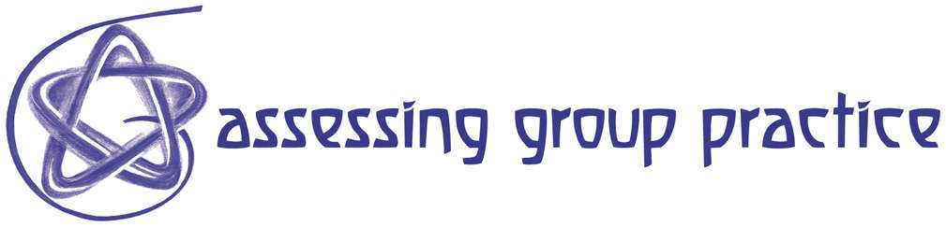

Resource 84 The Minute Paper

Please answer each question in 1 or 2 sentences:

1) What was the most useful or meaningful
thing you learned during this session?

2) What question(s) remain uppermost in your
mind as we end this session?

Reference: Angelo, T. A. & Cross, K. P. Classroom Assessment Techniques: A Handbook
for College Teachers, 2nd edition. San Francisco: Jossey-Bass, 1993, pp. 148-153.

The "Muddiest" Point*

What was the "muddiest" point in this session?
(In other words, what was least clear to you?)

* This Classroom Assessment Technique was developed by Dr. Frederick Mosteller,
a distinguished professor of statistics at Harvard University. For a detailed account of its development and use, see his article, The "Muddiest Point in the Lecture" as a Feedback Device in On Teaching and Learning: The Journal of the Harvard-Danforth Center, Vol. 3, April 1989, pp. 10-21.

Reference: Angelo, T. A. & Cross, K. P. Classroom Assessment Techniques: A Handbook
for College Teachers, 2nd edition. San Francisco: Jossey-Bass, 1993, pp. 154-158.

