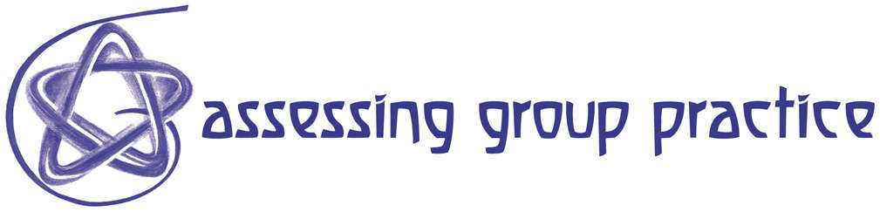
Resource 85 Collaborative Learning Technique (CoLT) 3

Jigsaw

This CoLT is particularly effective in helping students master a large body of information that can be divided into discrete, though related, sub-topics. It puts into practice the adage, “To teach is to learn twice.” Variations of the Jigsaw have long been used by medical and law students.

Estimated Time and Effort Required for

Faculty to prepare this CoLT MEDIUM

Students to use this CoLT MEDIUM
Faculty to assess/follow up MEDIUM

Complexity MEDIUM
Risk of Failure MEDIUM

Duration & Location 30 minutes to several hours/In class or out of class

Group Size & Structure Triads to Quintets/Some pre-organizing required

Description

The name of this CoLT refers to jigsaw puzzles, in which a number of disparate pieces are brought together to form a coherent picture. Students learn best by teaching other students, and in the Jigsaw, each member of a team assumes responsibility for becoming the master and the teacher of one specific part of a topic, issue, or problem. This CoLT can help students learn new subject matter and/or provide opportunities for them to practice solving complex problems. It’s particularly useful in courses where students are required to master a large body of information. Jigsaw also creates opportunities for equal participation and achievement; since each student has the chance to be in the spotlight. It requires that students assume responsibility for their learning, gives them double exposure to material, and allows for peer coaching. It also requires positive interdependence, since all members of the group need each other - and need to collaborate effectively - in order to put the pieces together and succeed individually.

Procedure

1. The instructor presents a list of related topics to be learned, making the division of the material into component parts clear. The number of topics should be equal to or a small multiple of the number of students in each group; and usually no more than 3-5 per person.

2. With the proviso that all assigned topics must eventually be learned by all students, learners may be given the option to identify topic preferences.

3. Students work in “expert” groups -- with the other students who have selected or been assigned the same topic(s) -- to master their common topic(s). They also must determine the best ways to help others learn the material they’ve mastered.

- Once the expert groups have mastered their material, the class splits into new groups in which each student serves as the only expert on a specific topic(s). In these new “tutorial” or “study” groups, topic experts take turns teaching the material and leading the discussion.
- When student groups indicate that they have gained a full knowledge and understanding of the topics covered, the professor holds a full class discussion on all topics or gives an assignment, quiz, or exam to assess their individual and collective learning.

