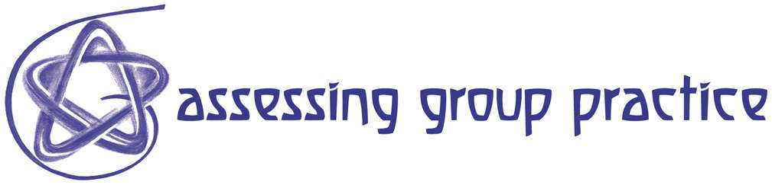
R90 Definitions of Collaborative Learning and Classroom Assessment

Classroom Assessment is a simple method faculty can use to collect feedback, early and often, on how well their students are learning what they are being taught. The purpose of classroom assessment is to provide faculty and students with information and insights needed to improve teaching effectiveness and learning quality. College instructors use feedback gleaned through Classroom Assessment to inform adjustments in their teaching. Faculty also share feedback with students, using it to help them improve their learning strategies and study habits in order to become more independent, successful learners. . . . Classroom Assessment is one method of inquiry within the framework of Classroom Research, a broader approach to improving teaching and learning.

Angelo, T. A. (1991). Ten easy pieces: Assessing higher learning in four dimensions.
In T. A. Angelo (ed.) Classroom Research: Early Lessons from Success. San
Francisco: Jossey-Bass. New Directions for Teaching and Learning, no. 46, 17-31.

Collaborative Learning refers to those learning activities intentionally designed and assigned to be carried out by pairs or small groups of students. In addition to intentional design, two other elements are key to this definition. Co-laboring is the second necessary element. All participants in the group must engage actively in working together toward the stated objectives. If only one of two, or two of five group members complete a group task while the others watch, that does not constitute collaborative learning - or at least not effective collaborative learning. Whether all group members are assigned exactly the same task, or different pieces of a large assignment, they must all contribute more or less equally. Even active, equitable engagement of each member of the group in completing an assigned collaborative task is not sufficient, however. The third requirement is that meaningful learning - achieving the intended instructional goals - take place through that intentional, engaged collaboration. Others call this kind of activity cooperative learning, team learning, group learning, or peer-assisted learning - and philosophical differences sometimes lie behind the different labels. . . . Collaborative Learning Techniques, or CoLTs for short, are mainly simple and flexible tools that can be adapted to fit a wide variety of disciplines, instructional goals, and learning contexts.

Angelo,T.A. (2003). personal communication

