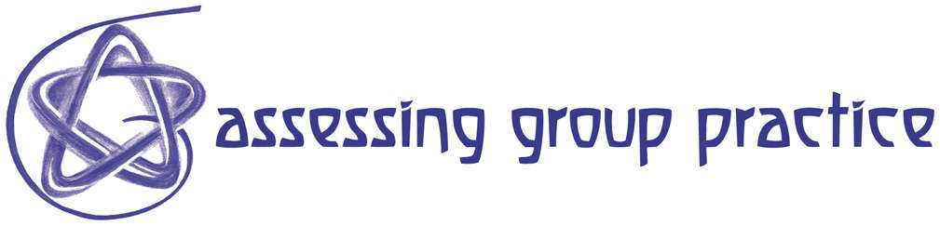

Exercise: Developing Effective Group Behaviour

Cordelia Bryan

Central School of Speech and Drama

c.bryan@cssd.ac.uk

Rationale:

This workshop aims to demonstrate and raise awareness of group roles and group tasks by engaging participants with a specific group task.
Structured observation is built into the exercise with guidelines for observers on how to feedback to the group in a way which is constructive and non-threatening.

Suitable for:

Staff and Students, in groups of between 7 and 12. It is possible to run 2 or 3 groups simultaneously providing the room is large enough to separate them.

Timings:

90 minutes total
15 minutes introduction, setting up and reading time for groups and observers;
20 minutes task;
40 minutes feedback from observers;
15 minutes facilitator led discussion with option of referring to other related materials.

Facilitators:

The main role of the facilitator is to ensure that the focus of the discussion and feedback is on helping the group to realise its strengths and weaknesses based on the materials supplied.

Resources needed:

Chairs arranged in a circle for each group (can be around a table).

Materials provided here:

Task sheet (sufficient for one per person, including observers) (R12)
Observation and Feedback sheet (sufficient for observers) (R19)

Running the workshop:

Stage 1: Introduction and setting up of task (15 + 20 minutes)
The introduction and setting up of this workshop should inform participants of the importance of group work (in HE and in employment and life situations) and explain how poorly functioning groups often fail to reach a satisfactory task outcome. I.e. Poorly functioning group = poor product/outcome/low grade.
The purpose of the workshop is to teach participants how they can each contribute to making the group work well by learning to share the responsibility.

Divide the participants into groups and distribute the tasks and observers sheet. These are self explanatory and, once distributed, the facilitator's role is to over see that the task runs within the time limit, warning the group when they are half way through and when they have 2 minutes left if necessary. It is worth checking that the observers know that they will have to feedback their observations and perhaps to encourage them to draw a seating plan indicating any dominant lines of communication within the group.

Stage 2: Feedback and group discussion (40 minutes)
The group should, if possible, listen to the feedback from the observers without any comment until the observers have said all they want to say. Only then should the facilitator invite a response if appropriate and contribute other observations of his/her own.
There are numerous theories and models for doing this (some of which are included in the Guidelines for Developing Effective Group Behaviour) and one or two should be selected to form the basis of the feedback and discussion.

Stage 3: summing up discussion (15 minutes)
The discussion should be concluded with participants being thanked for taking part and being offered further materials and references. The facilitator can point participants to specific theories and/or other exercises if appropriate.

Guidance notes and recommendations:

Additional guidance materials to support this workshop include R11; R13; R15 and R18
Note: If there are multiple groups operating simultaneously, allow more time for the facilitator led final joint discussion.

Variations:

There are numerous variations which can be applied to this basic format of a group performing a task, observed by peers who then feedback to the whole group.
- Devise new tasks but keep the same format
- Introduce simple self and peer grading (Scale of 1-5) for group task; individual contribution to task; individual contribution to group maintenance. Allow more time for discussion around the need for clear criteria when applying any grading system. Requiring participants to self and peer grade inevitably raises many interesting issues!
- Introduce role playing to certain members of the group.
- Apply De Bono's Six Hat method (R12) to demonstrate parallel thinking or to prompt the group to pause and reflect for a minute using a specific hat.
- Stop the group at a couple of critical moments and ask each member to jot down what s/he feels right then - remember to include this in the feedback
- Allocate specific roles to each group member. eg. chair; time keeper; note taker.

Bibliography: (R1)

D. Jacques, (2000) Learning in Groups: a handbook for improving group work, Kogan Page (3rd edition) First published by Croom Helm in 1984

Comments from participants:

"I have taught groups, I think pretty effectively, for 25 years or more and thought I would just 'coast' through this session. I got completely caught up in the task and realise how I neglected the well being of the group. May be that is because I'm always the facilitator?"

"I love the simplicity of the format. It could work in almost any group situation."

Cordelia Bryan
FDTL - Assessing Group Practice
Central School of Speech and Drama
December 2002
c.bryan@cssd.ac.uk

