Mathematical Physics - I

Lecturer: Vladimir Falko

(room C3 in Physics Building)

_____________________________________________________________________________________________________

Mathematical Physics:
Selection of analytical methods used in the studies of dynamical systems in classical mechanics, in electro-magnetism, and in quantum mechanics.

$\left.\underset{}{\overset{}{\underset{}{\overset{}{}}}}\right\}\text{PHYS}\text{201}$Toolbox to solve differential equations
ordinary differential equations…....
use of complex numbers…..….…
elements of Fourier analysis….…..
partial differential equations……...

$\text{PHYS}\text{273}$Linear algebra and matrices………...…

$\text{PHYS}\text{205}$Vector analysis…………………………..

Course program PHYS201

Ordinary differential equations: definitions, examples of integration of some diff. equations of the first order. Initial and boundary conditions. Separable 1st order diff. equations. 2nd order differential equations. First integral and its relation to conservation laws in mechanics. Integrating multipliers and the use of integrating multipliers for reducing the order of ODE's.

Linear differential equations and properties of their solutions. Method of e^{Dt} substitution and the auxiliary equation. Revision of operations with complex numbers. Complex numbers as variables. Functions of complex variables, function$e^{iωt}$. Roots of polynomials. Linear ODE's in application to oscillations driven by an external periodic force. Phenomenon of the resonance. Oscillations and resonance in electric circuits. Fourier series and basic notions of Fourier analysis. Use of Fourier transform for solving linear differential equations.

Functions of few variables. Partial derivatives and partial differential equations. Wave equation in one dimension; initial conditions for the wave equation. D'Alamber's method. Wave equation in restricted geometry, boundary conditions and vibration resonance. Separation of variables in partial differential equations. Diffusion equation and its solution in one dimension.

Books: All you wanted to know about Mathematics,
but were afraid to ask (V1&2),
L.Lyons - Cambridge Press

Mathematical Methods in Physical Sciences,
M.L. Boas – John Wiley & Sons

Mathematical Methods for Science Students,
G.Stephenson - Longman Scientific &Technical

Lecture notes:
www.lancs.ac.uk/users/esqn/mathphys/phys201

Printing out notes cannot replace attendance of lectures and problem classes (even those on Friday morning!). They are provided only for saving your time on writing during classes, so that you can concentrate on following the lecture. Use them as a template for adding your own notes when you follow lectures.

Classes for PHYS201

16 Lectures + 4 Seminars + Office hours - workshops

Lecture notes will w 2,3 - Wednesday Small group tutorials run by VF and

be displayed weekly w 4,5 - Friday Dr. Ed McCann for helping you to
work through examples and the
material of lectures. Please sign up for a particular group and attend regularly.

Regular attendance of workshops will help you to spread the workload over the module, cover gaps and make sure you follow the course without leaving unsolved questions to the end.

course mark = course work (20%) + exam (80%)
An algebraic equation:
${\text{ax}}^{2}+\text{bx}+c=0$$x_{1,2}=\frac{−b±\sqrt{b^{2}−4\text{ac}}}{2a}$$⇒$

_____________________________________________________________

What are 'Differential Equations' about?

$\frac{d^{2}x}{{\text{dt}}^{2}}+a\frac{\text{dx}}{\text{dt}}+x^{2}−x−f(t)=0$A differential equation:

relation between some unknown function x(t)
and its derivatives of various orders.
$\frac{\text{dx}(t)}{\text{dt}}≡x'$$\frac{d^{2}x}{{\text{dt}}^{2}}≡\frac{d}{\text{dt}}\left(\frac{\text{dx}(t)}{\text{dt}}\right)$

Mathematician's interest: Given a differential equation, to describe all functions x(t) which satisfy relation between derivatives and functions in that differential equation (that is, to express them in terms of known functions).

$\frac{d^{2}x}{{\text{dt}}^{2}}=\frac{\text{Force}\left(x(t),v(t)\right)}{m}$
19th century physicist's
$↑$Starting from Newton's laws,
to find how does some
$\frac{\text{dx}}{\text{dt}}≡x'≡v(t)$physical body move when
affected by various forces.

Anywhere in physics, mathematical formulation of fundamental laws and, therefore, of particular practical problems involves
relations between physical quantities, whose dependence on relevant variables have to be analysed, and their derivatives.

$|$Example: Slowing down of a one-dimensional motion of a particle with mass m due to the air resistance.
$v$
$v(t)$$→$

$v(t)=?$$⇐$ ________________

$F_{\text{Air}}=−\text{kv}(t)$
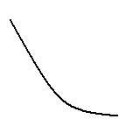

One uses the Newton equation to find out how

$t$does the velocity of a particle, v(t) vary in time: ___________

$\frac{\text{dv}}{\text{dt}}=\frac{F_{\text{Air}}}{m}=−\frac{k}{m}v(t)=−\frac{v(t)}{τ}$

$τ=\frac{m}{k}=\text{const}$acceleration

$\frac{\text{dv}}{\text{dt}}=−\frac{v(t)}{τ}$
$v(t)$ differential relates an unknown function
equation to its derivative

_____________________________________________________________

$v(t)=v_{0}e^{{−t}/τ}$

A very reasonable guess:

$\frac{\text{dv}}{\text{dt}}=−\frac{v(t)}{τ}$$\frac{d}{\text{dt}}e^{{−t}/τ}=−\frac{1}{τ}e^{{−t}/τ}⇒$
Why? Since

Example: Radioactive decay problem.
$x_{0}$
Given the initial concentration of radioactive nuclei in the medium,
$t$ one has to find out how many of them remain after the period of time ?
$x(t)=?$

$δt$${δt}/τ$$δx=−x⋅\frac{δt}{τ}$The probability for one nucleus to decay over an infinitely small interval of time is
$↑$

decay
$\frac{δx}{δt}=−\frac{x}{τ}$time constant

$\frac{\text{dx}(t)}{\text{dt}}=−\frac{1}{τ}x(t)$

Kinetic equation for
a radioactive decay

differential equation

$x(t)=x_{0}e^{{−t}/τ}$Reasonable guess for its solution:
$|$
_____________________________________________________________________
$x(t)$
$\frac{d}{\text{dt}}e^{\text{at}}={\text{ae}}^{\text{at}}$$x_{0}$
Why? Since

$t$$\text{_______}$ _______
$\frac{\text{dx}(t)}{\text{dt}}=−x_{0}\frac{d}{\text{dt}}e^{{−t}/τ}=−x_{0}\frac{1}{τ}e^{{−t}/τ}=−\frac{x(t)}{τ}$
and

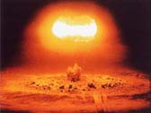
Example: Kinetics of nuclear reactions

$T_{0}$dense mixture
$⇒$

of deuterium
and tritium

$H_{1}^{2}$ ____________________________________________________________________________________________________



neutron

${\text{He}}_{2}^{4}$ if kinetic energy
E>E₀ is larger than the
reaction threshold E₀
$H_{1}^{3}$ releases energy U=17MeV
$T→T+δT$

$δT=\frac{δt}{τ}⋅T$due to the release of energy, the
$δt$deuterium & tritium mixture heats
up (over the time interval )
$\frac{\text{dT}(t)}{\text{dt}}=\text{kT}(t)$

Kinetic equation for
thermo-nuclear reaction
is a differential equation
___________________________________________
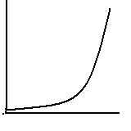$T(t)=T_{0}e^{t/τ}$$T$
Solution:

$\frac{d}{\text{dt}}e^{\text{at}}={\text{ae}}^{\text{at}}$
since
$t$
Ordinary differential equations represent mathematical formulation of models for dynamical physical systems.

Differential equation unknown function model for
______________________________________________________________
$\frac{\text{dT}(t)}{\text{dt}}=\frac{T(t)}{τ}$
T(t) heating in
chemical reactions
______________________________________________________________
$\frac{\text{dv}(t)}{\text{dt}}=−\frac{v(t)}{τ}$
v(t) damping by friction

$−ℏ^{2}\frac{d^{2}ψ(l)}{{\text{dl}}^{2}}=\text{εψ}(l)$______________________________________________________________
$ψ(l)$
electron wavefunction
in a Schroedinger eqn.
______________________________________________________________
$\frac{d^{2}r(t)}{{\text{dt}}^{2}}=−\frac{{\text{gR}}^{2}}{r^{2}}+f(t)$
r(t) satellite landing
onto the Earth
______________________________________________________________

_____________________________________________________________________
${\text{ax}}^{2}+\text{bx}+c=0$
To be distinguished from an algebraic
$x^{2}=e^{x}+\text{sin}t$or a transcendental equation:
______________________________________________________________

Notations we shall use in this course:

unknown function its derivatives some given
which has to be found: of the n-th order function
$x(t)$$\frac{d^{n}x}{{\text{dt}}^{n}}≡\frac{d}{\text{dt}}\frac{d^{n−1}x}{{\text{dt}}^{n−1}}≡\underset{n}{\underline{\frac{d}{\text{dt}}⋅⋅\frac{d}{\text{dt}}}}x(t)$$f(t)$

Ordinary differential equations describe the relations between derivatives of unknown function x(t) of a relevant variable t and values of these unknown functions and some other given functions. These relations should to be satisfied for any value of a variable t.

$\frac{d^{2}x(t)}{{\text{dt}}^{2}}=−\frac{{\text{gR}}^{2}}{x^{2}}+f(t)$

example:

Solving differential equation means finding the form of all possible functions, which obey such relations.

Procedure of solving differential equations consists
in a systematic construction of these solutions
following a sequence of mathematically approved steps.

Methods of solving ordinary differential are based upon

❶ knowledge of properties of elementary and some special functions
❷ experience with differentiation and integral relations
- exploitation of existence of complex numbers and use of functions
of complex variables
- use of additivity of solutions of linear differential equations and the
method of Fourier transform

$|$$|$Vibrations of molecules and phenomenon

of the resonance

$←\underset{}{}a\underset{}{}→$
when this molecule is in rest

${\text{Cl}}^{−}\underset{}{}\underset{}{}\underset{}{}{\text{Na}}^{+}$
$|$$|$

$←a+x(t)→$
when it is excited by an
alternating electric field
(from the InfraRed light)

$⇐⇒{}_{}\underset{}{}⇐⇒$

$−\text{eE}\text{cos}Ωt+\text{kx}$$−\text{kx}+\text{eE}\text{cos}Ωt$

$m\frac{d^{2}x}{{\text{dt}}^{2}}=−\text{kx}+\text{eE}\text{cos}Ωt$ Newton’s equation for

relative displacement, x(t)

( m is the reduced mass)

Mathematically rigorous

$x(t)=|A(Ω)|⋅\text{cos}(Ωt+ϕ)$solution can be found with the help of functions of complex variables
$|$

$|A(Ω)|$
- amplitude transmission = portion of the
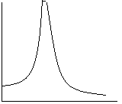 infrared light intensity that passes
through the gas of molecules
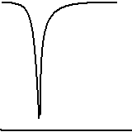

$Ω$
_________________________________________________________ ________________________________________________
$ω_{0}$$Ω$
$ω_{0}$ - resonance frequency

Standing waves in mechanical resonators
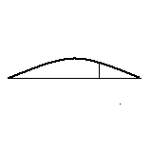
$x(l,t)$
function of two variables
$l$$x(l,t)$ 0 _________________________ L

$\frac{∂^{2}x}{∂t^{2}}−s^{2}\frac{∂^{2}x}{∂l^{2}}=f(l,t)$
wave equation:
partial differential
equation
$x(l=0,t)=0,$$x(l=L,t)=0$
boundary conditions

Solution requires the use of a function of a complex variable, exp(ikl), and elements of Fourier analysis.

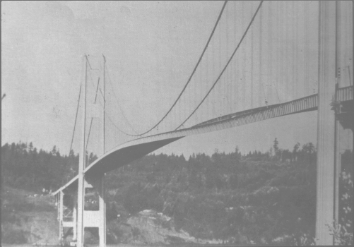
‘dangerous’
resonance frequencies:
$ω_{n}=\frac{π\text{ns}}{L}$

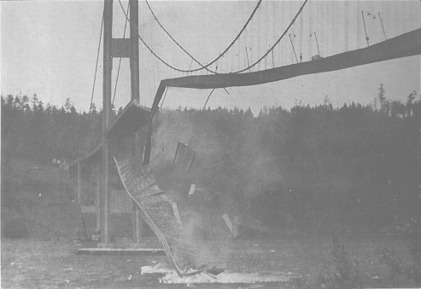

Takoma Bridge (1940)

