Partial Differential Equations
(PDE’s)

Functions of few variables and partial differentiation.
Change of variables in partial derivatives.

Linear partial differential equations.

Methods to solve the wave equation:
d’Alembert’s method and initial conditions for PDE’s.

Method of separation of variables and boundary conditions for PDE’s.

Standing wave solutions of the wave equation
and vibrational resonance in a rod.

Literature:
All you wanted to know about Mathematics,

but were afraid to ask, L.Lyons - V.2; Chapt. 14

Other reading:
Mathematical Methods for Science Students, G.Stephenson – Chs.19,24

Mathematical Methods in Physical Sciences, M.L.Boas
Wave
$\frac{∂^{2}x}{∂l^{2}}−\frac{1}{s^{2}}\frac{∂^{2}x}{∂t^{2}}=0$ equation

d'Alembert's solution of the wave equation
$x(l,t)=g(l+\text{st})+f(l−\text{st})$
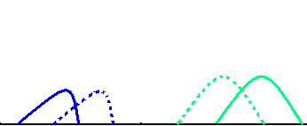
$s$$s$
$→$$←$

_______________________________________________

$x_{⇒}(l,t)=A\text{cos}(k[l−\text{st}])=A\text{cos}(\text{kl}−\text{skt})$Running waves

$\text{sk}=ω$

$x_{⇐}(l,t)=A\text{cos}(k[l+\text{st}])=A\text{cos}(\text{kl}+\text{skt})$

$x_{⇔}(l,t)=A\text{cos}(\text{kl}−\text{skt})−A\text{cos}(\text{kl}+\text{skt})$Standing wave

$=A[\text{cos}\text{kl}\text{cos}\text{skt}+\text{sin}\text{kl}\text{sin}\text{skt}]$
$−A[\text{cos}\text{kl}\text{cos}\text{skt}−\text{sin}\text{kl}\text{sin}\text{skt}]$

$x_{⇔}(l,t)=2A⋅\text{sin}\text{kl}⋅\text{sin}\text{skt}$

standing waves
$x_{⇔}(l,t)=2A⋅\text{sin}\text{kl}⋅\text{sin}\text{skt}$

$t$
Zero boundary conditions:
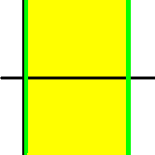$\begin{aligned}x(l=0,t)=0 \\ x(l=L,t)=0\end{aligned}$$↑$
$l$$0$$L$

$\text{sin}\text{kL}=0{}_{}⇒{}_{}\text{kL}=πn$Zero boundary condition selects some allowed wave numbers

$k=\frac{πn}{L}$

$x(l,t)=\sum_{n}{}A_{n}⋅\text{sin}\left(\frac{πn}{L}l\right)⋅\text{sin}\left(\frac{sπn}{L}t\right)$

Note: in each term in the Fourier sum representing that particular
solution, variables t and l were separated
____________________________________________________

Method of separation of variables

$x(l,t)=Λ(l)⋅Θ(t)$

$∂_{l}x=Θ(t)⋅\frac{dΛ}{\text{dl}}$$∂_{t}x=Λ(l)⋅\frac{dΘ}{\text{dt}}$

$∂_{l}^{2}x=Θ(t)⋅\frac{d^{2}Λ}{{\text{dl}}^{2}}$$∂_{t}^{2}x=Λ(l)⋅\frac{d^{2}Θ}{{\text{dt}}^{2}}$

$∂_{l}^{2}x=\frac{1}{s^{2}}∂_{t}^{2}x$

$Θ(t)\frac{d^{2}Λ}{{\text{dl}}^{2}}=\frac{Λ(l)}{s^{2}}\frac{d^{2}Θ}{{\text{dt}}^{2}}$

$\frac{1}{Λ}\frac{d^{2}Λ}{{\text{dl}}^{2}}=\frac{1}{s^{2}Θ}\frac{d^{2}Θ}{{\text{dt}}^{2}}$

$\frac{1}{Λ(l)}\frac{d^{2}Λ(l)}{{\text{dl}}^{2}}=β=\frac{1}{s^{2}Θ(t)}\frac{d^{2}Θ(t)}{{\text{dt}}^{2}}$

$\begin{aligned}x(l=0,t)=0 \\ x(l=L,t)=0\end{aligned}$$Λ(0)⋅Θ(t)=0$
$⇒$$Λ(L)⋅Θ(t)=0$

$\frac{d^{2}Λ(l)}{{\text{dl}}^{2}}=β⋅Λ(l);{}_{}Λ(0)=Λ(L)=0$

$\frac{d^{2}Θ(t)}{{\text{dt}}^{2}}=s^{2}β⋅Θ(t)$
these are 2nd order
linear ODE's.

$β$
Note that is still to be found,
$\underline{β>0}$$\underline{β=−k^{2}<0}$and there are two possibilities:
First, we have to analyse the first ODE, the one which is complemented with zero boundary conditions.

$\frac{d^{2}Λ}{{\text{dl}}^{2}}=β⋅Λ{}_{}{}_{}Λ(0)=Λ(L)=0$

$D^{2}=β$$A_{1}+A_{2}=0$
$A_{1}e^{\sqrt{β}L}+A_{2}e^{−\sqrt{β}L}=0$
$D_{1,2}=±\sqrt{β}$
$⇓$

$Λ(l)=A_{1}e^{D_{1}l}+A_{2}e^{D_{2}l}$$A_{1}=A_{2}=0$

$β>0$
No solution for
_______________________________________________
$β=−k^{2}<0$$D_{1,2}=±\text{ik}$$⇒$

$Λ(l)=A_{1}e^{\text{ikl}}+A_{2}e^{−\text{ikl}}=a\text{cos}\text{kl}+b\text{sin}\text{kl}$

$Λ(0)=a⋅1+b⋅0=0⇒a=0$$Λ(L)=b\text{sin}\text{kL}=0⇒k_{n}=\frac{nπ}{L}$$Λ(l)=b\text{sin}(k_{n}l)$
Solution of wave equation with zero boundary condition
( standing wave, or a mode )
$Λ_{n}(l)=b\text{sin}\left(\frac{nπl}{L}\right)$$β_{n}=−k_{n}^{2}=−{\left(\frac{πn}{L}\right)}^{2}$

$Λ_{n}$_____________________________________________
Time dependence associated with each 'mode'
$\frac{d^{2}Θ}{{\text{dt}}^{2}}=s^{2}β_{n}⋅Θ=−{\left(\frac{π\text{ns}}{L}\right)}^{2}Θ$
$Θ(t)=?$

$Θ_{n}(t)=A\text{cos}Ω_{n}t+B\text{sin}Ω_{n}t$

$Ω_{n}=\frac{πs}{L}n$

Solution:
$x(l,t)=\sum_{n}{A_{n}}⋅Λ_{n}(l)⋅Θ_{n}(t)$

$=\sum_{n}{A_{n}}⋅\text{sin}\left(\frac{nπ}{L}l\right)⋅\text{cos}\left(\frac{nπs}{L}t\right)$

$Ω_{n}=\frac{π\text{ns}}{L}$
Natural frequencies of vibrations of a
rod (these are analogous to the
resonance frequencies of an oscillator)

$\frac{∂^{2}x}{∂t^{2}}−s^{2}\frac{∂^{2}x}{∂l^{2}}=f(l,t)$

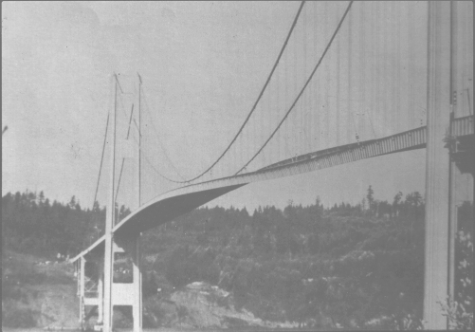

$x(l=L,t)=0$

$x(l=0,t)=0$

$f(l,t)=\sum_{n}{\int_{−∞}^{∞}{dΩ}f_{n}}(Ω)e^{iΩt}⋅\text{sin}\left(\frac{π\text{nl}}{L}\right)$

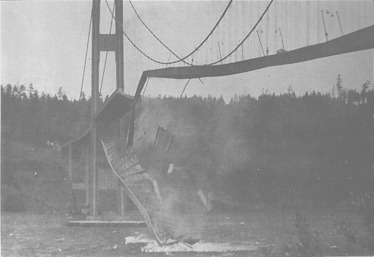

$Ω=\frac{π\text{ns}}{L}$

