Non-homogeneous linear
ODE’s and Fourier analysis

Particular solution of linear differential equations for damped oscillators subjected to a harmonic force.

Phenomenon of the resonance.

General solution of 2nd order linear ODE’s and its application to the description of oscillators.

General properties of linear differential equations.

$\text{cos}\frac{2π\text{nt}}{T}$$\text{sin}\frac{2π\text{nt}}{T}$
Integral properties of basis functions ,
Fourier series representation of periodic functions.
Fourier transform.

Literature:
All you wanted to know about Mathematics,

but were afraid to ask, L.Lyons - V. 1, Chs. 5, V.2; Chapt. 12

Other reading:
Mathematical Methods for Science Students, G.Stephenson – Chapts.15

Mathematical Methods in Physical Sciences, M.L.Boas
Any T-periodic function, f(t+T)=f(t) determined within the interval of the length T, 0<t<T, can be represented in a unique way in the form of the above-mentioned Fourier series.
$f(t)=F_{c0}+\sum_{n=1}^{∞}{F_{\text{cn}}\text{cos}\frac{2π\text{nt}}{T}}+\sum_{n=1}^{∞}{F_{\text{sn}}\text{sin}\frac{2π\text{nt}}{T}}$

$F_{c0}=\frac{1}{T}\int_{0}^{T}{\text{dt}f(t)}$$F_{\text{cn}}=\frac{2}{T}\int_{0}^{T}{\text{dt}f(t)\text{cos}\frac{2π\text{nt}}{T}}$

$F_{\text{sn}}=\frac{2}{T}\int_{0}^{T}{\text{dt}f(t)\text{sin}\frac{2π\text{nt}}{T}}$

_______________________________________________________________________________________________________

Complex Fourier representation

$f(t)=\sum_{n=−∞}^{∞}{F_{n}e^{iΩ_{n}t}}$$Ω_{n}=\frac{2π}{T}n$

$F_{n}=\frac{1}{T}\int_{0}^{T}{\text{dt}f(t)e^{−iΩ_{n}t}}$

$f(t)=\sum_{n=−∞}^{∞}{F_{n}e^{iΩ_{n}t}}$

${\left(F_{n}\right)}^{}={\left(\frac{1}{T}\int_{0}^{T}{\text{dt}f(t)e^{−iΩ_{n}t}}\right)}^{}$

$=\frac{1}{T}\int_{0}^{T}{\text{dt}f(t)e^{iΩ_{n}t}}=F_{−n}$

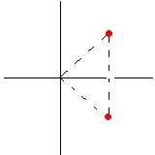$\text{Im}F$$\begin{aligned}F_{n}^{}=F_{−n} \\ F_{−n}^{}=F_{n}\end{aligned}$

$F_{n}$

$\text{Re}F$

$F_{−n}$

$\begin{aligned}\text{Re}F_{−n}=\text{Re}F_{n} \\ \text{Im}F_{−n}=−\text{Im}F_{n}\end{aligned}$

$f(t){}_{}↔{}_{}\sum_{n=−∞}^{∞}{F_{n}e^{iΩ_{n}t}}$
$T$$0$

$\text{Re}F_{n}$
$Ω_{n}=\frac{2π}{T}n$
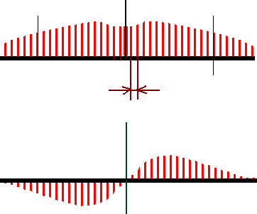$Ω_{−n}$

$Ω$$\frac{2π}{T}$$0$

$\text{Im}F_{n}$

$0$$Ω$
_____________________________
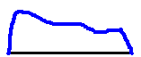$\tilde{T}$$\tilde{f}(t)$
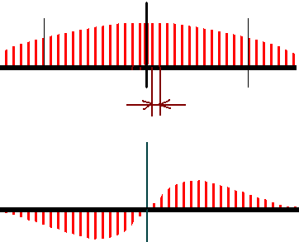$0$
$Ω$${\text{Re \{}\tilde{F}}_{n}$
$\frac{2π}{\tilde{T}}$
$Ω_{n}=\frac{2π}{\tilde{T}}n$
${\text{Im \{}\tilde{F}}_{n}$
$0$$Ω$

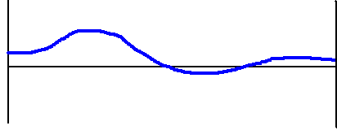$T$$0$
$f(t)=\sum_{n=−∞}^{∞}{F_{n}e^{iΩ_{n}t}}$

$Ω_{n}=\frac{2πn}{T}$
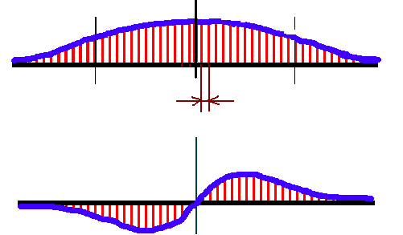$\begin{aligned}\text{Re}F(Ω) \\ ↑ \\ F(Ω) \\ ↓ \\ \text{Im}F(Ω)\end{aligned}$

$Ω$
$\frac{2π}{T}⇒dΩ$
$F(Ω)$

$Ω$

$f(t)=\int_{−∞}^{∞}{dΩF(Ω)e^{iΩt}}$
Fourier Integral
representation
$f(t)$
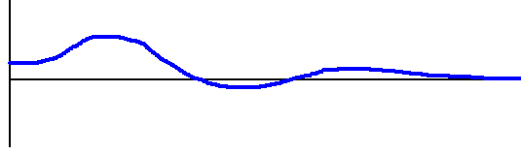

$t$
$0$

$F_{n}=\frac{1}{T}\int_{0}^{T}{\text{dt}f(t)e^{−iΩ_{n}t}}$

$Ω_{n}=\frac{2π}{T}n$

$n=\text{.}\text{.}\text{.},−2,−1,0,1,2,\text{.}\text{.}\text{.}$

$f(t)=\sum_{n=−∞}^{∞}{F_{n}e^{iΩ_{n}t}}$

$=\sum_{n=−∞}^{∞}{e^{iΩ_{n}t}}\frac{1}{T}\int_{0}^{T}{\text{dt}f(t)e^{−iΩ_{n}t}}$

$=\frac{1}{2π}\sum_{n=−∞}^{∞}{e^{iΩ_{n}t}}\frac{2π}{T}\int_{0}^{T}{\text{dt}f(t)e^{−iΩ_{n}t}}$

$\begin{aligned}↑ \\ \\ Ω\end{aligned}$

$\begin{aligned}↑ \\ dΩ\end{aligned}$$\begin{aligned}↑ \\ \int_{−∞}^{∞}{dΩ}\end{aligned}$___________________________________________________
$T→∞$

$f(t)=\int_{−∞}^{∞}{dΩe^{iΩt}×\frac{1}{2π}\int_{0}^{∞}{\text{dt}f(t)e^{−iΩt}}}$___________________________________________________

$=\int_{−∞}^{∞}{dΩF(Ω)e^{iΩt}}$

Integral Fourier Representation
(Fourier transform)
$f(t)=\int_{−∞}^{∞}{dΩF(Ω)e^{iΩt}}$

_________________________________________________

Fourier transform of a function
$F(Ω)=\frac{1}{2π}\int_{0}^{∞}{\text{dt}f(t)e^{−iΩt}}$

$f(t)$

$0$$∞$$0<t<∞$

_______________________________

$F(Ω)=\frac{1}{2π}\int_{−∞}^{∞}{\text{dt}f(t)e^{−iΩt}}$

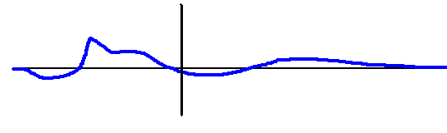$f(t)$

$−∞$$∞$
$−∞<t<∞$
Be careful:
$F(Ω)=\frac{1}{2π}\int_{−∞}^{∞}{\text{dt}f(t)e^{−iΩt}}$Fourier transform
of a function has
sense only when
integral converges
$f(t)=\int_{−∞}^{∞}{dΩF(Ω)e^{iΩt}}$
Inverse
Fourier
transform
____________________________________________________
$e^{−|t|}$
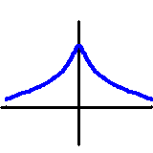Example: Find Fourier transform for the function

$f(t)=e^{−|t|}$

$t$

$F(Ω)=\frac{1}{2π}\int_{−∞}^{∞}{\text{dt}e^{−|t|}e^{−iΩt}}{}_{}⇒{}_{}\int_{−∞}^{0}{}+\int_{0}^{∞}{}$

$=\frac{1}{2π}\int_{0}^{∞}{\text{dt}e^{−t}\left(e^{−iΩt}+e^{iΩt}\right)}$

$=\frac{1}{2π}\int_{0}^{∞}{\text{dt}\left(e^{t(−1−iΩ)}+e^{t(−1+iΩ)}\right)}$

$e^{−∞}=0$

$F(Ω)=\frac{1}{2π}\left(\frac{e^{(−1−iΩ)⋅∞}−1}{−1−iΩ}+\frac{e^{(−1+iΩ)⋅∞}−1}{−1+iΩ}\right)=\frac{2/2π}{1+Ω^{2}}$
Our reason to study representation of functions in the form of a superposition of harmonic funcitons:

To find particular solutions of non-homogeneous linear differential equations (equations describing excitation of oscillations in
mechanical resonators and electrical circuits).

$\frac{d^{2}x}{{\text{dt}}^{2}}+k_{1}\frac{\text{dx}}{\text{dt}}+k_{0}x$$=f(t)≡\int_{−∞}^{∞}{dΩ}e^{iΩt}F(Ω)$

$x(t)=\int_{−∞}^{∞}{dΩ}e^{iΩt}X(Ω)$$↑$

$\frac{1}{2π}\int_{−∞}^{∞}{\text{dt}f(t)e^{−iΩt}}$

$\int_{−∞}^{∞}{dΩ}e^{iΩt}\left[−Ω^{2}+iΩk_{1}+k_{0}\right]⋅X(Ω)=$

$=\int_{−∞}^{∞}{dΩ}e^{iΩt}F(Ω)$

$X(Ω)=\frac{F(Ω)}{(k_{0}−Ω^{2})+iΩk_{1}}=\frac{(k_{0}−Ω^{2})−iΩk_{1}}{(k_{0}−Ω^{2})^{2}+{\left(Ωk_{1}\right)}^{2}}F(Ω)$

$x(t)=\int_{−∞}^{∞}{dΩ}\frac{(k_{0}−Ω^{2})−iΩk_{1}}{(k_{0}−Ω^{2})^{2}+{\left(Ωk_{1}\right)}^{2}}F(Ω)e^{iΩt}$

$x(t)=\int_{−∞}^{∞}{dΩ}\frac{F(Ω)}{(k_{0}−Ω^{2})+{\text{ik}}_{1}Ω}e^{iΩt}$

