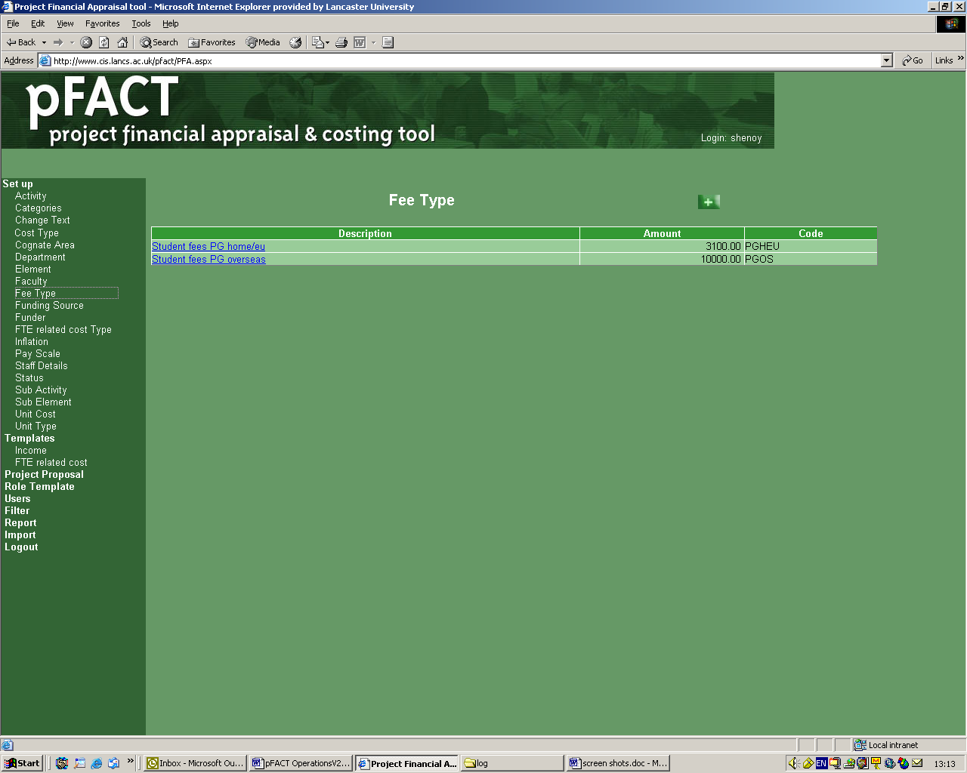

These notes are complementary to the pFACT Principal Investigator Guide which provides detailed operational instructions and can be downloaded from http://www.lancs.ac.uk/depts/research/

Access

pFACT can be accessed via the URL http://www.cis.lancs.ac.uk/pfact

A User ID and Password are required. If you have not already been issued with a User ID please contact the pFACT Helpdesk on ext. 92068 or rso-submissions@lancaster.ac.uk

The User ID will be the same as your allocated windows ID and the password will be allocated by the RSO.

IMPORTANT – once you have received your account details you must log on and change your password.

You will be asked to agree to the Policy on Confidentiality and Data Protection Act Terms and Conditions each time you log on.

Project View Permissions

As a Principal Investigator you will be able to see any project where you are named as PI, as well as projects where you are included as a named member of staff. The information you can see in pFACT is determined by the user type which restricts the information in some of the staff drop down lists:

Principal Investigator – this drop-down list will only contain staff from your department

Co Investigator – this drop down list will contain staff from your faculty

Add staff to project - this drop down list will contain staff from your faculty

New unnamed staff required for the project can be added by clicking on the link Add staff not in list. New unnamed staff can be allocated to any department. It is important to indicate which department staff will be working in if this is different from the main department as a different estates cost may apply.

When completing work spells it is important to accurately estimate the amount of time to be spent on the project, especially for the academic staff involved.

Note: If you intend to prepare a cross-faculty proposal you will need to contact the RSO who will grant access to cross-faculty staff on a project-by-project basis.

Costs to include

The pFACT software has been designed to allow the full cost of a research project to be identified so this can be compared to the price (the income received from the funder).
The cost of a project will always be the same and may include elements that may not be deemed as eligible for funding by a particular funder, in which case these items would not be included in the price. When building up your project costs it is important to identify all the costs whether they are eligible for funding or not. For example:

- Academic staff time (including time for report writing and supervision of the researchers)
- Other project staff (researcher, dedicated technicians and support staff etc)
- Project studentships (stipend and fees)
- Recruitment costs (all projects that employ new staff should include advertising costs)
- Equipment (including installation charges, maintenance and insurance)
- Travel and subsistence
- Consumables
- Disposal of waste (e.g. specialist disposal of chemicals)
- Software
- Training courses
- External fees

Of course, this is not an exhaustive list and the costs included will depend on the research being undertaken.

Note: At present all facilities costs are included in the Estates Charge so don’t need to be included as a separate cost.

Removal of Data

Costs can be removed at any time whist the project status is ‘draft’ by using the remove option. A pop up box will request a reason for removal. This is required for audit purposes and the number of staff added and removed from a proposal will be monitored.

Indirect costs

The FTE related costs are comprised of an indirect cost and an estates charge for the project. The FTE related costs for the project are calculated using the institutional rates and the FTE values of academic and research staff involved in the project.

Funders

The most frequent or recent research funders at Lancaster University have been included in the pFACT database.

Funding Source – the drop down list is grouped into the main funding sources.

Funder – the drop down list will show the funders classified under a particular funding source. If the funder you require is not listed please contact the RSO.

Note: For reporting reasons The Royal Society is included under UK Government and The British Academy is included under Research Councils.

Income Templates

Currently, there are a number of income templates built into the pFACT system each specifically set up to calculate the price of the research to different funders.

The templates include:

- 80% of fEC – for Research Council proposals from 1 September 2005 (80% of the full economic cost plus 100% of exceptions e.g. student stipends and fees).
- 100% fEC – for Government Departments
- Direct costs only – for UK Charities (no indirect costs, estates charge or academic costs included)
- EU FP6 – for European Commission Framework Programme 6 projects (additional direct costs plus 20% indirect costs)
- 100% fEC – for Industry or Commercial funders

If the funder you have identified does not have an obvious Income Template please contact the RSO for advise.

It is also possible to build up the project costs before a funder is identified by picking funding source and funder ‘to be confirmed’.

Recalculate

Whenever data that affects the overall cost of a project has been amended pFACT will recalculate the project costs. However, it is good practice to use the ‘recalculate’ button to check all changes have been incorporated into the project costs before sending to your Department Approver.

Approval Process

Before sending the proposal for approval note the following: -

- Use the ‘Notes’ button on Proposal Summary screen to add in a brief summary of the research to be undertaken. A section from the research proposal can be cut and pasted in.

- It is mandatory to answer all the questions in the ‘Additional Fields’ (found at the bottom of the right-hand menu). The questions are grouped under ‘Project Information’ and ‘Ethics Checklist’

- The final version of the submission e.g. funder’s proposal forms, case for support, should be forwarded to the RSO to allow validation against the information on pFACT. The HoD or Dean may also require this information.

Once the financial details are finalised and the pFACT proposal is complete and ready to be approved for submission, use the STATUS button to change the status from Draft to Pending HOD Approval as follows:-

Click on ‘change status’ button (on right hand side of screen)
Click on ‘‘ button
The ‘change status’ window will appear.

Complete the details on screen as follows:

Status from/status to: leave as default
Priority: as appropriate (this would normally be Medium)
Date of change: the current date (can be selected from calendar)
Target date: as appropriate (the deadline for submission appears at the bottom of the e-mail notifying the Head of Department that the proposal is awaiting approval).
Submitted to: select the appropriate department approver e.g. ‘* ES Approver’
Notes: Further notes can be added here for the approver’s attention if appropriate

Click on ‘save’ button, the proposal is now ready for first level approval and you will be taken to the e-mail notification screen.

By default the software will e-mail the PI, department approver and RSO, so you will see their names on the list. Additional people can be added to this list, if required. (You may also see tick boxes with no name next to them; these can be ignored.)

Click on ‘send’ button (IT IS IMPORTANT TO CLICK ON SEND BEFORE CLOSING, OTHERWISE NO-ONE WILL RECEIVE NOTIFICATION THAT THE PROPOSAL REQUIRES APPROVING)

The dialogue box can now be closed

It is important to indicate the deadline date for submission to the funder on your project summary and to allow sufficient time once you have completed your proposal for it to go through the approval process. The table below is provided as a guide.

Approval Stage | No. of days required
Proposal sent to HoD for approval | Allow 3 working days for approval
Proposal sent to Dean for approval (with effect from 1 August 2005) | Allow 3 working days for approval
Proposal approved and forwarded to RSO for validation and Approval. This should include the final version of the case for support or funder’s proposal forms. | Allow 3 working days for validation by RSO
Signature/approval by a Delegated Authority | Allow 3 working days for approval and signature (if required) by a Delegated Authority
Total number of days required for approval prior to submission deadline: | 12 working days (max.)

Note: If sufficient time is not allowed for this process, the submission of a proposal within the deadline may be jeopardised.

If the value of the proposal is likely to exceed £250K please advise the RSO as soon as possible so that arrangements can be made for signature by the relevant Delegated Authority.

RSO Helpdesk
Email: rso-submissions@lancs.ac.uk
Ext. 92068

